Industrial Buyer Intelligence: Product, Data Flow, And Roadmap Brief
1. Executive Summary
Industrial Buyer Intelligence is being built as a B2B sales-intelligence platform for discovering industrial buyers, tracking source-backed buying signals, finding decision-maker targets, managing lead workflow, preparing campaign lists, and exporting verified outreach-ready data.
The current build already establishes the core product workflow:
- search public project and procurement signals;
- extract company, project, requirement, and source evidence;
- save discovered candidates;
- convert candidates into CRM-style lead records;
- queue decision-maker research;
- track email verification state;
- organize accounts and contacts into lead lists;
- export list and CRM data;
- keep provider names and infrastructure details out of the client-facing interface.
The client’s target architecture is similar to a 6sense / ZoomInfo-style account-intelligence platform. To reach that level, the current product foundation will connect additional data layers for visitor identification, intent topics, enrichment, contact discovery, verification, technographics, events, hiring signals, first-party tracking, warehouse analytics, and AI reasoning.
2. What Is Already Built
2.0 Project UI Screenshot Walkthrough
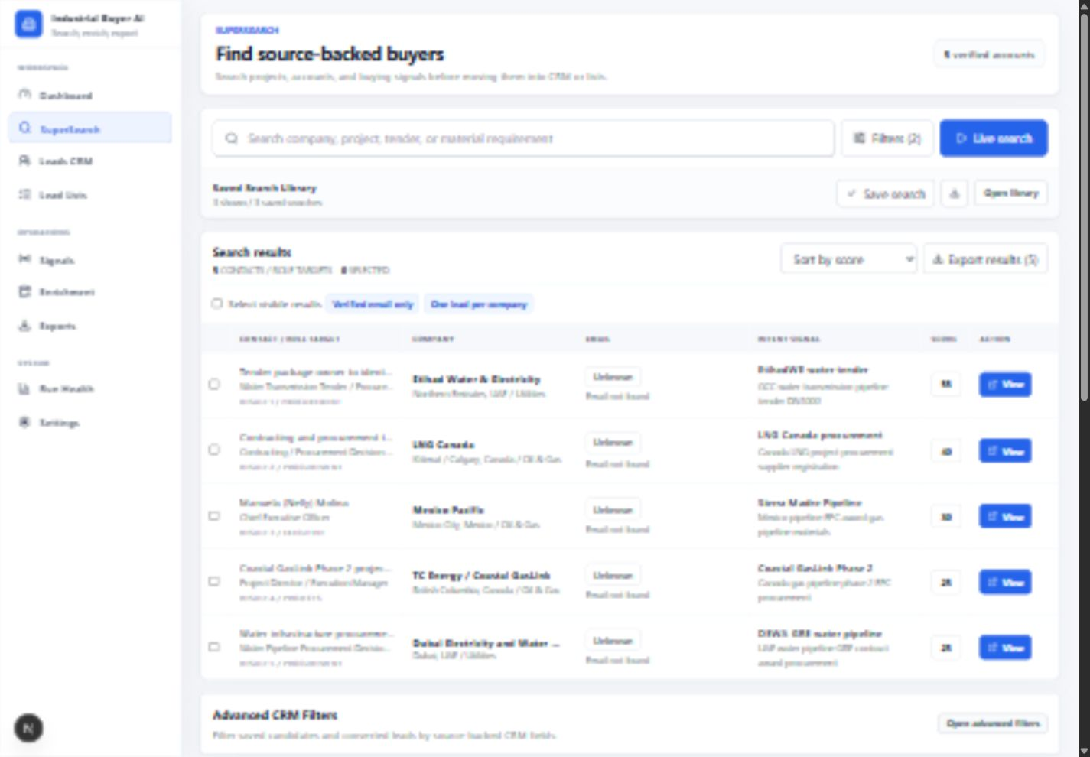
Figure 1. SuperSearch command center with search, filters, live discovery, saved search controls, and result controls.
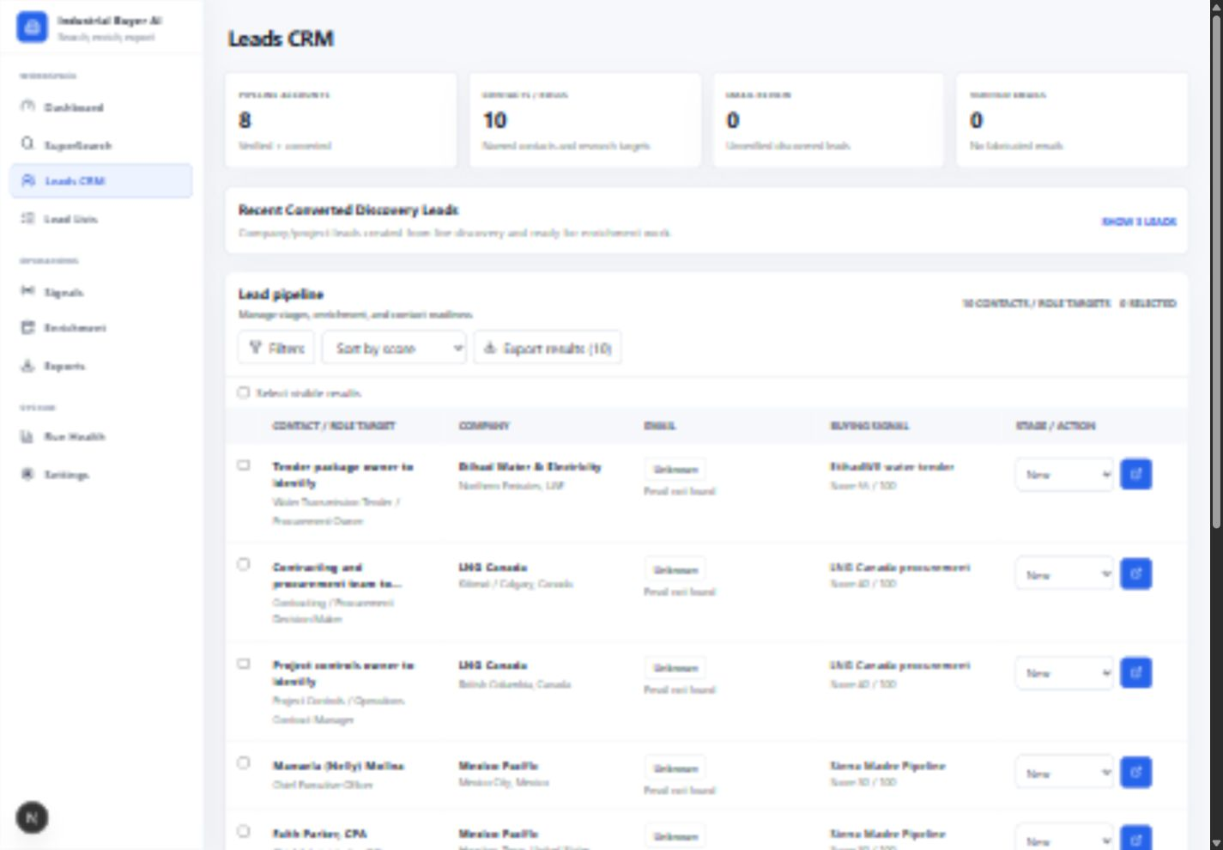
Figure 2. Leads CRM workspace showing converted leads, stage, enrichment state, email status, source-backed buying signal, and action flow.
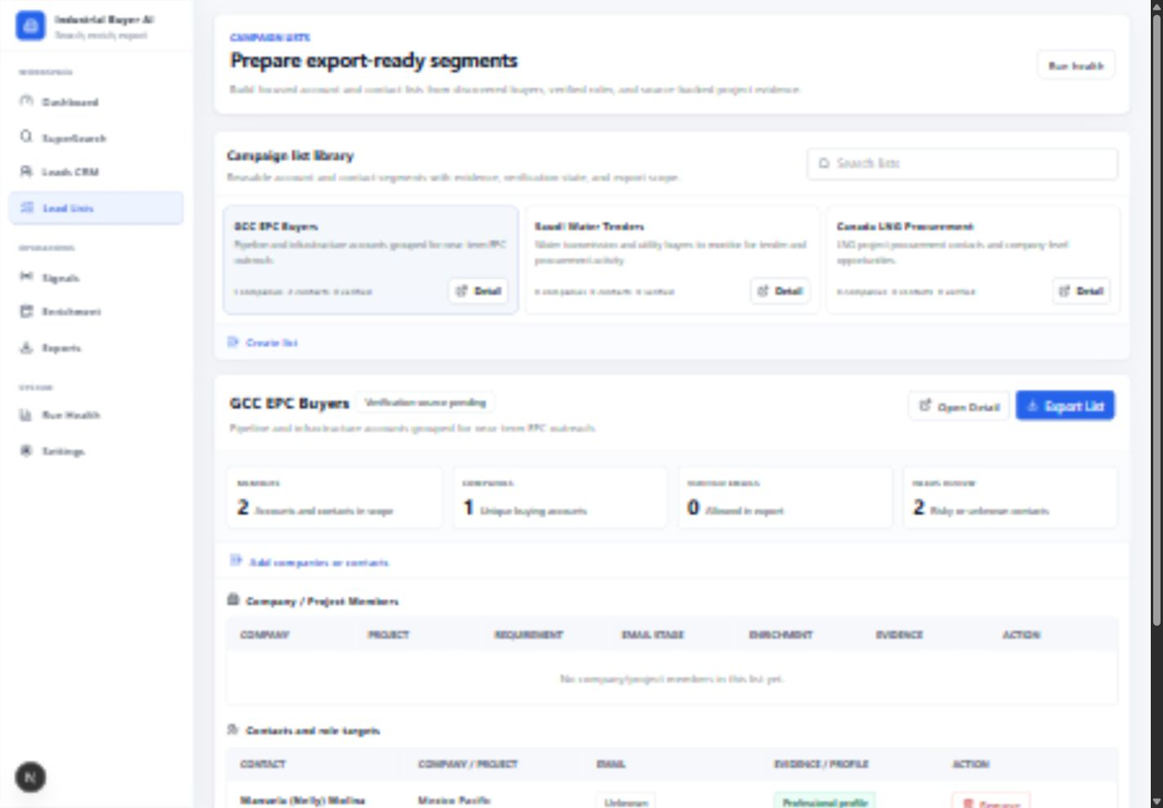
Figure 3. Lead Lists workspace showing campaign list organization, selected segment, metrics, member tables, and export preparation.
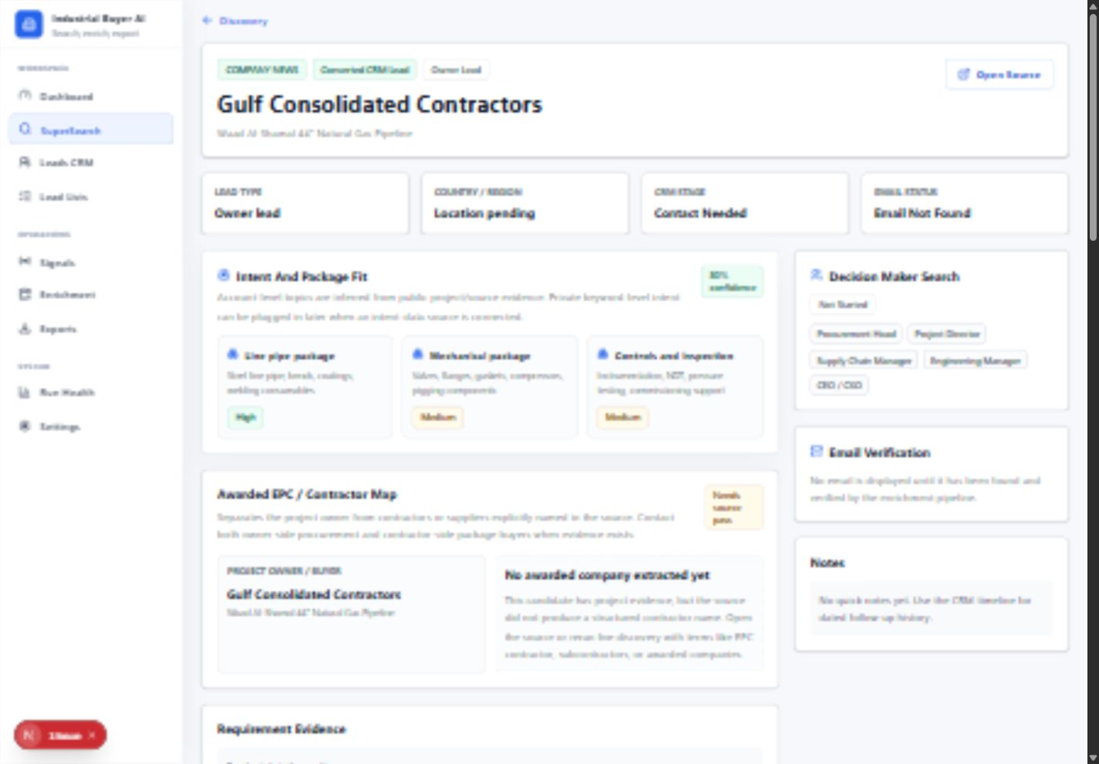
Figure 4. Lead detail workspace showing project context, owner/contractor separation, package fit, decision-maker search, and evidence panels.
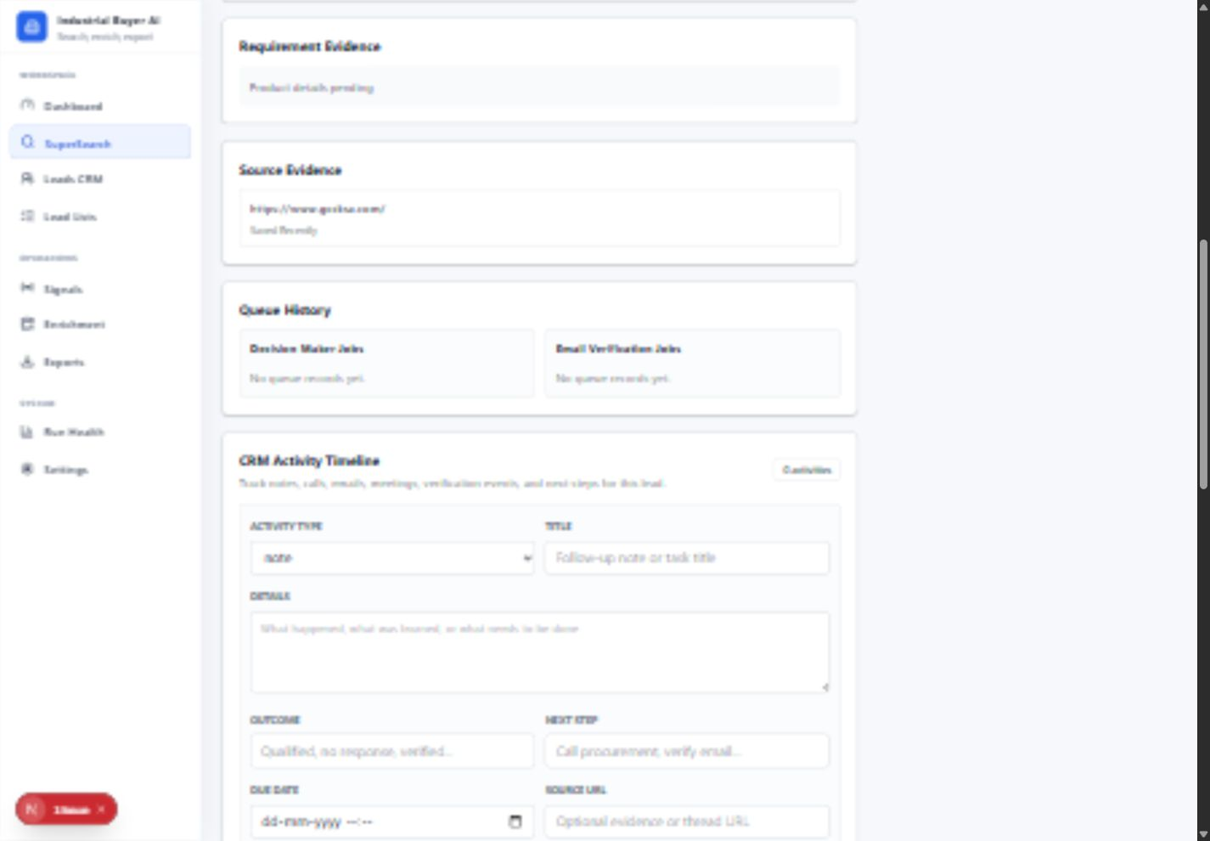
Figure 5. Contact evidence workflow showing requirement evidence, source evidence, queue history, CRM activity, and fields used for real contact research.
The Word version of this brief includes real product screenshots for the main workflows. Each screenshot is placed near the function it explains so the client can connect the written architecture to the actual interface.
Included screenshots:
- SuperSearch command center: shows search, filters, live discovery, saved searches, and result controls.
- Leads CRM workspace: shows lead records, decision-maker targets, source-backed projects, email states, and actions.
- Lead Lists workspace: shows campaign list organization, selected list context, table layout, and export preparation.
- Dashboard overview: shows executive summary metrics, recent signals, market coverage, and next actions.
- CRM action area: shows stage, decision-maker search, verification, and source actions.
2.1 SuperSearch
SuperSearch is the main discovery workspace. It lets the user search by company, project, tender, product requirement, region, or keyword.
Current capabilities:
- search public web sources for industrial buyer signals;
- process multiple URLs per discovery run;
- show which URLs were checked, skipped, failed, or saved;
- reject weak or irrelevant pages;
- prioritize company announcements, tender/procurement pages, government sources, EPC news, and source-backed project pages;
- show structured candidates with company, project, location, signal type, requirements, confidence, and source URL;
- save promising candidates for later CRM conversion.
Screenshot slot:
Screenshot | What To Capture | Purpose
SuperSearch command bar | Top search bar, filters button, live search button, saved search strip | Shows the primary search workflow
Live discovery run | Running state or completed run with checked/skipped/saved counts | Shows source processing transparency
New candidates | Candidate cards with company/project/source evidence | Shows public discovery extraction output

2.2 Advanced Filters
The app supports filters for narrowing buyer discovery and CRM-ready records.
Current filters include:
- location / region;
- project keywords;
- industry;
- employee range;
- email status;
- stage;
- confidence;
- source-backed requirement text;
- one lead per company;
- skip already-owned contacts;
- verified email only.
This follows the same product logic used by enterprise prospecting platforms: users keep the main search simple, then open filters when they need more precision.
2.3 Saved Searches
Saved searches allow repeated discovery workflows such as:
- GCC EPC Buyers;
- Saudi Water Tenders;
- Canada LNG Procurement;
- priority pipeline buyers;
- water infrastructure tenders.
Current capabilities:
- save current query, filters, regions, and keywords;
- apply saved searches later;
- export saved search definitions;
- keep the saved search library compact so the primary workspace stays focused.
2.4 Live Discovery Source Processing
This is the part that extracts real data from public sources.
Current live discovery flow:
- User enters query and filters.
- The search layer builds focused search queries.
- The search provider returns public web results.
- The source-quality layer scores each page.
- Weak pages are skipped with a reason.
- Strong pages are fetched and processed.
- The extraction layer identifies companies, projects, buyer signals, product requirements, and source evidence.
- The scoring layer assigns confidence.
- The UI shows new candidates and source status.
- The user can save candidates or convert them into CRM leads.
Legitimacy guardrails:
- only source-backed public evidence is shown;
- no fake contact emails are generated;
- unknown email remains unknown;
- private individual search activity is not claimed;
- exact private search keywords are not displayed unless a future approved data source explicitly provides a permitted equivalent;
- every discovered company/project should connect back to source evidence.
2.5 Saved Candidates
Saved candidates are company/project opportunities discovered from public sources.
Current candidate fields:
- company name;
- country / region;
- project name;
- signal type;
- product requirement summary;
- confidence;
- source URL;
- discovery date;
- stage.
User actions:
- save candidate;
- update stage;
- export saved candidates;
- convert candidate into CRM lead.
2.6 Candidate To CRM Lead Conversion
Saved candidates can become CRM-style company/project leads.
Current CRM lead fields:
- company / project;
- CRM stage;
- decision-maker enrichment state;
- target roles;
- email verification state;
- requirement summary;
- source evidence;
- confidence.
This is the bridge between raw discovery and sales workflow.
2.7 Leads CRM
Leads CRM manages discovered leads, role targets, enrichment status, and verification status.
Current capabilities:
- view converted company/project leads;
- filter by country, stage, signal, requirement, score, and email state;
- track decision-maker search state;
- queue verification actions;
- show discovered/known decision-maker targets;
- export selected rows;
- keep unverified email state visible instead of inventing contact data.
Screenshot slot:
Screenshot | What To Capture | Purpose
Leads CRM table | CRM rows with stage, email status, LinkedIn/profile state, source project | Shows lead-management workflow
Selected lead detail | Right-side detail or detail page with evidence | Shows source-backed review before export

2.8 Decision-Maker Enrichment Workflow
The decision-maker workflow is designed to identify relevant people inside target accounts.
Current target roles:
- Procurement Head;
- Project Director;
- Supply Chain Manager;
- Engineering Manager;
- CEO / CXO;
- project owner / package owner;
- contracting/procurement decision maker.
Current state:
- role targeting UI is built;
- enrichment state is tracked;
- discovered or known contacts can be attached to companies;
- future provider results can flow into the same structure.
2.9 Email Verification Pipeline
The app models the verification lifecycle without showing unsupported email claims.
Current email states:
- Email Not Found;
- Search Queued;
- Verification Pending;
- Verified;
- Risky.
Rules:
- only verified emails should be shown as verified;
- unknown emails stay unknown;
- risky emails are separated from verified emails;
- export logic can restrict email output to verified addresses.
2.10 Lead Lists
Lead Lists turn accounts and contacts into focused campaign/export segments.
Current capabilities:
- create list;
- switch list;
- add companies/projects;
- add decision-maker contacts;
- show member counts;
- show company count;
- show verified email count;
- show review-needed count;
- export list as CSV;
- maintain source evidence and email state.
Screenshot slot:
Screenshot | What To Capture | Purpose
Lead Lists library | Campaign list cards and selected list workspace | Shows segment management
List detail | Companies, contacts, verified email count, export button | Shows export preparation workflow

2.11 Dashboard
The dashboard is the command center for high-level review.
Current dashboard areas:
- verified account count;
- average score;
- role target count;
- contacts needing verification;
- latest source-backed signals;
- market coverage;
- priority next actions.
The dashboard is designed to help a user decide where to focus next.
2.12 Run Health And Client-Safe Status
Run Health explains operational state without exposing internal provider names.
Current capabilities:
- show whether discovery is connected;
- show whether persistence is connected;
- show last run status;
- show checked, skipped, failed, and saved counts;
- hide internal vendor details from client-facing UI.
3. What Is Actual Data Today Vs Planned Integration Data
Area | Current State | Data Source Behavior | Future Integration Target
Public discovery | Built | Extracts from public search results and crawled source pages | Expand source coverage and ranking
Source-quality filtering | Built | Scores page quality and rejects weak sources | Add stronger source categories and confidence rules
Company/project extraction | Built | Extracts from public evidence pages | Add external company enrichment
Product requirement extraction | Built | Pulls requirement clues from project/tender/source text | Add structured requirement taxonomy
Candidate saving | Built | User saves source-backed candidates | Add automated review queue
CRM conversion | Built | Candidate becomes CRM lead | Add automatic enrichment triggers
Decision-maker roles | Built as workflow | Tracks target roles and contacts | Connect contact databases
Email verification states | Built as workflow | Tracks verification lifecycle | Connect verification network
Lead lists | Built | Groups companies and contacts | Add campaign sync and scoring
Visitor identification | Planned | Not inferred from public search alone | Connect visitor identification network
Intent data | Planned | Public topic signals only today | Connect account-level intent topics
Technographics | Planned | Not deeply enriched today | Connect technology-detection network
Company events | Planned | Public source signals today | Connect company-event source
Hiring signals | Planned | Public/source-backed signals possible | Connect job/hiring data feed
First-party tracking | Planned | Product-ready concept | Add tracking script and event ingestion
AI scoring explanations | Partially built | Uses source evidence and structured fields | Add full account scoring model

4. Client-Requested Enterprise Stack Mapping
The client described a 12-layer B2B intelligence stack. Below is how this project maps to that architecture.
4.1 Website Visitor Identification
Target purpose:
- identify the company behind anonymous website traffic;
- detect repeat visits;
- identify pricing-page and high-intent page visits;
- connect visitor activity to account records.
Planned product behavior:
- account timeline shows website sessions;
- account score increases when important pages are visited;
- visitor company appears as an account signal;
- exact individuals are not claimed unless a permitted source identifies them.
Current status:
- UI and architecture can support this layer;
- first-party tracking and visitor matching are planned.
4.2 Intent Data
Target purpose:
- detect companies researching relevant industrial topics;
- show topic interest, surge behavior, and account-level intent.
Planned product behavior:
- display topics such as pipeline EPC, LNG procurement, water transmission tender, gas turbine subcontracting;
- show topic score, trend, and last-seen date;
- attach intent topics to account scoring.
Important client-safe clarification:
- account-level intent normally means topics/categories/signals;
- it should not be presented as the exact private words typed by a specific person unless a permitted source explicitly provides that level of data.
4.3 Company Enrichment
Target purpose:
- enrich accounts with industry, employee count, revenue band, domain, location, corporate hierarchy, and firmographic details.
Planned product behavior:
- company profile becomes richer;
- filters become stronger;
- scoring can include company size, sector, geography, and account fit.
4.4 Contact Database
Target purpose:
- find relevant decision-makers inside target accounts.
Planned product behavior:
- company record shows procurement, project, supply chain, engineering, and executive contacts;
- contacts include title, department, seniority, region, source, and verification state;
- role targets can be added to lead lists.
4.5 Email Verification
Target purpose:
- verify discovered emails before export or outreach.
Planned product behavior:
- email state changes from unknown/search pending to verified/risky/not found;
- verified emails can be included in export;
- unknown and risky emails remain separated.
4.6 Technographics
Target purpose:
- identify what technologies a company uses.
Planned product behavior:
- company profile includes detected technologies;
- search filters can target companies using specific tools or platforms;
- scoring can consider technology fit.
4.7 Company Events
Target purpose:
- detect funding, acquisitions, leadership changes, growth signals, and expansion activity.
Planned product behavior:
- account timeline shows relevant company events;
- recent events can increase lead priority;
- event source remains visible.
4.8 Job And Hiring Signals
Target purpose:
- use hiring activity as a buying signal.
Planned product behavior:
- hiring for project, procurement, engineering, maintenance, or operations roles can increase account priority;
- job-posting source appears in account evidence;
- filters can target companies hiring in specific functions.
4.9 Web Crawling And Search
Target purpose:
- discover companies, public pages, tenders, projects, and source-backed signals.
Current product behavior:
- this layer is already active;
- the app searches public sources, checks URLs, filters weak pages, extracts structured data, and shows the result with source evidence.
4.10 First-Party Tracking
Target purpose:
- track page views, sessions, repeat visits, form activity, and high-intent page engagement.
Planned product behavior:
- a tracking script records first-party product-site activity;
- the account timeline shows engagement;
- scoring uses repeat visits and high-intent pages.
4.11 Data Warehouse
Target purpose:
- store accounts, contacts, events, intent signals, scoring history, and run history.
Planned product behavior:
- operational records are stored in a relational store;
- high-volume event and activity data can flow to an analytical warehouse;
- reporting can show trends over time.
4.12 AI Layer
Target purpose:
- summarize accounts;
- reason about lead priority;
- explain scoring;
- generate personalized outreach context;
- extract structured facts from evidence.
Current and planned behavior:
- source evidence is structured into candidate and lead records;
- future AI scoring explains why an account is a good fit;
- future outreach drafts can reference verified project/source context;
- the AI layer should use OpenAI API for reasoning, summarization, extraction, and personalization.
5. End-To-End Data Flow
5.1 Public Discovery Flow
- User searches for a project, buyer type, material, or region.
- Search queries are generated from the entered text and filters.
- Public source URLs are collected.
- Each URL is checked for relevance and source quality.
- Bad pages are skipped with reasons.
- Good pages are processed.
- Structured fields are extracted:
- company;
- project;
- region;
- buyer signal;
- product requirement;
- source evidence;
- confidence.
- Candidates appear in SuperSearch.
- User saves candidates.
- User converts candidates into CRM leads.
- CRM leads can be enriched, verified, listed, and exported.
5.2 Lead Management Flow
- Saved candidate becomes a CRM lead.
- CRM lead gets a stage.
- Target roles are assigned.
- Decision-maker search is requested.
- Contacts are attached when available.
- Email status is tracked.
- Lead can be added to a list.
- List can be exported.
5.3 Future Enterprise Intelligence Flow
- First-party website activity identifies account engagement.
- Intent topics add external research signals.
- Company enrichment completes firmographic details.
- Contact enrichment identifies decision-makers.
- Email verification validates contactability.
- Technographics and company events add fit and timing signals.
- Hiring signals add growth/buying indicators.
- AI scoring explains why the account matters.
- Sales users work the account through CRM, lists, and export workflows.
6. Function Map: What Each Screen Does
Screen / Function | What User Sees | What It Does Behind The Scenes | Current / Planned
SuperSearch command bar | Search input, filters, live search | Builds discovery queries and starts source processing | Current
Filters drawer | Region, title, keyword, email, employee, list filters | Narrows discovery/results scope | Current
Saved Search Library | Saved/reusable searches | Stores reusable search conditions | Current
Live Discovery Run | Checked/skipped/failed/saved counts | Shows source-processing result | Current
Candidate cards | Company/project/source candidates | Displays extracted public evidence | Current
Search results table | Role targets and verified account rows | Lets users select, export, or list contacts | Current
Saved candidates | Candidate list | Stores reviewed discovery opportunities | Current
Converted CRM leads | Company/project lead rows | Turns candidate into CRM workflow record | Current
Lead detail | Company, evidence, roles, verification | Reviews one lead in detail | Current
Leads CRM | CRM table with filters/actions | Manages stages, enrichment, verification, export | Current
Lead Lists | List library and selected campaign list | Prepares segmented exports | Current
Run Health | Operational status and run counts | Shows client-safe connectivity/run state | Current
Exports | Export workflow | Produces CSV outputs | Current
Settings | Client-safe configuration | Shows policies without internal provider details | Current
Visitor Identification | Account traffic intelligence | Matches anonymous visits to accounts | Planned
Intent Topics | Account-level research signals | Adds topic/surge signals to scoring | Planned
Company Enrichment | Full company profile | Adds firmographic enrichment | Planned
Contact Enrichment | Decision-maker contacts | Adds people and role data | Planned
Technographics | Technology profile | Adds detected company technologies | Planned
Company Events | Funding/growth/acquisition events | Adds timing signals | Planned
Hiring Signals | Open roles and team growth | Adds buying/growth indicators | Planned
AI Scoring | Explainable lead priority | Summarizes and scores account fit | Planned

7. What The Product Should Not Claim
To keep the platform credible and client-safe:
- do not claim exact private search keywords unless a permitted data source explicitly provides that level of signal;
- do not invent emails;
- do not mark unknown contacts as verified;
- do not show internal provider names in the frontend;
- do not expose infrastructure details in the frontend;
- do not imply every future data layer is already connected;
- do not export risky/unknown emails as verified.
8. Recommended Next Build Order
Phase 1: Finish Current Product Surface
- Finish final UI polish for SuperSearch, Leads CRM, Lead Lists, Dashboard, and detail pages.
- Add better empty states and loading states.
- Add account timeline layout.
- Add clearer evidence drawer/detail panel.
- Finalize export review screen.
Phase 2: Add Provider Integration Layer
- Create a provider abstraction for company enrichment, contact enrichment, verification, technographics, events, and intent.
- Normalize provider responses into internal account/contact/event models.
- Add provider health checks to Run Health without exposing provider names.
Phase 3: Add Enterprise Intelligence
- First-party tracking script.
- Visitor-company matching.
- Account-level intent topics.
- Company enrichment.
- Contact enrichment.
- Email verification waterfall.
- Technographics.
- Company events.
- Hiring signals.
- AI lead scoring and explanation.
Phase 4: Client-Ready Operating Workflow
- Account timeline.
- Lead scoring explanation.
- List builder improvements.
- Export approval flow.
- Outreach-personalization assistant.
- Role-based access and audit log.
- Reporting dashboard.
9. Suggested Screenshot Checklist
Use these screenshots in the final client-facing deck or handoff document.
Screenshot Number | Page / Area | What To Show | Caption
1 | Dashboard | Buyer pipeline overview and priority next actions | Executive command center
2 | SuperSearch | Search bar, filters, live search | Source-backed discovery
3 | Live Discovery Run | Checked/skipped/failed/saved source status | Transparent source processing
4 | Candidate Cards | New discovered accounts/projects | Extracted buyer opportunities
5 | Search Results | Role targets and export controls | Source-backed contact review
6 | Saved Candidates | Saved discovery opportunities | Reviewed buyer candidates
7 | Converted CRM Leads | CRM stage, target roles, verification | Discovery-to-CRM workflow
8 | Lead Detail | Source evidence and decision-maker area | Evidence-backed account review
9 | Leads CRM | Full CRM lead table | Operational lead management
10 | Lead Lists | Campaign list workspace | Export-ready segment preparation
11 | Run Health | Connected/run-state metrics | Client-safe operational status
12 | Exports | CSV export workflow | Data handoff and CRM import

10. Client Explanation Script
The current product is the operating foundation for an industrial buyer-intelligence platform. It already supports source-backed public discovery, CRM-style lead management, decision-maker workflow, verification states, lead lists, exports, and client-safe operational status.
The client’s target architecture adds deeper enterprise data layers: visitor identification, intent topics, company enrichment, contact discovery, email verification, technographics, company events, hiring signals, first-party tracking, warehouse analytics, and AI reasoning.
The architecture is designed so each of those layers can plug into the same account, contact, event, scoring, list, and export workflow. Current public discovery creates the first source-backed account records. Future data integrations enrich those records with stronger account intelligence, verified contacts, buying signals, and scoring explanations.
The product should be described as an evidence-first system: it separates known facts, pending enrichment, unverified contacts, and verified outreach data. This keeps the platform credible while still showing a clear path toward a full 6sense / ZoomInfo-style intelligence workflow.
11. What Comes Next And Final Product Position
11.1 Immediate Next Build Priorities
The next build phase should focus on making the existing workflow feel complete before adding more data sources.
Recommended next steps:
- Finish the account timeline view so each company has a chronological record of discovery signals, source pages, contact research, verification status, and list/export activity.
- Add an evidence drawer so users can inspect source proof without leaving the current table or workspace.
- Add export review so users can see exactly which companies, contacts, email states, source links, and notes will be included before downloading.
- Add clearer enrichment states for accounts and contacts so users immediately understand what is known, what is pending, and what is ready for outreach.
- Improve dashboard metrics so the command center reflects real discovered leads, saved candidates, list membership, verification readiness, and recent discovery activity.
11.2 Integration Build Priorities After APIs Are Provided
Once the required APIs are provided, the next engineering work is to connect each data layer through a clean provider interface. The frontend should not need to know which provider produced the data. It should only receive normalized account, contact, event, signal, verification, and scoring records.
Recommended integration order:
- Company enrichment, because this strengthens account profiles, filters, and scoring.
- Contact database enrichment, because it turns account-level leads into actionable role targets.
- Email verification, because outreach-ready export depends on verified contactability.
- Intent topics, because account-level research signals improve timing and prioritization.
- Technographics, company events, and hiring signals, because these add fit and timing context.
- First-party tracking and visitor identification, because these make the product closer to a complete account-intelligence system.
- AI scoring explanations and outreach context, because the AI layer becomes more valuable after the account and contact data are richer.
11.3 Final Product Compared With The Client POV
If all requested APIs are provided and connected correctly, the end product can match the client’s 6sense / ZoomInfo-style POV in architecture and workflow.
It will match the client POV in these areas:
- account discovery;
- company enrichment;
- contact discovery;
- email verification;
- account-level intent topics;
- visitor identification;
- technographics;
- company events;
- hiring signals;
- source-backed evidence;
- lead scoring;
- CRM-style workflow;
- list building;
- export preparation;
- AI-based summaries and scoring explanations.
It can become better than the client POV in one important way: it is specialized for industrial procurement. General B2B intelligence platforms are broad. This product can be narrower and more useful for industrial buyers because it can focus on project evidence, tender activity, EPC awards, material requirements, pipeline/LNG/water/power infrastructure signals, procurement roles, and export-ready industrial lead lists.
It would be lesser than the client POV only if one or more data layers are not connected. For example, without visitor identification, it cannot identify anonymous website traffic. Without intent-topic data, it can only show public/source-backed buying signals. Without contact and verification data, it cannot reliably provide verified outreach contacts at scale.
The final position should therefore be explained clearly:
The current product is the operating system for industrial buyer intelligence. With the full API stack connected, it becomes a complete account-intelligence platform. It can match the client’s requested architecture and may become stronger for industrial procurement use cases because the workflow is purpose-built around projects, tenders, requirements, evidence, decision-maker roles, verification, lists, and exports.

Client Demo Usage Guide And Current Product State
This section explains how to operate the software during the client walkthrough and what each workflow is expected to prove. The product should be presented as a source-backed industrial buyer intelligence workflow: discover evidence, separate owners from awarded contractors, create leads, attach real contact evidence, prepare lists, and export only data with clear status labels.
What Is Ready To Show Today
- SuperSearch can run live discovery against project, tender, company, contractor, and procurement keywords.
- Discovery results show company or project name, region, signal type, requirement, confidence, and source evidence.
- Saved candidates can be converted into CRM leads.
- The detail workspace separates the project owner or buyer from awarded EPC contractors and suppliers when the source names them.
- Contractor leads can be created from the awarded contractor map, preserving parent project and owner context.
- Decision maker targets can be generated for owner-side and contractor-side roles, including package-specific procurement, contracts, project, engineering, and supply-chain roles.
- Real contact evidence can now be patched into the decision-maker record: LinkedIn URL, email candidate, phone candidate, source URL, data source type, confidence, and evidence notes.
- Lead Lists can organize accounts and contacts into export-ready campaign segments with source and verification status preserved.
Important Data Integrity Rule
No contact field should be presented as verified unless the verification workflow confirms it. Emails, phone numbers, and LinkedIn profiles that are found from public or procured sources should be saved as candidates with source evidence and confidence. This keeps the platform credible while still allowing real data work to begin immediately.
Step By Step Operator Workflow
Step | User action | What the system does | Expected result
1 | Open SuperSearch and enter a project, company, tender, product, contractor, or procurement keyword. | The discovery workflow searches and reads source-backed public evidence. | Candidate accounts and projects appear with source URLs and confidence.
2 | Review the discovered candidate row and open Detail when the source looks relevant. | The detail workspace shows project owner, requirement evidence, source evidence, package fit, and extracted contractors. | The user can understand whether the named company is the owner, buyer, awarded contractor, or supplier.
3 | Click Save Candidate for promising records. | The candidate is stored for CRM review without forcing immediate outreach decisions. | The record remains available for later qualification.
4 | Click Convert To Lead when the account or contractor should enter the sales workflow. | The candidate becomes a CRM lead with stage, enrichment status, email status, and target roles. | The lead appears in the CRM and list workflow.
5 | If the source names awarded EPC contractors or suppliers, use Create Contractor Lead. | The system creates a contractor-side lead and attaches the original owner and project as parent context. | The contractor lead does not get confused with the project owner.
6 | Use Find Contractor Contacts or prepare a decision-maker role target. | The system creates role-level contact targets based on contractor scope and package fit. | Procurement, contracts, project, engineering, supply-chain, and package roles are ready for research.
7 | Patch real person evidence only when found. | The user adds the person's name, title, company, LinkedIn, email candidate, phone candidate, source URL, source type, confidence, and notes. | The contact becomes a real sourced decision-maker record, not a placeholder.
8 | Queue verification for email candidates. | The verification state moves to pending until a verifier or contact provider confirms it. | The record remains useful but is not overstated as verified.
9 | Add leads or contacts to Lead Lists. | The list workspace groups selected accounts and decision makers into focused campaign segments. | The user can prepare an export by segment, project, owner, contractor, or role.
10 | Export only when the list has the desired source and verification status. | CSV exports preserve status fields, source URLs, LinkedIn, phone candidate, evidence notes, and confidence. | The exported data is clear enough for CRM import or outreach review.

How To Explain The ADNOC Example
When a result says ADNOC LNG or ADNOC Gas, that is usually the project owner or buyer. The awarded contractor map is the important next layer: it identifies companies such as Tecnicas Reunidas or TECC when the source explicitly names them as EPC, construction, commissioning, contractor, or supplier parties. The recommended outreach path is to contact both the owner-side procurement organization and the contractor-side package buyers when evidence exists.
Current Product Capability Map
Capability | Current state | Next build
Live discovery | Built. Searches, reads sources, extracts project and company evidence, and shows confidence. | Improve source coverage and provider routing for more markets and procurement sources.
Owner versus contractor separation | Built. The awarded contractor map separates project owner from named contractors and suppliers. | Add deeper package mapping so each contractor can be tied to material categories and subcontract needs.
Decision maker targeting | Built for role targets and manual sourced contacts. | Connect contact data providers so role targets become real people automatically.
LinkedIn capture | Built as a sourced field on decision-maker records. | Add automated profile matching and duplicate detection.
Email capture | Built as sourced candidate data with verification status protection. | Connect verification workflow so candidates become verified, risky, rejected, or unknown.
Phone capture | Built as sourced candidate data with phone status and source URL. | Add contact provider and phone-verification enrichment when available.
Lead Lists | Built for campaign segments, member management, and export. | Add stronger list QA, scoring, and export readiness checks.
AI reasoning | Built for extraction, scoring, and source-backed summaries. | Add deeper account scoring, next-best-action reasoning, and personalized outreach support.

What Still Needs External Data Connections
The current application can store real contact evidence today, but automatic people discovery and automatic verification require connected data sources. Once account, person, LinkedIn/profile, email verification, phone, intent, technographic, event, and first-party tracking sources are connected, the same workflow can populate and verify records without manual patching.
- Contact database connection: converts target roles into real decision makers.
- Email verification connection: confirms whether stored email candidates are valid, risky, rejected, or unknown.
- Profile matching connection: improves LinkedIn/profile confidence and reduces duplicates.
- Phone/contact enrichment connection: adds phone candidates and verification status where available.
- Intent and visitor identification sources: move the product closer to account intelligence platforms by showing which accounts are actively researching relevant categories.
Client Demo Talk Track
- Start with Discovery and search a real industrial project or procurement phrase.
- Open Detail and point out source evidence, confidence, package fit, and awarded contractor extraction.
- Create a contractor lead and explain the parent project relationship.
- Prepare contractor contact targets and show where real LinkedIn, email, phone, and source evidence is added.
- Open Leads CRM and show how converted owner and contractor leads are managed with stage, enrichment, contacts, email status, and parent context.
- Open Lead Lists and show how accounts and contacts move into campaign-ready segments with export controls.
End Product Direction Compared With The Client Vision
If all required data connections are provided, the end product can match the client's requested architecture in workflow shape: anonymous account identification, intent detection, project discovery, contractor mapping, company enrichment, decision-maker discovery, email and phone verification, lead-list preparation, and AI-assisted reasoning. The current build is strongest as the workflow and data model foundation. The remaining gap is automated data supply and verification depth, not the basic product logic.
With the planned connections, the product can become comparable to leading B2B sales intelligence workflows for this industrial niche, and potentially stronger in project and contractor-context specificity because it focuses on procurement evidence, awarded parties, package needs, and source-backed lead reasoning rather than generic company lists.
Latest Product Update Source Backed Contractor Contact Automation
The current build now performs a real source backed contractor contact search from the awarded contractor card. This closes the gap between a visual queue and an operational enrichment workflow. The system searches public source results, reads supported pages, extracts real named people when evidence exists, and automatically saves those people as enriched decision maker records.
Current automated flow:
- Find contractor contacts starts a live search for the selected awarded EPC, contractor, or supplier.
- The search uses contractor name, parent project, owner company, package scope, and target procurement or project roles.
- Readable sources and search evidence are scanned for real people, role titles, professional profile links, email candidates, and phone candidates.
- The system rejects obvious non person matches such as company names, locations, legal suffixes, education fragments, and generic pages.
- Source backed people are saved automatically as enriched decision makers for the contractor lead.
- Email candidates are marked Verification Pending until a verifier confirms them. LinkedIn or professional profile URLs are marked Profile Found. Phone values are marked Candidate Found until validated.
- Saved contacts appear in Discovery detail, Leads CRM, Lead Lists, and export workflows without manual re entry.
This does not invent missing contact data. If a public source does not expose a real person, email, LinkedIn profile, or phone number with enough evidence, the job completes as No Source Contact and explains that a narrower role or location search is needed.
Recommended User Workflow From Discovery To Export
- Open SuperSearch and run a live search using a project, company, tender, EPC award, or subcontract keyword.
- Review the source backed accounts and open Detail for the strongest candidate.
- Use the source and requirement evidence to confirm the project context.
- Save candidate or convert the candidate to a CRM lead when the account is worth pursuing.
- Review the Awarded EPC / Contractor Map to separate the project owner from awarded contractors or suppliers.
- Create contractor leads for the companies that are realistic buying or package targets.
- Click Find contractor contacts on each contractor card. The system now searches sources and auto patches real people when evidence exists.
- Open Leads CRM to review enriched people, LinkedIn/profile status, email status, phone status, source URL, and evidence notes.
- Add qualified leads and contacts to Lead Lists, then export only after emails and phone data have the right verification state for the intended campaign.
How This Maps To The Client Target Stack
The product now covers the front end workflow and the first operational version of source backed account, contractor, and contact discovery. When dedicated company enrichment, person database, email verification, phone enrichment, technographic, intent, visitor identification, and event data sources are connected, the same flow can become a full 6sense or ZoomInfo style intelligence product rather than a demo workflow.
- Already working: live project and procurement discovery, source evidence, candidate saving, CRM conversion, awarded contractor extraction, contractor lead creation, source backed contact search, decision maker auto patching, list building, and export.
- Next provider layer: company enrichment for normalized company profiles, employee bands, domains, revenue, locations, and industry tags.
- Next people layer: person database lookup for broader coverage of decision makers, LinkedIn/profile URLs, work emails, and phone candidates.
- Next verification layer: email and phone verification so patched candidates can move from Verification Pending or Candidate Found into verified outreach states.
- Next intelligence layer: intent, technographics, company events, hiring signals, website visitor identification, and first party tracking to score timing and buying fit.
- End product target: equal or stronger than the client requirement if all data sources are connected, because the workflow already separates owner, contractor, package, person, evidence, verification, CRM, list, and export context.

