ASSIGNMENT – 2

# Subject – Computer Science Workshop-1(CSE 2141)

# NAME – DEEPTESH ROUT

# Registration Number – 2341018166

# Section – 23412G1

# Branch – B. Tech (CSE)

1. Create an HTML page with headings and paragraphs. Apply inline styles to the h1 andh2 headings, such as changing the font color and size. Use internal styles for the h3 andh4 headings by applying styles using the id attribute, such as setting text alignment and font-weight. Additionally, link an external stylesheet to define the body background color, style the h5 heading, and set the paragraph's text color and font size using the class attribute. Ensure the external stylesheet is properly linked to the HTML page.

Answer: -

HTML CODE

<html>

<head>

    <title>Deepteshrout Assignment 2 Question1</title>

    <link rel="stylesheet" href="styles.css">

    <style>

        #h3-heading {

            text-align: centre;

            font-weight: bold;

        }

        #h4-heading {

            text-align: right;

            font-weight: normal;

        }

    </style>

</head>

<body>

    <h1 style="colour: darkblue; font-size: 36px;">This is an H1 Heading with Inline Styles</h1>

    <h2 style="colour: green; font-size: 28px;">This is an H2 Heading with Inline Styles</h2>

    <h3 id="h3-heading">This is an H3 Heading with Internal Styles</h3>

    <h4 id="h4-heading">This is an H4 Heading with Internal Styles</h4>

    <h5 class="h5-heading">This is an H5 Heading styled by an external stylesheet</h5>

    <p class="paragraph">This is a paragraph with text colour and font size set using an external stylesheet. </p>

</body></html>

CSS CODE: -

body {

    background-colour: #f0f0f0;

}

.h5-heading {

    colour: purple;

    font-size: 22px;

}

. paragraph {

    colour: #555;

    font-size: 18px;

}

OUTPUT OF THE CODE: -

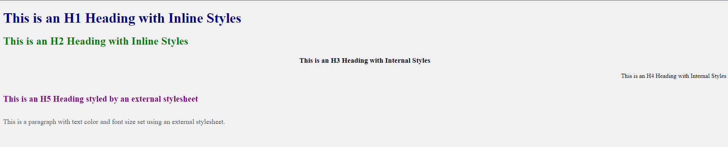

1. Imagine you are designing a webpage for a product display. You want to style the product container using the CSS box model. The product container should have a content width of 400px, padding of 20px on all sides, a border of 10px, and a margin of 15px around it. Inside this container, place an image of the product along with a brief description. Arrange three products in a row and ensure that the images and descriptions are properly aligned within each container.

ANSWER

HTML CODE

< html>

<head>

    <title> Deepteshrout Assignment 2 Question2</title>

    <link rel="stylesheet" href="styles.css">

</head>

<style>

body {

    font-family: Arial, sans-serif;

    background-color: #f4f4f4;

    padding: 20px;

    text-align: centre;

}

. product-row {

    display: flex;

    justify-content: space-between; /* Distribute products evenly */

    margin-top: 20px;

}

. product-container {

    width: 400px;

    padding: 20px;

    border: 10px solid #ddd;

    margin: 15px;

    background-color: #fff;

    box-shadow: 0px 4px 8px rgba(0, 0, 0, 0.1);

    text-align: left;

}

. product-container img {

    width: 100%;

    height: auto;

    margin-bottom: 10px;

}

. product-container p {

    font-size: 16px;

    color: #333;

}

</style>

<body>

    <h1>Product Display</h1>

    <div class="product-row">

        <div class="product-container">

            <img src="product1.jpg" alt="Product 1 Image">

            <p>Product 1: A brief description of the first product.</p>

        </div>

        <div class="product-container">

            <img src="product2.jpg" alt="Product 2 Image">

            <p>Product 2: A brief description of the second product.</p>

        </div>

        <div class="product-container">

            <img src="product3.jpg" alt="Product 3 Image">

            <p>Product 3: A brief description of the third product.</p>

        </div>

    </div>

</body>

</html>

OUTPUT OF THE CODE

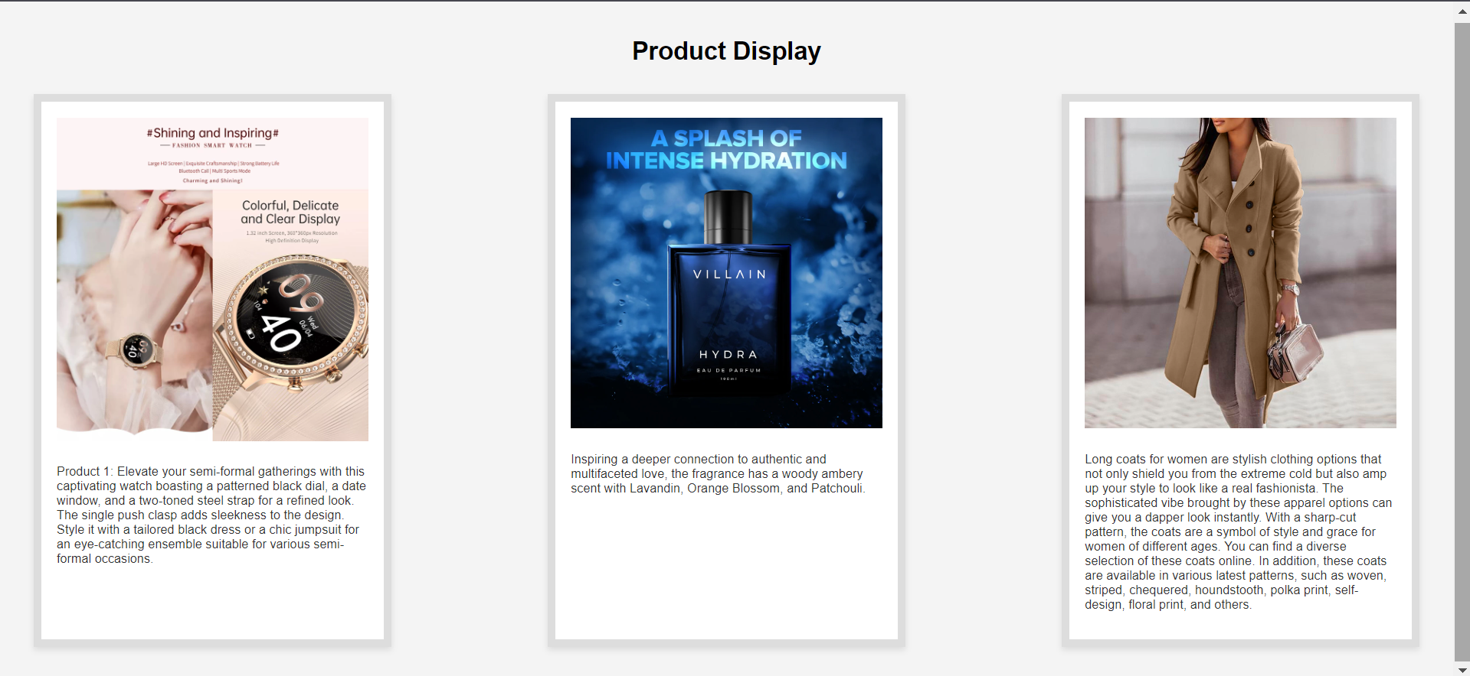

1. Add a <div> element and an image element. Write "My Special Div" as inline text inside the <div> like <div> My Special Div </div>. Change the text colour of the <div> when the user moves the mouse over the image, and change it back when the user moves the mouse out of the image.

ANSWER: -

HTML CODE: -

< html>

<head>

    <title> Deepteshrout Assignment 2 Question3</title>

    <style>

        #special-div {

            font-size: 20px;

            color: black;

        }

        img {

            width: 300px;

            height: auto;

            display: block;

            margin-top: 20px;

        }

        img:hover + #special-div {

            color: red;

        }

    </style>

</head>

<body>

    <img src="bird.jpg" alt="Hover over this image" id="hover-image">

    <div id="special-div">My Special Div</div>

</body>

</html>

output of the code

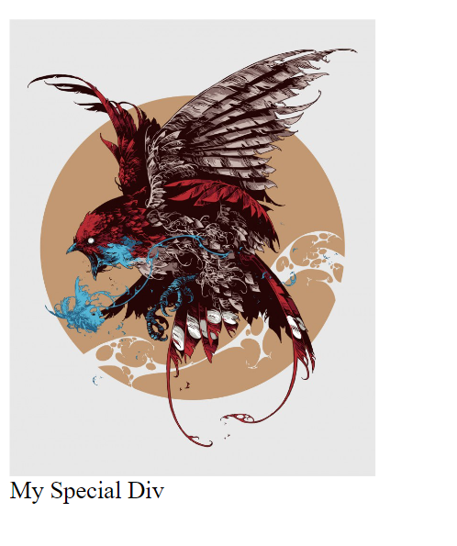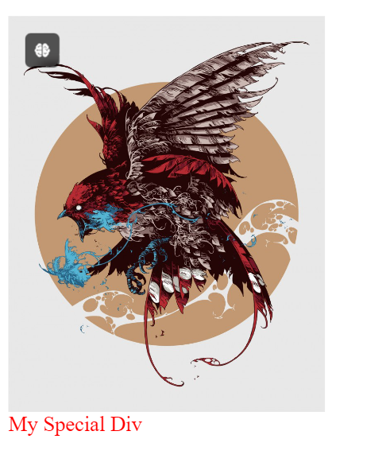before AFTER

1. Add an image as the background of a <div> element and change the image source when the user hovers the mouse over the image. In other words, when the user moves the mouse pointer over the image, the background image should change.

ANSWER: -

HTML CODE

<!DOCTYPE html>

<head>

    <title> Deepteshrout Assignment 2 Question4</title>

    <style>

        .image-div {

            width: 400px;

            height: 300px;

            background-image: url('default-image.jpg');

            background-size: cover;

            background-position: center;

            border: 2px solid #333;

            transition: background-image 0.3s ease-in-out; /* Smooth transition */

        }

        .image-div:hover {

            background-image: url('hover-image.jpg');

        }

    </style>

</head>

<body>

    <div class="image-div"></div>

</body>

</html>

Output of the code

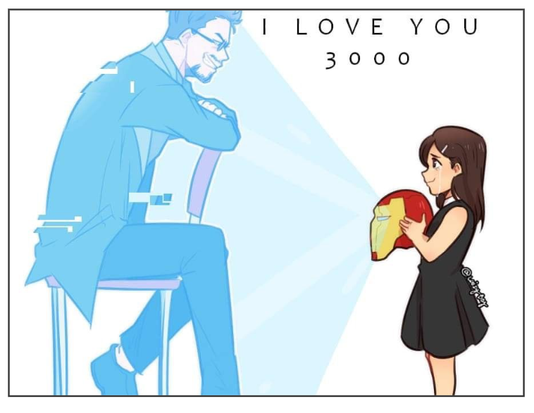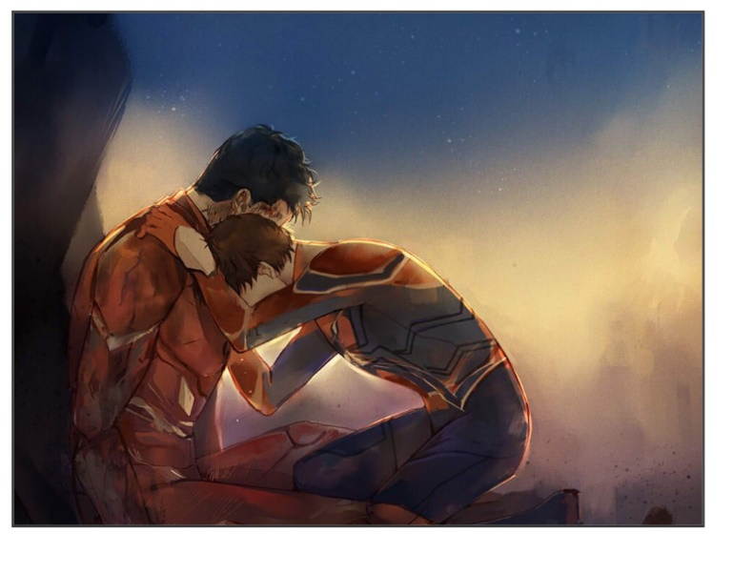before After

1. Create an unordered list using the SOA Logo image as the list marker by applying the list-style-image property. Ensure proper padding, background size, and positioning for correct alignment, and set the image to no-repeat. The font of the unordered list text should be set from the sans-serif font family.

ANSWER: -

HTML CODE

<!DOCTYPE html>

<head>

    <title> Deepteshrout Assignment 2 Question 5</title>

    <style>

        body {

            font-family: sans-serif;

        }

        .custom-list {

            list-style: none;

            padding-left: 40px;

        }

        .custom-list li {

            padding-left: 40px;

            background: url('soa-logo.png') no-repeat left center;

            background-size: 20px 20px;

            margin-bottom: 10px;

        }

    </style>

</head>

<body>

    <ul class="custom-list">

        <li>Item 1</li>

        <li>Item 2</li>

        <li>Item 3</li>

        <li>Item 4</li>

    </ul>

</body>

</html>

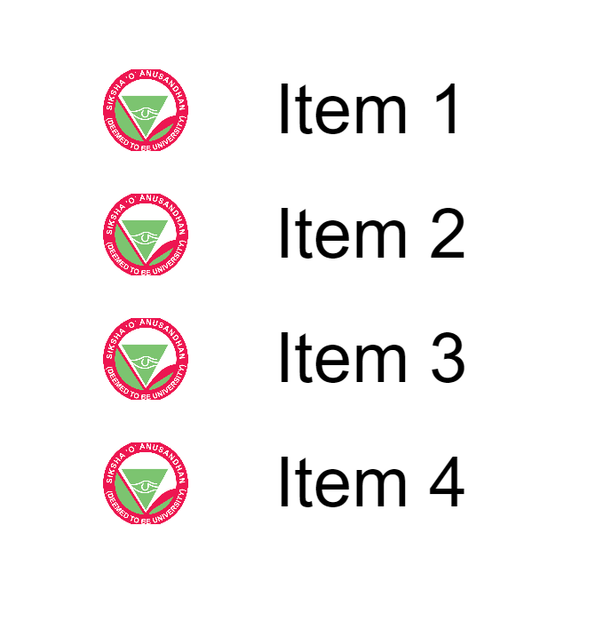OUTPUT OF THE CODE

1. Create a webpage that displays an HTML table. Apply CSS styles (such as border, border-collapse, width, height, padding, etc.) to enhance its appearance. Additionally, set a background color for the 1st, 4th, 7th, 10th, and every third row thereafter.

ANSWER

HTML CODE

<html>

<head>

    <title> Deepteshrout Assignment 2 Question 6</title>

    <style>

        table {

            width: 80%;

            border-collapse: collapse;

            margin: 20px auto;

        }

        th, td {

            border: 2px solid #333;

            padding: 12px 15px;

            text-align: center;

            height: 50px;

        }

        th {

            background-color: #444;

            color: #fff;

        }

        tr:nth-child(3n+1) {

            background-colour: #f2f2f2;

        }

        tr:hover {

            background-colour: #d3d3d3; /* Highlight row on hover */

        }

    </style>

</head>

<body>

    <table>

        <thead>

            <tr>

                <th>#</th>

                <th>Name</th>

                <th>Age</th>

                <th>City</th>

            </tr>

        </thead>

        <tbody>

            <tr>

                <td>1</td>

                <td>Alice</td>

                <td>25</td>

                <td>New York</td>

            </tr>

            <tr>

                <td>2</td>

                <td>Bob</td>

                <td>30</td>

                <td>Los Angeles</td>

            </tr>

            <tr>

                <td>3</td>

                <td>Charlie</td>

                <td>22</td>

                <td>Chicago</td>

            </tr>

            <tr>

                <td>4</td>

                <td>Diana</td>

                <td>28</td>

                <td>Houston</td>

            </tr>

            <tr>

                <td>5</td>

                <td>Eva</td>

                <td>26</td>

                <td>Miami</td>

            </tr>

            <tr>

                <td>6</td>

                <td>Frank</td>

                <td>24</td>

                <td>San Francisco</td>

            </tr>

            <tr>

                <td>7</td>

                <td>Grace</td>

                <td>29</td>

                <td>Boston</td>

            </tr>

            <tr>

                <td>8</td>

                <td>Henry</td>

                <td>31</td>

                <td>Seattle</td>

            </tr>

            <tr>

                <td>9</td>

                <td>Irene</td>

                <td>27</td>

                <td>Dallas</td>

            </tr>

            <tr>

                <td>10</td>

                <td>Jack</td>

                <td>23</td>

                <td>Austin</td>

            </tr>

        </tbody>

    </table>

</body>

</html>

OUTPUT OF THE CODE

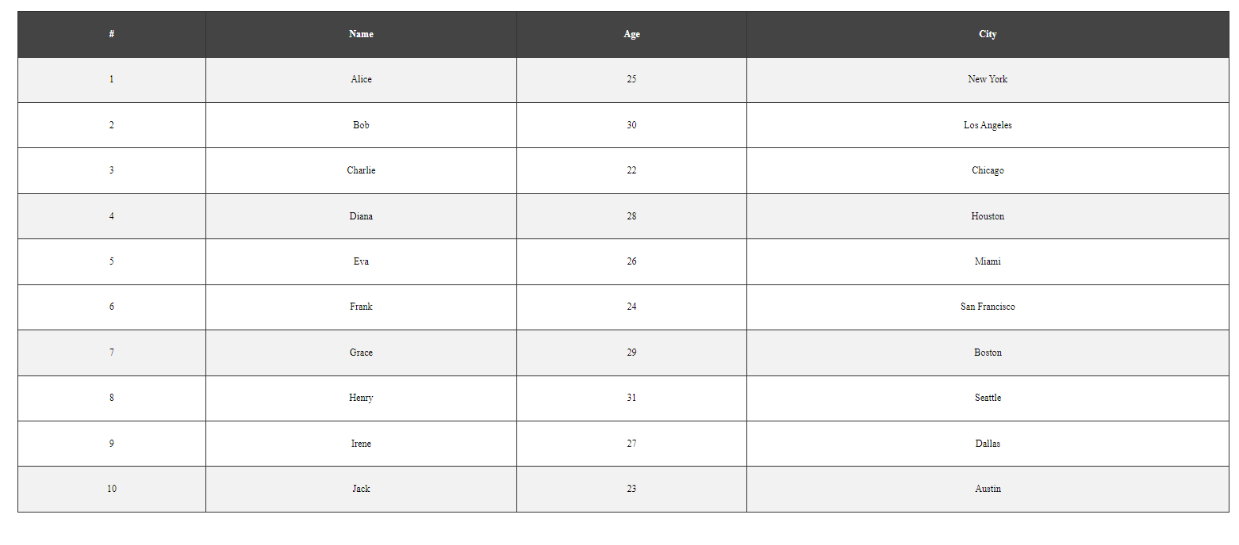

1. Create a vertical menu bar that sticks to either the left or right side of the page. Additionally, make the menu bar fixed so that it remains in the same position even when the user scrolls down the page. (To add a scrollbar to the page, you can simulate longer content by adding padding at the bottom of the page using the div element.)

ANSWER

HTML CODE: -

< html>

<head>

    <title> Deepteshrout Assignment 2 Question 7</title>

    <style>

        body {

            font-family: Arial, sans-serif;

            margin: 0;

            padding: 0;

        }

        .menu-bar {

            position: fixed;

            top: 0;

            left: 0;

            width: 200px;

            height: 100%;

          background-color: #333;

            padding-top: 20px;

            overflow: hidden;

        }

        .menu-bar a {

            display: block;

            color: white;

            padding: 12px 20px;

            text-decoration: none;

            text-align: left;

        }

        .menu-bar a:hover {

            background-color: #575757;

        }

        .content {

            margin-left: 220px;

            padding: 20px;

        }

        .padding-bottom {

            height: 1500px;

        }

    </style>

</head>

<body>

    <div class="menu-bar">

        <a href="#">Home</a>

        <a href="#">About</a>

        <a href="#">Services</a>

        <a href="#">Portfolio</a>

        <a href="#">Contact</a>

    </div>

    <div class="content">

        <h1>Welcome to My Page</h1>

        <p>This is the main content area. Scroll down to see the fixed menu bar.</p>

        <div class="padding-bottom"></div>

    </div>

</body>

</html>

OUTPUT OF THE CODE: -

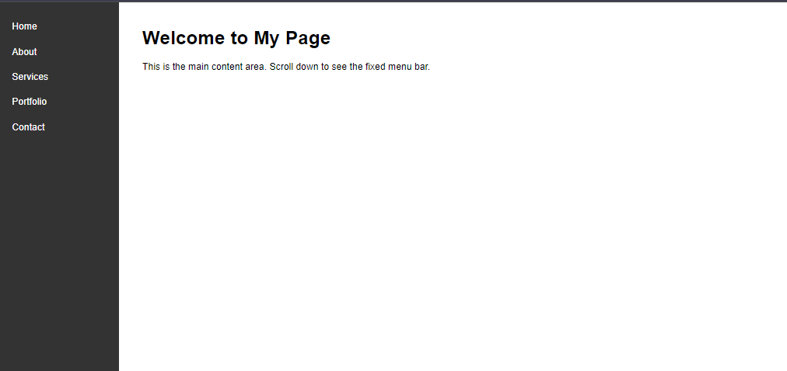

1. Create a page having image with horizontal repetition, a horizontal navigation bar with hover effect and sticky position, and some style text. Image encircled with border and outline of different style, width, and color. Increase the page height for the scroll effect.

ANSWER: -

HTML CODE

<!DOCTYPE html>

<html lang="en">

<head>

    <title> Deepteshrout Assignment 2 Question 8 </title>

    <style>

        /* General body styling */

        body {

            font-family: Arial, sans-serif;

            margin: 0;

            padding: 0;

        }

        .navbar {

            position: -webkit-sticky; /* For Safari */

            position: sticky;

            top: 0;

            background-color: #333;

            overflow: hidden;

            padding: 10px;

        }

        .navbar a {

            float: left;

            display: block;

            color: white;

            text-align: center;

            padding: 14px 20px;

            text-decoration: none;

            font-size: 18px;

        }

        /* Change color on hover */

        .navbar a:hover {

            background-color: #575757;

            color: white;

        }

        /* Clear floats */

        .navbar::after {

            content: "";

            clear: both;

            display: table;

        }

        .repeated-image {

            background-image: url('your-image.jpg'); /* Replace with your image */

            background-repeat: repeat-x; /* Repeats image horizontally */

            background-size: contain;

            height: 200px; /* Height for the image block */

        }

        .styled-image {

            display: block;

            margin: 20px auto;

            width: 300px;

            height: 200px;

            border: 5px solid #000; /* Solid border */

            outline: 10px dashed #ff5733; /* Dashed outline */

            outline-offset: 5px; /* Space between border and outline */

        }

        .styled-text {

            text-align: center;

            font-size: 24px;

            font-weight: bold;

            color: #444;

            padding: 20px;

        }

        .content {

            height: 1500px;

            padding: 20px;

        }

    </style>

</head>

<body>

    <div class="navbar">

        <a href="#home">Home</a>

        <a href="#services">Services</a>

        <a href="#about">About</a>

        <a href="#contact">Contact</a>

    </div>

    <div class="repeated-image"></div>

    <img src="your-image.jpg" alt="Styled Image" class="styled-image">

    <div class="styled-text">

        Welcome to the Styled Webpage!

    </div>

    <div class="content">

        <p>This is a long page to demonstrate the sticky navigation bar and scrolling effect. Keep scrolling to see the effect.</p>

    </div>

</body>

</html>

OUTPUT OF THE CODE

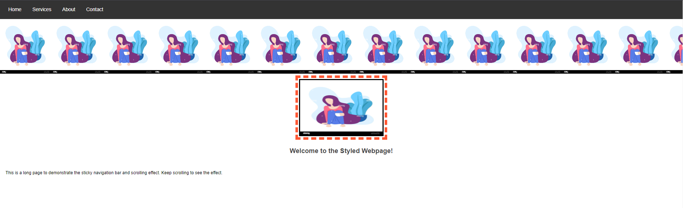

1. Add a dropdown element with multiple values. Style each dropdown entry differently, such as using different fonts, colors, sizes, etc. When the user hovers over an element, a dropdown box should appear in that area of the webpage.

Answer

HTML CODE

< html>

<head>

    <title> Deepteshrout Assignment 2 Question 9 </title>

    <style>

        body {

            font-family: Arial, sans-serif;

            margin: 0;

            padding: 0;

            height: 1500px; /* For scrollable content */

        }

        .dropdown {

            position: relative;

            display: inline-block;

            margin: 50px;

        }

        . dropdown-content {

            display: none;

            position: absolute;

            background-color: #f9f9f9;

            box-shadow: 0px 8px 16px rgba(0, 0, 0, 0.2);

            padding: 12px 16px;

            min-width: 200px;

            z-index: 1;

        }

        .dropdown:hover .dropdown-content {

            display: block;

        }

        .dropdown-content p {

            margin: 8px 0;

            padding: 8px;

            text-align: left;

            cursor: pointer;

        }

        .dropdown-content p:nth-child(1) {

            font-family: 'Courier New', Courier, monospace;

            font-size: 18px;

            color: #2e8b57;

        }

        .dropdown-content p:nth-child(2) {

            font-family: 'Georgia', serif;

            font-size: 16px;

            color: #8b4513;

            background-color: #f0e68c;

        }

        .dropdown-content p:nth-child(3) {

            font-family: 'Verdana', sans-serif;

            font-size: 14px;

            color: #4682b4;

            background-color: #fafad2;

        }

        .dropdown-content p:nth-child(4) {

            font-family: 'Arial Black', sans-serif;

            font-size: 20px;

            color: white;

            background-color: #ff6347;

        }

        .dropdown-content p:hover {

            background-color: #ddd;

        }

        .content {

            height: 1200px;

            padding: 20px;

        }

    </style>

</head>

<body>

    <div class="dropdown">

        <span>Hover to see options</span>

        <div class="dropdown-content">

            <p>Option 1 - Courier New, Green</p>

            <p>Option 2 - Georgia, Brown, Yellow BG</p>

            <p>Option 3 - Verdana, Blue, Light Yellow BG</p>

            <p>Option 4 - Arial Black, White, Red BG</p>

        </div>

    </div>

    <div class="content">

        <p>Scroll down to see more content.</p>

    </div>

</body>

</html>

Output of the code

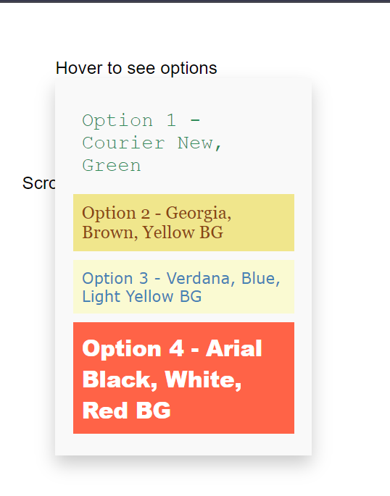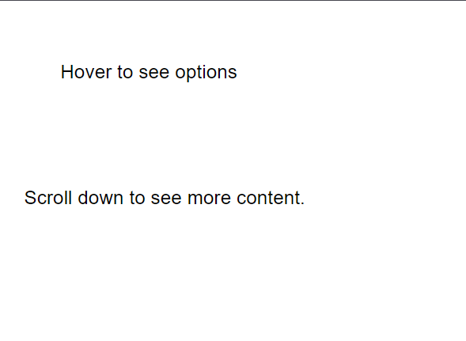before After

1. Create a registration page that features the SOA logo centered on the page, along with form elements including text input fields, a password field, an email field, a radio button, a dropdown list, and a submit button. Additionally, apply CSS to style each form element for a better appearance.

ANSWER: -

HTML CODE

<html>

<head>

  <title> Deepteshrout Assignment 2 Question 10 </title>

  <style>

    * {

        margin: 0;

        padding: 0;

        box-sizing: border-box;

    }

    body {

        font-family: Arial, sans-serif;

        background-color: #f5f5f5;

        display: flex;

        justify-content: center;

        align-items: center;

        height: 100vh;

    }

    .container {

        background-color: white;

        padding: 30px;

        border-radius: 10px;

        box-shadow: 0 8px 16px rgba(0, 0, 0, 0.2);

        max-width: 400px;

        width: 100%;

        text-align: center;

    }

    h2 {

        font-size: 24px;

        margin-bottom: 10px;

    }

    /* SOA Logo */

    .logo {

        display: block;

        margin: 0 auto 20px;

    }

    /* Form styling */

    form {

        display: flex;

        flex-direction: column;

        gap: 15px;

    }

    input[type="text"],

    input[type="password"],

    input[type="email"],

    select {

        width: 100%;

        padding: 12px;

        border-radius: 5px;

        border: 1px solid #ccc;

        font-size: 16px;

    }

    /* Invalid password input background */

    input[type="password"]:invalid {

        background-color: rgb(255, 255, 255);

    }

    /* Styling the radio buttons */

    .radio-group {

        display: flex;

        justify-content: center;

        gap: 20px;

        font-size: 16px;

    }

    /* Submit and Clear Buttons */

    .button-group {

        display: flex;

        justify-content: space-between;

    }

    input[type="submit"],

    input[type="reset"] {

        background-color: #4CAF50;

        color: white;

        padding: 12px;

        border: none;

        border-radius: 5px;

        cursor: pointer;

        font-size: 16px;

        width: 48%;

    }

    input[type="submit"]:hover {

        background-color: green;

    }

    input[type="reset"]:hover {

        background-color: red;

    }

    /* Styling the dropdown list */

    select {

        background-color: white;

    }

    .hint {

        font-size: 12px;

        color: #555;

        text-align: left;

    }

  </style>

</head>

<body>

  <!-- Container for registration form -->

  <div class="container">

    <!-- Heading for Registration Form -->

    <h2>SOA Registration Form</h2>

    <!-- SOA Logo -->

    <img src="SOA.png" alt="SOA Logo" class="logo" height="50px" width="50px">

    <!-- Registration Form -->

    <form action="Test1.html" method="POST">

      <!-- Text Input for Name (No numbers allowed) -->

      <input type="text" name="name" placeholder="Full Name" pattern="[A-Za-z\s]+" title="Only letters and spaces allowed" required>

      <div class="hint">Hint: Only letters and spaces allowed in the name.</div>

      <!-- Email Input -->

      <input type="email" name="email" placeholder="Email" title="Please enter a valid email" required>

      <div class="hint">Hint: Please enter a valid email address (e.g., name@example.com).</div>

      <!-- Password Input -->

      <input type="password" name="password" placeholder="Password" pattern="(?=.*\d)(?=.*[a-z])(?=.*[A-Z])(?=.*[@#$%^&+=]).{8,}" title="Password must contain at least 8 characters, including 1 uppercase, 1 lowercase, 1 digit, and 1 special character" required>

      <div class="hint">Hint: Must be at least 8 characters with at least 1 uppercase letter, 1 lowercase letter, 1 digit, and 1 special symbol.</div>

      <!-- Confirm Password -->

      <input type="password" name="confirm_password" placeholder="Confirm Password" required>

      <div class="hint">Hint: Confirm password must match the entered password.</div>

      <!-- Radio Button Group -->

      <div class="radio-group">

        <label><input type="radio" name="gender" value="male" required> Male</label>

        <label><input type="radio" name="gender" value="female" required> Female</label>

        <label><input type="radio" name="gender" value="others" required> Others</label>

      </div>

      <!-- Dropdown List for Course Selection -->

      <select name="course" required>

        <option value="" disabled selected>Select Course</option>

        <option value="B.Tech.">B.Tech.</option>

        <option value="M.Tech.">M.Tech.</option>

        <option value="BCA">BCA</option>

        <option value="MCA">MCA</option>

        <option value="Ph.D.">Ph.D.</option>

      </select>

      <!-- Button Group (Submit and Clear Buttons) -->

      <div class="button-group">

        <input type="submit" value="Register">

        <input type="reset" value="Clear">

      </div>

    </form>

  </div>

</body>

</html>

TEST1.HTML

<html>

<head>

    <title>Registration Confirmation</title>

    <style>

        body {

            font-family: Arial, sans-serif;

            background-color: #f5f5f5;

            display: flex;

            justify-content: center;

            align-items: center;

            height: 100vh;

            text-align: center;

        }

        .message-container {

            background-color: white;

            padding: 40px;

            border-radius: 10px;

            box-shadow: 0 8px 16px rgba(0, 0, 0, 0.2);

            max-width: 400px;

            width: 100%;

        }

        h2 {

            color: #4CAF50;

        }

        p {

            font-size: 16px;

        }

    </style>

</head>

<body>

    <!-- Confirmation message container -->

    <div class="message-container">

        <h2>Registration Done Successfully!</h2>

        <p>Thank you for registering with SOA.</p>

    </div>

</body>

</html>

OUTPUT OF THE CODE

