# Instructions csci-e63 Final Project Presentation Video

**Per HW#12 Final Project Instructions, all student final projects will be recorded and YouTube link must be provided. Presentations will include narration of your project demo (code) and slides, not more than 15 min.’s long** (and try to upload YouTube files less than 20GB). You may record your screencast videos with any software of your choice.Information on downloading and installing free screencast software follows.

* **All students must submit a HW#12 to be published via YouTube and links shared online at the course website**. **YouTube URL must be included in your final project zip**  
    
  **Making a Screencast Video for YouTube (see how to upload videos below)**

There are various screencast software packages available via free trials: Camtasia, SnapzProX, <http://camstudio.org/>, Snagit (<http://www.techsmith.com/snagit.html>) or Jing <http://www.techsmith.com/jing.html> , ScreenHunter Pro, HyperSnap, Ashampoo Snap). Below we describe one for Mac OsX and one for Windows, but you are welcome to use any software you choose. FYI for capturing live video from the iPhone’s screen … AirPlay mirror your iPhone 4S, iPad 2 to any Mac or PC, wirelessly, <https://www.reflectorapp.com/> transmits the iPhone/iPad/Touch’s video image to the screen of your Mac or PC.

**For Windows Users: Camtasia**  
free trial version of the Techsmith software [Camtasia](http://www.techsmith.com/camtasia.asp) will last for 30 days. Camtasia is an easy to use recording and editing suite, with splice and dice capabilities for screen captures into a final movie. Download and install the [Camtasia software](http://www.techsmith.com/camtasia.asp).  
  
The best way to learn about Camtasia is to actually watch a couple of their [how-to videos](http://video.techsmith.com/camtasia/5/edu/quickstart/enu/default.html) on recording and editing. Experiment with the compression options for Quicktime when you produce you video to make sure the final video is as small as small as possible.

**For Mac Users: SnapzProX or “QuickTime"**

“QuickTime”  
If running MacOS X 10.x, you can use the new screencast feature of Quick Time X. More information is available at <http://www.makeuseof.com/tag/quick-screencasting-using-quicktime-x-in-mac-snow-leopard/>

“SnapzProX”  
Or free trial version of the Ambrosia software [SnapzProX](http://www.ambrosiasw.com/utilities/snapzprox/) (<http://www.ambrosiasw.com/utilities/snapzprox/> ) that will last for 15 days or 100-uses, whichever comes first. SnapzProX is relatively easy to use, but the trial version does not contain video editing software. Thus, once you record and compress your two-minute demo you can't make any changes unless you use some other sort of video editing software.  
  
Download the [SnapzProX software](http://www.ambrosiasw.com/utilities/snapzprox/) ( <http://www.ambrosiasw.com/utilities/snapzprox/> )and install SnapzProX in your Applications directory.  
  
Once you run SnapzProX the first time, it will always be running in the background on your machine, but no icon will appear in your icon tray. To start SnapzProX, press command+shift+3. A window like the image below will pop up.  
  
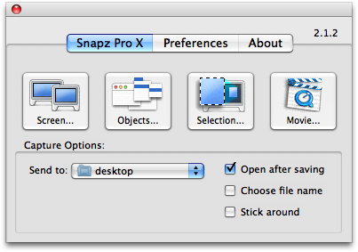  
  
Click the Movie button. Your desktop will dim, and a dashed-line rectangle will appear, along with the following window:  
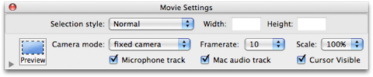  
  
In the window, select the microphone track if recording audio narration of your demo, and also select Mac audio track if demo includes sound. Also, make sure that the Camera mode is set to fixed camera so that the capture area remains fixed during recording. Drag the rectangle around and position over the part of your screen you want to capture. Adjust the size of the area. If your video is larger than 100MB, try selecting the scale to be 50% or 75%.  
When you are ready to start recording, press the enter key.

Run your demo.  
When finished, press command+shift+3 again to stop recording.

The following window will pop up:   
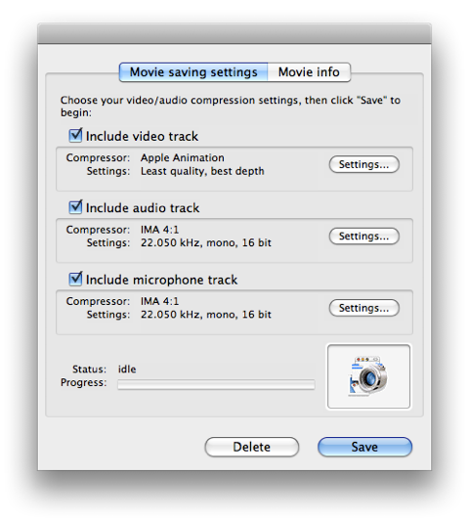  
Make sure to check the audio and microphone tracks if needed (or deselect). Experiment with the Video track settings to ensure that video file is smallest size possible.

If click on Settings under the Video track, you will get a window as below (left side):   
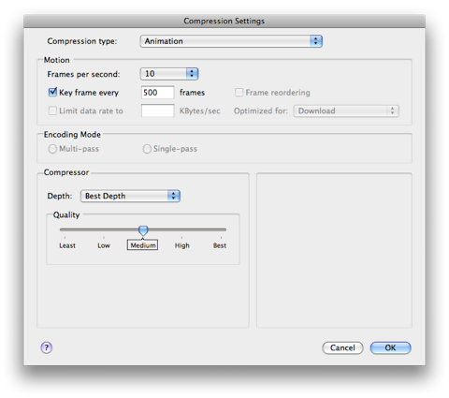  
Try different compression levels to see how compressed you can make your video without sacrificing the content.

## How to upload YouTube videos

## From your created Gmail account … sign into YouTube … www.youtube.com/my_videos_upload

<http://support.google.com/youtube/bin/answer.py?hl=en&answer=57924&topic=2888648&ctx=topic>

To get started uploading videos on YouTube, follow the steps below:

1. Sign into YouTube.
2. Click the **Upload** link at the top of the page.
3. Select the video you'd like to upload from your computer. You can also record a video from your webcam, or create a video slideshow.

Once the upload is completed, YouTube will send you an email to notify you that your video is done uploading and processing.

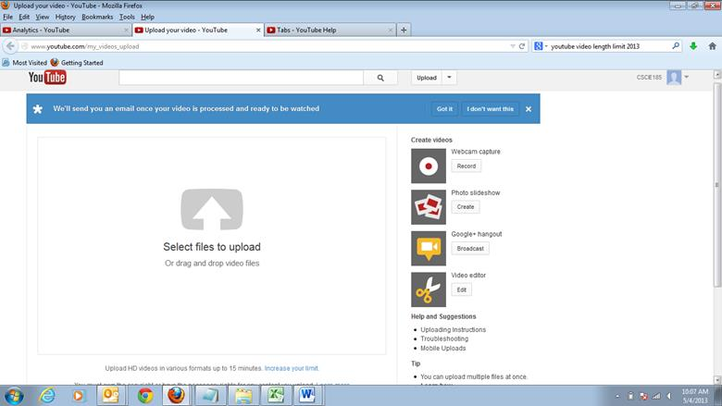

Set Channel to:

CSCI-E63 Your Name

OR You May Use YOUR OWN CHANNEL … as you wish

Pull down menu, with options for:

“Dashboard”,

“Video Manager”,

“Analytics”

Make sure that you’re using one of the following formats:

* .MOV
* .MPEG4
* .AVI
* .WMV
* .MPEGPS
* .FLV
* 3GPP
* WebM

## Set default upload settings

1. Go to your Settings page by clicking your **name** in the upper right of the page, then **Settings**
2. In the Settings menu on the left side of the page, click **Defaults**
3. Use the defaults menu to set your defaults. Options that can be defaulted are privacy, category, title, license, tags, suggested edits, and more
4. Click **Save**

Now when you upload a video, you'll see the default fields pre-set according to your choices.

You’ll still be able to change settings after you upload.

Everyone with a YouTube account also has their very own YouTube Channel. Your YouTube Channel is a personalized home for:

* the videos you’ve uploaded.
* broadcasts of playlists you have created.
* your YouTube activities: likes, favorites, subscriptions, comments.
* the information about your Channel that you’d like to share: About This Channel, social links, and linked websites.

You can find more information on your Channel in our [Channels Design Getting Started Guide](http://support.google.com/youtube/bin/static.py?hl=en&guide=1734705&topic=1735163&page=guide.cs).

In the Info and Settings tab, you can customize your Channel’s Title, Description, Tags, and also set which tab users will see by default when they visit your Channel.

You can set channel to CSCI-E63 Your Student Name OR YOU MAY USE YOUR OWN CHANNEL

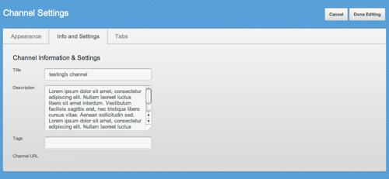

Make sure to give your Channel a **name and description** that make sense. We will use this name and description wherever your Channel is found on YouTube, and they are also displayed in the “About” section on your Channel.

The **title** you choose will be shown at the top of your Channel, next to your Avatar, it should be identified by “**CSCI-E63, 2014 Final Project – Topic” … etc.** The character count of the Channel description is **1,000 characters**, but only 250 characters will be exposed by default in the "About" section, with the remainder available behind a "more" link. Be sure to write concise and useful descriptions; this shortened version of this description will also appear across the site.

**Set Channel Name = csci-e63 Your Student Name**

**Set Channel Description = “2014 Final Project – HW#12 Topic” (e.g. Neo4J NoSQL Graph Databasse**) “**csci-e63 Big Data Analytics**, **Harvard Extension School”**

Verify Your YouTube Account

Account Verification (Step 1 of 2)

To enable additional features on your account, we require you to verify that your account is currently under your control by providing us your phone number. Please enter your phone number, and we’ll either call you or send you a text message containing a verification code from Google. [Learn more](https://support.google.com/youtube/bin/answer.py?answer=1628029&hl=en-US)

## Verify your account by phone

When signing up for a YouTube account, you may be asked to provide a phone number for account verification. We'll send you a verification code via voice call or SMS.

Once you've verified your account, you will be able to [upload videos longer than 15 minutes](http://support.google.com/youtube/bin/answer.py?answer=71673), as long as your account is in good standing (csci-e63 should be < = 15 min’s)

To Upload videos longer than 15 minutes … However**, please try to keep your csci-e63 videos short** (and small size)!

http://support.google.com/youtube/bin/answer.py?hl=en&answer=71673&topic=2888648&ctx=topic