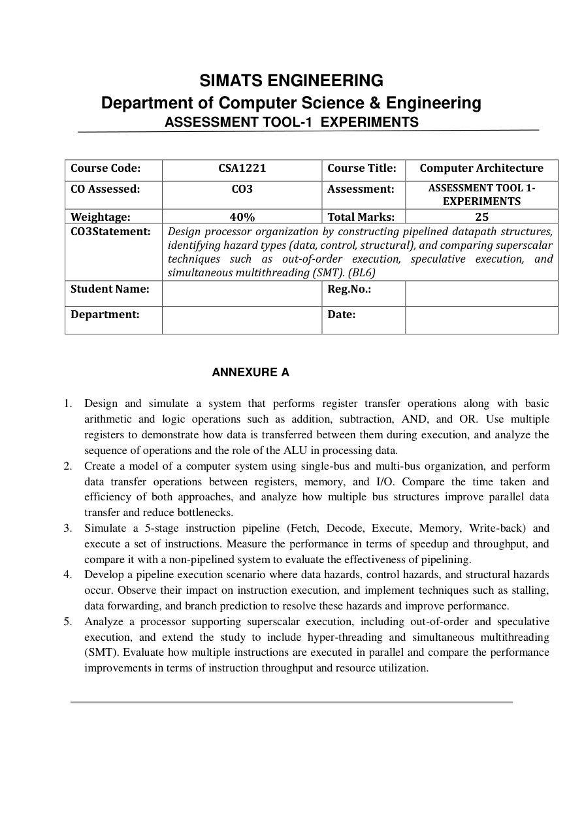

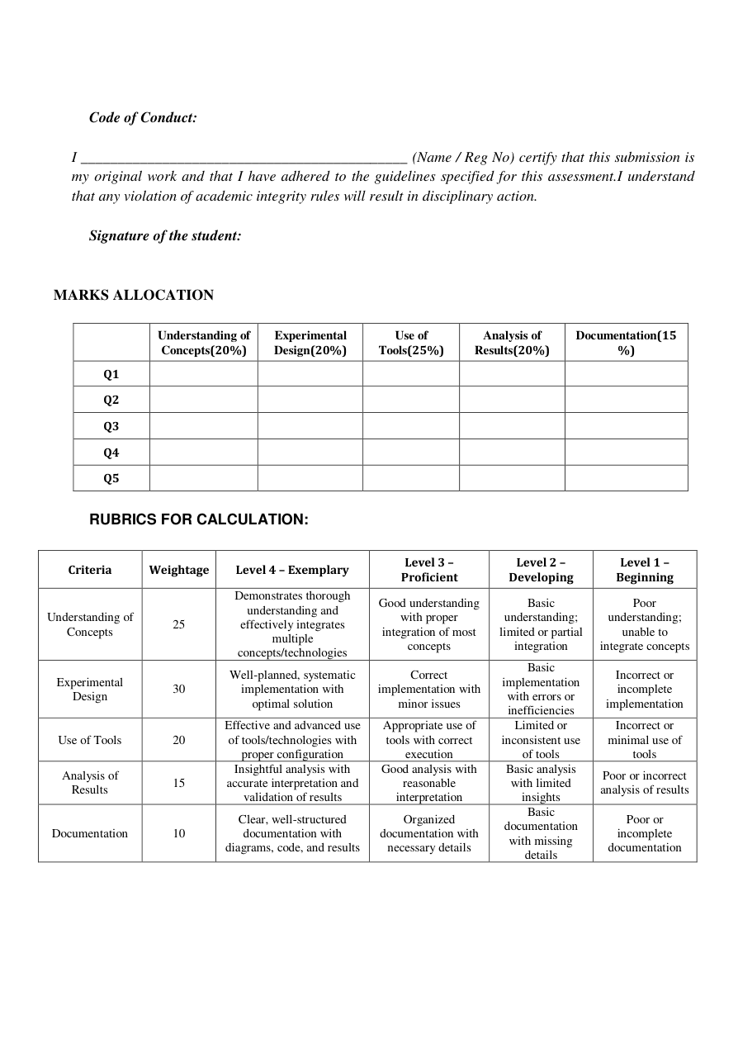

Q1. Register Transfer Operations and ALU Operations
Course: CSA1221 – Computer Architecture | Assessment Tool 1 – Experiments | CO3
Answer – Part 1
Aim
To design and simulate a processor datapath that performs register transfer operations and basic arithmetic and logic operations such as addition, subtraction, AND and OR, using multiple registers and an Arithmetic Logic Unit (ALU).
Introduction
A register is a high-speed storage element inside the processor. Register transfer refers to moving binary information from one register to another under the control of the control unit. The ALU performs arithmetic and logical processing on data supplied by registers. A simple datapath can therefore be represented as source registers, an internal data path, the ALU, destination registers and control signals.
System Design
Consider four registers R0, R1, R2 and R3, each of equal width. R0 and R1 act as input registers, while R2 and R3 store intermediate and final results. Multiplexers select the required source register and route its value to the ALU. The ALU has an operation-select input that chooses ADD, SUB, AND or OR. The result is written into a selected destination register on the active clock edge.
Register Transfer Sequence
Typical micro-operations are R2 ← R0, R3 ← R1, R2 ← R2 + R3, R2 ← R2 − R3, R2 ← R2 AND R3 and R2 ← R2 OR R3. The arrow indicates that the contents of the source are transferred to the destination. During a transfer, the source register places data on the internal path and the destination register loads it when its load-enable control signal is active.
Experiment Summary
Step | Control Action | Operation
1 | Select source | Choose R0/R1
2 | Enable transfer | Load destination register
3 | Select ALU | ADD/SUB/AND/OR
4 | Execute | ALU processes operands
5 | Write result | Load result into destination

Q1. Register Transfer Operations and ALU Operations – Continued
Answer – Part 2
ALU Operation
For addition, the ALU receives R2 and R3 and produces their binary sum. For subtraction, the second operand can be complemented and a carry-in added, implementing two's-complement subtraction. AND performs bit-by-bit logical conjunction, while OR performs bit-by-bit logical disjunction. Status flags such as zero, carry and negative may also be generated.
Example Execution
Assume R0 = 0011 (3) and R1 = 0010 (2). First, R2 ← R0 transfers 0011 to R2 and R3 ← R1 transfers 0010 to R3. Addition gives R2 ← R2 + R3 = 0101 (5). Subtraction gives R2 ← R2 − R3 = 0011 (3). For 0011 and 0010, AND produces 0010, while OR produces 0011.
Control and Timing
Each operation is completed in a controlled clock cycle. The control unit generates source-select, ALU-select and destination-load signals. For ADD, R2 and R3 are selected as ALU inputs, ADD is selected, and the destination register is enabled. Correct sequencing prevents unintended register changes.
Analysis
The experiment demonstrates the relationship between register organization and ALU processing. Registers provide fast local storage, while the ALU performs computation. The control unit coordinates both. A single internal bus simplifies hardware but may permit only one transfer at a time, while more buses can improve parallel movement at higher hardware cost.
Result and Conclusion
The simulated datapath successfully performs register transfers, addition, subtraction, AND and OR. Registers hold operands and results while the ALU performs the selected computation. The experiment establishes the foundation for understanding processor datapaths, control signals and instruction execution.
Experimental Procedure
- Define the processor components, registers, buses and control signals required by the experiment.
- Create the datapath or pipeline model and initialize registers, memory and instruction inputs.
- Execute the selected instruction sequence step by step while recording clock cycles and intermediate values.
- Observe the effect of the architecture feature and record performance measures such as cycle count, throughput or speedup.
- Repeat the experiment after applying the proposed optimization or hazard-resolution technique.
- Compare both observations and explain the performance difference using the architecture principles.
Expected Observation / Analysis
The expected observation is that the selected architecture technique improves processor resource utilization or reduces unnecessary waiting. The improvement is limited by dependencies, resource conflicts, control decisions and implementation overhead. Simulation results should therefore be interpreted rather than simply listed.
Final Result
The experiment demonstrates the selected Computer Architecture concept and its effect on processor organization and performance. The observations support the CO3 objective of designing and analyzing processor organization, pipelined datapaths, hazards and advanced execution techniques.

Q2. Single-Bus and Multi-Bus Computer Organization
Course: CSA1221 – Computer Architecture | Assessment Tool 1 – Experiments | CO3
Answer – Part 1
Aim
To model a computer system using single-bus and multi-bus organization, perform transfers among registers, memory and I/O, and compare the approaches in terms of transfer time, parallelism, hardware complexity and bottlenecks.
Single-Bus Organization
In a single-bus organization, a common bus is shared by processor registers, the ALU path, memory interface and other units. Only one major source normally places data on the bus at a time. A transfer such as R1 ← R2 requires R2 to place its contents on the bus while the load control for R1 is enabled.
Example Sequence
Suppose an instruction requires R3 ← R1 + R2. In a simple single-bus datapath, R1 may first be transferred to an ALU input register, followed by R2 to the other input register. The ALU then performs addition and the result is placed on the bus for loading into R3. Each step consumes control and clock time.
Multi-Bus Organization
A multi-bus system provides two or more independent data paths. A common three-bus arrangement has two source buses feeding the ALU and one result bus returning the output. This allows two operands to be selected simultaneously. For R3 ← R1 + R2, R1 and R2 can be placed on separate input buses at the same time.
Experiment Summary
Feature | Single Bus | Multi Bus
Transfers | Mostly sequential | More parallel
Hardware | Lower | Higher
Contention | Higher | Lower
Throughput | Lower | Higher potential

Q2. Single-Bus and Multi-Bus Computer Organization – Continued
Answer – Part 2
Memory and I/O Transfers
Memory communication involves address, data and control signals. In a single-bus design, processor-to-memory transfers may occupy the shared bus and delay other transfers. In a multi-bus design, independent paths can allow address generation, operand movement and result transfer to overlap when the architecture permits it.
Comparison
Single-bus organization is simpler, cheaper and easier to control because fewer physical paths are required. Its disadvantage is bus contention and more sequential transfers. Multi-bus organization increases hardware and control complexity but improves parallel data movement and can reduce the cycles needed for an instruction.
Performance Analysis
If an operation requires several sequential transfers on a single bus, total transfer time grows with the number of transactions. A multi-bus datapath can combine independent transfers, so the same operation may complete in fewer cycles. Exact improvement depends on buses, ALU structure, register-file ports, memory latency and control.
Advantages and Limitations
Single-bus: low hardware cost, simple design and easy expansion, but limited parallelism and a shared bottleneck. Multi-bus: higher throughput and reduced contention, but increased wiring, multiplexing, power use and control complexity.
Result and Conclusion
The experiment shows that bus organization strongly affects datapath performance. The single-bus model performs transfers sequentially and is economical, whereas the multi-bus model supports greater parallelism and reduces bottlenecks.
Experimental Procedure
- Define the processor components, registers, buses and control signals required by the experiment.
- Create the datapath or pipeline model and initialize registers, memory and instruction inputs.
- Execute the selected instruction sequence step by step while recording clock cycles and intermediate values.
- Observe the effect of the architecture feature and record performance measures such as cycle count, throughput or speedup.
- Repeat the experiment after applying the proposed optimization or hazard-resolution technique.
- Compare both observations and explain the performance difference using the architecture principles.
Expected Observation / Analysis
The expected observation is that the selected architecture technique improves processor resource utilization or reduces unnecessary waiting. The improvement is limited by dependencies, resource conflicts, control decisions and implementation overhead. Simulation results should therefore be interpreted rather than simply listed.
Final Result
The experiment demonstrates the selected Computer Architecture concept and its effect on processor organization and performance. The observations support the CO3 objective of designing and analyzing processor organization, pipelined datapaths, hazards and advanced execution techniques.

Q3. Five-Stage Instruction Pipeline
Course: CSA1221 – Computer Architecture | Assessment Tool 1 – Experiments | CO3
Answer – Part 1
Aim
To simulate a five-stage instruction pipeline consisting of Fetch, Decode, Execute, Memory and Write-back, measure speedup and throughput, and compare pipelined execution with a non-pipelined processor.
Pipeline Stages
IF—Instruction Fetch reads the instruction; ID—Instruction Decode identifies the opcode and operands; EX—Execute performs an ALU operation or address calculation; MEM—Memory accesses data for loads or stores; WB—Write-back stores the result in the destination register.
Basic Operation
In a non-pipelined processor, one instruction completes all stages before the next starts. In a pipeline, different instructions occupy different stages simultaneously. While I1 is in EX, I2 can be in ID and I3 can be in IF. After filling, ideally one instruction completes every clock cycle.
Illustrative Schedule
Consider five independent instructions I1–I5. In an ideal five-stage pipeline, I1 completes in cycle 5, I2 in cycle 6, I3 in cycle 7, I4 in cycle 8 and I5 in cycle 9. Thus five instructions require 9 cycles in the ideal pipeline instead of 25 stage-times in a strictly sequential five-stage implementation.
Experiment Summary
Stage | Name | Main Function
1 | IF | Fetch instruction
2 | ID | Decode/read operands
3 | EX | ALU/address calculation
4 | MEM | Memory access
5 | WB | Write result

Q3. Five-Stage Instruction Pipeline – Continued
Answer – Part 2
Speedup
For n instructions and k pipeline stages, ideal pipelined execution requires approximately k+n−1 cycles, while a simple non-pipelined model requires approximately nk cycles if every stage takes one cycle. For n=5 and k=5, ideal speedup is 25/9 ≈ 2.78. For large n, theoretical speedup approaches k.
Throughput
Pipeline throughput is the number of completed instructions per unit time. Once a five-stage pipeline is full, ideal throughput is approximately one instruction per clock cycle. Individual instruction latency does not necessarily decrease; the main benefit is increased completion rate.
Non-Pipelined Comparison
In a non-pipelined processor, functional resources may remain idle while another stage is being used. Pipelining improves utilization by allowing different instructions to use different stages simultaneously. Pipeline registers and stalls, however, reduce the ideal gain.
Simulation and Observation
The simulation should display the instruction occupying each stage during every clock cycle. With no hazards, completion should approach one instruction per cycle after the initial fill period. Dependencies and branches should demonstrate why real speedup is below the ideal value.
Result and Conclusion
The five-stage pipeline improves instruction throughput by overlapping instruction execution. Compared with sequential execution, more instructions can be completed in a given period. Hazard handling and pipeline control are essential for maintaining performance.
Experimental Procedure
- Define the processor components, registers, buses and control signals required by the experiment.
- Create the datapath or pipeline model and initialize registers, memory and instruction inputs.
- Execute the selected instruction sequence step by step while recording clock cycles and intermediate values.
- Observe the effect of the architecture feature and record performance measures such as cycle count, throughput or speedup.
- Repeat the experiment after applying the proposed optimization or hazard-resolution technique.
- Compare both observations and explain the performance difference using the architecture principles.
Expected Observation / Analysis
The expected observation is that the selected architecture technique improves processor resource utilization or reduces unnecessary waiting. The improvement is limited by dependencies, resource conflicts, control decisions and implementation overhead. Simulation results should therefore be interpreted rather than simply listed.
Final Result
The experiment demonstrates the selected Computer Architecture concept and its effect on processor organization and performance. The observations support the CO3 objective of designing and analyzing processor organization, pipelined datapaths, hazards and advanced execution techniques.

Q4. Data, Control and Structural Hazards
Course: CSA1221 – Computer Architecture | Assessment Tool 1 – Experiments | CO3
Answer – Part 1
Aim
To develop a pipeline scenario containing data, control and structural hazards, observe their effects on execution, and apply stalling, data forwarding and branch prediction to reduce performance loss.
Data Hazards
A data hazard occurs when an instruction depends on the result of an earlier instruction whose result is not yet available. A common RAW dependency is I1: R1 ← R2 + R3 followed by I2: R4 ← R1 + R5.
Stalling
Without special hardware, a dependent instruction may wait until the earlier instruction writes its result. The pipeline inserts one or more bubbles, cycles in which useful instruction work is not performed. Stalling guarantees correctness but decreases throughput.
Data Forwarding
Forwarding sends a newly produced ALU result directly from a later pipeline stage to an earlier stage that needs it. Instead of waiting for register write-back, a dependent instruction can receive the value from a bypass path. Some cases, such as certain load-use dependencies, may still require a stall.
Control Hazards
A control hazard occurs when the next instruction address depends on a branch or jump whose outcome is not yet known. The processor may fetch instructions from the wrong path. If the branch is taken, incorrectly fetched instructions may be flushed.
Experiment Summary
Hazard | Cause | Typical Solution
Data | Operand dependency | Forwarding / stall
Control | Branch decision | Prediction / flush
Structural | Resource conflict | Stall / duplicate resource

Q4. Data, Control and Structural Hazards – Continued
Answer – Part 2
Branch Prediction
Branch prediction guesses whether a branch will be taken and may predict its target address. Correct prediction allows the pipeline to continue without waiting. Wrong prediction causes recovery and a performance penalty.
Structural Hazards
A structural hazard occurs when two stages require the same hardware resource at the same time. If instruction fetch and a data-memory operation share one memory unit, both may request it simultaneously. Solutions include stalling, duplicating resources or redesigning the datapath.
Combined Scenario
Consider a sequence containing an ALU dependency, a conditional branch and a memory access occurring with instruction fetch. The dependency demonstrates a data hazard, the branch a control hazard and shared memory a structural hazard. Run the sequence first without mitigation and record stalls and flushes, then enable forwarding, branch prediction and separate resources.
Performance Analysis
Stalling is simple and reliable but reduces throughput. Forwarding needs extra paths and control logic but reduces unnecessary waiting. Branch prediction adds hardware but can reduce control-hazard penalties. Additional resources remove structural conflicts at the cost of area and power.
Result and Conclusion
The experiment demonstrates that hazards are a major reason real pipeline speedup is below the ideal value. Data forwarding reduces data stalls, branch prediction reduces control delays, and adequate resources reduce structural conflicts.
Experimental Procedure
- Define the processor components, registers, buses and control signals required by the experiment.
- Create the datapath or pipeline model and initialize registers, memory and instruction inputs.
- Execute the selected instruction sequence step by step while recording clock cycles and intermediate values.
- Observe the effect of the architecture feature and record performance measures such as cycle count, throughput or speedup.
- Repeat the experiment after applying the proposed optimization or hazard-resolution technique.
- Compare both observations and explain the performance difference using the architecture principles.
Expected Observation / Analysis
The expected observation is that the selected architecture technique improves processor resource utilization or reduces unnecessary waiting. The improvement is limited by dependencies, resource conflicts, control decisions and implementation overhead. Simulation results should therefore be interpreted rather than simply listed.
Final Result
The experiment demonstrates the selected Computer Architecture concept and its effect on processor organization and performance. The observations support the CO3 objective of designing and analyzing processor organization, pipelined datapaths, hazards and advanced execution techniques.

Q5. Superscalar, Out-of-Order, Speculative Execution and SMT
Course: CSA1221 – Computer Architecture | Assessment Tool 1 – Experiments | CO3
Answer – Part 1
Aim
To analyze a processor supporting superscalar execution, out-of-order and speculative execution, and extend the study to hyper-threading or simultaneous multithreading (SMT), evaluating instruction throughput and resource utilization.
Superscalar Execution
A superscalar processor can issue and execute more than one instruction per clock cycle when sufficient independent instructions and resources are available. A processor with a theoretical issue width of two may dispatch two suitable instructions in one cycle. Actual throughput depends on dependencies, branch behavior, functional-unit availability and memory delays.
Out-of-Order Execution
Out-of-order execution allows ready instructions to execute before earlier instructions that are temporarily blocked. The processor examines a window of decoded instructions and selects those whose operands and functional units are available. This improves utilization because an idle unit can execute another independent instruction.
Maintaining Correctness
Although execution may occur out of program order, the processor must preserve the architectural effect expected by the program. Register renaming reduces false dependencies such as WAR and WAW, while reorder mechanisms can ensure results become visible in correct order.
Speculative Execution
Speculative execution allows instructions to execute before a branch outcome is definitely known. A branch predictor supplies a predicted path. Correct prediction means useful work has been completed early; wrong prediction requires speculative work to be discarded and execution to recover.
Experiment Summary
Technique | Parallelism | Main Benefit
Superscalar | Instruction-level | Multiple issue
Out-of-order | Instruction-level | Uses ready instructions
Speculation | Control-level | Reduces branch waiting
SMT | Thread-level | Uses idle resources

Q5. Superscalar, Out-of-Order, Speculative Execution and SMT – Continued
Answer – Part 2
Instruction-Level Parallelism
The benefit of superscalar and out-of-order execution depends on instruction-level parallelism. Independent instructions can execute simultaneously, whereas dependent instructions must wait. Two unrelated arithmetic instructions can use separate ALUs in the same cycle, while a dependent instruction must wait for its operand.
Hyper-Threading and SMT
Simultaneous multithreading allows one physical core to maintain state for multiple threads and issue instructions from more than one thread when resources are available. If one thread is stalled by a cache miss or dependency, another may use otherwise idle resources. SMT can increase overall throughput but does not simply double performance.
Resource Utilization
Shared resources include execution units, instruction queues, caches, branch predictors, register files and memory bandwidth. Superscalar out-of-order execution tries to keep them busy. SMT can fill unused issue slots with instructions from another thread, although contention can reduce the benefit.
Comparison and Evaluation
A conventional in-order scalar pipeline has limited parallelism. Superscalar execution increases instructions issued per cycle. Out-of-order execution exposes more independent work, speculative execution reduces branch waiting, and SMT adds thread-level parallelism. Each technique increases complexity, power consumption and verification requirements.
Result and Conclusion
Modern processor performance comes from exploiting parallelism at multiple levels. Superscalar issue increases throughput, out-of-order execution improves functional-unit utilization, speculation reduces branch-related waiting, and SMT allows multiple threads to share resources efficiently.
Experimental Procedure
- Define the processor components, registers, buses and control signals required by the experiment.
- Create the datapath or pipeline model and initialize registers, memory and instruction inputs.
- Execute the selected instruction sequence step by step while recording clock cycles and intermediate values.
- Observe the effect of the architecture feature and record performance measures such as cycle count, throughput or speedup.
- Repeat the experiment after applying the proposed optimization or hazard-resolution technique.
- Compare both observations and explain the performance difference using the architecture principles.
Expected Observation / Analysis
The expected observation is that the selected architecture technique improves processor resource utilization or reduces unnecessary waiting. The improvement is limited by dependencies, resource conflicts, control decisions and implementation overhead. Simulation results should therefore be interpreted rather than simply listed.
Final Result
The experiment demonstrates the selected Computer Architecture concept and its effect on processor organization and performance. The observations support the CO3 objective of designing and analyzing processor organization, pipelined datapaths, hazards and advanced execution techniques.

