Reading & Moving data to DB - SPOT Rate file:
- Read the below excel file in DataFrame.
- 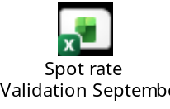
- Select only the below mentioned columns:
- Country, From, To, Exch. Rate.
- Format Exch. Rate column – remove commas, /(tabs) or any other special characters.
- Save the 4 columns in a SQL server.
SQL Table insert query:
GO
CREATE TABLE [dbo].[RCP_spot_rate](
[company_code] [nvarchar](50) NULL,
[curr_from] [nvarchar](50) NULL,
[curr_to] [nvarchar](50) NULL,
[exchange_rate] [float] NULL
) ON [PRIMARY]
GO

Country from dataframe should be saved in company_code column in the table.
From -> curr_from
To -> curr_to
Exch. Rate -> exchange_rate

Reading & Moving data to DB - Exchange Rate file:
- Read the below excel file into a dataframe
- 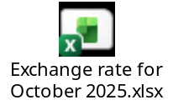
- Read only “Current” Sheet.
- Ignore top 2 rows.
- Read only ISOCode(B column), Accounting Rates as of (C column) & Accouting rates as of (k column)
- Need to push Currency and rate to the table.
- If the K column is blank, consider C column as the value.
- If the K column has a value, use this formula:
  - Rate = 1/B column value.
- Add “USD” to currency and 1 to the value into the dataframe.
- Push the dataframe to the table
CREATE TABLE [dbo].[curr_rate](
[Currency] [nvarchar](50) NULL,
[Rate] [float] NULL
) ON [PRIMARY]
GO

