SIMATS ENGINEERING
CSA6303- Threat Intelligence and Network Security
A1-Threat Intelligence Report
Subject | Threat Intelligence
Total Marks | 50
Questions | 10 (all compulsory)
Marks per Question | 5
Reg. No | 192411211
Name | V. Teja Sree
Faculty | Dr. V. Parthipan
Slot | A
Instructions: Answer all questions. Each question carries 5 marks. Support answers with examples and diagrams where appropriate.
CO3: Perform threat analysis using intelligence models and utilize industry tools for monitoring and detection.

Dr. V. Parthipan Total: 50

Student Name : V. Teja Sree Register number: 192411211

Code of Conduct:
I V. Teja Sree (192411211) (Name / Reg No) certify that this submission is my original work and that I have adhered to the guidelines specified for this assessment. I understand that any violation of academic integrity rules will result in disciplinary action.

Signature of the student


1. Threat Hunting Techniques

Introduction
Threat hunting is the proactive, analyst-driven search for attackers who have bypassed automated defences. In this scenario the team has three weak signals: unusual login times, unexpected processes and connections to unfamiliar external servers. Together they suggest that an attacker holds valid access inside the network, so a structured hunt is needed to confirm the intrusion, find its scope and remove it.
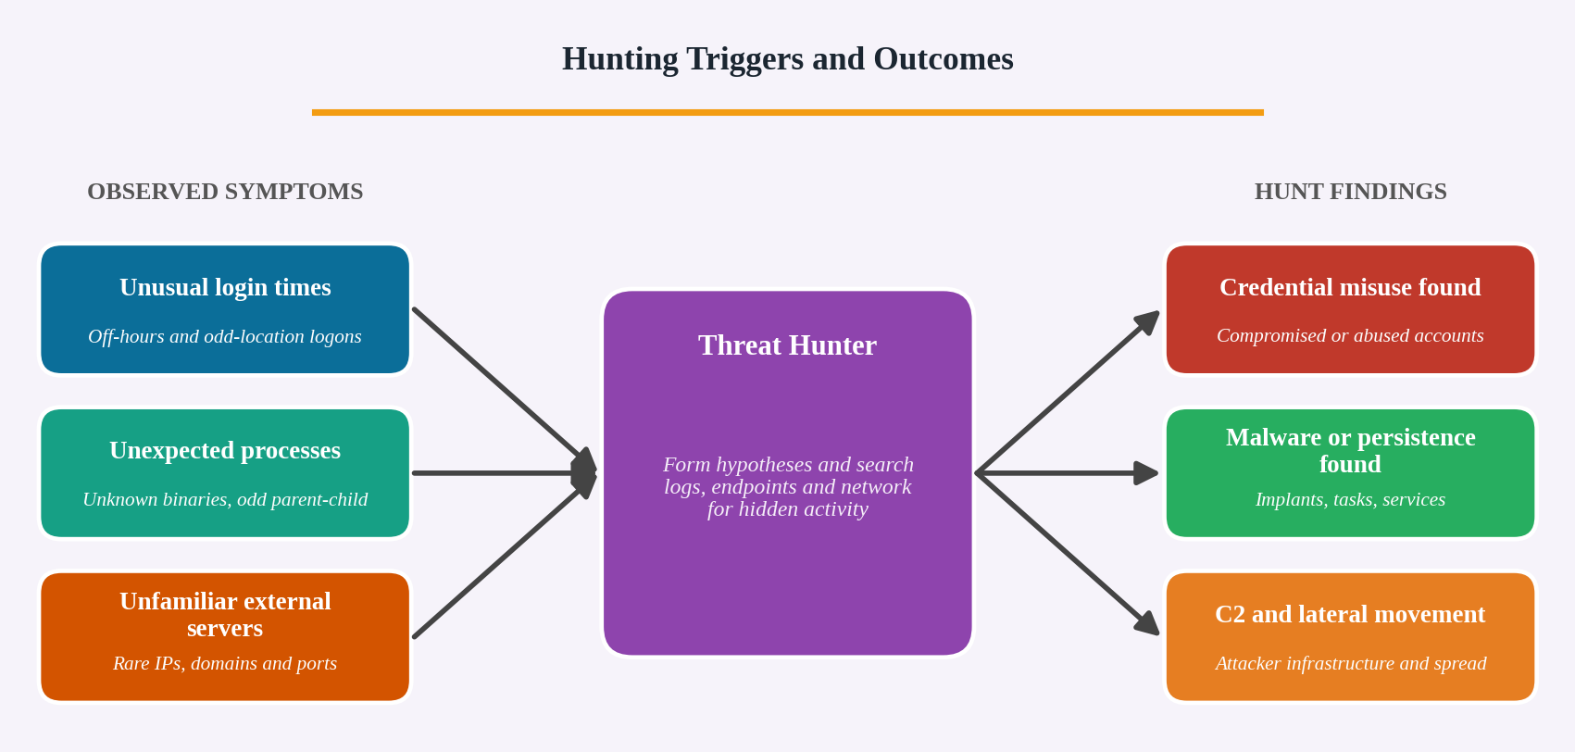
Figure 1: Hunting triggers and expected findings

Types of Hunting Techniques Used
Technique | Meaning | Application in this case
Hypothesis-driven hunting | Start from a testable statement based on intelligence or observation. | “An attacker is using stolen credentials to log in after hours and run a remote-access tool.”
IoC-driven hunting | Search for known bad IPs, domains, hashes and file names. | Check the unfamiliar servers and process hashes against threat feeds such as VirusTotal and MISP.
Anomaly and baseline hunting | Compare current behaviour with normal behaviour (stacking, frequency analysis, outlier detection). | Find logins outside working hours and rare processes seen on only one or two hosts.
TTP-driven hunting (MITRE ATT&CK) | Hunt for attacker techniques rather than single indicators. | Look for valid accounts (T1078), PowerShell (T1059), scheduled tasks (T1053) and application-layer C2 (T1071).

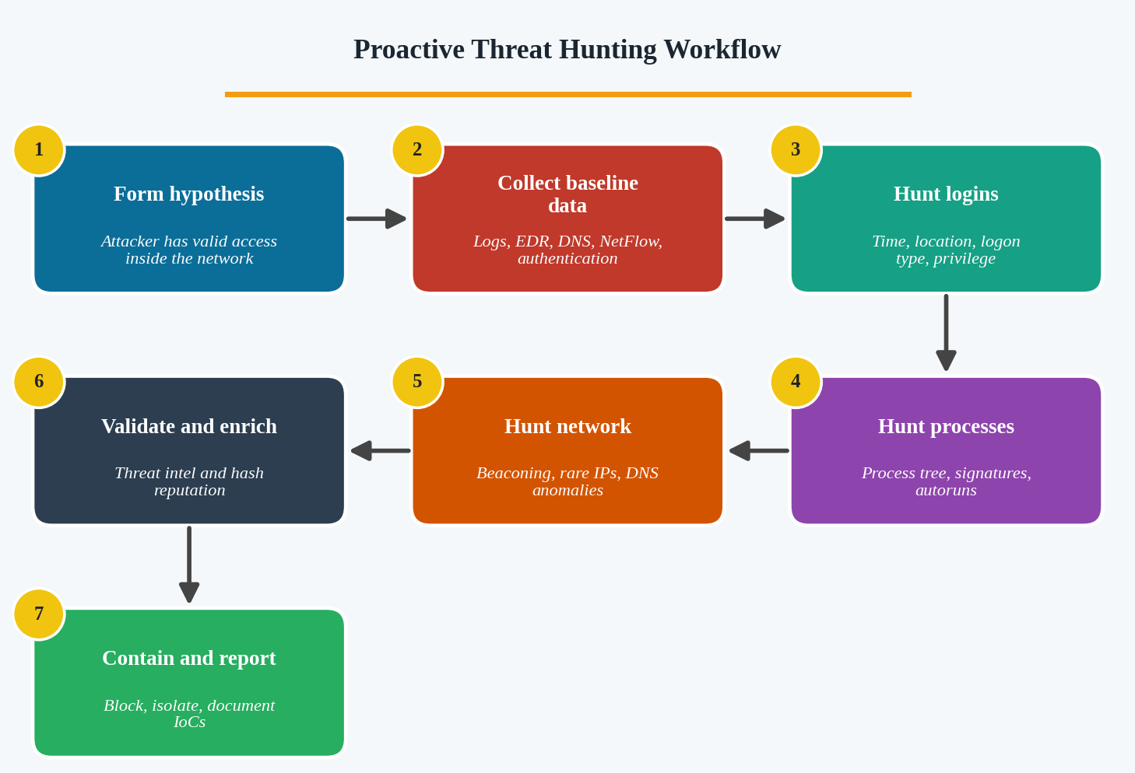
Figure 2: Proactive threat hunting workflow

Step 1: Prepare and Form a Hypothesis
Define the scope (affected network segments, users and servers), collect authentication, endpoint, DNS, proxy, firewall and NetFlow logs, and preserve volatile evidence. Establish a baseline of normal working hours, normal processes and normal destinations so that deviations can be recognised.

Step 2: Hunt for Unusual Logins
- Review Windows Security events: 4624 (successful logon), 4625 (failed logon), 4648 (explicit credentials) and 4672 (special privileges).
- Filter logins outside business hours, on weekends or from new countries or IP addresses (impossible travel).
- Check logon types: type 10 (remote desktop) and type 3 (network) for servers and admin accounts that rarely log in this way.
- Look for one account logging in to many hosts in a short time, which indicates lateral movement, and for brute-force patterns of many failures followed by a success.
- Review VPN, Active Directory and cloud sign-in logs and service account usage.

Step 3: Hunt for Unexpected Processes
- Use EDR or Sysmon (Event 1 process creation, Event 7 image load, Event 10 process access) to build the process tree.
- Look for suspicious parent-child chains such as Word or a browser launching PowerShell or cmd, or svchost.exe started from the wrong parent.
- Check unsigned binaries, files running from Temp, AppData or Public folders, and names that imitate system files (svch0st.exe).
- Use stacking: list all processes across hosts and examine those that appear on very few machines.
- Check persistence with Autoruns: Run keys, services, scheduled tasks and WMI subscriptions.
- Detect credential dumping (access to LSASS) and use of living-off-the-land tools (certutil, bitsadmin, PsExec).

Step 4: Hunt for Connections to Unfamiliar External Servers
- Analyse firewall, proxy and NetFlow logs for rare destinations, unusual ports and long-lived or large outbound sessions.
- Detect beaconing: connections at regular intervals (for example, every 60 seconds) with similar packet sizes.
- Review DNS logs for newly registered, random-looking (DGA) domains, many NXDOMAIN responses and very long TXT queries (DNS tunnelling).
- Link each connection to the process that created it (Sysmon Event 3) and check the IP or domain reputation and geolocation.

Step 5: Validate, Collect IoCs and Respond
- Validate findings with hash lookups, signature checks and threat intelligence to remove false positives.
- Record IoCs: IPs, domains, file hashes, paths, registry keys, accounts and command lines.
- Search the whole estate for the same IoCs to find all affected systems.
- Contain: isolate hosts, disable compromised accounts, force password resets and block the IoCs at the firewall and DNS.
- Document the hunt and convert the findings into new SIEM and EDR detection rules.
Conclusion: By combining hypothesis, IoC, baseline and ATT&CK-driven techniques across logins, processes and network traffic, the team can confirm whether an attacker is inside, trace how they moved, remove them and improve detection for the future.

2. SIEM Tools and Security Monitoring

Introduction
A Security Information and Event Management (SIEM) system combines security information management (log storage and reporting) with security event management (real-time monitoring and alerting). It gives analysts a central view of events from across the network, which is essential when alerts about suspicious logins and unusual outbound connections must be understood together.
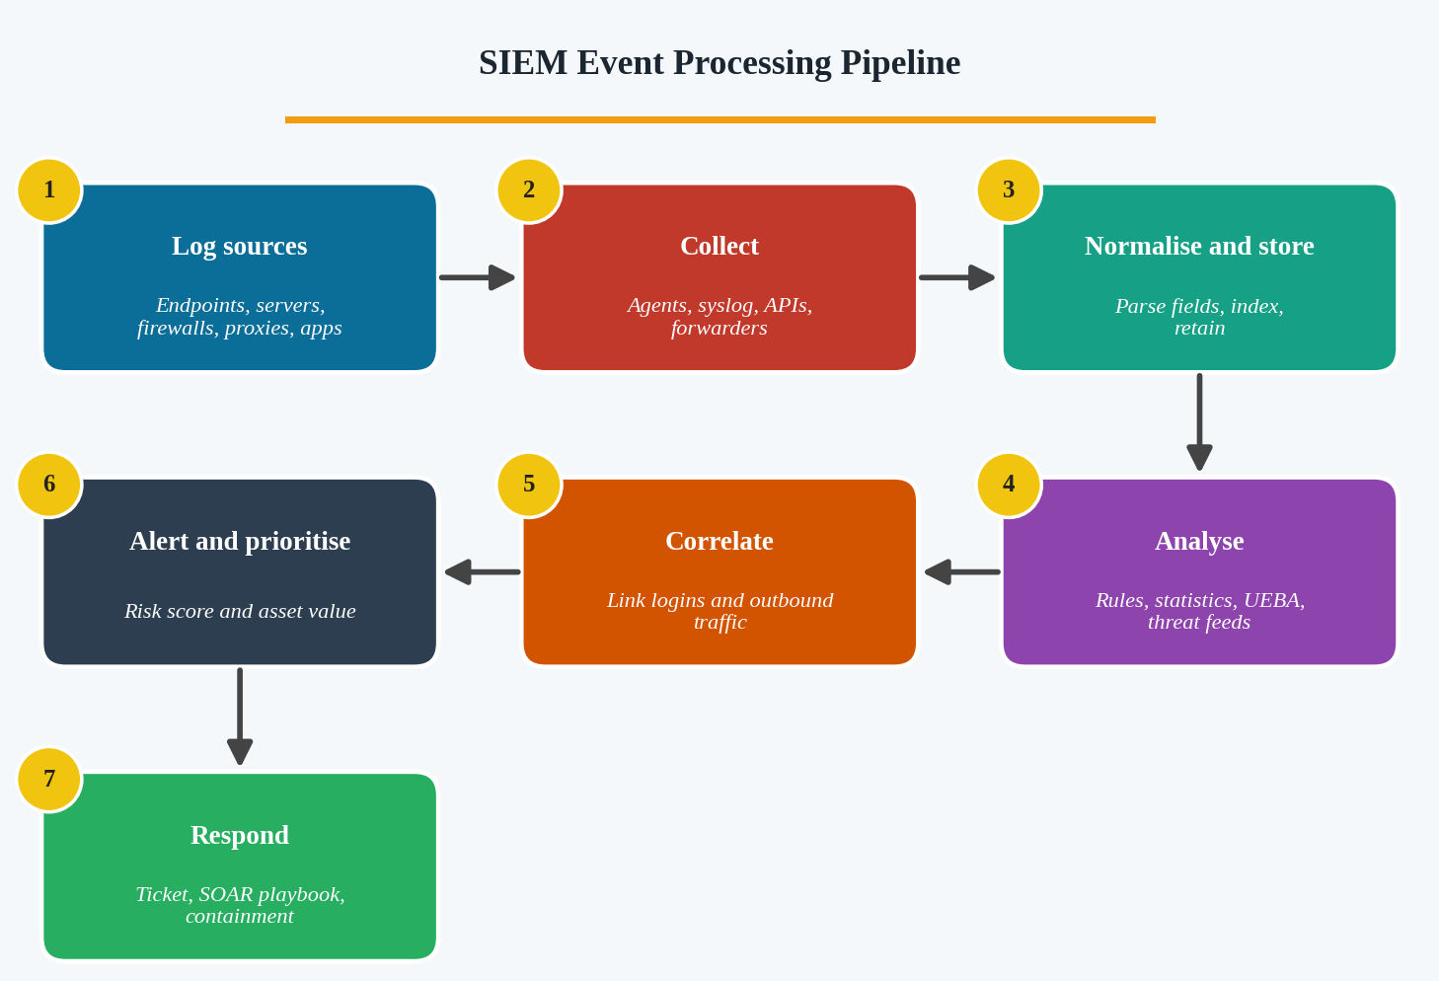
Figure 3: SIEM event processing pipeline

1. Collecting Security Events
- Sources: firewalls, IDS/IPS, servers, domain controllers, endpoints (EDR), VPN, proxies, DNS, databases, cloud services and applications.
- Methods: agents (for example, Splunk Universal Forwarder or Wazuh agent), syslog, Windows Event Forwarding, API connectors and flow data.
- Normalisation and parsing: raw logs in different formats are converted into common fields such as time, user, host, source IP, destination IP, action and result.
- Storage and retention: events are indexed for fast search and kept to meet compliance requirements.

2. Analysing Events
- Rule-based detection: for example, more than 10 failed logins in 5 minutes from one IP.
- Statistical and behavioural analysis (UEBA): compares activity with a user or host baseline, such as a login at 3 a.m. by an office worker.
- Threat intelligence enrichment: matches IPs, domains and hashes against feeds to mark known-bad indicators.
- Search and visualisation: dashboards and timelines help analysts explore events and identify patterns.

3. Correlating Alerts
Correlation connects separate events into one meaningful incident using shared fields and time. In this scenario the SIEM can link: (a) many failed logins to one account, (b) a successful login from the same source IP, (c) a new process on that host, and (d) an outbound connection to a rare external IP. Individually these are low-value alerts, but in sequence they indicate credential compromise followed by command-and-control or data theft.
Correlation rule | Events combined | Meaning
Brute force then success | Multiple 4625 failures followed by 4624 from the same IP within 15 minutes. | Password attack succeeded.
Login then outbound traffic | Successful login followed by large or rare outbound connection from the same host. | Possible C2 or exfiltration.
Impossible travel | Same user logs in from two distant countries within a short time. | Stolen credentials.
Threat feed match | Outbound connection to an IP on a threat intelligence list. | Confirmed malicious communication.

4. Prioritising Threats
- Risk scoring: severity of the rule, confidence of the detection and reputation of the indicator.
- Asset criticality: alerts on domain controllers, databases and finance systems rank above alerts on ordinary workstations.
- User context: privileged or executive accounts increase priority.
- Number of correlated indicators: several linked alerts raise confidence and urgency.
- False-positive tuning: whitelists and rule tuning reduce noise so analysts focus on real threats.
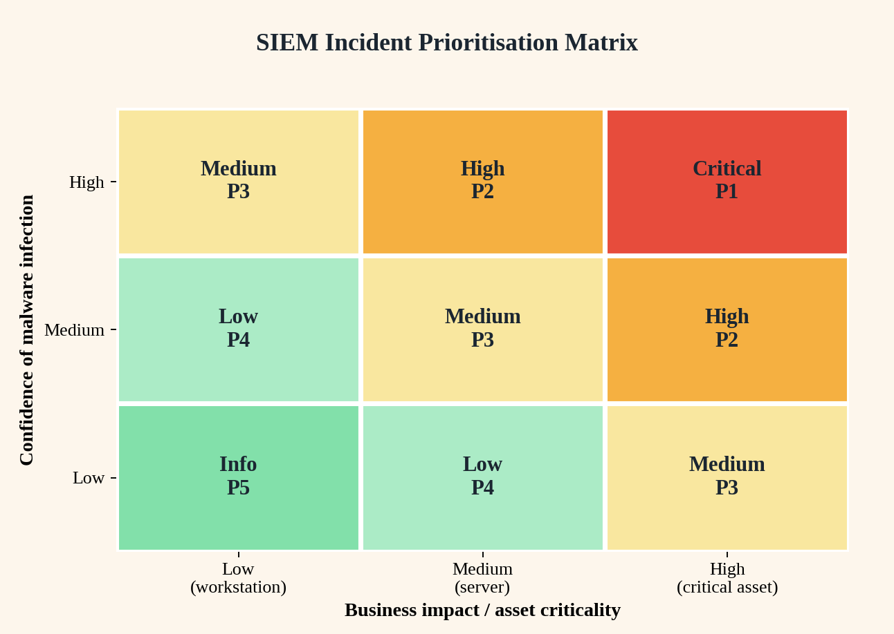
Figure 4: Incident prioritisation matrix

5. Response
After prioritisation, the SIEM opens a ticket, assigns an analyst and may trigger a SOAR playbook to block the IP, disable the account or isolate the host. Reports and dashboards document the incident for audit and lessons learned.
Conclusion: A SIEM collects and normalises logs, analyses them with rules, baselines and threat intelligence, correlates related alerts into incidents and ranks them by risk and asset value. This allows analysts to concentrate on the most serious threats, such as a compromised account sending data outside the company.

3. Security Monitoring and Anomaly Detection

Introduction
A database server that normally sends only small amounts of data suddenly produces a large outbound transfer outside working hours. This is a classic indicator of data exfiltration, but it could also be a scheduled backup or an approved migration. The investigation must therefore validate the anomaly first and then determine whether data has been stolen.
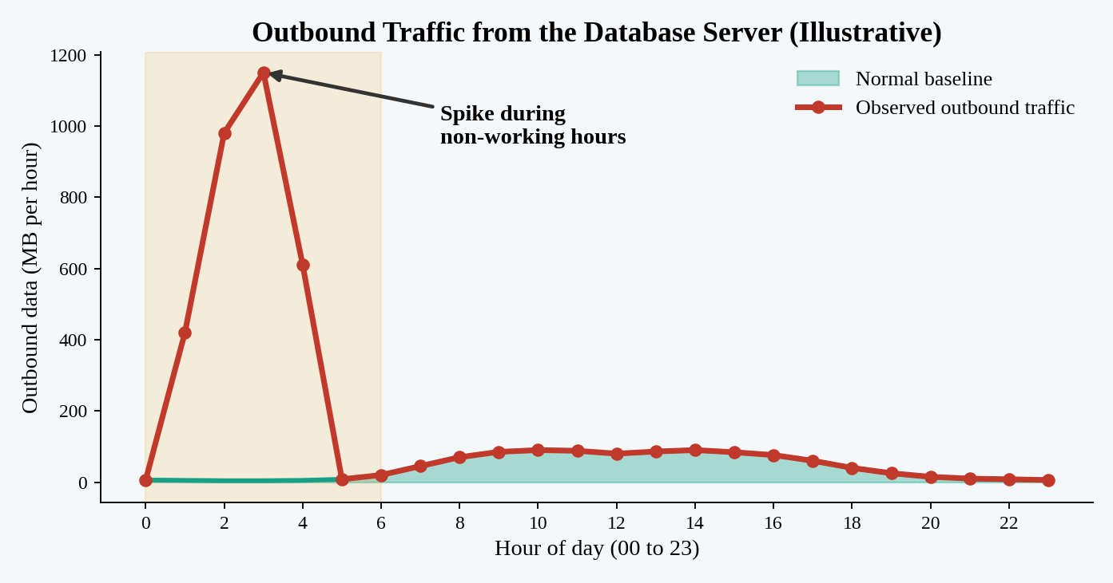
Figure 5: Anomalous outbound traffic compared with the baseline
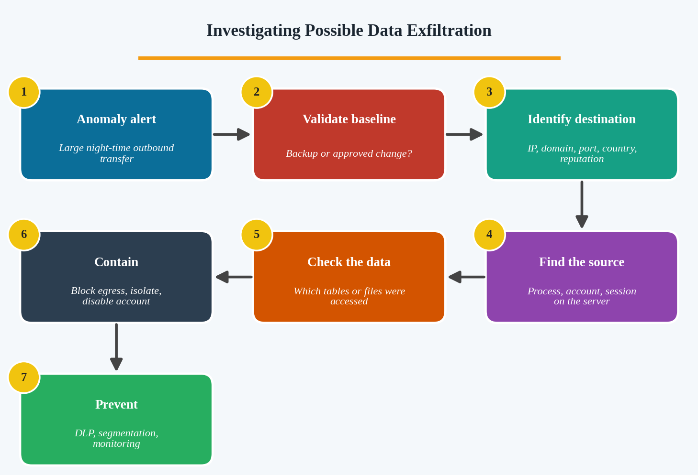
Figure 6: Data exfiltration investigation workflow

Step 1: Validate the Anomaly
- Check change-management records and the backup schedule to see whether the transfer was authorised.
- Compare the traffic with the historical baseline (volume, time, destination) on the monitoring dashboard.
- Confirm the alert is not caused by a misconfigured or duplicated monitoring source.

Step 2: Analyse the Network Traffic
- Use NetFlow, firewall and proxy logs to identify destination IP, domain, port, protocol, country and total bytes sent.
- Check the destination reputation with threat intelligence and look for cloud storage or file-sharing services, unknown hosting providers or Tor exit nodes.
- Check for unusual protocols and encodings: FTP, SFTP, HTTPS POST to a rare site, DNS tunnelling (long TXT queries) and ICMP tunnelling.
- Capture packets with Wireshark or Zeek for deeper inspection where legal and technically possible.

Step 3: Investigate the Database Server
- Identify the process, user account and session that generated the traffic (Sysmon Event 3, EDR, netstat, login records).
- Review database audit logs for large SELECT queries, exports or dumps (mysqldump, bcp, pg_dump) and access to sensitive tables.
- Look for staging files: new archives (zip, rar, 7z) or large files in temporary folders, and the use of tools such as rclone, curl, scp or PowerShell.
- Check for new accounts, privilege escalation, web shells, scheduled tasks and unfamiliar logins around the same time.

Step 4: Confirm Possible Data Exfiltration
Indicator | Why it matters
Large outbound volume to a rare external host | Far above baseline for this server.
Transfer outside business hours | Attackers act when staff are absent.
Database queries returning very large result sets | Shows bulk data collection.
Compressed or encrypted archive created before transfer | Typical data staging behaviour.
Account used from an unusual host or location | Suggests stolen credentials.

Step 5: Containment
- Block the destination IP and domain at the firewall and proxy.
- Isolate the database server (or limit it to required connections) while preserving memory and disk evidence.
- Disable or reset the compromised account and revoke sessions and API keys.
- Assess what data was accessed, and start breach notification and legal procedures if personal or regulated data was exposed.

Monitoring and Prevention Measures
Measure | Purpose
Baselines and anomaly alerts (SIEM, UEBA) | Alert when a server exceeds normal data volume or sends data at unusual times.
Data Loss Prevention (DLP) and egress filtering | Block or flag transfers of sensitive data and allow outbound traffic only to approved destinations.
Database Activity Monitoring (DAM) | Log and alert on bulk queries, exports and privileged access.
Network segmentation and least privilege | Prevent the database server from reaching the internet and limit who can access data.
Encryption and tokenisation | Reduce the value of stolen data.
MFA and privileged access management | Protect administrator and service accounts.
DNS and NetFlow monitoring, IDS/IPS | Detect tunnelling, beaconing and known malicious destinations.
Regular testing and incident response drills | Make sure alerts are tuned and the team can respond quickly.

Conclusion: The anomaly should be validated against the baseline, traced to its destination and source process, and confirmed through database and host evidence. Containment limits loss, while DLP, egress control, database monitoring and baseline alerting reduce the chance and impact of future exfiltration.

4. Tools Used in the IT Industry for Threat Hunting

Introduction
When malware is suspected on several workstations, each available tool answers a different question. The SIEM shows the wider pattern, endpoint detection shows what happened on each host, network traffic analyzers show the communication, and vulnerability scanners show how the malware could enter and spread. Used together they allow the team to identify, analyse and contain the threat.
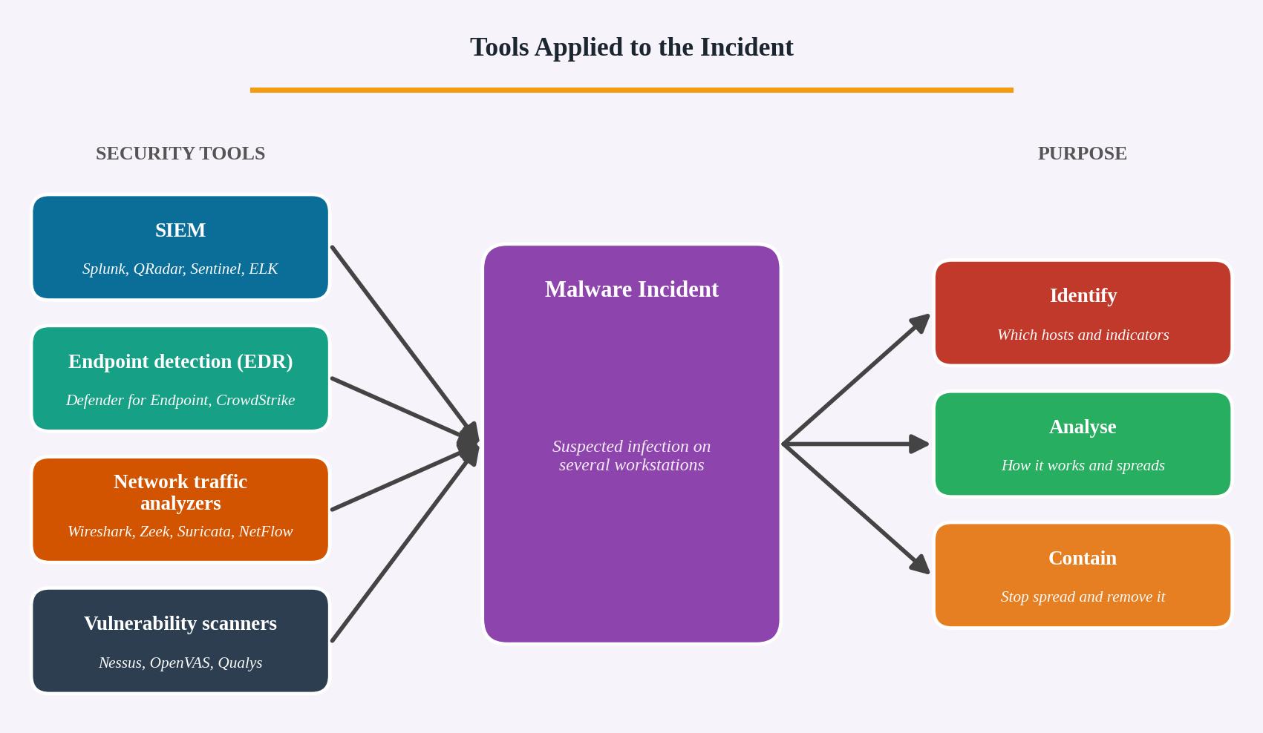
Figure 7: Tools applied to the malware incident

Selection and Role of Each Tool
Tool | Identify | Analyse | Contain
SIEM (Splunk, IBM QRadar, Microsoft Sentinel, ELK) | Search logs across all workstations for the same IoCs, suspicious processes, DNS queries and logins to find every affected host. | Correlate endpoint, DNS and firewall events into a timeline and enrich with threat intelligence. | Trigger alerts and SOAR playbooks to block IPs, disable accounts and open incident tickets.
Endpoint detection and response (Microsoft Defender for Endpoint, CrowdStrike Falcon, SentinelOne) | Detect malicious files and behaviour on each workstation and show the process tree. | Inspect process, file, registry and network activity; collect files and memory for analysis. | Isolate the host from the network, kill processes, quarantine files and roll back changes.
Network traffic analyzers (Wireshark, Zeek, Suricata, NetFlow tools) | Find unusual connections, rare destinations and beaconing from the workstations. | Examine packets and protocols to confirm command-and-control, downloads or data theft and extract domains and IPs. | Provide IoCs for firewall and DNS blocks; IPS mode can drop malicious traffic.
Vulnerability scanners (Nessus, OpenVAS, Qualys) | Find unpatched or misconfigured systems that the malware may have exploited and other exposed workstations. | Show the vulnerability (for example, an unpatched SMB or Office flaw) used for entry and spread. | Guide patching and hardening priorities to stop reinfection and block spread.

Supporting Tools
- Threat intelligence and sandboxes (VirusTotal, MISP, ANY.RUN, Cuckoo) to check hashes and observe malware behaviour safely.
- Memory and forensic tools (Volatility, Autopsy, Velociraptor) to examine compromised hosts in depth.
- Email and web security gateways to find and block the infection source, such as a phishing campaign.

Suggested Investigation Sequence
- Use the SIEM to confirm the scope: which hosts show the suspicious process, domains or hashes.
- Use the EDR to examine each affected workstation and immediately isolate infected machines.
- Use network analyzers to study the communication, identify the command-and-control server and block it.
- Use vulnerability scanners to find how the malware entered and which other systems are vulnerable, then patch them.
- Return to the SIEM and EDR to hunt for the new IoCs, confirm that the threat is gone and keep monitoring.
Conclusion: The SIEM identifies the scope, the EDR analyses and contains each host, network analyzers reveal and block the communication, and vulnerability scanners close the weaknesses used by the malware. Integrating these tools gives a complete investigation and an effective containment strategy.

5. Integrated Threat Hunting and Incident Reporting

Introduction
The company has detected suspicious user logins, connections to a malicious domain and an unknown process on an employee workstation. Using Splunk or the ELK Stack for log analysis and a threat intelligence platform (TIP) for verification, the team follows an integrated process from detection to reporting.
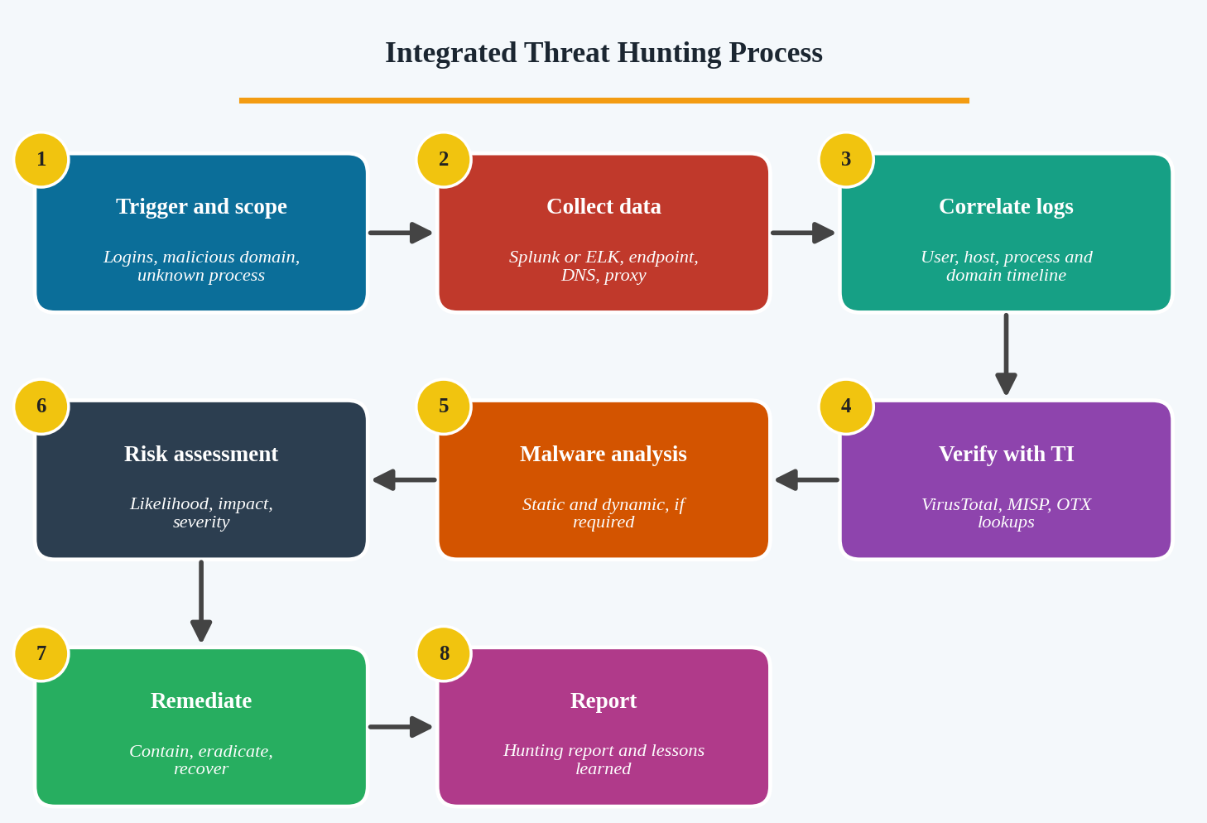
Figure 8: Integrated threat hunting process

Step 1: Scope and Hypothesis
Hypothesis: “The employee’s credentials were compromised and malware on the workstation is communicating with a malicious domain.” Define the time window, the user, the host and the domain, and open an incident ticket.

Step 2: Data Collection
- Authentication logs: Windows Security 4624, 4625, 4648, VPN and Active Directory logs.
- Endpoint telemetry: Sysmon and EDR (process creation, network connection, file and registry events).
- Network logs: DNS, proxy, firewall and NetFlow.
- Ingestion: forwarders send data to Splunk, or Beats and Logstash ship it to Elasticsearch, where it is parsed and normalised with consistent time, host and user fields.
- Preserve evidence: memory dump, disk image and copies of the suspicious file with hash values and chain of custody.

Step 3: Log Correlation and Investigation
Correlate the user, host, process and domain to build a timeline. Examples of searches are shown below.
Splunk (SPL) – which process contacted the malicious domain:
index=sysmon EventCode=3 DestinationHostname="bad-domain.example"
| stats count values(Image) AS process BY host user DestinationIp

Splunk (SPL) – logins by the suspicious user outside working hours:
index=wineventlog EventCode=4624 user=jdoe
| eval hour=strftime(_time,"%H") | where hour<6 OR hour>20
| stats count BY src_ip host LogonType

ELK (KQL) – equivalent search in Kibana:
destination.domain : "bad-domain.example" and event.category : "network"

- Find the first suspicious login, its source IP and what the account did next (lateral movement, new processes).
- Identify the parent process, command line, file path and user of the unknown process.
- Look for the same domain, hash or IP on other hosts to determine the scope.
- Check persistence (Run keys, tasks, services) and signs of data access or transfer.

Step 4: Verification with Threat Intelligence
- Check the domain, IP and file hash in VirusTotal, MISP and AlienVault OTX to confirm malicious status, malware family, first-seen date and related IoCs.
- Assess source reliability and confidence (trusted vendor, several sources agree, recent data).
- Map behaviour to MITRE ATT&CK techniques to predict the attacker’s next steps.

Step 5: Malware Analysis (If Required)
- Static analysis: hashes, strings, PE headers and imports (PEStudio, DIE, strings) without running the file.
- Dynamic analysis: run in an isolated sandbox with Procmon, Regshot and Wireshark to observe file, registry and network behaviour.
- Extract additional IoCs such as dropped files, mutexes and C2 addresses, and feed them back into the searches.

Step 6: Risk Assessment
Factor | Assessment questions
Likelihood / confidence | How strong is the evidence that the host and account are compromised (TI match, process behaviour, logs)?
Impact | What data and systems could be reached by the user and the host? Is there sensitive or regulated data?
Scope | How many hosts, accounts and domains are involved? Is there lateral movement?
Threat actor capability | Is it commodity malware or a targeted attack?
Overall rating | Low, medium, high or critical, with a priority for response.

Step 7: Remediation Actions
- Contain: isolate the workstation, block the malicious domain and IPs, quarantine the file hash.
- Credentials: reset the user’s password, revoke sessions and tokens, and enforce multi-factor authentication.
- Eradicate: terminate the process, remove files and persistence mechanisms, or re-image the machine.
- Recover: restore from clean backups, apply patches and monitor the host closely.
- Improve: add detections in Splunk or ELK, update email and web filtering, and train users on phishing.

Step 8: Threat Hunting Report
Section | Content
1. Executive summary | Brief overview, impact and risk rating in non-technical terms.
2. Scope and hypothesis | Systems, users and time range investigated, and the hunting hypothesis.
3. Data sources and tools | Splunk or ELK queries, endpoint and network logs, threat intelligence platform used.
4. Timeline of events | Chronological sequence from the first login to containment.
5. Findings and IoCs | Malicious domain, IPs, hashes, file paths, accounts and ATT&CK techniques.
6. Threat intelligence assessment | Malware family, source reliability and confidence.
7. Risk assessment | Impact, scope and severity rating.
8. Remediation actions | Containment, eradication and recovery steps with owners and dates.
9. Lessons learned and recommendations | New detections, control improvements and awareness training.
10. Appendices | Screenshots, queries, log extracts and tool outputs.

Conclusion: The integrated process moves from a hypothesis, through data collection, correlation in Splunk or ELK and verification with threat intelligence, to malware analysis, risk assessment and clear remediation. The final report documents the evidence and turns the lessons into stronger detection and prevention.

