CSA6303- Threat Intelligence and Network Security

AT2– Malware Analysis Assignment
Subject | Threat Intelligence
Total Marks | 50
Questions | 10 (all compulsory)
Marks per Question | 5
Reg. No | 192411211
Name | V. Teja Sree
Faculty | Dr. V. Parthipan
Slot | A
Instructions: Answer all questions. Each question carries 5 marks. Support answers with examples and diagrams where appropriate.
CO3: Perform threat analysis using intelligence models and utilize industry tools for monitoring and detection.

Dr. V. Parthipan Total: 50

Student Name : V. Teja Sree Register number: 192411211

Code of Conduct:
I V. Teja Sree (192411211) (Name / Reg No) certify that this submission is my original work and that I have adhered to the guidelines specified for this assessment. I understand that any violation of academic integrity rules will result in disciplinary action.

Signature of the student


1. Malware Analysis Using Static Techniques

Introduction
Static malware analysis is the examination of a suspicious file without executing it. The analyst studies the file’s metadata, structure, embedded text and code references to judge whether it is malicious. It is the safest first step for an executable received through a phishing email, because nothing can run, spread or contact an attacker during the examination.
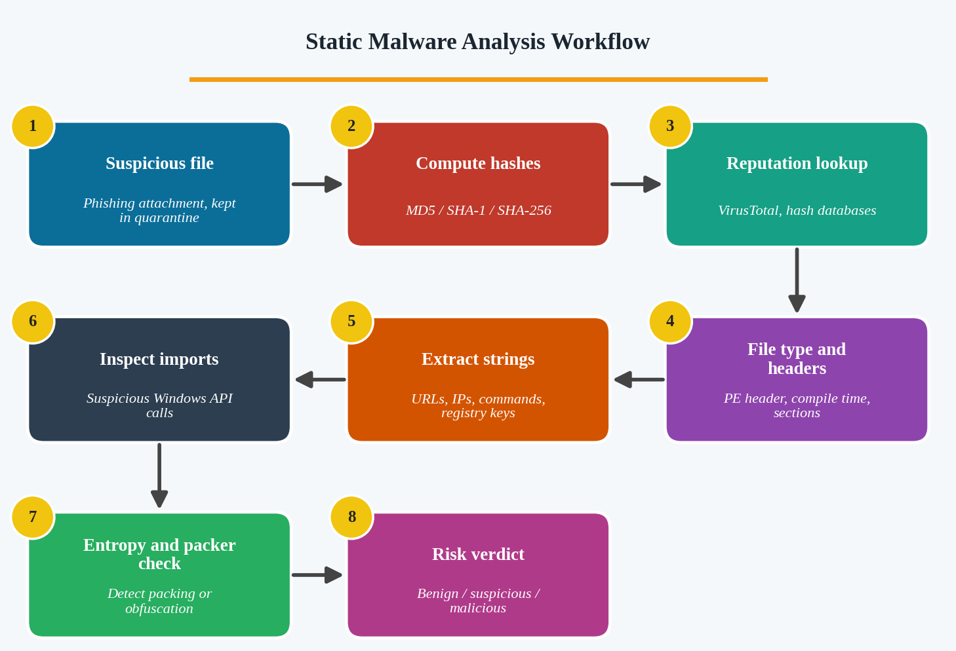
Figure 1: Static malware analysis workflow

Steps and What They Reveal
Technique | What the analyst does | Suspicious signs
File hashing | Calculate MD5, SHA-1 and SHA-256 with tools such as certutil or HashMyFiles, then search the hash in VirusTotal. | Hash already flagged by many antivirus engines or linked to a known family.
File properties | Check file type, size, icons, digital signature and PE header (compile time, sections) using PEStudio or Detect It Easy. | Document icon on an .exe, unsigned file, fake or very recent compile time, odd section names.
Strings extraction | Run the strings tool or FLOSS to read readable text inside the binary. | Hard-coded URLs, IP addresses, PowerShell commands, registry keys, ransom messages.
Imported functions | Review the Import Address Table (IAT) in PEStudio or CFF Explorer. | APIs such as VirtualAlloc, WriteProcessMemory, CreateRemoteThread, URLDownloadToFile, RegSetValue.
Entropy and packing | Measure section entropy and detect packers (UPX and others). | Entropy close to 8 suggests packed or encrypted code used to evade antivirus.

Example
A file named Invoice_Oct.pdf.exe is attached to an email. Static analysis shows it is an unsigned PE file with a high-entropy .text section, strings containing an unknown URL and a Run registry path, and imports of WriteProcessMemory and CreateRemoteThread (process injection). The SHA-256 hash is flagged by many engines on VirusTotal. The analyst concludes the file is highly likely to be a trojan dropper.

Risk Assessment Without Execution
- Reputation: a known-bad hash gives immediate confirmation.
- Capability: imported APIs and strings show what the program can do (download, inject, persist, encrypt).
- Intent: embedded URLs, IPs and commands point to command-and-control or data theft.
- Evasion: packing, obfuscation and a missing signature raise the risk score.
Conclusion: Static analysis quickly reveals identity, structure and likely capabilities of a file in a safe way, allowing the analyst to decide whether it is benign, suspicious or malicious and whether deeper dynamic analysis is needed. Its limitation is that packed or encrypted code can hide behaviour, which is why it is followed by dynamic analysis.

2. Malware Analysis Using Dynamic Techniques

Introduction
Dynamic malware analysis runs the suspected program in a controlled, isolated environment and records everything it does. It is used when an organisation suspects that a program changes system files and contacts an external server, because the real behaviour (file changes, registry edits, network traffic) can only be seen while the code is running.
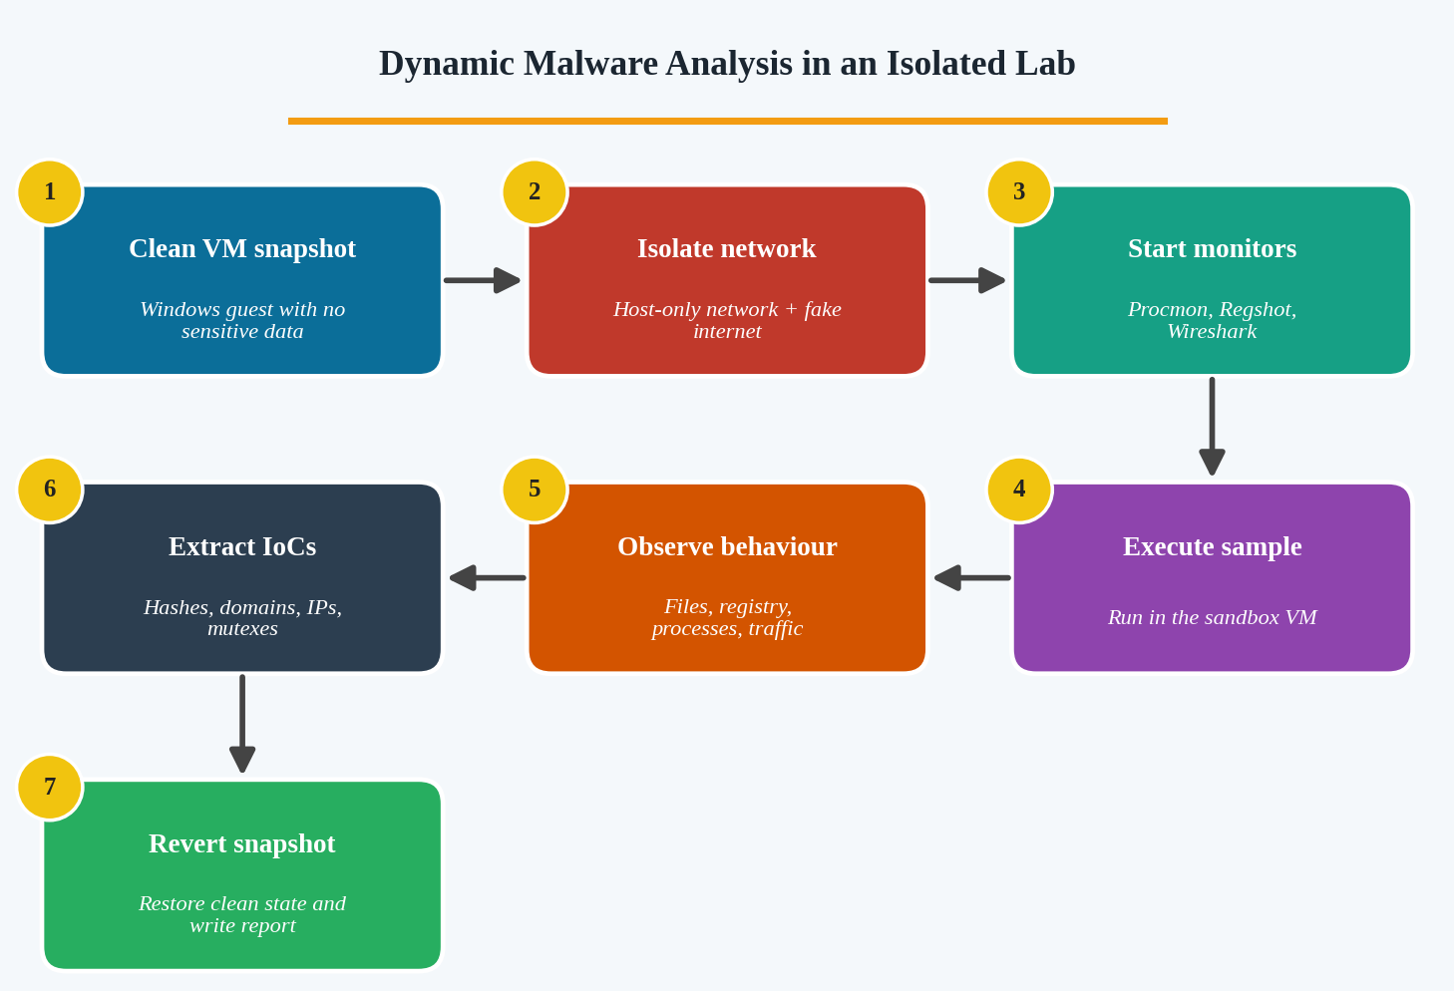
Figure 2: Dynamic analysis in an isolated virtual lab

Building the Isolated Environment
- Virtual machine: use VMware or VirtualBox with a Windows guest that has no real data, and take a clean snapshot before every run.
- Network isolation: use a host-only or internal network. Tools like INetSim or FakeNet-NG simulate the internet so the malware reveals its requests without reaching a real server.
- Disable sharing: turn off shared folders, clipboard sharing and drag and drop so malware cannot escape to the host.
- Sandbox option: automated sandboxes such as Cuckoo or ANY.RUN produce a behaviour report quickly.

Monitoring Tools and What They Capture
Tool | Behaviour observed | Possible IoC
Process Monitor (Procmon) | File, registry and process activity in real time. | Files created or modified in System32, new Run keys.
Process Explorer / Process Hacker | Parent-child process tree, loaded DLLs, injected threads. | Unknown process spawned by Word or a browser.
Regshot | Compares registry and file system before and after execution. | New registry keys, services, scheduled tasks.
Wireshark / Fiddler | DNS queries, HTTP/HTTPS requests and packet captures. | C2 domain, IP address, beacon pattern, User-Agent.
Autoruns | Persistence locations (startup, services, tasks). | Startup entry pointing to a temp or AppData file.

Procedure
- Restore the clean snapshot and start all monitoring tools.
- Take a baseline (Regshot first shot) and begin packet capture.
- Execute the sample and let it run for several minutes, simulating user activity if needed.
- Record new or modified files, registry changes, processes, services and network connections.
- Take the second shot, compare results, save logs and PCAP files, then revert the snapshot.

Indicators of Compromise Identified
- File hashes of the original and any dropped files.
- Domains, IP addresses and ports contacted, with URL paths.
- Registry keys, services, scheduled tasks and mutex names used for persistence.
- File names and paths of modified or dropped files (for example, a copy placed in AppData).
Conclusion: Dynamic analysis reveals real runtime behaviour such as system-file modification and communication with external servers. The IoCs it produces are used to hunt for the same malware on other machines and to block it at the firewall, DNS and endpoint level.

3. Malware Investigation Using a Threat Intelligence Platform

Introduction
A Threat Intelligence Platform (TIP) collects, stores and shares information on threats, such as malicious hashes, domains, IP addresses and attacker techniques. When the hash of a file found on an employee’s computer matches a known malware family, the analyst uses threat intelligence to understand the threat, measure how reliable the information is and choose the correct containment.
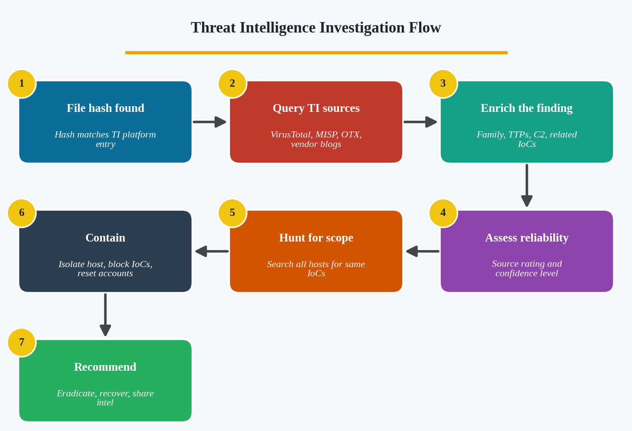
Figure 3: Investigating a file using threat intelligence

Investigating the File
- Query multiple sources: VirusTotal, MISP, AlienVault OTX, MITRE ATT&CK, vendor reports and CERT advisories.
- Identify the family: name, first-seen date, targeted sectors, delivery method (phishing, drive-by) and the attacker group if known.
- Collect related IoCs: C2 domains and IPs, mutexes, file names, registry keys and related hashes.
- Map to ATT&CK: list tactics and techniques (for example T1059 command execution, T1547 persistence) to predict what else the malware may have done.

Assessing Reliability of the Information
Factor | Question to ask
Source credibility | Is the source a trusted vendor, CERT or sharing community, or an unknown feed?
Timeliness | Is the intelligence recent? Old IPs and domains may now be reused by innocent parties.
Corroboration | Do two or more independent sources agree on the same family and IoCs?
Relevance | Does it match our environment, operating system and sector?
Confidence level | Rate the source (A–F) and the information (1–6) using the Admiralty scale, and mark confidence as high, medium or low.

Containment Recommendations
- Isolate the infected computer from the network (disable network, or quarantine through the EDR) but keep it powered on to preserve memory evidence.
- Block the known C2 domains, IPs and file hashes at the firewall, DNS filter, proxy and endpoint protection.
- Hunt across all endpoints and logs for the same IoCs to find other infected machines.
- Reset credentials used on the host and revoke active sessions and tokens.
- Preserve evidence (disk image, memory dump, logs), then eradicate the malware and restore from clean backups.
- Share and record the findings with the threat intelligence community and update detection rules.
Conclusion: Threat intelligence converts a single hash match into a complete picture of the threat. By verifying source reliability and acting on the enriched IoCs, the team can contain the infection quickly, search for further victims and avoid acting on false or outdated information.

4. Malware Detection Through Data Collection and Correlation

Introduction
Unusual processes, suspicious DNS requests and unexpected outbound connections may each have an innocent explanation. Correlation joins these separate pieces of evidence using common fields (host name, user, IP address and time) to decide whether the university computers are truly infected.
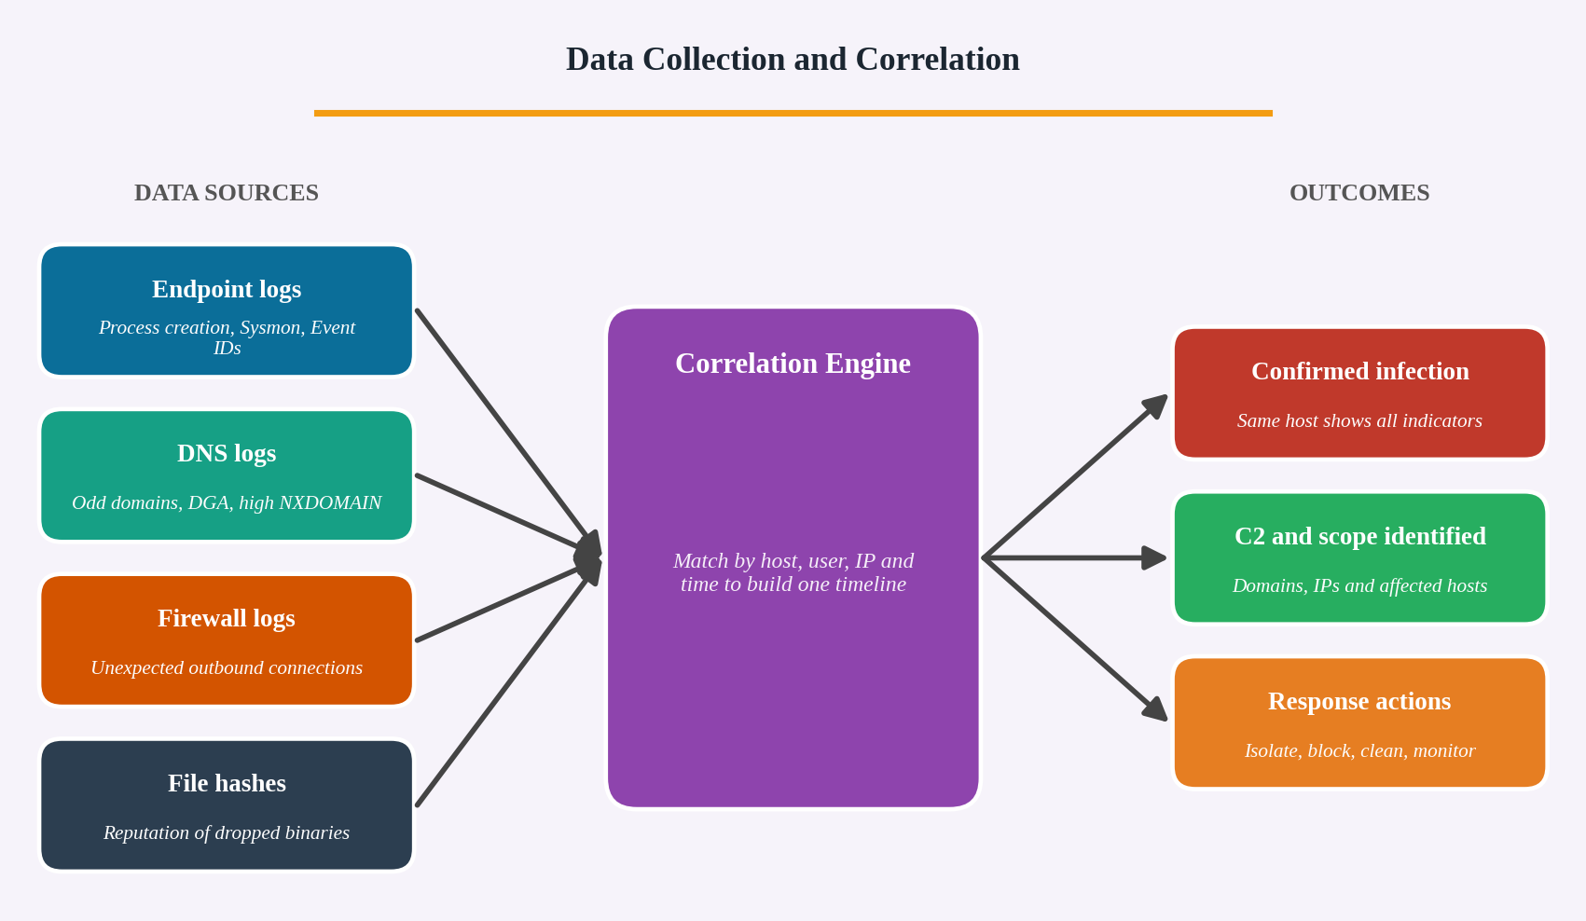
Figure 4: Collecting and correlating multiple data sources

Data to Collect
Source | Information collected | What to look for
Endpoint logs | Windows Event Logs (4688 process creation), Sysmon (Event 1, 3, 11, 13), EDR telemetry. | Unknown processes, scripts launched from Temp or AppData, odd parent-child relationships.
DNS records | Query name, type, client IP, response code and time. | Rare or newly registered domains, random-looking (DGA) names, many NXDOMAIN, repeated queries at fixed intervals.
Firewall logs | Source, destination, port, bytes and action. | Outbound traffic to unknown IPs or unusual ports, large uploads, connections at odd hours.
File hashes | SHA-256 of suspicious binaries, checked on VirusTotal or internal threat feeds. | Hash flagged malicious or the same hash on several machines.

Correlation Process
- Centralise all logs into one platform (SIEM or log server) and synchronise time with NTP.
- Pick a starting point: for example, one host that queried a suspicious domain.
- Link events by key fields: match the DNS client IP to the host, the process that made the connection (Sysmon Event 3) and the firewall record to the same destination.
- Build a timeline: the process starts, the file is written, the DNS lookup follows, then the outbound connection occurs.
- Validate the file: hash the executable and check reputation.
- Check spread: search the same IoCs on all other computers to find the infected set.

Decision
If one host shows an unknown process, a flagged hash, DNS requests to the same suspicious domain and an outbound connection to the resolved IP, the evidence is strongly consistent and the computer is treated as infected. If only one weak indicator appears (for example, a rare domain with no process link), it is treated as a false positive or watch item.
Conclusion: Correlating endpoint, DNS, firewall and hash data turns scattered warnings into a single, verifiable chain of events. This allows the analyst to confirm infection, find the C2 server, identify every affected computer and start containment with confidence.

5. Malware Investigation Using SIEM Tools

Introduction
A Security Information and Event Management (SIEM) system collects logs from many sources, normalises them, correlates events and raises alerts. In the financial institution, three alerts (suspicious process execution, repeated failed logins and unusual network connections) come from the same workstation, which strongly suggests a single incident rather than three unrelated events.
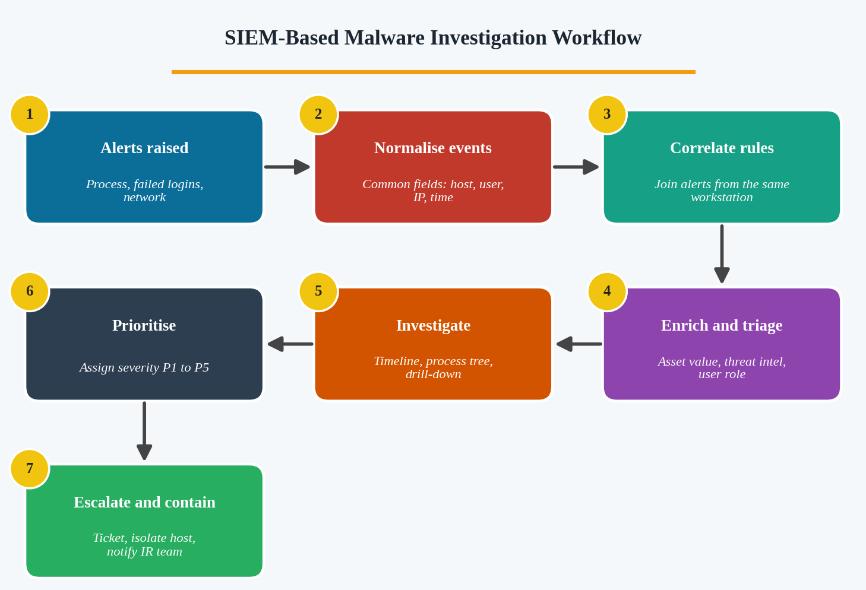
Figure 5: SIEM investigation workflow

Using SIEM Capabilities
- Log aggregation and normalisation: endpoint, authentication, firewall and proxy logs are converted into common fields such as host, user, source IP, destination IP and timestamp.
- Correlation rules: a rule such as “failed logins followed by successful login followed by new process and outbound connection within 30 minutes on the same host” links the alerts into one high-fidelity incident.
- Search and drill-down: filter by the workstation name to view every event, build a timeline and inspect the process tree (for example, a Word document spawning PowerShell).
- Threat intelligence enrichment: compare destination IPs, domains and file hashes against threat feeds.
- UEBA and dashboards: compare the activity with the user’s normal baseline and display it visually.
- Case management: open a ticket, attach evidence, assign an owner and track actions.

Investigation Steps
- Group the three alerts by workstation and time to confirm they are related.
- Review failed logins (Event ID 4625) to see whether a brute-force or credential-stuffing attack occurred, and any following success (4624).
- Examine the suspicious process: path, parent process, command line, hash and signature.
- Check the network connections: destination reputation, port, frequency (beaconing) and data volume.
- Check lateral movement by searching other hosts for the same IP, hash or account.
- Decide whether it is malware, and isolate the host through the EDR integration if confirmed.

Prioritising the Incident
Priority depends on the confidence that the host is infected and the business impact. In a financial institution, access to customer data or payment systems raises the severity, so a confirmed infection on a workstation with privileged access is rated P1 or P2.
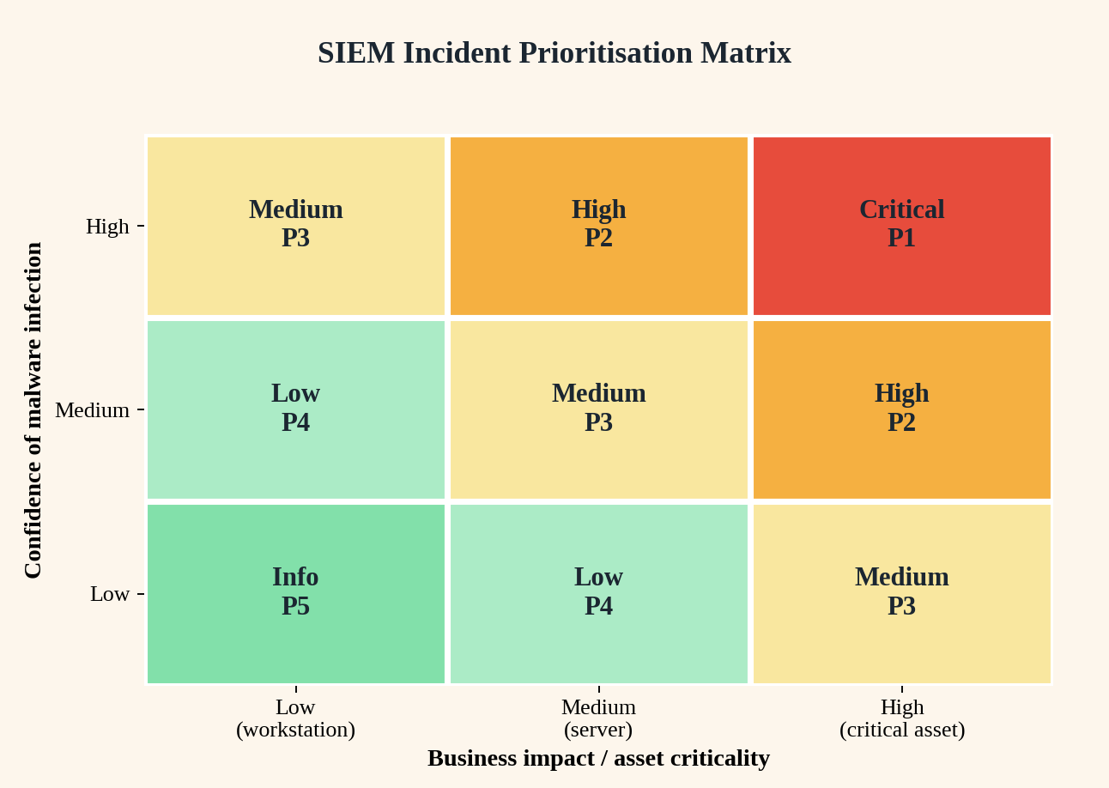
Figure 6: Incident prioritisation matrix
Conclusion: SIEM correlation merges separate alerts into one meaningful incident, provides the evidence needed to confirm malware and supports risk-based prioritisation, so the most dangerous incidents in a financial environment are handled first.

6. Malware Detection and Log Analysis Using Splunk

Introduction
Splunk indexes machine data and lets analysts search it with the Search Processing Language (SPL). To find malware contacting an external command-and-control (C2) server, the team searches endpoint, DNS, proxy and firewall logs for communication patterns that normal users do not produce.
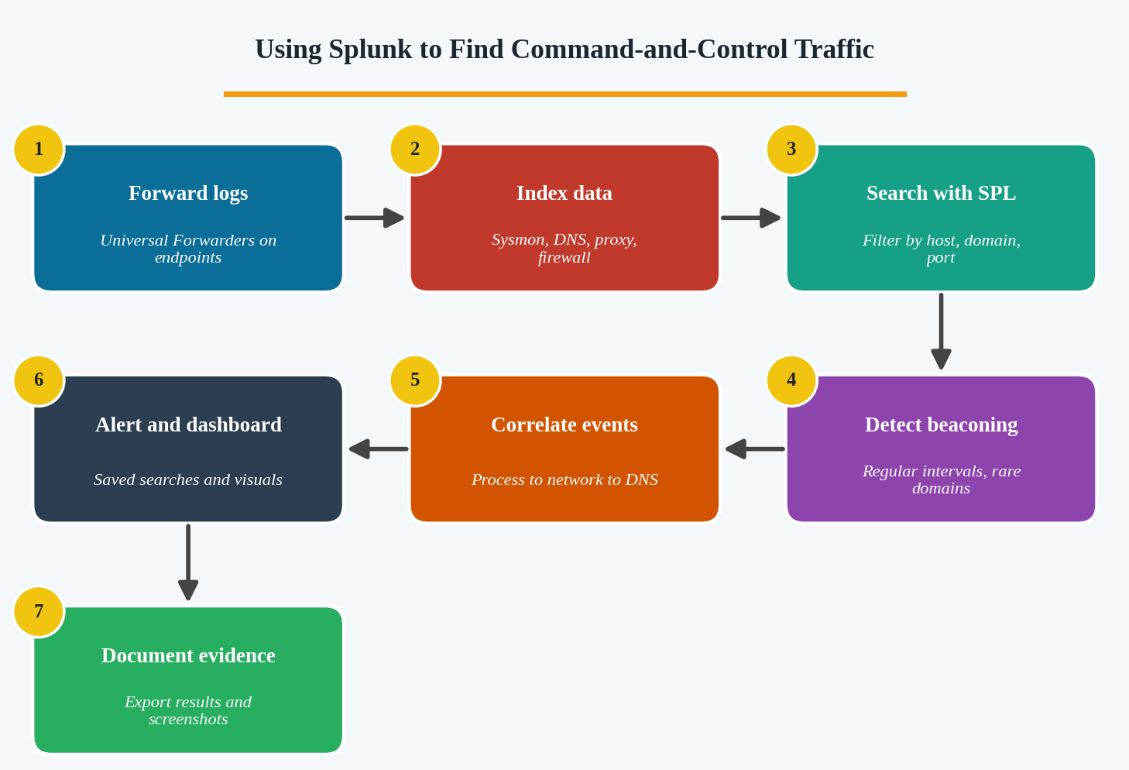
Figure 7: Splunk workflow for finding C2 activity

Searching Relevant Logs
Data from Sysmon, Windows Event Logs, DNS, firewall and proxy are forwarded with Universal Forwarders and stored in indexes. Example SPL searches are shown below.
1) Rare outbound destinations:
index=firewall action=allowed direction=outbound
| stats count dc(src_ip) AS hosts BY dest_ip
| where hosts<=2 | sort - count

2) Beaconing (regular intervals) for each host and destination:
index=proxy | sort 0 _time
| streamstats current=f last(_time) AS prev BY src_ip dest
| eval delta=_time-prev
| stats avg(delta) stdev(delta) count BY src_ip dest
| where count>50 AND stdev_delta<5

3) Process to network correlation (Sysmon Event 3):
index=sysmon EventCode=3 | stats values(DestinationIp) BY Image host

Identifying Suspicious Communication Patterns
- Beaconing: connections to the same destination at fixed intervals (for example, every 60 seconds) with small, equal-sized packets.
- Rare or new domains: domains seen on only one or two hosts, newly registered domains, or random-looking DGA names.
- Unusual ports and protocols: traffic to uncommon ports, or DNS tunnelling shown as very long TXT queries.
- Odd initiators: non-browser processes such as cmd.exe, wscript.exe or an unknown executable making outbound connections.
- Data volume: large outbound transfers suggesting exfiltration.

Correlating Events and Documenting Evidence
- Join the DNS query, proxy or firewall record and Sysmon process event using host and time to show which process contacted the C2.
- Use the transaction or stats command to build a timeline for the affected host.
- Compare IPs and domains with a threat intelligence lookup in Splunk (for example, Enterprise Security threat feeds).
- Create a saved search or alert and a dashboard so that new matches are detected automatically.
- Document the evidence: export results as CSV or PDF, record search queries and time ranges, take screenshots, and note hashes, hosts, domains and timestamps in the incident ticket.
Conclusion: Splunk allows fast searching across large volumes of logs, reveals C2 patterns such as beaconing and rare domains, links network activity to the responsible process and provides exportable evidence for the incident report.

7. Malware Investigation Using the ELK Stack

Introduction
The ELK Stack is an open-source platform made of Elasticsearch (search and storage), Logstash (collection and processing) and Kibana (visualisation). It often works with Beats lightweight shippers. For the e-commerce company it provides one place to analyse web server, firewall and endpoint events.
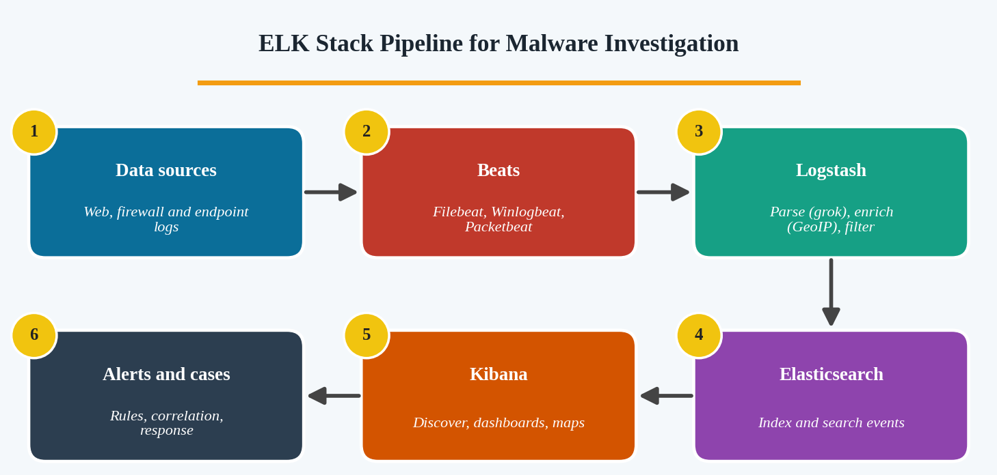
Figure 8: ELK Stack pipeline

How ELK Supports Malware Investigation
Stage | Component | Role in the investigation
Collection | Filebeat, Winlogbeat, Packetbeat, Elastic Agent | Ship web server logs, firewall records, Windows and Sysmon events to the stack.
Processing | Logstash pipelines | Parse logs with grok, normalise field names, add GeoIP and threat-intel tags, drop noise.
Searching | Elasticsearch | Index data and allow fast queries by domain, IP, hash, user or process.
Visualisation | Kibana Discover, Lens, Maps | Show timelines, top domains, connection counts and geographic location of destinations.
Correlation and alerting | Kibana Security, detection rules, EQL | Detect sequences such as process creation followed by a connection to a rare domain.

Investigation Approach
- Search for the suspicious domains in Kibana Discover with a KQL query, for example: destination.domain : “example-bad.com”.
- Pivot to the hosts and processes that connected to them using fields such as host.name, process.name and destination.ip.
- Visualise the number of connections per host over time to spot beaconing, and create a data table of the most frequently contacted rare domains.
- Check unusual file activity in Sysmon or Auditbeat data (file creation in temp folders, changes to system files, mass renaming that may indicate ransomware).
- Correlate web server logs with endpoint events to see whether a web attack (upload of a web shell) led to the malware.
- Alert and report: save the searches as detection rules, add them to a dashboard and export evidence for the case.
Conclusion: The ELK Stack provides scalable log collection, flexible parsing, fast search and clear visualisation. Together with correlation rules, it helps the security team connect suspicious domain traffic and file activity to specific systems and confirm a malware infection.

8. Threat Hunting for Malware Activities

Introduction
Threat hunting is the proactive search for threats that automated tools have missed. Because no antivirus alert has fired, the team must start from a hypothesis: “The workstation is infected with malware that evades signature-based detection and communicates with an external server.”
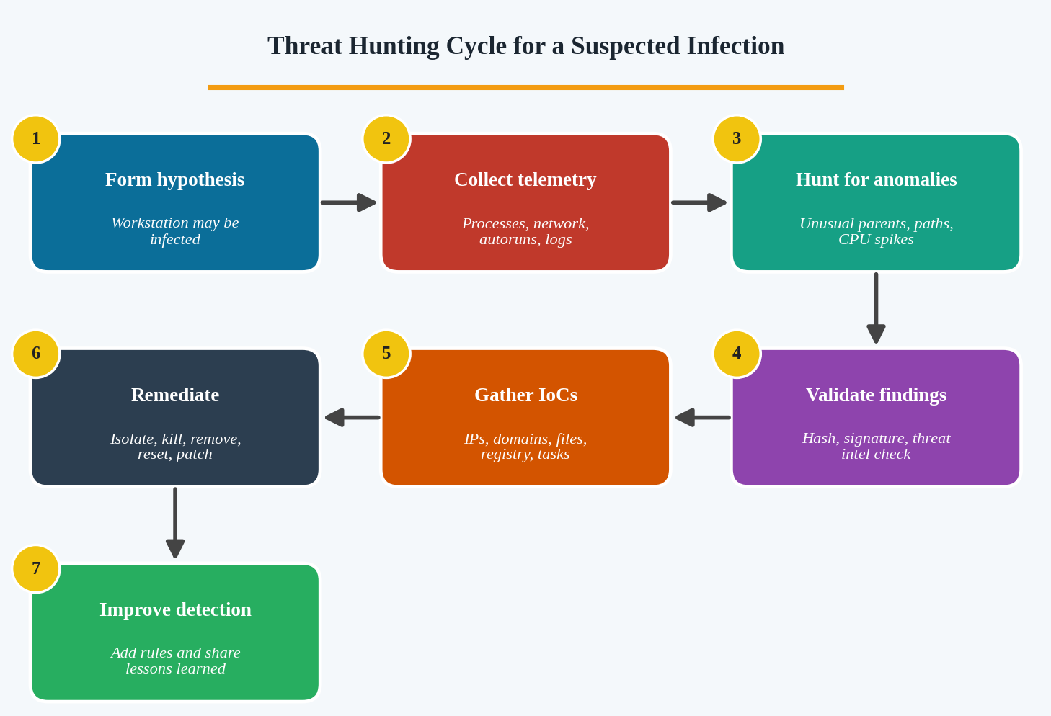
Figure 9: Threat hunting cycle

Hunting Approach
- Hypothesis and scope: the symptoms (high CPU, unfamiliar processes, unknown external IPs) suggest malware, possibly a crypto-miner, RAT or backdoor. Isolate or closely monitor the host and capture volatile data first.
- Collect data: running processes, network connections, startup entries, scheduled tasks, services, event logs, EDR telemetry, DNS and firewall logs, and a memory image.
- Hunt for anomalies: look for the behaviours listed in the table below.
- Validate: check hashes on VirusTotal, verify digital signatures and compare the destination IPs with threat intelligence.
- Gather IoCs and map to ATT&CK, then search all other endpoints for the same indicators.
- Remediate and improve detection.
Area | Tools | Suspicious behaviour
Processes | Task Manager, Process Explorer, Process Hacker | Names that imitate system files (svch0st.exe), wrong path, no signature, Office or browser spawning PowerShell or cmd.
CPU and memory | Resource Monitor, Process Explorer | Constant high CPU by an unknown process (possible miner), hidden injected threads.
Network | netstat -ano, TCPView, Wireshark | Connections to unknown IPs, unusual ports, periodic beaconing.
Persistence | Autoruns, Task Scheduler, registry Run keys | New startup entries, tasks or services pointing to AppData or Temp.
Logs | Sysmon, Event Viewer | Event 4688 and Sysmon 1, 3, 7, 8, 11 showing new processes, connections and DLL loads.
Memory | Volatility, Velociraptor | Injected code, hidden processes, malicious DLLs.

Indicators of Compromise to Collect
- File names, paths and SHA-256 hashes of suspicious executables.
- External IP addresses, domains, ports and URLs.
- Registry keys, scheduled tasks, services and mutex names.
- Command lines, parent-child process chains and user accounts used.

Remediation Measures
- Contain: isolate the workstation from the network and block the IoCs at the firewall, DNS and EDR.
- Eradicate: terminate malicious processes, remove persistence and files, or re-image the machine when trust is lost.
- Credential security: reset passwords and revoke tokens used on the host.
- Recover and harden: restore from clean backups, apply patches, enforce application allow-listing and least privilege, and enable EDR and Sysmon.
- Improve detection: create new SIEM or EDR rules from the IoCs, update the playbook and train users.
Conclusion: A structured, hypothesis-driven hunt can reveal stealthy malware that antivirus missed. The collected IoCs allow the organisation to find other victims, remove the threat completely and strengthen future detection.

9. Comparing Malware Analysis Tools Used in the IT Industry

Introduction
Different tool categories answer different questions about a suspicious file. No single category is enough on its own, so analysts combine them. The comparison below covers the purpose and usefulness of each category.

Comparison of Tool Categories
Category | Purpose | Examples | Advantages | Limitations
Static analysis tools | Inspect the file without running it (hashes, headers, strings, imports, disassembly). | PEStudio, Detect It Easy, strings/FLOSS, Ghidra, IDA, CFF Explorer | Safe and fast; shows capabilities and embedded IoCs. | Packed or encrypted code hides details; needs skill to read code.
Dynamic analysis tools | Run the sample in a sandbox and observe behaviour. | Cuckoo, ANY.RUN, Procmon, Process Hacker, Regshot | Shows real actions: files, registry, processes and network. | Takes longer; malware may detect the sandbox or wait before acting.
Network traffic analyzers | Capture and examine traffic to detect C2, downloads and exfiltration. | Wireshark, Fiddler, Zeek, INetSim, Suricata | Reveals domains, IPs, protocols and beacons. | Encrypted traffic is hard to read; produces large data volumes.
Threat intelligence platforms | Provide reputation, context and relationships for hashes, domains and IPs. | VirusTotal, MISP, AlienVault OTX, Recorded Future | Instant verdict, malware family, TTPs and related IoCs. | Unknown or new malware may have no data; quality of sources varies.

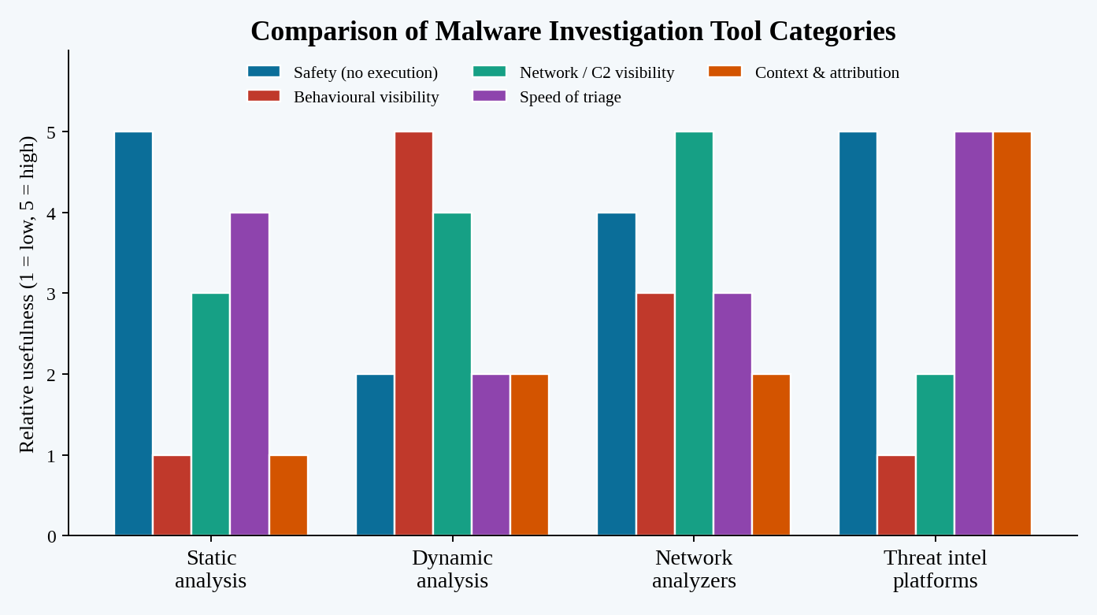
Figure 10: Relative usefulness of tool categories (indicative rating)

Recommended Combination
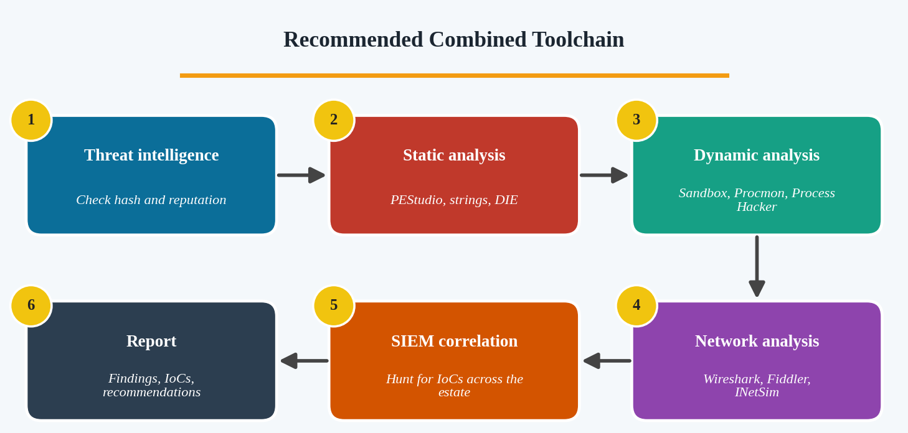
Figure 11: Recommended layered toolchain
- Threat intelligence first: check the hash on VirusTotal and MISP for a rapid verdict and context.
- Static analysis next: use PEStudio, DIE and strings to understand structure and capabilities safely.
- Dynamic analysis in a sandbox: run in an isolated VM or Cuckoo/ANY.RUN with Procmon and Regshot to record behaviour.
- Network analysis during execution: Wireshark and INetSim capture C2 communication.
- SIEM or EDR hunting: search the organisation’s logs for the collected IoCs.
- Reverse engineering (if needed): Ghidra or IDA for deep analysis of complex samples.
Conclusion: Static tools provide safety and speed, dynamic tools show behaviour, network analyzers expose communication and threat intelligence supplies context. Using them together gives a complete and reliable verdict on whether a file contains malicious code.

10. Malware Analysis Report and Incident Response

Introduction
A malware analysis report records what was found, how it was found and what actions are recommended. It supports decision-making by management and the incident response team and acts as evidence and a knowledge base. The following outline is prepared for the suspicious executable discovered on the employee’s computer.
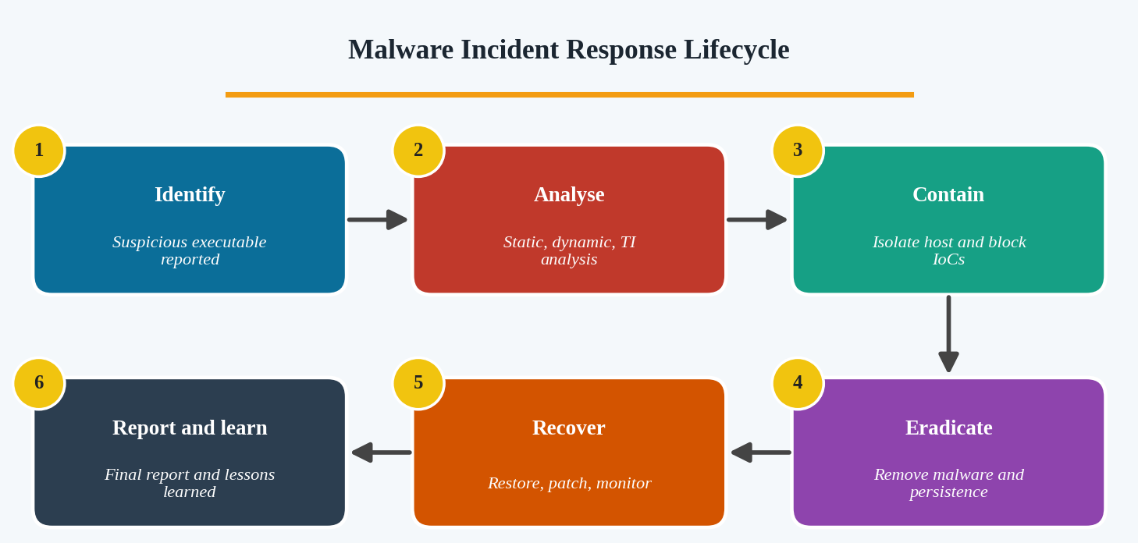
Figure 12: Malware incident response lifecycle

Outline of the Malware Analysis Report
Section | Content to include
1. Executive summary | Short non-technical overview: what was found, impact, risk level and key actions.
2. Incident details | Report ID, date and time, analyst name, affected host and user, how the file was discovered (for example, phishing email), and chain of custody.
3. File information | File name, size, type, MD5, SHA-1, SHA-256, compile time, digital signature, packer and VirusTotal detection ratio.
4. Analysis methodology | Tools and environment used: static (PEStudio, strings), dynamic (isolated VM, Procmon, Regshot), network (Wireshark, INetSim) and threat intelligence sources.
5. Observed behaviour | Unfamiliar process and its parent, modified system configuration (registry or startup changes), files created or altered, and communication with the suspicious external domain.
6. Indicators of Compromise | Hashes, file paths, domains, IPs, URLs, registry keys, mutexes and scheduled tasks, in a table suitable for blocklists and SIEM searches.
7. Threat intelligence findings | Malware family, related campaigns, ATT&CK techniques, source reliability and confidence level.
8. Risk assessment | Likelihood, impact on confidentiality, integrity and availability, affected assets and an overall rating (low, medium, high or critical).
9. Containment, eradication and recovery | Actions listed below with owners and deadlines.
10. Lessons learned and recommendations | Control improvements, user awareness, detection rules and next steps.
11. Appendices | Screenshots, log extracts, PCAP references and tool outputs.

Recommended Containment and Recovery Actions
Phase | Actions
Containment | Isolate the computer from the network, block the malicious domain and IP, quarantine the file hash on all endpoints, disable or reset affected accounts.
Eradication | Terminate the malicious process, delete the file and its persistence mechanisms, revert the modified configuration, scan the network for the same IoCs.
Recovery | Rebuild or re-image the system if needed, restore data from clean backups, apply patches, change credentials and monitor the host closely.
Post-incident | Update email filtering and EDR rules, run user awareness training, share IoCs, and review the incident response plan.

Conclusion: A well-structured malware analysis report gives a clear record of the file, its behaviour, the evidence and the risk. Together with prompt containment, eradication and recovery, it limits damage and strengthens the organisation against future attacks.

