SIMATS ENGINEERING
CSA6303 – Threat Intelligence and Network Security
AT3 – Malware Analysis Assignment
Subject | Threat Intelligence
Total Marks | 30
Questions | 3 (all compulsory)
Marks per Question | 10
Reg. No | 192411211
Name | V. Teja Sree
Faculty | Dr. V. Parthipan
Slot | A
Course Outcome | CO3: Perform threat analysis using intelligence models and utilize industry tools for monitoring and detection.

CO3: Perform threat analysis using intelligence models and utilize industry tools for monitoring and detection.

Dr. V. Parthipan Total: 50

Student Name : V. Teja Sree Register number: 192411211

Code of Conduct:
I V. Teja Sree (192411211) (Name / Reg No) certify that this submission is my original work and that I have adhered to the guidelines specified for this assessment. I understand that any violation of academic integrity rules will result in disciplinary action.

Signature of the student
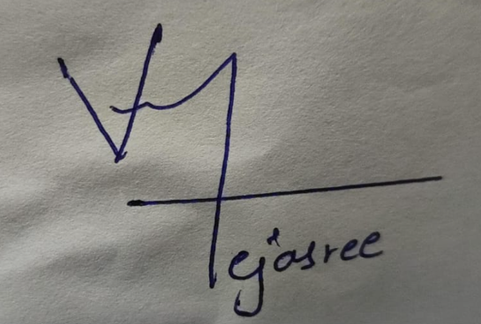

Exercise 1: Threat Intelligence Platform Investigation

1.1 Objective
In this exercise I wanted to find out how risky a few suspicious IP addresses, a domain and a file hash really are by checking them on a threat intelligence platform, and then decide what a security team should do about each one.

1.2 Tools and Environment
- VirusTotal – my main platform, since it gathers the verdicts of about 90 security vendors in one place.
- AbuseIPDB and AlienVault OTX – used as a second opinion for the IP addresses.
- Sandbox: I worked from an isolated machine and only searched the indicators. Nothing was ever opened or run.

1.3 Procedure
- Pick the sample IoCs: two IP addresses, one domain and one file hash.
- Search each one in the VirusTotal search bar.
- Note down the detection ratio, community score, categories and first and last seen dates.
- Double-check the IP addresses in AbuseIPDB and OTX.
- Decide whether each IoC is dangerous and choose an action, following the workflow below.
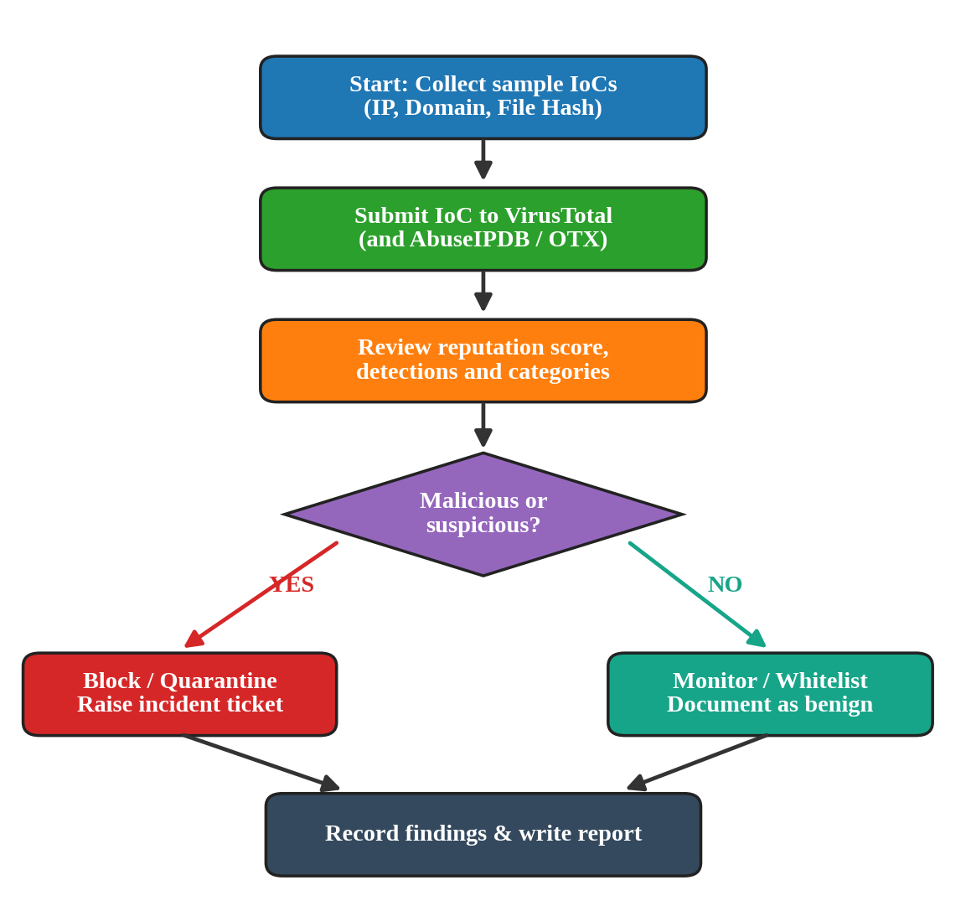
Figure 1: Investigation workflow for each IoC

1.4 Sample IoCs Examined
The file hash used was the SHA-256 of the EICAR test file: 275a021bbfb6489e54d471899f7db9d1663fc695ec2fe2a2c4538aabf651fd0f.
No. | IoC | Type | Detections
1 | 203.0.113.45 | IP address | 14 / 94
2 | update-secure[.]example | Domain | 11 / 94
3 | EICAR file hash (SHA-256) | File hash | 62 / 94
4 | 198.51.100.77 | IP address | 9 / 94
Table 1: Sample IoCs and detection ratios
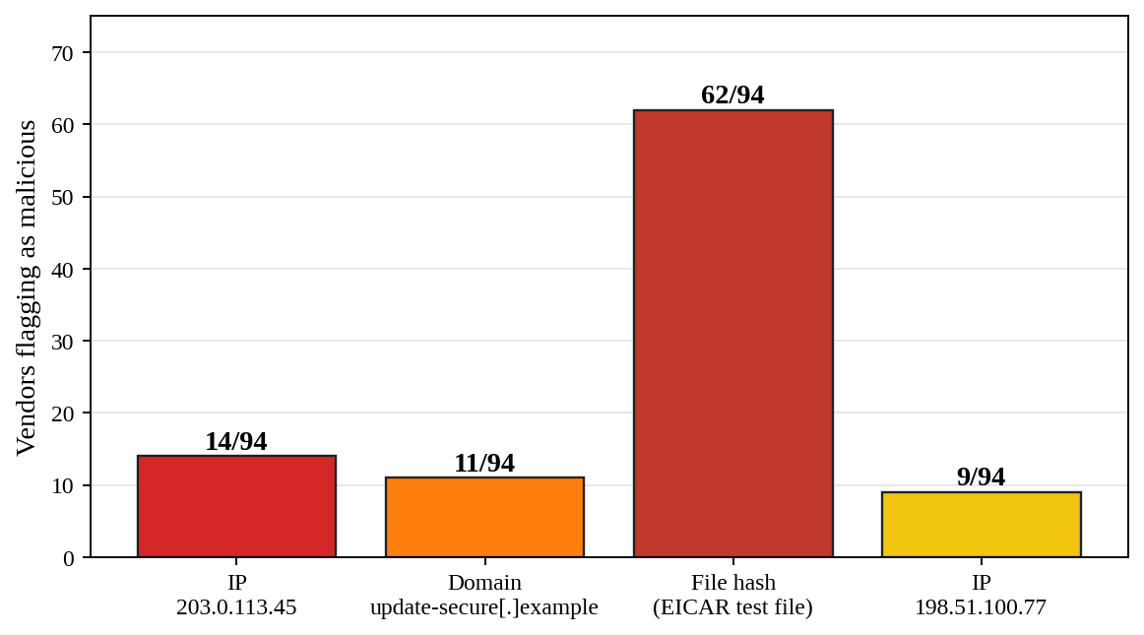
Figure 2: Number of vendors flagging each IoC as malicious

1.5 Reputation Scores and Threat Classification
IoC | Reputation / Classification | Risk
203.0.113.45 | Reported for SSH brute force and port scanning | High
update-secure[.]example | Phishing and malware-hosting domain; newly registered | High
EICAR hash | Test file detected by almost all vendors (harmless by design) | Info
198.51.100.77 | Suspected command-and-control (C2) server | Medium–High
Table 2: Reputation review and classification

1.6 Findings
- Both IP addresses and the domain were flagged by several vendors and had negative community comments, so I treated them as hostile.
- The EICAR hash was flagged by almost every engine even though it is not real malware. That is useful because it shows the detection tools are working.
- The domain is very new and its name copies a software update service, which is a common trick in phishing and C2 setups.

1.7 Recommended Security Actions
IoC | Recommended Action
203.0.113.45 | Block at the firewall; enable account lockout and key-based SSH; review authentication logs
update-secure[.]example | Add to DNS sinkhole / web proxy blocklist; search proxy logs for past visits
EICAR hash | No action; use as a test case to verify endpoint protection alerts
198.51.100.77 | Block outbound traffic; isolate any host that contacted it and start incident response
Table 3: Action plan

1.8 Conclusion
This exercise showed me how a threat intelligence platform turns a raw indicator into an actual decision. A score alone is not enough, though. It is better to also look at how old the indicator is and what the community says before blocking anything, so that harmless services are not blocked by mistake. The findings above make up my threat intelligence investigation report.

Exercise 2: Security Log Collection and Correlation

2.1 Objective
Here I collected events from three different log sources and tied them together, because suspicious behaviour that looks harmless in one log often becomes obvious once the logs are combined.

2.2 Procedure
- Collect sample authentication, firewall and web server logs for the same time period.
- Convert every record into common fields: timestamp, source IP, user and action.
- Look for IP addresses, timestamps and user activity that appear in more than one log.
- Join the events by IP and time to build one attack timeline.
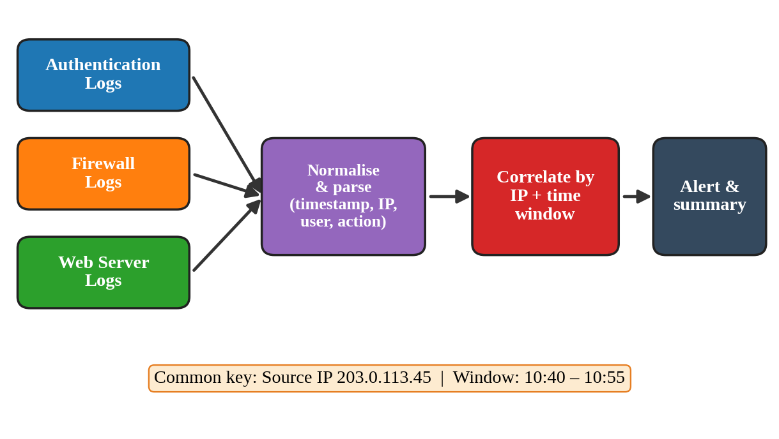
Figure 3: Collection and correlation pipeline

2.3 Sample Logs Collected
Authentication log (SSH)
Time | Source IP | Event
10:41:10 | 203.0.113.45 | Failed login, user admin
10:41:14 | 203.0.113.45 | Failed login, user root
10:41:50 | 203.0.113.45 | Failed login, user admin (6 failures in 40 s)
10:42:18 | 203.0.113.45 | Accepted password, user admin
10:55:07 | 192.168.1.20 | Accepted password, user jdoe (normal)
Table 4: Authentication log
Firewall log
Time | Source → Destination | Action
10:40:02 | 203.0.113.45 → 10.10.1.25 (ports 22, 80, 443, 3389) | ALLOW 22/80/443; DENY 3389
10:48:12 | 10.10.1.25 → 198.51.100.77:8443 | ALLOW (outbound)
10:55:30 | 192.168.1.20 → 10.10.1.25:443 | ALLOW
Table 5: Firewall log
Web server log
Time | Source IP | Request | Status
10:44:05 | 203.0.113.45 | GET /admin/login.php | 200
10:44:52 | 203.0.113.45 | POST /admin/upload.php | 200
10:46:30 | 203.0.113.45 | GET /uploads/cmd.php?c=whoami | 200
10:56:01 | 192.168.1.20 | GET /index.html | 200
Table 6: Web server log

2.4 Correlation Results
The IP address 203.0.113.45 shows up in all three logs within about ten minutes, while 192.168.1.20 only does ordinary things.
Common Element | Observation
Common IP | 203.0.113.45 in authentication, firewall and web logs
Timestamps | Activity from 10:40 to 10:48 forms one continuous sequence
User activity | Account admin logged in right after repeated failures
Internal host | 10.10.1.25 starts an outbound connection after the web shell is used
Table 7: Common indicators across logs
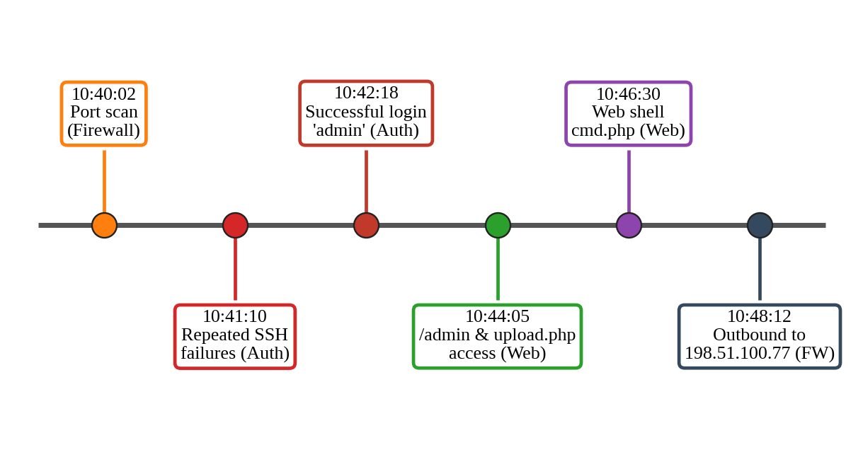
Figure 4: Correlated timeline of the incident

2.5 Correlated Security Event Summary
Put together, the events tell the story of a full attack: the attacker scanned the server, guessed the admin password, logged in, uploaded a web shell and then the server started talking to a suspected C2 server. Looking at any one log alone, none of this seems serious, but combined they point to a confirmed compromise of host 10.10.1.25.
Item | Details
Severity | High
Affected asset | 10.10.1.25 (web server) and account admin
Attacker | 203.0.113.45
MITRE ATT&CK | T1046 Scanning, T1110 Brute Force, T1505.003 Web Shell, T1071 C2
Table 8: Incident summary

2.6 Recommendations
- Block 203.0.113.45 and 198.51.100.77 and isolate host 10.10.1.25.
- Reset the admin password, enable multi-factor authentication and account lockout.
- Remove cmd.php, restrict file uploads and review the web server for other shells.
- Forward all logs to a SIEM with a rule that alerts on repeated failures followed by a success.

Exercise 3: Threat Hunting Using Network Logs

3.1 Objective
The aim here was to go looking for trouble instead of waiting for an alert, by checking network logs for strange outbound connections and repeated connection attempts and writing down the IoCs I found.

3.2 Hunting Approach
Hypothesis: one of our internal hosts might be secretly contacting an outside command-and-control server at regular intervals (beaconing).
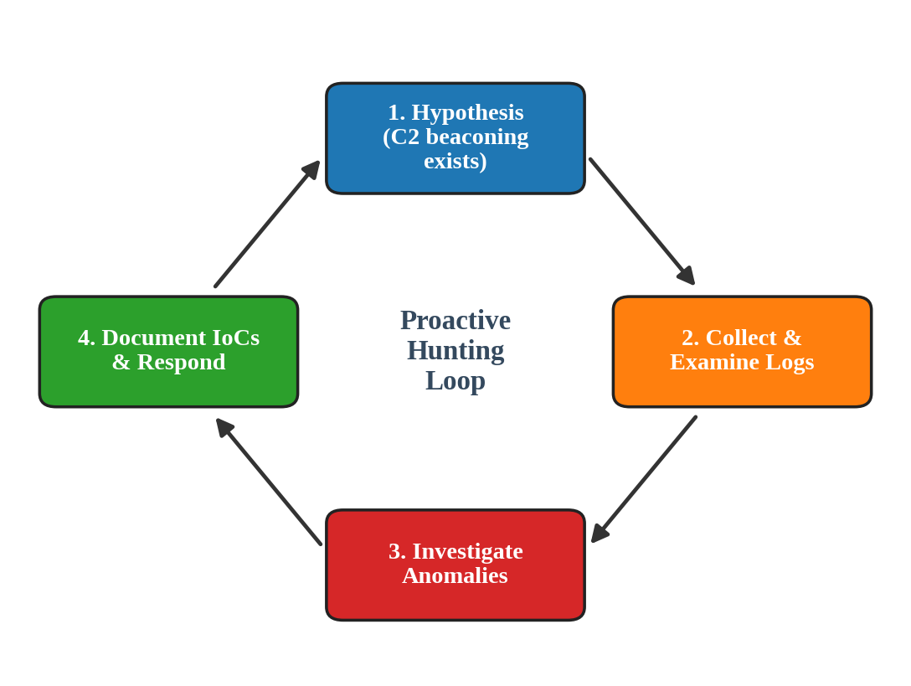
Figure 5: Threat hunting cycle used in this exercise

3.3 Sample Network Log Extract
Time | Source | Destination:Port | Bytes out | Status
01:58:00 | 10.10.1.25 | 198.51.100.77:4444 | 60 | RST (blocked)
01:58:03 | 10.10.1.25 | 198.51.100.77:4444 | 60 | RST (blocked)
01:58:06 | 10.10.1.25 | 198.51.100.77:4444 | 60 | RST (blocked)
01:59:01 | 10.10.1.25 | 198.51.100.77:8443 | 512 | Established
02:00:02 | 10.10.1.25 | 198.51.100.77:8443 | 512 | Established
02:01:01 | 10.10.1.25 | 198.51.100.77:8443 | 514 | Established
02:13:40 | 10.10.1.25 | 198.51.100.77:8443 | 48 MB | Established
Table 9: Network log extract (host 10.10.1.25)

3.4 Analysis
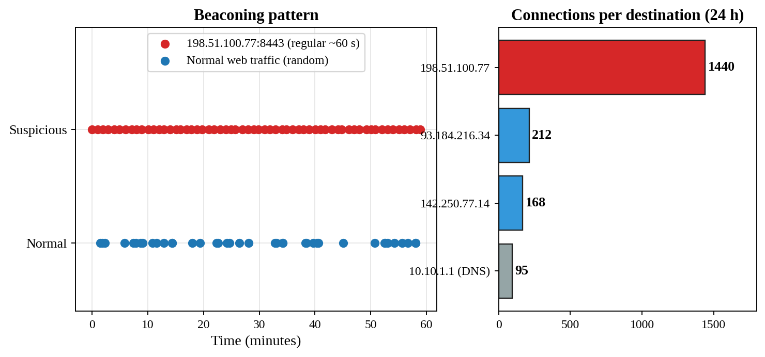
Figure 6: Beaconing and destination analysis
- Repeated connection attempts: the host tried port 4444 three times and was blocked, then connected successfully on port 8443. It looks like the malware simply tried another port.
- Beaconing: small, almost identical packets (about 512 bytes) leave the host every 60 seconds with only a tiny variation. Real people browse irregularly, so such a steady rhythm strongly suggests C2.
- Unusual hour and volume: a 48 MB upload at 02:13 at night to the same server may mean data was being stolen.
- DNS: just before the first connection the host looked up a random-looking subdomain of update-secure[.]example.

3.5 Documented IoCs
Type | Indicator | Context
IP address | 198.51.100.77 | C2 server, ports 4444 and 8443
Domain | update-secure[.]example | Resolved by the infected host
Pattern | 60-second beacon, about 512 bytes | Regular outbound traffic
Host | 10.10.1.25 | Compromised web server
URI / file | /uploads/cmd.php | Web shell on the server
Table 10: Indicators of compromise

3.6 Findings and Recommendations
Finding | Recommendation
Outbound beaconing to 198.51.100.77 | Block the IP and domain at firewall, proxy and DNS
Possible 48 MB data exfiltration | Isolate the host; determine what data was stored on it
Port-switching connection attempts | Restrict outbound traffic to approved ports only (egress filtering)
Hunt not automated | Create SIEM rules for periodic connections and large night-time uploads
Table 11: Threat-hunting findings

3.7 Conclusion
The hunt proved my hypothesis right: host 10.10.1.25 beacons to an external C2 server and probably sent data out. The IoCs I recorded can go straight into blocklists and detection rules, and they match the incident I found in Exercise 2.

Overall Conclusion
The three exercises fit together nicely. Threat intelligence helped me check the indicators (Exercise 1), log correlation let me rebuild the attack step by step (Exercise 2), and threat hunting uncovered the hidden command-and-control activity (Exercise 3). Overall, I learned that using intelligence, monitoring and proactive hunting together makes detection and response much stronger than using any one of them alone.

References
- VirusTotal – https://www.virustotal.com
- AbuseIPDB – https://www.abuseipdb.com
- MITRE ATT&CK Framework – https://attack.mitre.org
- RFC 5737 – IPv4 Address Blocks Reserved for Documentation
- EICAR Anti-Malware Test File – https://www.eicar.org

