# Date :22 october 2024

# Ishan Kishan Returns; Ruturaj Gaikwad To Lead As BCCI Name India A Squad For Australia TourRuturaj Gaikwad- (Source: @Johns/X.com)

October 21, the BCCI announced the India A squad for the upcoming Australia tour. The apex board of cricket in India released a 15-member squad that would be led by Ruturaj Gaikwad and Abhimanyu Easwaran as his deputy.

It is worth noting that ahead of the much-awaited [Border-Gavaskar Trophy](https://cricket.one/featured-news/haunting-issues-for-india-ahead-of-bgt-2024-25-46-all-out-serves-timely-reminder/67110a50ac94d32b0f027dfd)starting on November 22, India A will face Australia for two first-class matches before squaring off against the senior men's team in an intra-squad match.

India A squad for the tour of Australia: Ruturaj Gaikwad (C), Abhimanyu Easwaran (VC), Sai Sudharsan, Nitish Kumar Reddy, Devdutt Padikkal, Ricky Bhui, Baba Indrajith, Ishan Kishan (WK), Abishek Porel (WK), Mukesh Kumar, Khaleel Ahmed, Yash Dayal, Navdeep Saini, Manav Suthar, Tanush Kotian

Talking about the matches, India A will face Australia in the first Test at Mackay from October 31- November 3. The caravan will then move towards Melbourne, which will host the second first-class match from November 7-10.

India A will then take on the senior Indian side in an intra-squad match from November 15-17 at Perth.

# **UEFA Nations League:**

# **Ronaldo held scoreless,**

# **Spain advances**

# **To quarterfinals**

[Cristiano Ronaldo](https://www.foxsports.com/soccer/cristiano-ronaldo-player) was held scoreless and [Portugal](https://www.foxsports.com/soccer/portugal-men-team) lost its perfect record in the [Nations League](https://www.foxsports.com/soccer/nations-league) after a 0-0 draw at [Scotland](https://www.foxsports.com/soccer/scotland-men-team) on Tuesday.

Portugal had won its first three matches in the competition but couldn't find a breakthrough against the Scots at Hampden Park in Glasgow.

Ronaldo, sitting on 133 international goals, had a few good chances to break the deadlock. He seemed upset with the referee after the game ended, leaving the field with a sarcastic applause, waving his arms and with thumbs down.

The world record holder, Jan Zelezny, remains unmatched with his legendary 98.48m throw set in 1996, making him the greatest javelin thrower of all time.

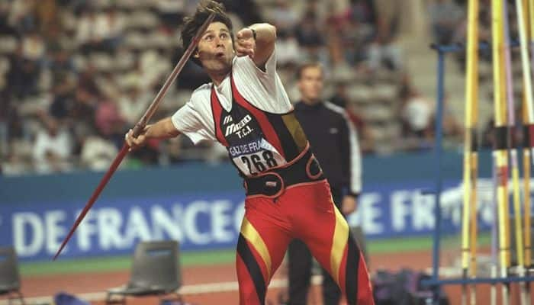

**What Is World Record For Longest Javelin**

**Throw? In Pics**

1. Javelin throw has seen some remarkable feats over the years, with athletes pushing the limits of distance. Arshad Nadeem's recent Olympic record at the Paris 2024 Olympics has added to the rich history of this event. Here’s a look at the top 10 longest throws in javelin history, along with where Nadeem's incredible performance stands.