GitHub Repository Link

https://github.com/deepthibommireddy/1973413_deepthi_TCSMEANStackTraining

Files created

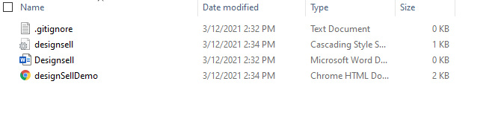

**desiSellDemo.html**: It contains <p> tag <h1> tag <div> tag <table >tag

**designsell.css:** created external css file and added few css properties for each html tag in desiSellDemo.html

**Designsell docs**

**.gitignore**