Linux – OS

What is Operating System?
An Operating System (OS) is an interface between a computer user and computer hardware. An operating system is a software which performs all the basic tasks like file management, memory management, process management, handling input and output, and controlling peripheral devices such as disk drives and printers.
Example: Windows, Linux, MacOS, iOS, android
LINUX is an operating system, or a kernel distributed under an open-source license. Its functionality list is quite like UNIX. The kernel is a program at the heart of the Linux operating system.
Types of Operating Systems
1. Batch Operating System
This type of operating system does not interact with the computer directly. There is an operator which takes similar jobs having the same requirements and groups them into batches. The other jobs will have to wait for an unknown time if any job fails.
EX: Payroll Systems, Bank statements
2. Multi-Programming Operating System [Non – Pre emptive]
In this OS more than one program is present in the main memory and any one of them can be kept in execution. When one program waits for input/output (I/O) operations, the CPU can switch to another ready-to-run program, optimizing performance.
Increases the throughput of the system.
3. Multi-Processing OS
This type of operating system makes use of more than one CPU to improve performance. Multiple processors work parallelly to perform the given task. Since it has several processors, if one fails we can process with another processor.
4. Multi-Tasking Operating systems
This OS allows multiple tasks or processes to run simultaneously on a single CPU. This capability enhances efficiency and user experience.
EX: Round Robin Algorithm
4.a. Preemptive Multitasking: The operating system can interrupt a running process to allocate CPU time to another process. Examples include UNIX, Windows NT, and Windows 95
4.b. Cooperative Multitasking/Non-Preemptive:
Once a program starts running, it keeps going until it finishes or decides to pause, and the computer won't interrupt it. This means other tasks must wait until the current task is finished before they can run.
5. Time Sharing OS:
Each task is given some time to execute. So that all tasks are performed. The time each task gets to execute is called quantum. After this time interval OS switches to next task. These systems are also known as multitasking.
It provides the advantage of quick response. EX: Windows terminal services.
6.Real Time OS:
All real-time operating systems are designed to execute their task within a particular time interval, and thus they have to be fast enough to be up to their deadline. Real-time systems are concurrent that means it can respond to several processes at a time. There are several different tasks going on within the system and it responds accordingly to every task in short intervals.
6.a. Hard Real time systems: These are meant for applications where time cinstraints are very strict and even the shortest possible delay is not acceptable. These systems are designed for saving lives
EX> Automatic parachutes, airbags, Missiles, Air Traffic Control etc.
6.b. Soft Real Time systems: Applications where time constraints are less strict.
EX: Computer games, Instagram live.
7. Distributed OS:
Multiple computers (nodes) are connected via a network. Each node has its own local OS, CPU, and memory. The distributed OS coordinates resource sharing, task scheduling, and communication. To users, it looks like they're working on one single system—even though it's many. A distributed operating system is classified as a loosely coupled system.
EX: Cloud computing platforms (e.g. AWS, Google Cloud), Data centers
8. Network OS:
A Network Operating System is designed to manage and allow communication between multiple computers connected over a network—but each computer runs its own OS independently. This type of OS allows shared access to files, applications over a small private network.
EX: Windows Server. Used in School or office networks
9.Embedded OS:
This type of OS works on a fixed functionality like washing machine, microwave etc. It will work only on that functionality. We cannot make any changes. They are designed for specific hardware and tasks.
Process States
state Diagram
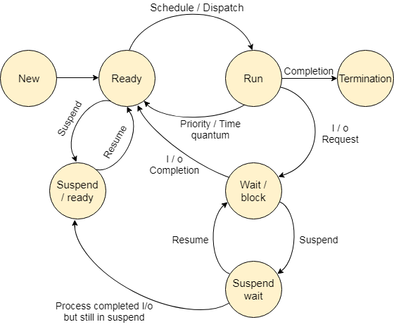
1. New
A program which is going to be picked up by the OS into the main memory is called a new process.
2. Ready : The processes which are ready for the execution and reside in the main memory are called ready state processes. There can be many processes present in the ready state.
3. Running
One of the processes from the ready state will be chosen by the OS depending upon the scheduling algorithm. Hence, if we have only one CPU in our system, the number of running processes for a particular time will always be one. If we have n processors in the system then we can have n processes running simultaneously.
4. Block or wait
From the Running state, a process can make the transition to the block or wait state depending upon the scheduling algorithm or the intrinsic behavior of the process.
When a process waits for a certain resource to be assigned or for the input from the user then the OS moves this process to the block or wait state and assigns the CPU to the other processes.
5. Completion or termination
When a process finishes its execution, it comes in the termination state. All the context of the process (Process Control Block) will also be deleted the process will be terminated by the Operating system.
6. Suspend ready
A process in the ready state, which is moved to secondary memory from the main memory due to lack of the resources (mainly primary memory) is called in the suspend ready state.
If the main memory is full and a higher priority process comes for the execution then the OS have to make the room for the process in the main memory by throwing the lower priority process out into the secondary memory. The suspend ready processes remain in the secondary memory until the main memory gets available.
7. Suspend wait
Instead of removing the process from the ready queue, it's better to remove the blocked process which is waiting for some resources in the main memory. Since it is already waiting for some resource to get available hence it is better if it waits in the secondary memory and make room for the higher priority process. These processes complete their execution once the main memory gets available and their wait is finished.

Operations on the Process
1. Creation
Once the process is created, it will be ready and come into the ready queue (main memory) and will be ready for the execution.
2. Scheduling
Out of the many processes present in the ready queue, the Operating system chooses one process and start executing it. Selecting the process, which is to be executed next, is known as scheduling.
3. Execution
Once the process is scheduled for the execution, the processor starts executing it. Process may come to the blocked or wait state during the execution then in that case the processor starts executing the other processes.
4. Deletion/killing
Once the purpose of the process gets over then the OS will kill the process. The Context of the process (PCB) will be deleted, and the process gets terminated by the Operating system.
Linux Booting Process:
1. BIOS/UEFI
What it is: The BIOS (Basic Input/Output System) or UEFI (Unified Extensible Firmware Interface) is firmware stored on the motherboard.
Function: It performs POST (Power-On Self-Test) and initializes hardware components (CPU, RAM, disk, etc.).
Boot Device Selection: It looks for a bootable device (like an SSD or USB) according to the boot order.
2. Bootloader (GRUB)
What it is: GRUB (GRand Unified Bootloader) is the most common bootloader in Linux systems.
Function:
Loads a menu where the user can choose which OS/kernel to boot (if multiple are installed).
Loads the selected Linux kernel into memory and passes control to it.
3. Kernel Initialization
  - The kernel (e.g., /boot/vmlinuz) is a compressed file. It decompresses and initializes hardware drivers, memory management, and other low-level tasks.
  - Mounts the initial RAM filesystem (initramfs/initrd) to access essential drivers needed to mount the real root filesystem.
Mounts a temporary initial RAM filesystem (initramfs/initrd)
4. initramfs/initrd (Initial RAM Filesystem):
Initramfs (or initrd in older systems) is a temporary root filesystem loaded into RAM by the kernel before the actual root partition is available.
Some root filesystems (e.g., LVM, RAID, encrypted volumes) need special drivers before they can be accessed — initramfs provides these.
Function: Prepares the system for handing off control to the real root filesystem.
5. systemd or init Process (PID 1)
In systemd, a target is like a modern replacement for a runlevel. A target groups together related services (units) that should start (or stop) at the same time.
What it is: The first user-space process, responsible for starting all other services.
System Manager: Most modern distributions use systemd. Older ones used SysVinit or Upstart.
In systemd, a target is like a modern replacement for a runlevel — but more powerful and flexible.
A target groups together related services (units) that should start (or stop) at the same time.
What it does:
- Reads configuration from /etc/systemd/system/
- Starts:
  - Networking - Brings up interfaces so the system can communicate
  - Mount points
  - Display manager
  - User services
- Finally, presents the login screen or shell prompt.
- Target | - Purpose
- local-fs.target | - Mounts local filesystems
- network.target | - Brings up networking
- graphical.target | - Starts GUI login and desktop

6. Login Prompt / Display Manager
- If you're using a CLI system, you'll see a text login prompt (tty).
- If you're using a GUI, a display manager (like GDM, LightDM) will show the graphical login screen.
Runlevel Programs:
These are replaced by systemd.
In SysVinit, each runlevel has its own directory containing scripts that start/stop services
Most modern Linux distributions use systemd, which replaces runlevels with targets:
Runlevel | systemd Target
0 | poweroff.target
1 | rescue.target
3 | multi-user.target
5 | graphical.target
6 | reboot.target
Runlevels: Pre-systemd method of defining OS states.
Runlevel programs: Scripts started/stopped when entering a runlevel.
Modern Linux: Uses systemd targets instead of traditional runlevels.

Functions:
Resource Management – Allocates amount of time or how much hardware required if there are many requests from many users (parallel processing)
Process Management
File System Management
Memory Management
Device Management
Resource Allocation and Scheduling
Network Management
Security
Function | Description | Key Tools
Process Management | Manages processes and CPU usage | top, ps, kill
Memory Management | Allocates and monitors RAM/swap | free, vmstat
File System Management | Organizes and accesses files | ls, chmod, mount
Device Management | Interacts with hardware devices | lsblk, /dev
Network Management | Manages network connections | ip, ping, netstat
Security and Access Control | Controls permissions and authentication | sudo, chown, passwd
Resource Allocation | Shares system resources efficiently | nice, ulimit, cgroups
User Interface | CLI or GUI for user interaction | Bash, GNOME, KDE

Concept | Analogy
Process Management - when it runs, how much CPU it gets, how it interacts with other processes, etc. | Managing workers in a factory (who works, for how long, on what task)
- Process Synchronization - Preventing conflicts in shared resources, ensures that when multiple processes share a resource (like a file or memory), they don’t interfere with each other. | Ensuring two workers don’t use the same machine at the same time

- Process Management (CPU Scheduling):
Whenever you issue a command in Unix, it creates, or starts, a new process. When you tried out the ls command to list the directory contents, you started a process. A process, in simple terms, is an instance of a running program.
The operating system tracks processes through a five-digit ID number known as the pid or the process ID. Each process in the system has a unique pid.
Starting a Process:
When you start a process (run a command), there are two ways you can run it.
Foreground Processes
By default, every process that you start runs in the foreground. It gets its input from the keyboard and sends its output to the screen.
While a program is running in the foreground and is time-consuming, no other commands can be run (start any other processes) because the prompt would not be available until the program finishes processing and comes out.
Background Processes
A background process runs without being connected to your keyboard. If the background process requires any keyboard input, it waits.
The advantage of running a process in the background is that you can run other commands; you do not have to wait until it completes to start another!
to start a background process is to add an ampersand (&) at the end of the command.
If the command wants any input (which it does not), it goes into a stop state until we move it into the foreground and give it the data from the keyboard.
You need to know the job number to manipulate it between the background and the foreground.
Ps – Lists running processes.
Stopping process:
Ending a process can be done in several different ways. Often, from a console-based command, sending a CTRL &plus; C keystroke (the default interrupt character) will exit the command. This works when the process is running in the foreground mode.
If a process is running in the background, you should get its Job ID using the ps command. After that, you can use the kill command to kill the process.
the kill command terminates the first_one process. If a process ignores a regular kill command, you can use kill -9 followed by the process ID.
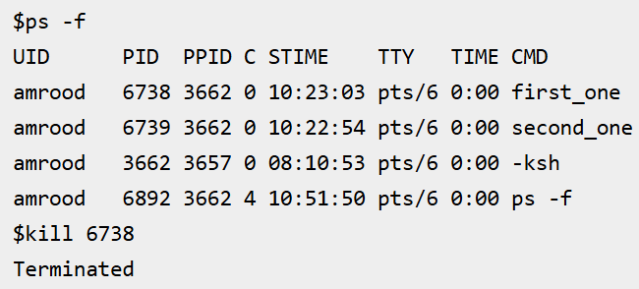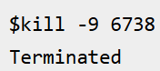
Parent and Child Processes:
Each unix process has two ID numbers assigned to it: The Process ID (pid) and the Parent process ID (ppid). Each user process in the system has a parent process.
A parent process is any process that creates another process.
A child process is the new process created by the parent using the fork() system call.
Most of the commands that you run have the shell as their parent. Check the ps -f example where this command listed both the process ID and the parent process ID.
Orphan Process:
Normally, when a child process is killed, the parent process is updated via a SIGCHLD signal. Then the parent can do some other task or restart a new child as needed. However, sometimes the parent process is killed before its child is killed. In this case, the "parent of all processes," the init process, becomes the new PPID (parent process ID). These processes are called orphan processes.
Zombie Process:
A zombie process is a child process that has finished execution but still has an entry in the process table, because its parent hasn’t read its exit status yet (hasn’t called wait()).
Every child process sends an exit status to its parent when it finishes. The parent must call wait() or waitpid() to collect it. If not collected, the child becomes a zombie.
Daemon Processes:
A daemon process is a background process that runs independently of any terminal or user session (They don't need a window or terminal. They start and keep running silently.). It usually provides system or network services (like sshd, cron, httpd, etc.). You can’t “see” or “open” them like apps. They often log output to files, not the screen. They keep running even if you log out.
Feature | Description
Runs in Background | Doesn’t interact with user terminals
Detached from Shell | Has no controlling terminal (session leader)
Long-Lived | Often starts at boot time and runs until shutdown
Adopted by init | Usually has init (or systemd) as parent (PID 1)
Uses syslog | Logs messages to /var/log via the syslog facility instead of stdout

Fork():
fork() is a system call in Linux used to create a new process. It creates an exact duplicate of the parent. When a program calls fork(), it creates a copy of itself — this copy is called the child process. The original process is called the parent.
Return Value | Process | Meaning
0 | Child | You’re in the child process
> 0 | Parent | You’re in the parent process, return value is child’s PID
-1 | Error | Fork failed (no new process created)
1. 🔄 Process Creation (fork())
Linux uses the fork() system call to create a new process.
2. 🛠️ Executing Programs (exec())
After using fork(), a process can call exec() to replace itself with a new program.
This replaces the current process image with the ls program
3. ⏳ Waiting for a Process (wait())
A parent process can wait for its child to finish. This prevents zombie processes.
4. ❌ Terminating a Process
A process ends when:
It finishes its task and returns from main(). It is killed using kill or killall. It exits using exit().

- File System Management (Storage Management):
A file system is the structure and method used by Linux to:
- Store files and directories
- Organize them in a hierarchy - / root file system
- Manage permissions and access - chmod, chown, and chgrp
- Track available and used space
Command | Description
df -h | Shows disk space usage (human-readable)
du -sh /path | Shows size of a specific directory
lsblk | Lists block devices and partitions
mount / umount | Mount or unmount devices

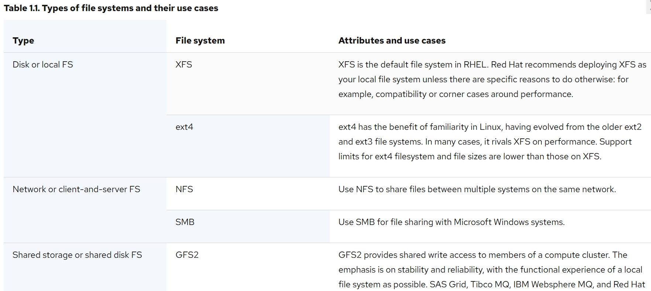
EXT4 (4th Extended File System) - It supports files and filesystems of up to 16TB in size and caps the maximum filename length to 255 bytes.
Highlights of EXT4:
Allocation Improvements – The Ext4 filesystem improves reads and write performance through efficient allocation of storage blocks before writing them to disk.
Timestamp Improvements, Faster File System Checks, Online Defragmentation, Journal Checksums
Local file systems are file systems that run on a single, local server and are directly attached to storage.
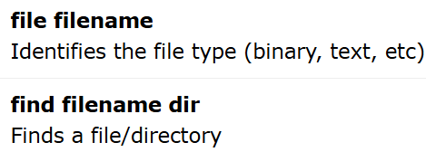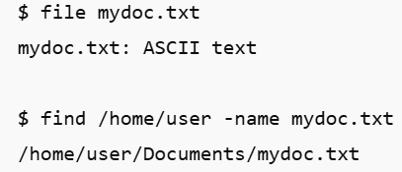
Disk Partitioning:
Disk partitioning is the process of dividing a hard drive or SSD into separate sections (called partitions) so that your computer can manage and store data more efficiently.
Organize data (OS files, personal files, backups, etc.)
Install multiple operating systems (e.g., Windows + Linux)
Improve performance and manage disk errors better
Separate system and user files (safe during OS reinstall)
Backup & Recovery becomes easier
A partition scheme is the method your computer uses to organize and manage partitions on a storage device (like an HDD or SSD). It defines:
- Where the partitions start and end. How many partitions you can have. How the system boots (BIOS vs UEFI)
Disk partitions differ depending on the partitioning scheme used:
- MBR (Master Boot Record) – Older system, supports up to 2 TB and 4 primary partitions.
- GPT (GUID Partition Table) – Newer system, supports much larger disks and more partitions.
Types of Partitions:
1. ✅ Primary Partition
Main partitions that store your OS and important files.
You can have up to 4 primary partitions on an MBR disk.
In GPT, there is no strict limit (you can have many).
One of the primary partitions can be marked as active (bootable) to load the OS.
Example:
In Windows, the C: drive is usually a primary partition that holds the operating system.
2. 🧩 Extended Partition (Only in MBR)
An Extended Partition is a special partition type created only when using MBR (Master Boot Record) partitioning scheme.
- MBR allows only 4 primary partitions.
- If you need more than 4, one of those 4 must be turned into an Extended Partition.
- This extended partition acts like a container.
- It cannot store data directly.
- Inside it, you create Logical Partitions, which can hold your data.
3. 📂 Logical Partition (Inside Extended)
Created inside the extended partition.
Used for storing personal data, files, games, documents, etc.
You can create multiple logical partitions inside one extended partition.
Each logical partition gets its own drive letter in Windows (e.g., D:, E:).
Normally cannot be used as boot partitions (like C:).
However, Linux can boot from logical partitions with GRUB.
Example:
You might have D: for music, E: for movies, etc.—all logical partitions.
4. 🚀 EFI System Partition (ESP) (Only in GPT/UEFI systems)
- Used on modern systems with UEFI firmware.
- Contains bootloader files and essential data to start the OS.
- Usually formatted in FAT32 and around 100–300 MB in size.
This partition is required for booting UEFI-based systems like modern Windows or Linux.
5. 🧠 Swap Partition (Linux only)
A swap partition is a special area on your hard disk used as extra memory (RAM) by the Linux operating system when your physical RAM is full.
Think of it as a backup RAM on your hard disk.
Real-Life Analogy
Imagine your desk is your RAM, and you're working with books (applications).
When your desk is full, you move some books to a nearby shelf (swap space).
- 📚 Desk (RAM) = Fast but limited
- 📁 Shelf (Swap) = Slower but more space
So when RAM is full, Linux temporarily moves less-used data to swap.
Why Is Swap Used?
- ✅ When RAM is full – Keeps your system from crashing.
- ✅ For background processes – Moves idle apps to swap to free up RAM.
- ✅ For hibernation – Swap stores your RAM contents before turning off.
- ✅ Smooth multitasking – Helps manage multiple programs efficiently.
Hibernation means your RAM is copied to swap before shutdown, so swap must be at least as big as RAM.
Type | Description
Swap Partition | A dedicated disk partition used for swapping
Swap File | A special file on an existing partition used as swap

You have 4 GB RAM
- You open multiple tabs in Chrome, VS Code, and a video editor.
- RAM fills up.
- Linux moves background tabs to swap.
- Your system keeps running smoothly instead of freezing.
Swap is used for memory paging in Linux specially during System Hibernation. The current stage of System is written to Swap when the system is paused (Hibernate) at a point of time.
A System which will never go hibernation needs a swap space equal to the size of its RAM.
Acts as virtual memory when RAM is full.
sss
Size is typically 1–2 times the size of your RAM.
Partition Type | Scheme Used | Can Store Data | Bootable? | Notes
Primary | MBR/GPT | ✅ Yes | ✅ Yes | Max 4 in MBR
Extended | MBR only | ❌ No | ❌ No | Container for logical partitions
Logical | MBR only | ✅ Yes | ❌ No | Inside extended partition
EFI System (ESP) | GPT only | ⚠️ System files | ✅ Yes | Needed for UEFI boot
Swap | Linux only | ⚠️ No user data | ❌ No | Acts as virtual memory
Recovery | Any | ⚠️ System tools | ❌ No | Used to restore OS

Logical Volume Management:
LVM is a complex partitioning used in Large Storage Installation. The LVM structure overlays the actual physical disk partitioning.
It lets you combine multiple disks or partitions into one large storage pool, then create virtual partitions from that pool.
• Can't use LVM unless LVM tools (lvm2) are installed
• Resize operations must be done carefully
• Backup important data before shrinking volumes
Use of LVM:
Feature | Explanation
🔄 Resize volumes easily | Increase/decrease size without rebooting
➕ Add disks anytime | Expand storage by adding new drives to the VG
🧱 Flexible partitioning | No need to worry about fixed partition sizes
🔒 Snapshots | Create backups of volumes at specific points
📦 Combine small disks | Make one large storage pool from many small disks

How LVM Works:
Step 1: Physical Volumes (PV)
- These are your actual disks or partitions
- You tell LVM: "Hey, this disk is yours to use"
Step 2: Volume Group (VG)
- Combine one or more PVs into a Volume Group
- A Volume Group is like your entire water system
Now my_vg might have, say, 500 GB total space.
Step 3: Logical Volumes (LV)
- Create Logical Volumes from the Volume Group
- These are like virtual partitions
This creates a 100 GB logical volume named my_data inside my_vg.
Step 4: Format & Mount
- Format the LV like any disk and mount it
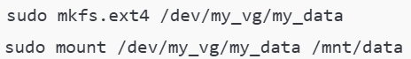
Before a file system (like ext4, xfs, or btrfs) can be used, the disk must be partitioned. Imagine your disk (/dev/sda) is 1TB. You can divide it like:
- /dev/sda1 – 100 GB → File system: ext4 → Mounted as /boot
- /dev/sda2 – 500 GB → File system: xfs → Mounted as /home
- /dev/sda3 – 400 GB → File system: ext4 → Mounted as /
Each partition is like a container, and each container needs a file system to organize its data.
The df Command
The first way to manage your partition space is with the df (disk free) command. The command df -k (disk free) displays the disk space usage in kilobytes,

You can use the -h (human readable) option to display the output in a format that shows the size in easier-to-understand notation.
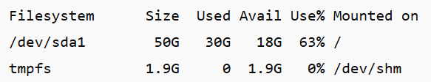

The du Command
The du (disk usage) command enables you to specify directories to show disk space usage on a particular directory.
This command is helpful if you want to determine how much space a particular directory is taking. The following command displays number of blocks consumed by each directory.
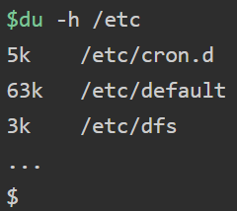
Concept | Disk Partitioning | File System Management
Role | Divides disk into usable sections | Organizes data inside partitions
Example Tool | fdisk, parted, gparted | mkfs, fsck, mount
Output | /dev/sda1, /dev/sdb2, etc. | ext4, xfs, btrfs, etc.
Link | You format partitions with file systems | You manage file systems on partitions

3. Memory Management (RAM):
Memory management system is designed to efficiently manage memory usage, allowing processes to access and use memory they require while preventing them from accessing memory they do not own. To keep track of used memory space by processes. To minimize fragmentation issues.
Type | What It Is | Who Sees It
Logical Address | Address used by the program | Seen by the program (user)
Physical Address | Actual location in RAM (hardware) | Seen by the hardware (RAM/CPU)

Logical and Physical Address Space:
Address: Computers need addresses to read/write data in memory.
When a program runs, it uses addresses to find its variables and code.

Logical Address Space: It is also known as a Virtual address. A logical address can be changed. Generated by the CPU when a program runs. It’s like a temporary address used by your application. It doesn’t point to real RAM directly. Managed by the Operating System (OS) and Memory Management Unit (MMU).
Example:
Your Python script stores a variable. It might be assigned logical address 0x001234. But this address is not the real address in RAM
Physical Address:
This is the real address in physical RAM (hardware) and cannot be changed. The computer must convert the logical address into this real location to access data. The Memory Management Unit (MMU) translates the logical address to a physical address.
Example:
The logical address 0x001234 might actually correspond to physical address 0xABCD1234 in RAM.
Logical to physical address conversion:
Step | What Happens
1️⃣ | Program generates logical address
2️⃣ | CPU sends it to the MMU
3️⃣ | MMU looks in page table
4️⃣ | Finds corresponding physical address
5️⃣ | Accesses that part of RAM

Memory Allocation
Memory allocation is a process of assigning memory to a process or program. It controls how memory is allocated and deallocated to processes, which is key to both performance and stability. Two main methods for memory allocation: static and dynamic.

Static Memory Allocation(Loading):
• Memory is given before the program runs.
• The size cannot be changed.
• Used for fixed things
Static Loading is basically loading the entire program into a fixed address. It requires more memory space. Static memory allocation is done at compile-time, where memory allocation for a program is fixed and cannot be changed during runtime. memory is allocated in program's data section or stack segment. data section contains global variables and static variables, while stack segment contains local variables.
Dynamic Memory Allocation
• Memory is given while the program is running.
• You can ask for more or give it back when done.
• Used for changing things, like scores, user input, etc.
Dynamic loading program routines into memory only when they are needed. This saves memory by not loading unused routines. The routines remain on disk in relocatable(can be loaded at any memory location) format until called. Dynamic memory allocation is done during runtime, where memory allocation for a program can be dynamically adjusted based on program's requirements. kernel provides various system calls such as malloc(), calloc(), and realloc() to dynamically allocate memory. These functions allocate memory from heap segment of program's address space.
Virtual Memory
• RAM (Random Access Memory) is fast, short-term memory used by your computer to run programs.
• But RAM is limited. What if the system needs more memory than is physically available?
Virtual memory is a memory management technique that allows a program to use more memory than is physically available in system. In Linux, virtual memory is implemented using a combination of hardware and software. hardware component is Memory Management Unit (MMU), which is responsible for translating virtual memory addresses to physical memory addresses. software component is kernel's Virtual Memory Manager (VMM), which manages allocation and deallocation of virtual memory.
Example: have a program that tries to use 6 GB of memory, but your computer has only 4 GB of RAM.
- Linux gives the program the full 6 GB of virtual memory, even though only 4 GB of real memory (RAM) exists.
- It loads the most important 4 GB into the RAM — the parts the program is using right now.
- The other 2 GB (not being used at the moment) are moved to a part of your hard disk, called swap space.
- Later, if the program needs something from that 2 GB, Linux:
  - Moves something out of RAM to swap, and
  - Brings that needed 2 GB chunk back into RAM.
This back-and-forth movement is called paging or swapping.
This is handled by
  - MMU: Translates fake (virtual) memory to real memory
  - Kernel (VMM): Decides what goes in RAM and what stays in swap
Even if the RAM is small, the computer can still work with many programs by swapping them in and out.
Memory Mapping
Instead of flipping through every page, you use the table to jump directly to the chapter you want. Similarly, memory mapping lets a program jump directly to the part of a file it needs.
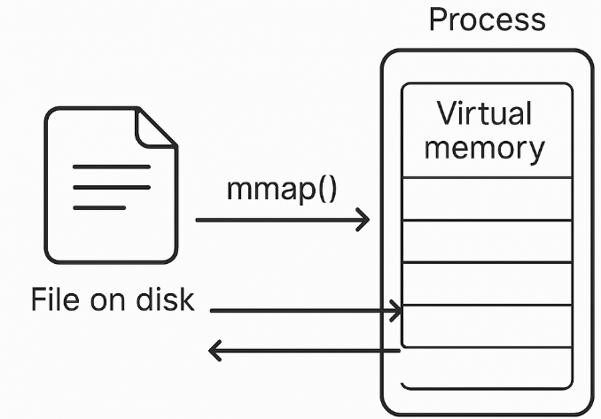
In memory mapping, the contents of a file are linked directly into the virtual address space of a process. Memory mapping is a technique that allows a process to access a file's contents as if it were part of a process’s memory. In Linux, memory mapping is implemented using mmap() system call. mmap() system call maps a file into a process's virtual memory address space, allowing process to read and write to file's contents as if it were part of its own memory. Memory mapping is commonly used in applications such as databases and multimedia players, where large files need to be accessed efficiently.
Shared Memory:
It is one of the fastest ways for processes to communicate (this is called Inter-Process Communication, or IPC). Shared memory is a technique that allows multiple processes to access the same portion of memory. Shared memory is a way for two or more programs (or processes) to talk to each other and share data very quickly.
it gives multiple programs access to the same area in memory, so they can read and write data directly without copying or sending messages
It is useful when:
Processes need to share large amounts of dataSpeed is important (e.g., in real-time systems, databases, etc.)
shmget() – to create shared memory
shmat() – to attach it to a process
shmdt() – to detach it
shmctl() – to control (or remove) it
Imagine you have a calculator app and a graphing app.
The calculator solves equations. The graphing app draws the result.
Instead of saving the result to a file, the calculator just puts the answer in shared memory, and the graphing app picks it up instantly.
Because all processes can change the data at the same time, they need to be careful to not overwrite each other’s work. This is usually handled using something called semaphores or mutexes (like a traffic signal).
Swapping:
Swapping is a memory management technique used in Linux when your RAM (memory) is full. it temporarily moves programs or data from RAM to a special area on the hard disk called swap space.
swapping is implemented using a combination of hardware and software. hardware component is disk, which is used as swap space. software component is kernel's Swapping Manager, which manages swapping process. When system's memory is low, Swapping Manager selects pages of memory to swap out to disk, freeing up memory for other processes.
Kernel Memory Management
The Linux kernel itself also requires memory management, and it uses a separate set of memory management techniques to manage kernel memory. Kernel memory is used to store data structures and code required by kernel to operate. kernel uses techniques like memory mapping, page caching, and memory allocation to manage kernel memory.
Memory Protection
Memory protection is another critical aspect of memory management in Linux. Memory protection techniques prevent processes from accessing memory they are not authorized to access. MMU implements memory protection by using page tables, which map virtual memory addresses to physical memory addresses and track permissions for each memory page.
Memory Management Techniques
Memory management techniques are methods used by an operating system to efficiently allocate, utilize, and manage memory resources for processes.
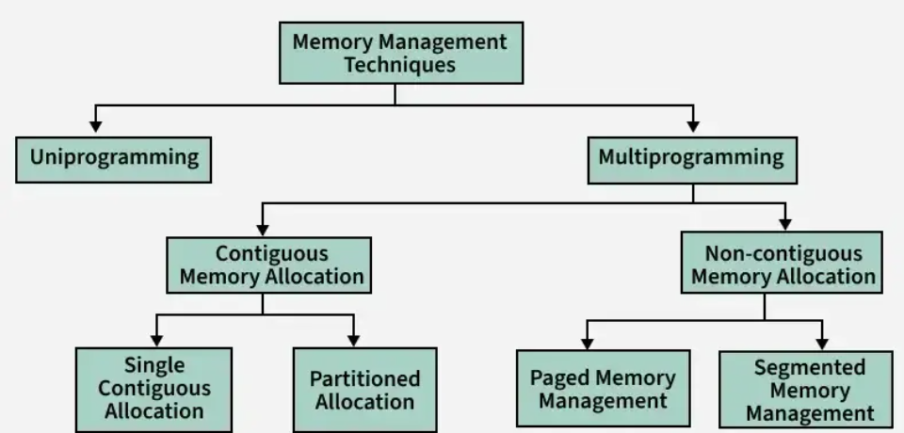
Memory Management with Monoprogramming (Without Swapping)
This is the simplest memory management approach the memory is divided into two sections: One part of the operating system. The second part of the user program
- the operating system keeps track of the first and last location available for the allocation of the user program. The operating system is loaded either at the bottom or at top
Multiprogramming with Fixed Partitions (Without Swapping)
- A memory partition scheme with a fixed number of partitions was introduced to support multiprogramming. this scheme is based on contiguous allocation
- Each partition is a block of contiguous memory
- Memory is partitioned into a fixed number of partitions.
- Each partition is of fixed size
Partition Table : Once partitions are defined operating system keeps track of the status of memory partitions it is done through a data structure called a partition table.
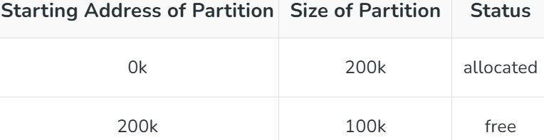
Contiguous Memory Allocation
Contiguous memory allocation is a memory management method where each process is given a single, continuous block of memory. This means all the data for a process is stored in adjacent memory locations.
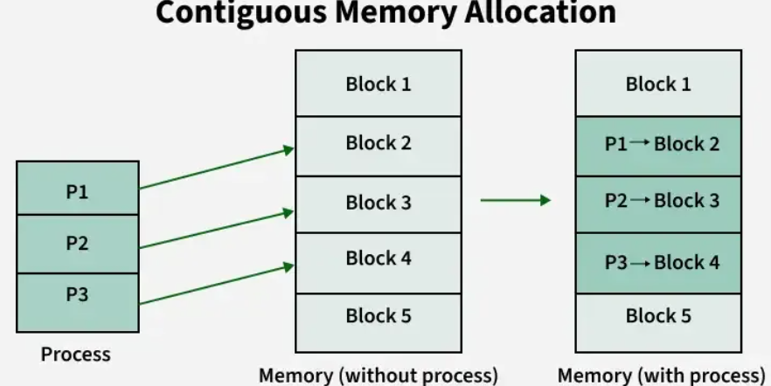
Non-Contiguous Memory Allocation
This method allows processes to be broken into smaller parts, which are placed in different, non-adjacent memory locations. Techniques for non-contiguous memory allocation include:
- Paging: The process is divided into fixed-size blocks called "pages," and the memory is divided into blocks of the same size called "frames." The operating system keeps a page table to map logical pages to physical frames.
- Segmentation: The process is divided into segments of varying sizes, such as code, data, stack, etc. The operating system maintains a segment table to map logical segments to physical memory.
Fragmentation:
Fragmentation is defined as when the process is loaded and removed after execution from memory, it creates a small free hole. These holes can not be assigned to new processes because holes are not combined or do not fulfill the memory requirement of the process. In the operating systems two types of fragmentation are:
- Internal fragmentation: Happens when fixed-sized memory blocks are allocated to processes larger than needed, leaving unused space within the allocated block. For example, if a process needs 2MB of memory but is allocated a 3MB block, 1MB is wasted.
- External fragmentation: Occurs when free memory is scattered in small blocks across the system, making it impossible to allocate a large contiguous block to a process, even though the total free memory is enough.
Placement Algorithms: When allocating memory, the OS uses placement algorithms to decide which free block should be assigned to a process:
First Fit: Allocates the first available partition large enough to hold the process.
Best Fit: Allocates the smallest available partition that fits the process, reducing wasted space.
Worst Fit: Allocates the largest available partition, leaving the largest remaining space.
Next Fit: Similar to First Fit but starts searching for free memory from the point of the last allocation.

