Cab Booking
Online Cab Booking System using MERN Stack

1. INTRODUCTION
The Cab Booking System is a web-based application developed using the MERN Stack (MongoDB, Express.js, React.js, and Node.js). The main objective of this project is to provide a simple, secure, and user-friendly platform for booking cabs online. Users can register, log in securely using JWT authentication, book a cab by entering pickup and drop locations, view their bookings, and cancel bookings when required.
The system also includes an Admin Dashboard, where administrators can view all booking requests and manage them by accepting or rejecting bookings. All user and booking information is stored securely in MongoDB Atlas, while RESTful APIs are used for communication between the frontend and backend.
The application provides a responsive interface developed using React.js, with Node.js and Express.js handling the backend operations. This project demonstrates the implementation of a complete full-stack web application with secure authentication, booking management, role-based access, and efficient database connectivity, making it suitable for modern online cab reservation services.

2. PROBLEM STATEMENT
Traditional cab booking methods require users to make phone calls or visit booking centers, which can be time-consuming and inconvenient. Managing bookings manually may also lead to delays, errors, and difficulty in tracking booking status.
The objective of this project is to develop a secure and user-friendly online cab booking system that allows users to register, log in, book cabs, view their bookings, and cancel bookings when required. The system also provides an Admin Dashboard where administrators can view all booking requests and accept or reject them efficiently. This improves booking management, reduces manual effort, and provides a better experience for both users and administrators.

3. OBJECTIVES
The main objectives of the Cab Booking System are:
- To provide a simple and user-friendly online cab booking platform.
- To allow users to register and log in securely using JWT authentication.
- To enable users to book cabs by entering pickup and drop locations.
- To allow users to view and cancel their bookings.
- To provide an Admin Dashboard for managing all booking requests.
- To store user and booking information securely in MongoDB Atlas.
- To improve the efficiency of cab booking through a web-based application.

4. SCOPE OF THE PROJECT
The Cab Booking System is designed to simplify the cab booking process through an online platform. It enables users to register, log in, and book cabs from any location using a web browser. Users can view their booking history and cancel pending bookings whenever required.
The system also provides an Admin Dashboard where administrators can monitor all bookings and update their status by accepting or rejecting requests. The project demonstrates a complete MERN Stack application with secure authentication, database connectivity, and role-based access control. It can be further enhanced by integrating online payment, GPS tracking, driver management, and real-time notifications.

5. EXISTING SYSTEM
In the traditional cab booking system, users usually book cabs through phone calls or by visiting a booking office. This process is time-consuming and requires manual management of customer information and bookings. There is no efficient way to track booking status, maintain booking history, or provide real-time updates.
These limitations may result in delays, booking errors, and reduced customer satisfaction.

6. PROPOSED SYSTEM
The proposed Cab Booking System is a web-based application developed using the MERN Stack. It provides a secure and efficient platform where users can register, log in, and book cabs online. Users can also view their booking history and cancel pending bookings.
The system includes an Admin Dashboard that allows administrators to manage all booking requests by accepting or rejecting them. Secure JWT authentication, MongoDB Atlas database connectivity, and RESTful APIs ensure reliable and efficient system performance.

7. SOFTWARE REQUIREMENTS
The software requirements for developing the Cab Booking System are as follows:
Software | Version/Tool
Operating System | Windows 10/11
Frontend | React.js (Vite)
Backend | Node.js, Express.js
Database | MongoDB Atlas
API Testing | Postman
Code Editor | Visual Studio Code
Browser | Google Chrome
Version Control | Git & GitHub
Runtime Environment | Node.js

8. HARDWARE REQUIREMENTS
The hardware requirements for developing the Cab Booking System are:
Hardware | Specification
Processor | Intel Core i3 or above
RAM | 4 GB or above
Hard Disk | 20 GB Free Space
Internet | Required
Keyboard & Mouse | Standard Input Devices

9. TECHNOLOGY STACK
The Cab Booking System is developed using the MERN Stack and related technologies.

Frontend
- React.js
- Vite
- HTML5
- CSS3
- JavaScript
- Axios

Backend
- Node.js
- Express.js

Database
- MongoDB Atlas
- Mongoose

Authentication
- JSON Web Token (JWT)

Development Tools
- Visual Studio Code
- Git
- GitHub
- Postman

10. SYSTEM ARCHITECTURE
The Cab Booking System follows a three-tier architecture.
Presentation Layer
- React.js User Interface
- Login Page
- Home Page
- Book Cab Page
- My Bookings Page
- Admin Dashboard
Application Layer
- Node.js
- Express.js
- REST APIs
- JWT Authentication
- Booking Controller
- Authentication Controller
Database Layer
- MongoDB Atlas
- User Collection
- Booking Collection
The user interacts with the React frontend. API requests are sent to the Express server, where authentication and booking operations are performed. Finally, the data is stored and retrieved from MongoDB Atlas.

11. DATABASE DESIGN
The project contains two main collections.

User Collection
Field | Type
_id | ObjectId
name | String
email | String
password | String
role | String

Booking Collection
Field | Type
_id | ObjectId
userId | ObjectId
pickupCity | String
dropCity | String
fare | Number
status | String
createdAt | Date
The User collection stores the authentication details of registered users. The Booking collection stores cab booking details along with the current booking status such as Pending, Accepted, Rejected, or Cancelled.

12. FRONTEND IMPLEMENTATION
The frontend of the Cab Booking System is developed using React.js with Vite. It provides a responsive and user-friendly interface for users and administrators to interact with the application. Axios is used to communicate with the backend REST APIs.

Login Module

Description
The Login module allows registered users to authenticate using their email and password. After successful login, a JWT token and User ID are stored in the browser's local storage. The user is then redirected to the Home page.

Code Snippet
const response = await API.post("/auth/login", {
email,
password,
});

localStorage.setItem("token", response.data.token);
localStorage.setItem("userId", response.data.user._id);

navigate("/home");

Explanation
- Sends login credentials to the backend.
- Receives the JWT token after successful authentication.
- Stores the token and User ID in localStorage.
- Redirects the user to the Home page.

Home Module

Description
The Home page acts as the main dashboard after login. It provides navigation to Book Cab, My Bookings, and Admin Dashboard pages through a navigation bar.

Book Cab Module

Description
The Book Cab module allows authenticated users to enter the Pickup City, Drop City, and Fare to create a cab booking request.

Code Snippet
await api.post(
"/booking/book",
{
pickupCity,
dropCity,
fare,
},
{
headers: {
Authorization: `Bearer ${token}`,
},
}
);

Explanation
- Collects booking details from the user.
- Sends the booking request to the backend API.
- Includes the JWT token in the Authorization header.
- Stores the booking details in MongoDB Atlas.

My Bookings Module

Description
The My Bookings page displays all bookings made by the logged-in user. Users can also cancel bookings that are still in the Pending state.

Code Snippet
const response = await api.get(`/booking/my/${userId}`);
setBookings(response.data);

Explanation
- Retrieves booking details of the logged-in user.
- Displays booking information such as pickup city, drop city, fare, and booking status.
- Allows cancellation of pending bookings.

Admin Dashboard Module

Description
The Admin Dashboard allows administrators to view and manage all cab bookings. Admins can accept or reject booking requests.

Code Snippet
await api.put(`/booking/accept/${id}`);
await api.put(`/booking/reject/${id}`);

Explanation
- Displays all booking requests.
- Updates booking status as Accepted or Rejected.
- Refreshes the booking list after every update.

13. BACKEND IMPLEMENTATION
The backend of the Cab Booking System is developed using Node.js and Express.js. It handles user authentication, booking management, database operations, and communication with the frontend through RESTful APIs.

Server Configuration (server.js)

Description
The server is configured using Express.js. It connects to MongoDB Atlas, enables CORS, loads environment variables, and registers authentication and booking routes.

Code Snippet
app.use("/api/auth", authRoutes);
app.use("/api/booking", bookingRoutes);

mongoose.connect(process.env.MONGO_URI);

app.listen(5000, () => {
console.log("Server running on port 5000");
});

Explanation
- Connects to MongoDB Atlas.
- Registers Authentication and Booking APIs.
- Starts the Express server on port 5000.

Authentication Routes

Description
Authentication routes allow users to register and log in.

Code Snippet
router.post("/register", registerUser);
router.post("/login", loginUser);

Explanation
- Registers new users.
- Authenticates existing users.
- Returns a JWT token after successful login.

Booking Routes

Description
Booking routes manage all cab booking operations.

Code Snippet
router.post("/book", protect, bookCab);
router.get("/my/:userId", getMyBookings);
router.put("/cancel/:id", cancelBooking);
router.put("/accept/:id", acceptBooking);
router.put("/reject/:id", rejectBooking);
router.get("/all", getAllBookings);

Explanation
- Creates a new booking.
- Retrieves user bookings.
- Cancels pending bookings.
- Accepts or rejects bookings.
- Displays all bookings for the administrator.

Authentication Controller

Description
The Authentication Controller processes user registration and login requests. It validates user credentials and generates JWT tokens.

Features
- User Registration
- User Login
- Password Validation
- JWT Token Generation

Booking Controller

Description
The Booking Controller manages all booking-related operations.

Features
- Create Booking
- Get User Bookings
- Cancel Booking
- Accept Booking
- Reject Booking
- Display All Bookings

User Model

Description
The User Model stores user information.

Fields
Field | Type
name | String
email | String
password | String
role | String

Booking Model

Description
The Booking Model stores cab booking details.

Fields
Field | Type
userId | ObjectId
pickupCity | String
dropCity | String
fare | Number
status | String
createdAt | Date

JWT Authentication Middleware

Description
JWT Middleware verifies the authentication token before allowing users to access protected APIs.

Code Snippet
const token = req.headers.authorization.split(" ")[1];

const decoded = jwt.verify(token, process.env.JWT_SECRET);

req.user = decoded;

next();

Explanation
- Reads the JWT token from the Authorization header.
- Verifies the token.
- Identifies the authenticated user.
- Protects secure API endpoints.

14. API ENDPOINTS
The following REST APIs are implemented in the Cab Booking System.

Authentication APIs
Method | Endpoint | Description
POST | /api/auth/register | Register a new user
POST | /api/auth/login | Login user

Booking APIs
Method | Endpoint | Description
POST | /api/booking/book | Book a cab
GET | /api/booking/my/:userId | View user bookings
PUT | /api/booking/cancel/:id | Cancel booking
PUT | /api/booking/accept/:id | Accept booking
PUT | /api/booking/reject/:id | Reject booking
GET | /api/booking/all | View all bookings

15. PROJECT FOLDER STRUCTURE
cab-booking/
│
├── client/
│ ├── src/
│ │ ├── components/
│ │ ├── pages/
│ │ ├── services/
│ │ ├── App.jsx
│ │ └── main.jsx
│
├── server/
│ ├── controllers/
│ ├── middleware/
│ ├── models/
│ ├── routes/
│ ├── config/
│ ├── server.js
│ └── package.json
│
└── README.md

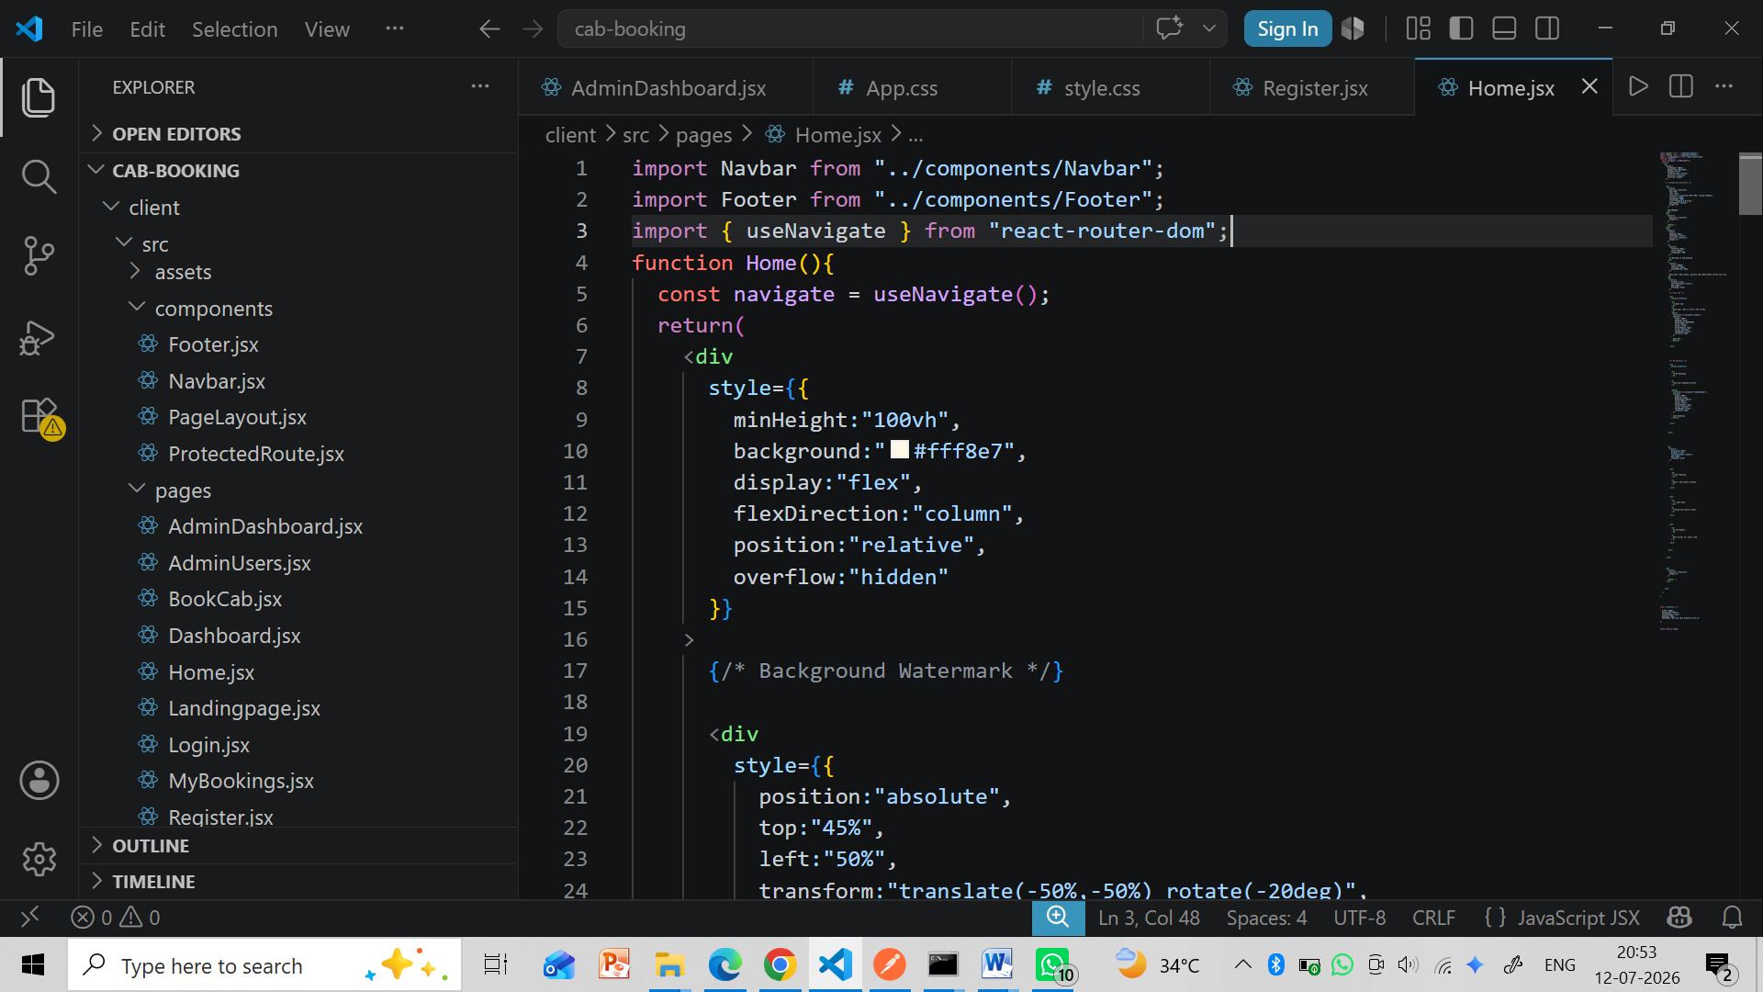

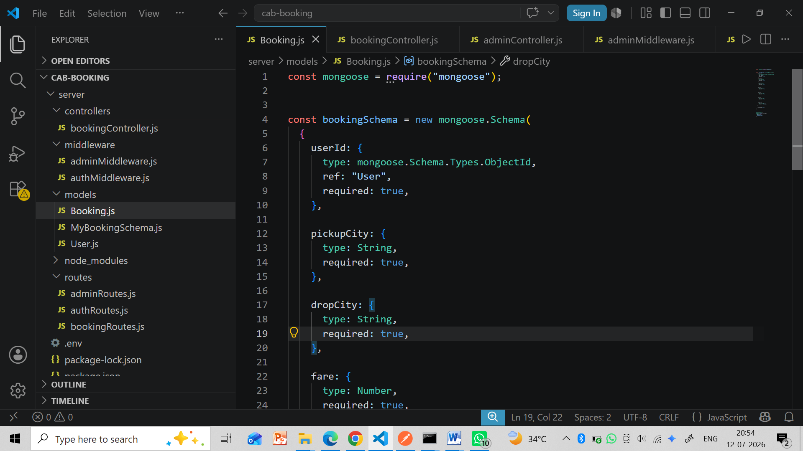

16. TESTING
The application was tested using different scenarios to ensure proper functionality.
Test Case | Expected Result | Status
User Registration | User registered successfully | Passed
User Login | Login successful | Passed
Book Cab | Booking created successfully | Passed
View My Bookings | Displays user bookings | Passed
Cancel Booking | Booking status changed to Cancelled | Passed
Admin Accept Booking | Status changed to Accepted | Passed
Admin Reject Booking | Status changed to Rejected | Passed

17. OUTPUT SCREENSHOTS
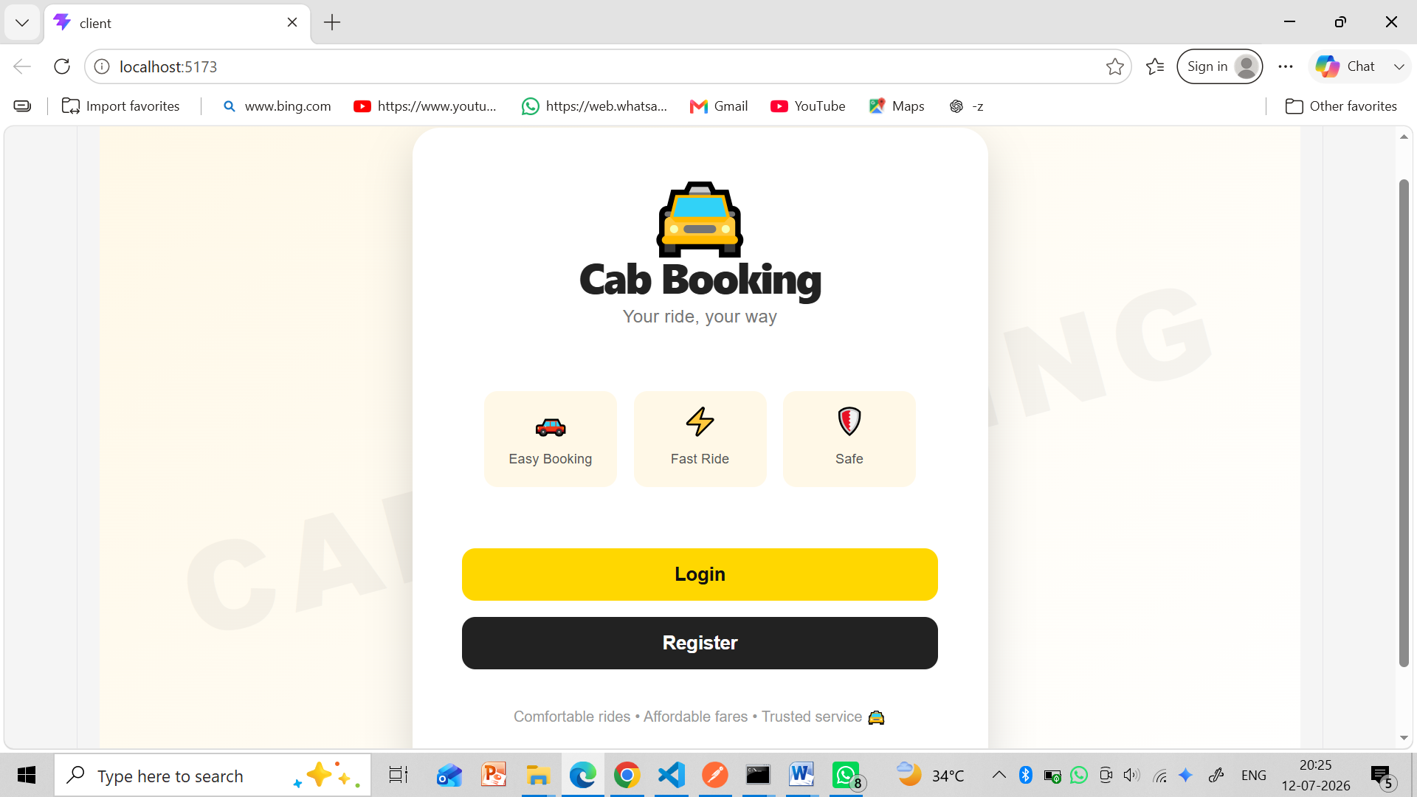
- Login Page
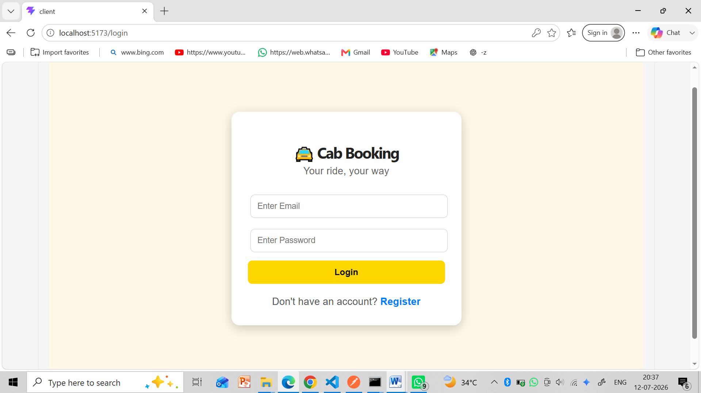
- Register page
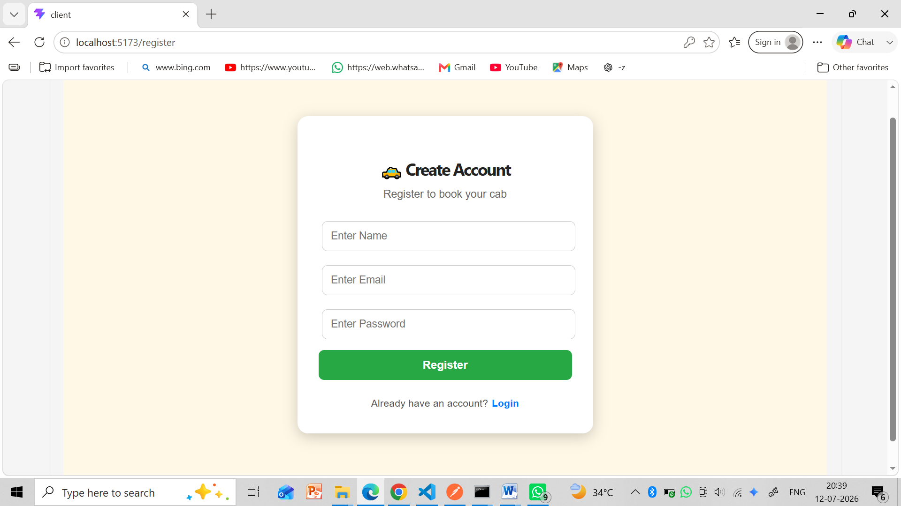

- Home page
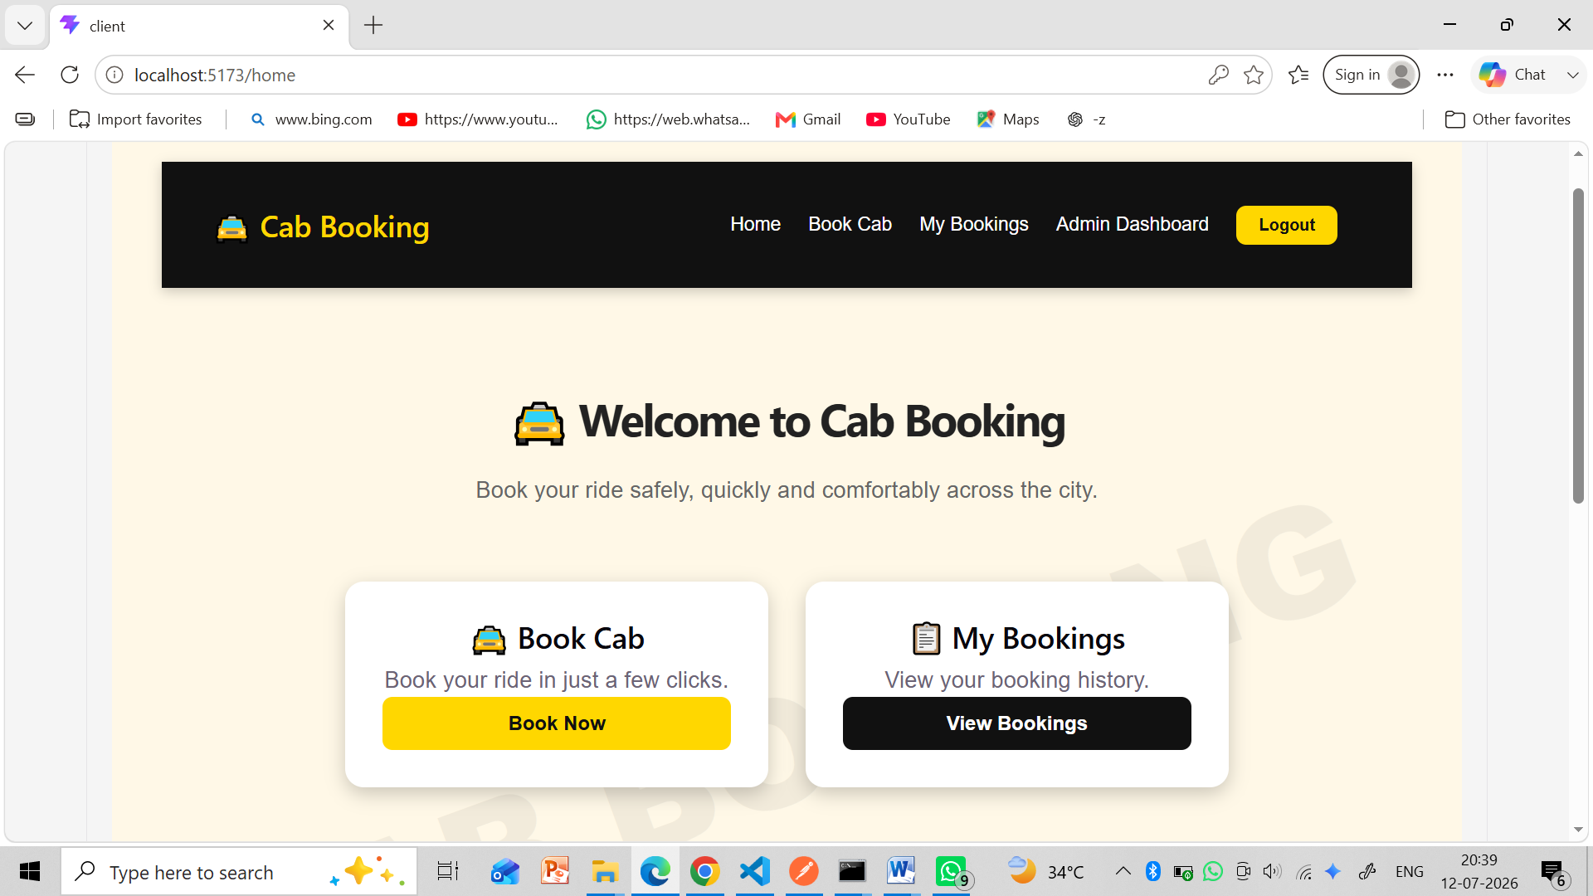
- Book Cab page
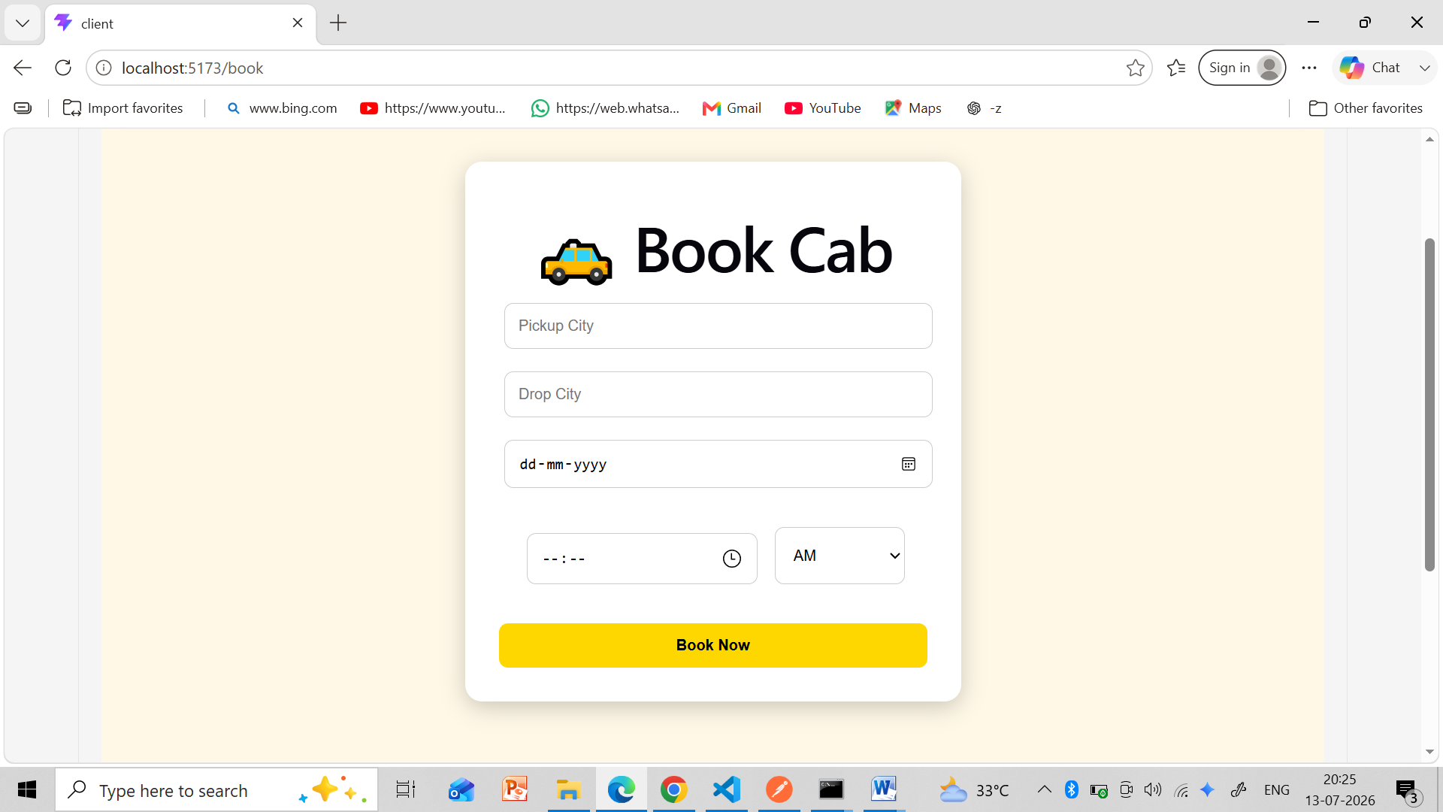
- MyBooking page
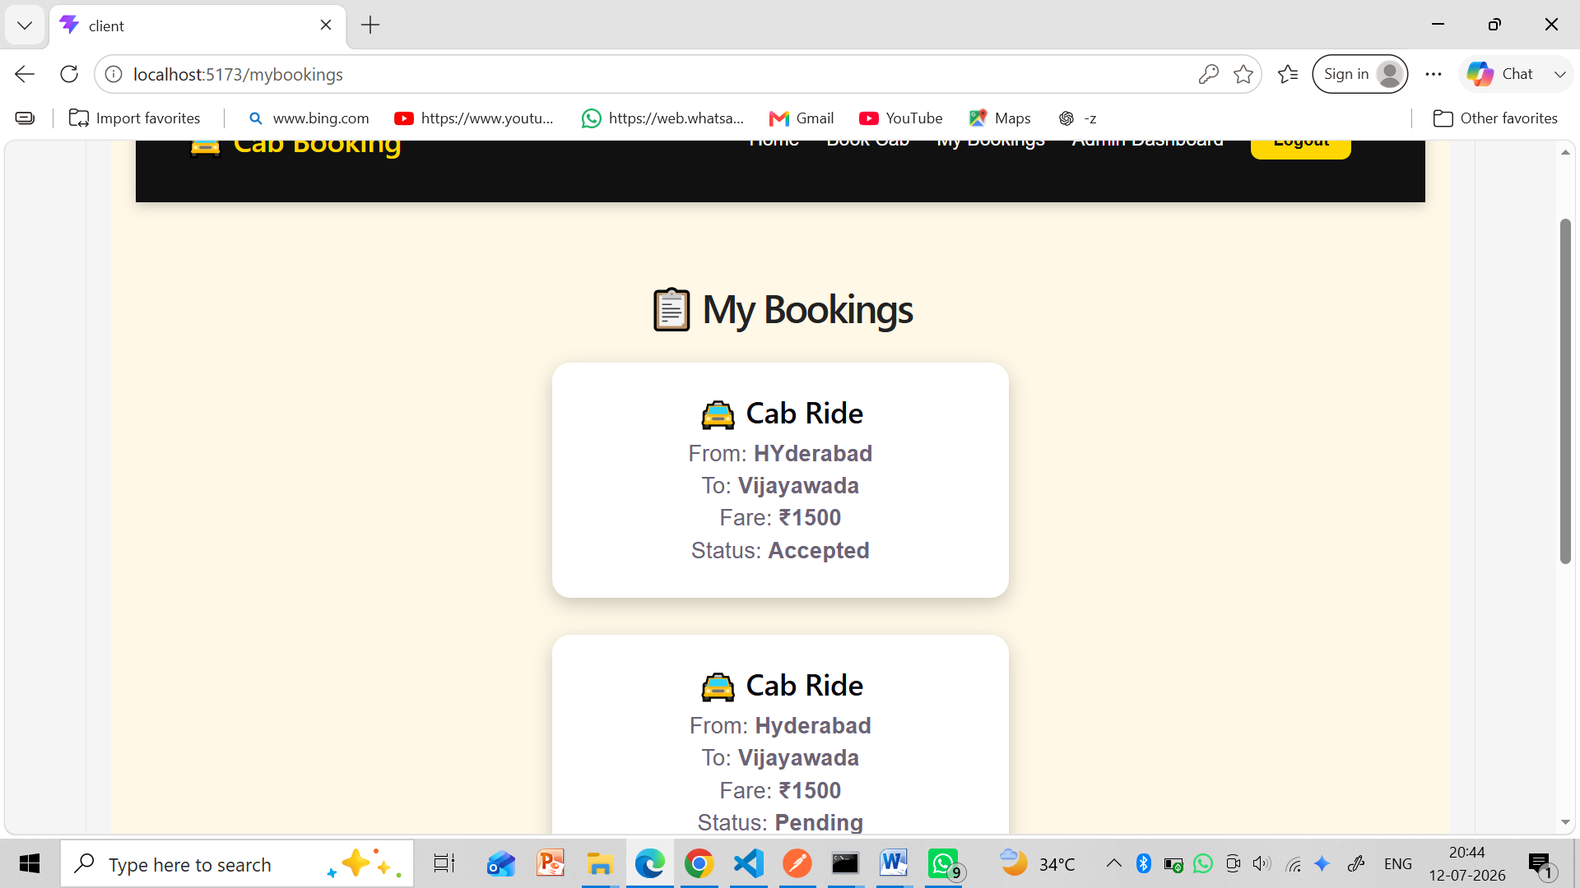

- Admin Page
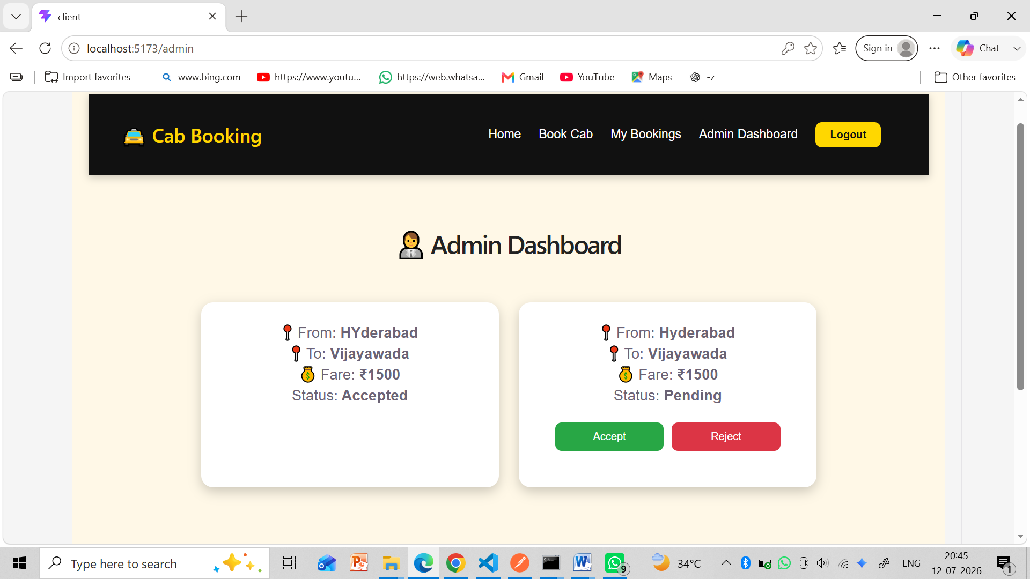

18. FUTURE ENHANCEMENTS
The following features can be added in future versions:
- Online payment integration.
- GPS-based live cab tracking.
- Driver registration and management.
- Fare calculation based on distance.
- Email and SMS notifications.
- Booking history reports.
- Mobile application support.
- Google Maps integration.

19. CONCLUSION
The Cab Booking System is a full-stack web application developed using the MERN Stack (MongoDB, Express.js, React.js, and Node.js). The application provides a secure and efficient platform for online cab booking with JWT authentication and MongoDB Atlas database connectivity. Users can register, log in, book cabs, view their bookings, and cancel pending bookings. The administrator can manage all bookings through the Admin Dashboard by accepting or rejecting requests.
The project successfully demonstrates full-stack web development concepts, RESTful APIs, authentication, database management, and role-based access control. It provides a strong foundation for developing advanced online transportation management systems.

