**Ex.1 Creating Microservices for account and loan**

**Account.java**

package org.example.account_microservice;

class Account{

private int number;

public int getNumber() {

return number;

}

public void setNumber(int number) {

this.number = number;

}

public String getType() {

return type;

}

public void setType(String type) {

this.type = type;

}

public int getBalance() {

return balance;

}

public void setBalance(int balance) {

this.balance = balance;

}

private String type;

private int balance;

public Account(){};

public Account(int number,String type,int balance){

this.balance=balance;

this.type=type;

this.number=number;

}

public int num(){

return number;

}

}

**AccountController.java**

package org.example.account_microservice;

import org.springframework.beans.factory.annotation.Autowired;

import org.springframework.web.bind.annotation.*;

@RestController

public class AccountController {

@Autowired

AccountService service;

@GetMapping("/accounts/getaccount/{number}")

public Account getaccount(@PathVariable int number){

return service.getacc(number);

}

@PostMapping("/accounts/addacc")

public String addaccount(@RequestBody Account acc){

return service.addaccount(acc);

}

}

**AccountMicroserviceApplication.java**

package org.example.account_microservice;

import org.springframework.boot.SpringApplication;

import org.springframework.boot.autoconfigure.SpringBootApplication;

@SpringBootApplication

public class AccountMicroserviceApplication {

public static void main(String[] args) {

SpringApplication.run(AccountMicroserviceApplication.class, args);

}

}

**AccountService.java**

package org.example.account_microservice;

import org.springframework.context.annotation.Bean;

import org.springframework.stereotype.Controller;

import org.springframework.stereotype.Service;

import java.util.ArrayList;

import java.util.List;

import java.util.Map;

@Service

public class AccountService {

List<Account> list=new ArrayList<>();

public String addaccount(Account acc){

list.add(acc);

return "Account added successfully";

}

public String deleteacc(Account acc){

list.remove(acc);

return "Account removed successfully";

}

public Account getacc(int number){

for(Account accounts:list){

if(accounts.num()==number){

return accounts;

}

}

return null;

}

}

**For loan folder**

**Account.java**

package org.example.loan_microservice;

public class Account {

private int number;

private String type;

private int loan;

private int emi;

private int tenure;

public Account(){};

public Account(int number, String type, int loan, int emi, int tenure) {

this.number = number;

this.type = type;

this.loan = loan;

this.emi = emi;

this.tenure = tenure;

}

public int getNumber() {

return number;

}

public void setNumber(int number) {

this.number = number;

}

public String getType() {

return type;

}

public void setType(String type) {

this.type = type;

}

public int getLoan() {

return loan;

}

public void setLoan(int loan) {

this.loan = loan;

}

public int getEmi() {

return emi;

}

public void setEmi(int emi) {

this.emi = emi;

}

public int getTenure() {

return tenure;

}

public void setTenure(int tenure) {

this.tenure = tenure;

}

}

**AccountController.java**

package org.example.loan_microservice;

import org.springframework.beans.factory.annotation.Autowired;

import org.springframework.web.bind.annotation.*;

@RestController

@RequestMapping("/accounts")

public class AccountController {

@Autowired

Accountservice service;

@PostMapping("/addaccount")

public String addaccount(@RequestBody Account account) {

return service.addaccount(account);

}

@GetMapping("/getaccount/{number}")

public Account getaccount(@PathVariable int number) {

return service.getaccount(number);

}

}

**AccountService.java**

package org.example.loan_microservice;

import org.springframework.stereotype.Service;

import java.util.ArrayList;

import java.util.List;

@Service

public class Accountservice {

List<Account> list= new ArrayList<>();

public Account getaccount(int number){

for(Account acc:list){

if(acc.getNumber()==number){

return acc;

}

}

return null;

}

public String addaccount(Account acc){

list.add(acc);

return "Account added successfully";

}

}

**LoanMicroserviceApplication.java**

package org.example.loan_microservice;

import org.springframework.boot.SpringApplication;

import org.springframework.boot.autoconfigure.SpringBootApplication;

@SpringBootApplication

public class LoanMicroserviceApplication {

public static void main(String[] args) {

SpringApplication.run(LoanMicroserviceApplication.class, args);

}

}

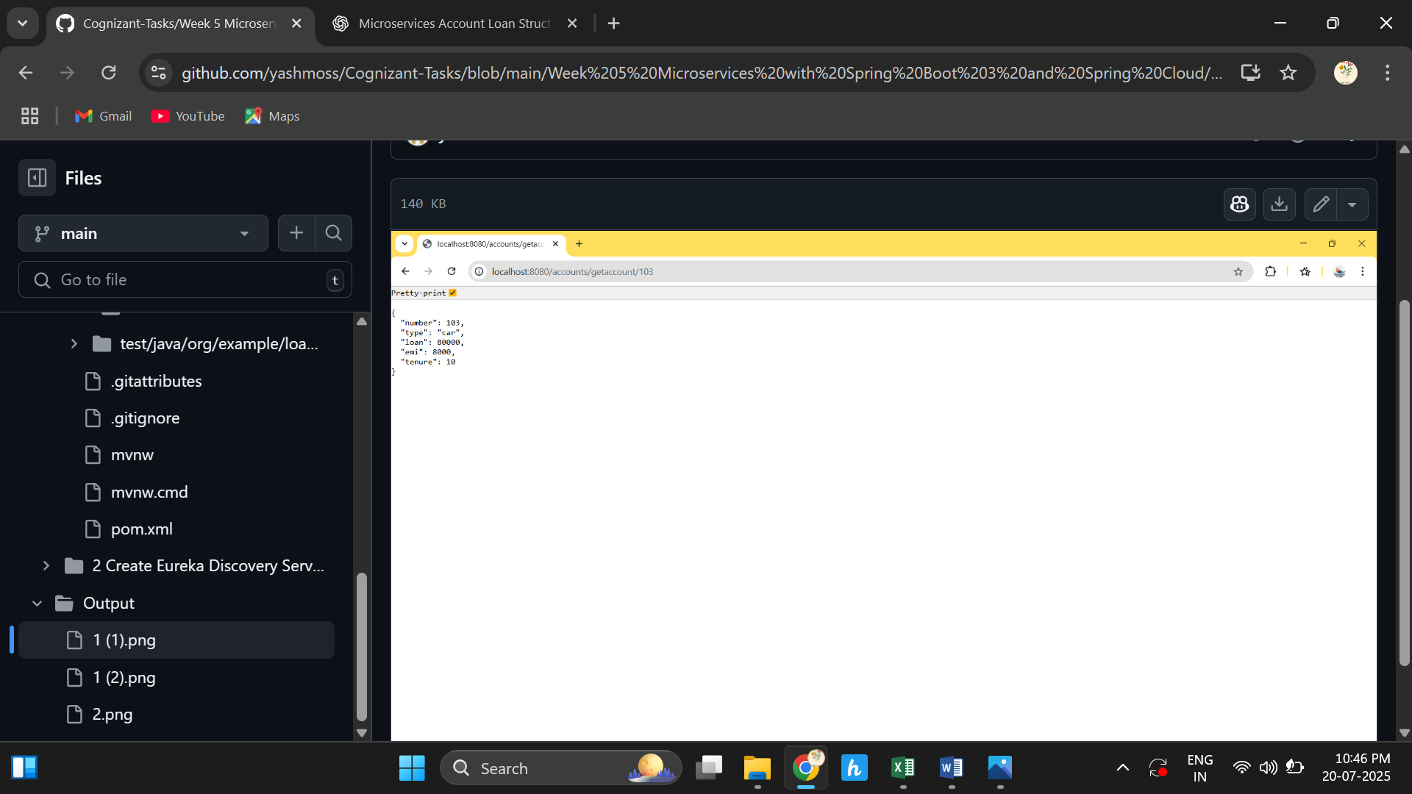

**Ex.2 create Eureka Discovery Server and register**

package org.example.eureka_server;

import org.springframework.boot.SpringApplication;

import org.springframework.boot.autoconfigure.SpringBootApplication;

import org.springframework.cloud.netflix.eureka.server.EnableEurekaServer;

@EnableEurekaServer

@SpringBootApplication

public class EurekaServerApplication {

public static void main(String[] args) {

SpringApplication.run(EurekaServerApplication.class, args);

}

}

