Ex.no :1

function Ex1(){

     //internal style

     const styles={

        backgroundColor:"pink",

        fontFamily:"Times New Roman",

        fontSize:"40px",

        color:"black",

         display: "flex",

        justifyContent: "center",

        alignItems: "center"

     }

    return(

        < div>

        <h1 style={styles}>Welcome To The First Session of React</h1>

        </div>

    )

}

export default Ex1;

import Ex1 from "./Ex1"

function App() {

   return (

   <Ex1/>

  )

}

export default App

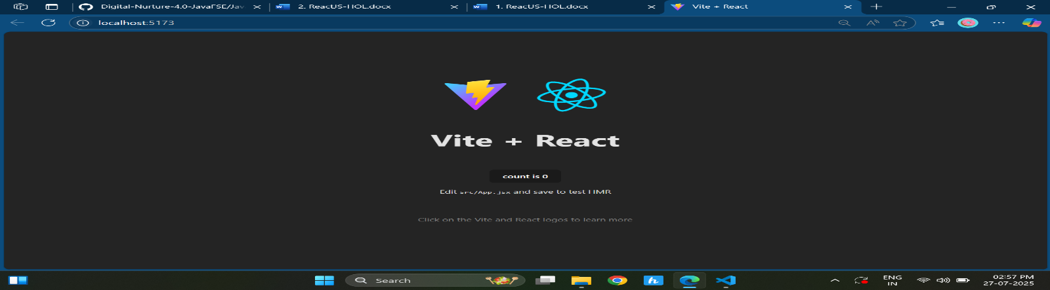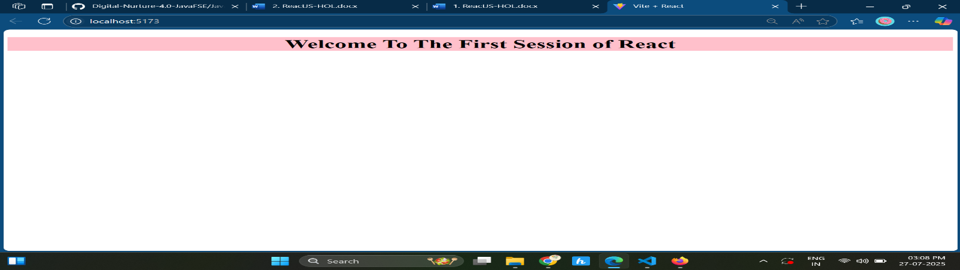Output:

Ex no 2 :

Home.jsx

function Home(){

     const styles={

        backgroundColor:"plum",

        fontFamily:"Times New Roman",

        fontSize:"40px",

        color:"black",

        display: "flex",

        justifyContent: "center",

        alignItems: "center"

     }

    return (

        <>

        <h1 style={styles}>WELCOME TO HOME PAGE OF STUDENT PORTAL</h1>

        </>

    )

}

export default Home;

About.jsx

function About(){

     const styles={

        backgroundColor:"pink",

        fontFamily:"Times New Roman",

        fontSize:"40px",

        color:"black",

         display: "flex",

        justifyContent: "center",

        alignItems: "center"

     }

    return (

        <>

        <h1 style={styles}>WELCOME TO ABOUT PAGE OF STUDENT PORTAL</h1>

        </>

    )

}

export default About;

Contact.jsx

function Contact(){

     const styles={

        backgroundColor:"skyblue",

        fontFamily:"Times New Roman",

        fontSize:"40px",

        color:"black",

         display: "flex",

        justifyContent: "center",

        alignItems: "center"

     }

    return (

        <>

        <h1 style={styles}>WELCOME TO CONTACT PAGE OF STUDENT PORTAL</h1>

        </>

    )

}

export default Contact;

App.jsx

import Home from "./Home"

import About from "./About"

import Contact from "./Contact"

function App() {

   return (

    <>

    <Home/>

   <About/>

   <Contact/>

    </>

  )

}

export default App

Output:

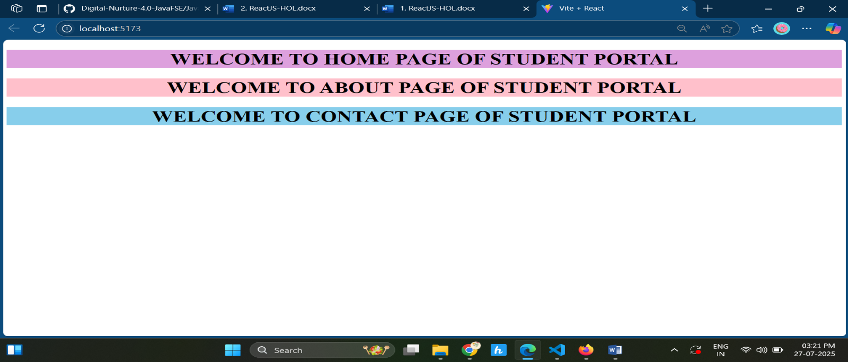

Ex.no:3

function Student(props){

    const styles={

        fontFamily:"Times New Roman",

        fontSize:"20px",

        color:"black",

        justifyContent: "center",

        alignItems: "center",

        margin:"0px",

        flexDirection:"row",

        textAlign:"center",

        padding:"0px"

    }

    const percentageToDecimal = (value) => {

    return value.toFixed(2) + '%';

  };

  const convertScore = (total) => {

    return total/5;

  };

  const percentage = percentageToDecimal(convertScore(props.total));

    return(

        <>

         <h4 style={{color:"darkred", textAlign:"center"}}>Student details</h4>

        <div style={styles}>

        <h6 style={{color:"blue"}}>Name:{props.name}</h6>

        <h6 style={{color:"red"}}>School:{props.school}</h6>

        <h6 style={{color:"purple"}}>Total:{props.total} out of 500</h6>

        <h6 style={{color:"forestgreen"}}>Percentage:{percentage}</h6>

        <h6>--------------------------------------------------------</h6>

        </div>

        </>

    )

}

export default Student;

import Student from "./Component/Student"

function App() {

   return (

    <>

    <Student name="Deepthikha" school="DNV Public school" total={489} />

     <Student name="RamaKumar" school="DNV Public school" total={495} />

    </>

  )

}

export default App

Output:

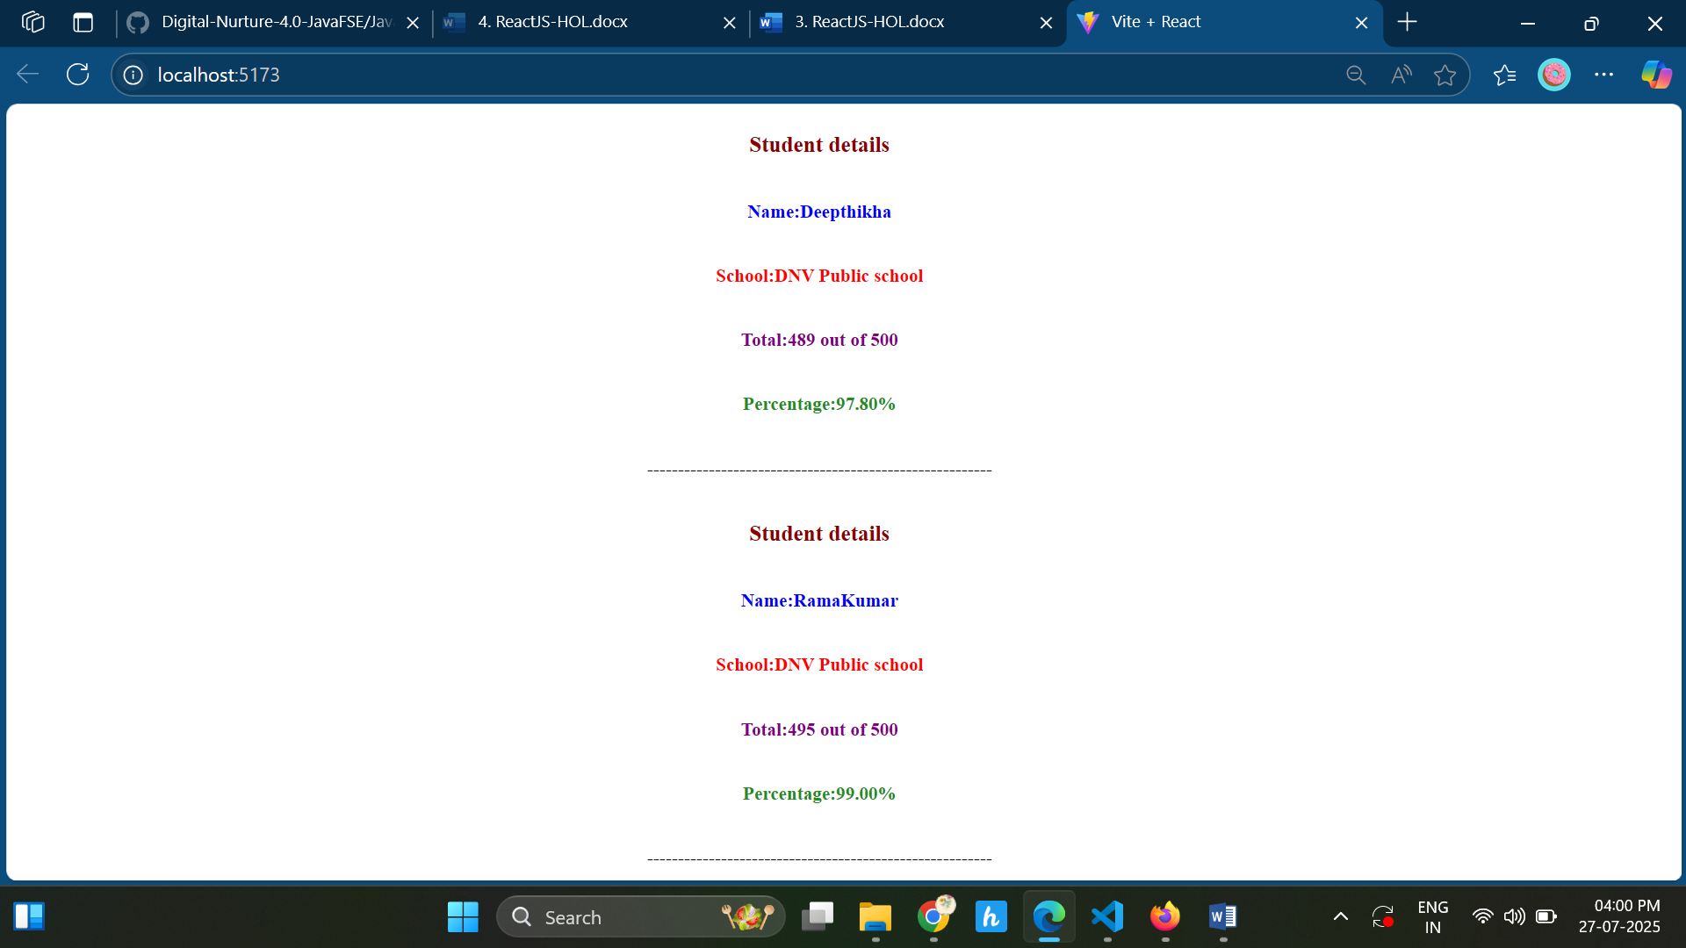

Exp.no:5

Exp5.jsx

import styles from './Exp5.module.css';

function Exp5(props){

    const check=(currentStatus)=>{

     if(currentStatus == "Ongoing"){

            return <h3 style={{color:"forestgreen"}}>{props.title}</h3>

            }else{

            return <h3 style={{color:"blue"}}>{props.title}</h3>

            }

    }

    const display=check(props.currentStatus);

    return(

        <div className={styles.container}>

        <div className={styles.box}>

            <h3>{display}</h3>

            <h3>Started On</h3>

            <h3 className={styles.special}>{props.startDate}</h3>

            <h3>Current Status </h3>

            <h3 className={styles.special}>{props.currentStatus}</h3>

            <h3 >Coach </h3>

            <h3 className={styles.special}>{props.coachName}</h3>

            <h3>Trainer</h3>

            <h3 className={styles.special}>{props.trainerName}</h3>

        </div>

        </div>

    )

}

export default Exp5;

css

.container{

  display: inline-flex;  /\* or use display: flex; \*/

  justify-content: center;

  gap: 20px; /\* space between boxes \*/

  padding: 20px;

}

.box{

    width: 350px;

    height: 350px;

    overflow:hidden;

    margin: 0%;

    padding: 0%;

    display: flex;

    flex-direction: column;

    text-align:left;

    margin: 10px;

    padding-top: 10px;

    padding-bottom: 20px;

    border-radius: 10px;

    border:1px solid black;

    flex-wrap: wrap;

}

.box h3 {

    padding-left: 25px;

  margin: 4px 0;  /\* Reduce top & bottom margin \*/

  line-height: 1.5;  /\* Reduce line spacing \*/

}

.special{

        padding-left: 35px;

        text-align: center;

    align-items: center;

    font-weight: lighter;

}

App.jsx

import Exp5 from "./Component/Exp5"

function App() {

   return (

    <>

    <h1>Cohorts Details</h1>

    <Exp5 title="INSTADMDF10 -.NET FSD" startDate="22-FEB-2022" currentStatus="Scheduled" coachName="Aathma" trainerName="Jojo Jose"/>

    <Exp5 title="ADM21JF014 -JAVA FSD" startDate="10-SEP-2021" currentStatus="Ongoing" coachName="Apoorv" trainerName="Elisa Smith"/>

    <Exp5 title="CDBHF21025 -JAVA FSD" startDate="24-DEC-2021" currentStatus="Ongoing" coachName="Aathma" trainerName="John Doe"/>

    </>

  )

}

export default App

Output:

