**Ex-9**

function Cricket(props){

    return(

    <>

    <table>

    <ul style={{ padding: 0, margin: 0, listStyle: "none" }}>

    <li style={{marginLeft: "auto",fontFamily:"sans-serif",fontSize:"15px"}}>

    <td><strong>Name :</strong>Mr.{props.name}</td>

    <td><strong>-----</strong></td>

    <td><strong>Score :</strong> {props.score}</td>

    </li>

    </ul>

    </table>

    </>

    );

}

export default Cricket;

import { useState } from "react";

import Cricket from "./Cricket";

function CricketList(){

    //create list of players

    const[flag] = useState(false);

    const [players] = useState([

       {name : "Jack", score : 50} ,

       {name : "Micheal", score : 70},

       {name : "John", score : 400},

       {name : "Ann", score : 61},

       {name : "Elisabeth", score : 61},

       {name : "Sachin", score : 95},

       {name : "Dhoni", score : 100},

       {name : "Virat", score : 84},

       {name : "Jadeja", score : 64},

       {name : "Raina", score : 75},

       {name : "Rohit", score : 80}

    ])

   const filteredPlayers = players.filter((player)=> player.score < 70)

   const T20Players =["First : Sachin 1","Second : Dhoni 2"," Third : Virat 3"];

   const RanjiTropyPlayers =["Fourth : Rohit 4","Fifth :Yuvaraj 5","Sixth : Raina 6"];

   const mergedPlayers =[...T20Players,...RanjiTropyPlayers];

   //filter odd players

   const oddPlayer = mergedPlayers.filter((_,index)=>index%2!==0);

   //filter even players

   const evenPlayer = mergedPlayers.filter((_,index)=>index%2===0);

    return(

        <>

        {flag && (

        <>

        <h1> List of players</h1>

        {players.map((player,index)=>(

           <Cricket key={index} name={player.name} score={player.score} />

        ))}

        <h1>List of players having score less than 70</h1>

        {filteredPlayers.map((player,index)=>(

           <Cricket key={index} name={player.name} score={player.score} />

        ))}

        </>

        )}

        {!flag && (

            <>

            <h1>Odd Players</h1>

            {oddPlayer.map((player,index)=>(

            <li key={index}>{player}</li>

            )

            )}

            <h1>Even Players</h1>

            { evenPlayer.map((player,index)=>(

                <li key={index}>{player}</li>

            ))}

             <h1>list of Indian players mergered</h1>

             {mergedPlayers.map((player,index)=>(

                <li key={index}>{player}</li>

            ))}

            </>

        )}

        </>

    )

}

export default CricketList;

import CricketList from './Components/CricketList'

import './App.css'

function App() {

    return(

        <>

        <CricketList/>

        </>

    )

}

export default App

**Output:**

**when flag=true;  
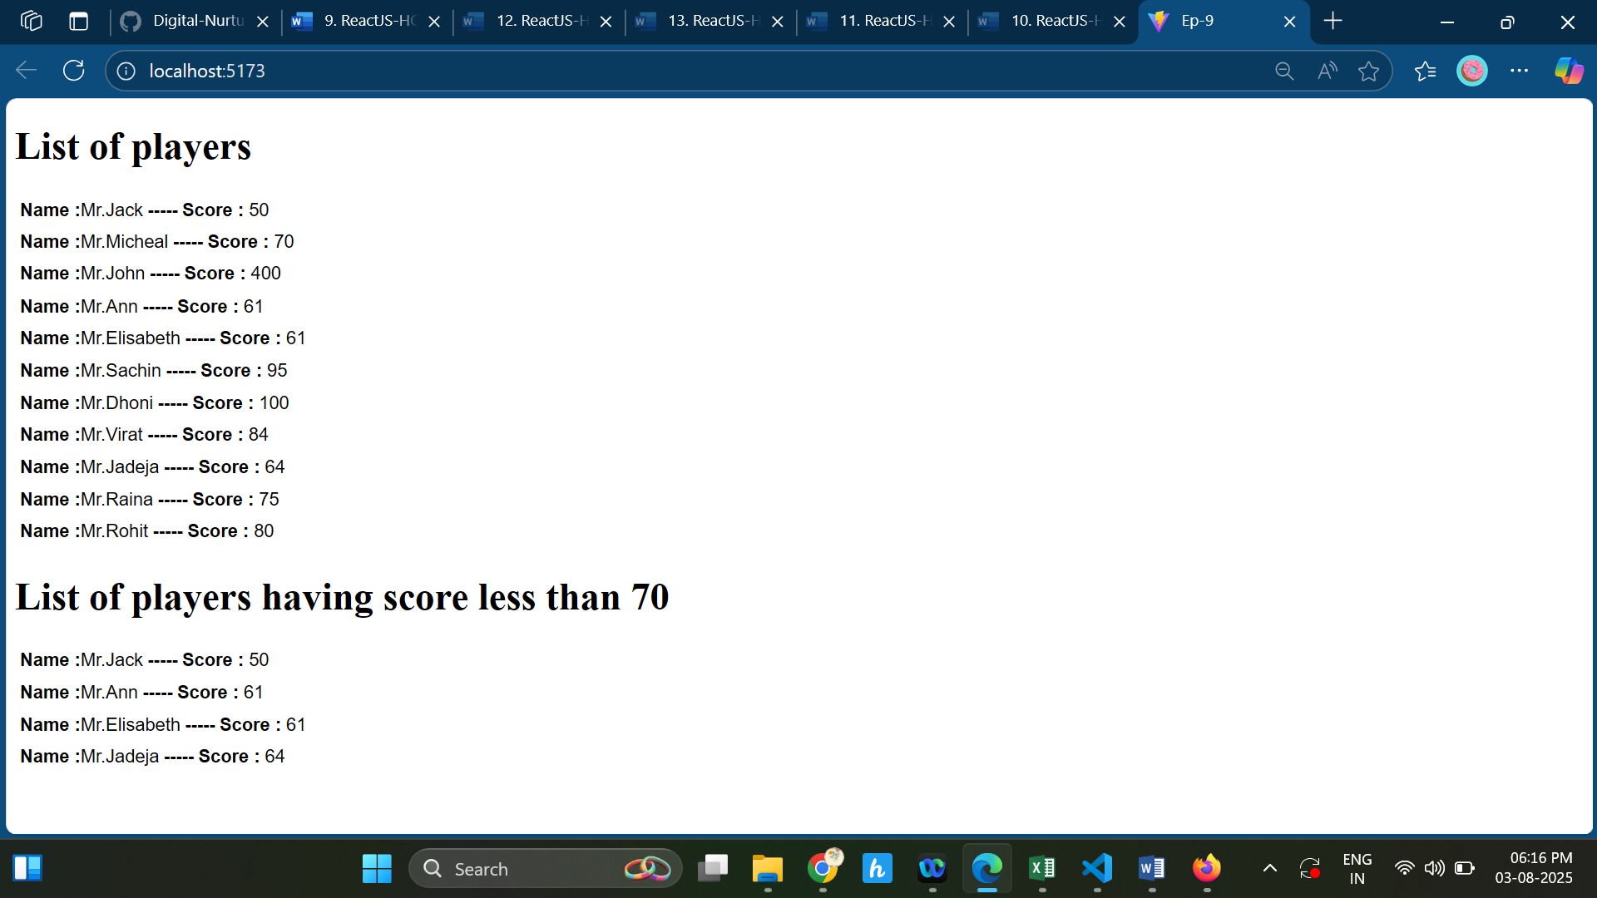**

**when flag=false**

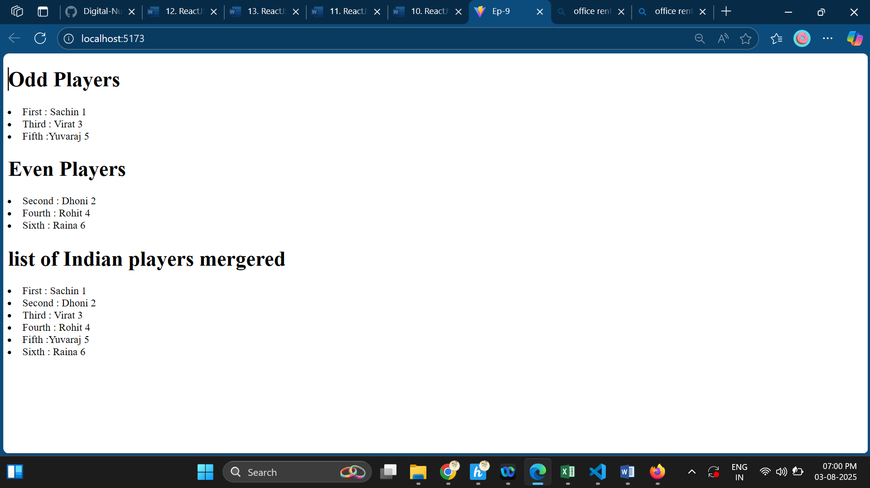

**Ex-10**

import styles from './Office.module.css';

function Office(props){

    return(

        <>

        <div className={styles.box} >

        <img src={props.image} style={{height:"50%",width:"50%"}}/>

        <h4>Name : {props.name}</h4>

        <h4 style={{color : props.price < 60000 ? "red" :"green"}}>Rent : {props.price}</h4>

        <h4>Address : {props.address}</h4>

        </div>

        </>

    );

}

export default Office;

.box{

    width: 30%;

    height: 30%;

    border:2px solid black;

    padding: 4px;

    margin: 5px;

    text-align: center;

    font-family: 'Times New Roman', Times, serif;

    font-weight: bold;

    font-size: 10px;

    display: flexbox;

    flex-direction: column;

    justify-content: center;

    align-items: center;

    margin-left: 40%;

    margin-right: 50%;

    border-radius: 10px;

    display: inline-block;

}

.button1{

  width: 250px;

  height: 50px;

  background-color: red;

  color: white;

  padding: 25px;

  margin: 25px;

  align-items: center;

  text-align: center;

  margin-left: 40%;

    margin-right: 50%;

}

.button2{

  width: 250px;

  height: 50px;

  background-color: forestgreen;

  color: white;

  padding: 25px;

  margin: 25px;

  align-items: center;

  text-align: center;

  margin-left: 40%;

    margin-right: 50%;

}

import { useState } from 'react';

import p1 from '../assets/office1.jpg';

import p2 from '../assets/office2.jpg';

import p3 from '../assets/office3.jpg';

import p4 from '../assets/office4.jpg';

import p5 from '../assets/office5.jpeg';

import styles from './Office.module.css';

import Office from './Office';

function OfficeList() {

    const [allOffices] = useState([

        { image: p1, name: "Magic Touch", price: 80000, address: "Chennai" },

        { image: p2, name: "Team Intelligence", price: 60000, address: "Chennai" },

        { image: p3, name: "Decision Makers", price: 65000, address: "Chennai" },

        { image: p4, name: "Red Wings", price: 33000, address: "Chennai" },

        { image: p5, name: "Horrible", price: 40000, address: "Chennai" },

    ]);

    const [office, setOffice] = useState(allOffices);

    function handleRed(price) {

        const filter = allOffices.filter((office) => office.price < price);

        setOffice(filter);

    }

    function handleGreen(price) {

        const filter = allOffices.filter((office) => office.price > price);

        setOffice(filter);

    }

    return (

        <>

            {office.map((office, index) => (

                <Office key={index} image={office.image}

                name={office.name} price={office.price}

                address={office.address}

                />

            ))}

            <button onClick={() => handleRed(60000)} className={styles.button1}>

                Affordable

            </button>

            <button onClick={() => handleGreen(60000)} className={styles.button2}>

                Comfortable

            </button>

        </>

    );

}

export default OfficeList;

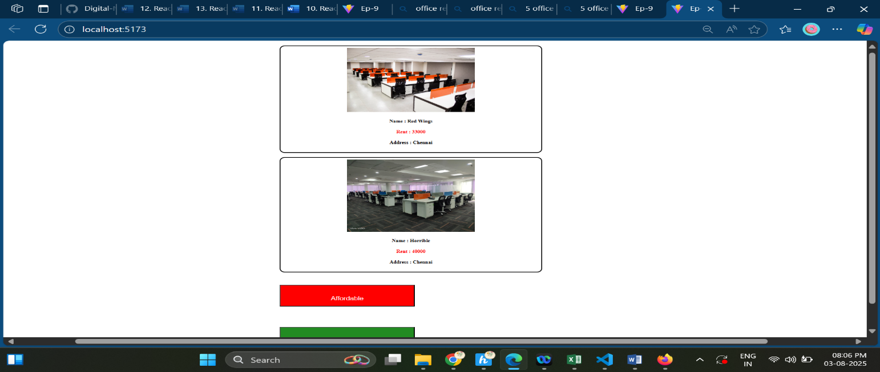

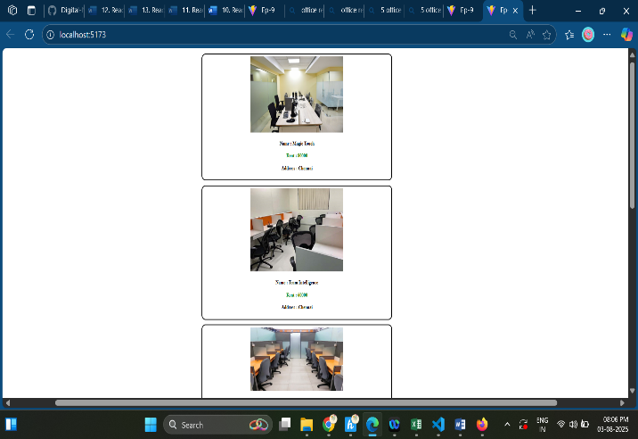

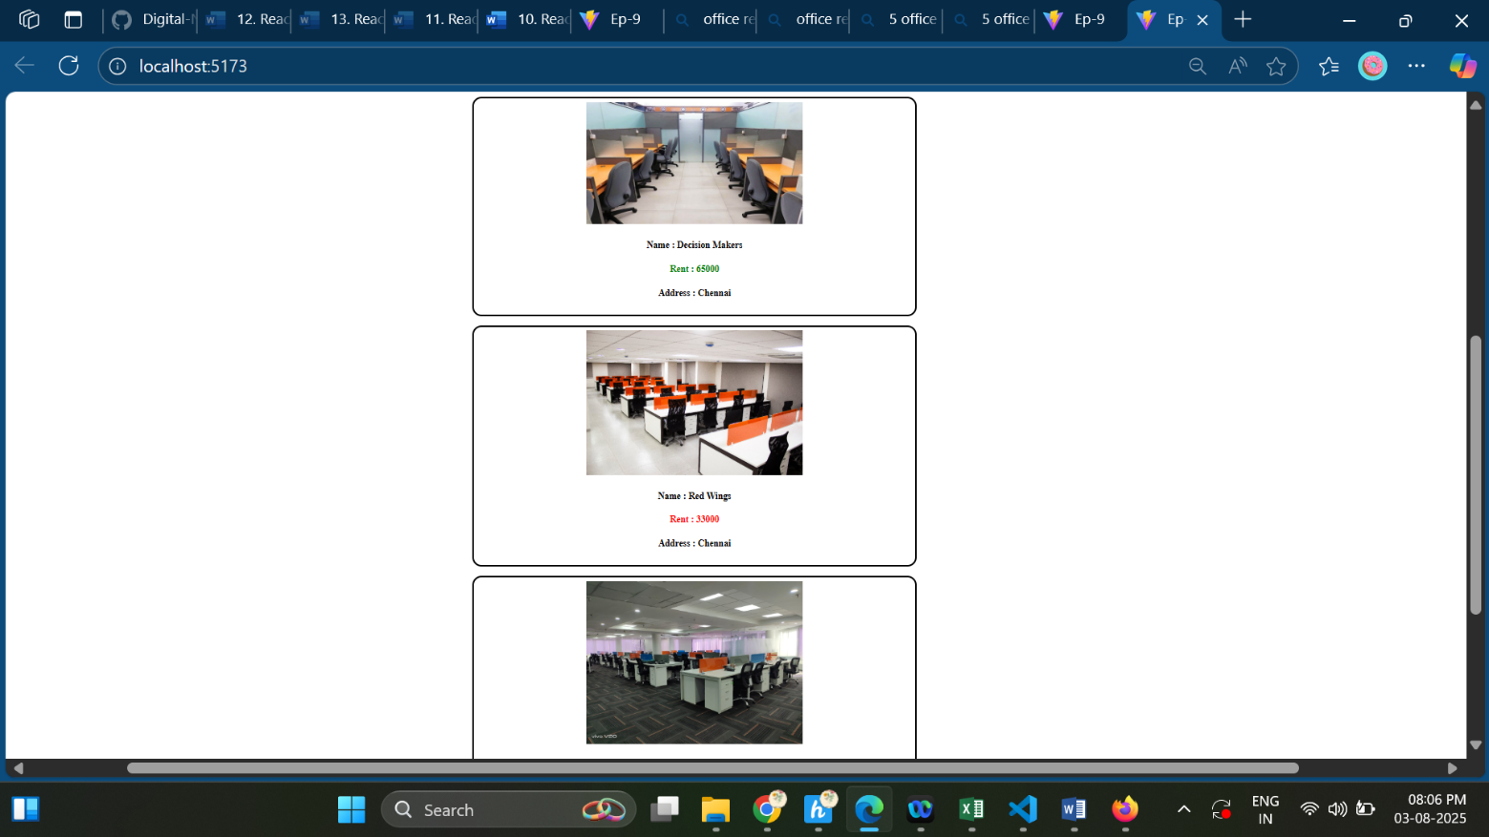

**When Click on Affortable..**

## **When click on Comfortable**

**Exp 11**

import { useState } from "react";

function Exp11(){

      const [result,setResult]= useState("");

      const [text, setText] = useState("");

      const[amount,setAmount]=useState();

      const[currency,setCurrency] =useState();

      const [number,setNumber] =useState(0);

    const style={

        width:"350px",

        heigth:"350px",

        border:"2px solid black",

        padding:"20px",

        borderRadius:"5px",

        marginLeft:"40%",

        marginRight:"40%"

    }

    const style1={

        margin:"30px",

       padding:"10px",

        border:"2px solid black",

        borderRadius:"5px",

        marginLeft:"40%",

        gap:"20px",

        textAlign:"center",

    }

    const button={

 width: "250px",

  height: "50px",

  backgroundColor:"forestgreen",

  color: "white",

  padding:"25px",

  margin:"25px",

  alignItems:"center",

  textAlign:"center"

}

function handleIncrement(count){ count=count+1; setNumber(count); alert("Helloo I'm Incrementing");};

function handleDecrement(count){count=count-1; setNumber(count);};

function handleReset(){setNumber(0);};

function Convertor(text, amount) {

        const new_text = text.toLowerCase();

        let converted;

        if (new_text === "euro") {

            converted = (amount / 90).toFixed(2);

            setResult(`${converted} EUR`);

        } else if (new_text === "dollar") {

            converted = (amount / 83).toFixed(2);

            setResult(`${converted} USD`);

        } else if (new_text === "won") {

            converted = (amount * 16).toFixed(0);

            setResult(`${converted} WON`);

        } else {

            setResult("Not Available");

        }

    }

    return(

        <>

        <div style={style1}><h1 style={{textAlign:"center"}}>{number}</h1>

            <button style={button} onClick={()=>handleDecrement(number)}>Decrement</button>

            <button style={button} onClick={handleReset}>Reset</button>

            <button style={button}onClick={()=>handleIncrement(number)}>Increment</button>

            <button style={button} onClick={()=>alert("WELCOME")}>Say Welcome</button>

            <button style={button}  onClick={()=>alert("I WAS CLICKED!!")}>Click on me</button>

        </div>

        <div style={style}>

        <h1 style={{color:"forestgreen",fontFamily:"Times New Roman"}}>Currency Convertor!!!</h1>

        <label for="IndianRupee">Amount :</label>

        <input

        type="number"

        value={amount}

        onChange={(e) => setAmount(e.target.value)}

        placeholder="Enter INR amount"

        required

        style={{width:"200px",padding:"10px",marginLeft:"10px"}}/>

        <br></br><br></br>

        <label for="currency">Currency :</label>

       <input

       type="text"

       value={currency}

       onChange={(e)=>setCurrency(e.target.value)}

        placeholder="Enter currency (euro, dollar, won)"

       style={{width:"200px",padding:"10px",marginLeft:"10px"}}

       required

       />

        <br></br><br></br>

        <button style={button} onClick={() => Convertor(currency, amount)}>Submit</button>

        <p>Result : {result}</p>

        </div>

        </>

    )

}

export default Exp11;

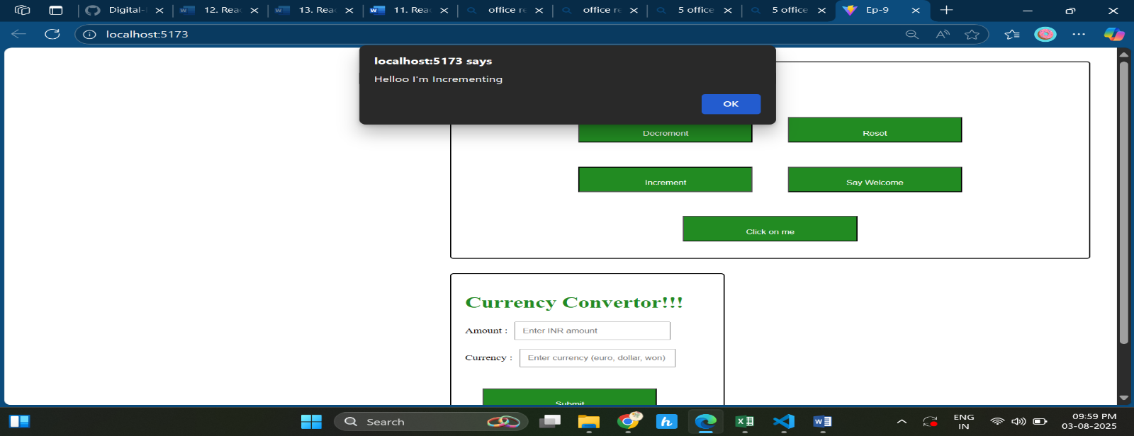

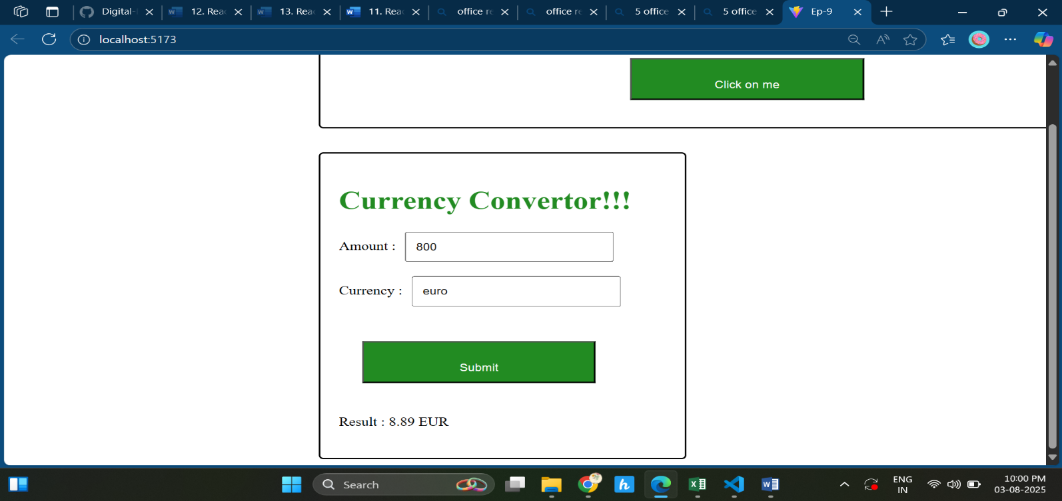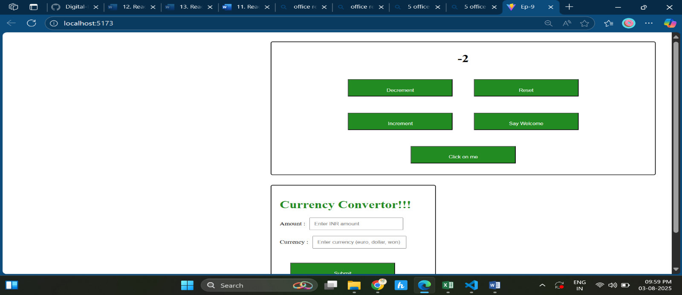

Exp 12

import { Link } from 'react-router-dom';

function Home() {

  const style = {

    backgroundColor: "forestgreen",

    color: "white",

    margin: "25px",

    padding: "15px",

    textAlign: "center",

    textDecoration: "none",

     display: "inline-block",

    borderRadius: "6px"

  };

  return (

    <div style={{ textAlign: "center", padding: "25px" }}>

      <h1>Please Sign Up</h1>

      <Link to="/login" style={style}>Login</Link>

    </div>

  );

}

export default Home;

import { Link } from 'react-router-dom';

function Login(){

const style={

  backgroundColor:"red",

  color: "white",

  margin:"25px",

  padding:"15px",

  alignItems:"center",

  textAlign:"center" ,

 textDecoration:"none",

  display: "inline-block",

    borderRadius: "6px"

    }

 return(

        <><div style={{textAlign:"center",padding:"25px"}}>

        <h1>Welcome back</h1>

        <Link to="/" style={style}>Logout</Link></div>

        </>

    )

}

export default Login;

import { StrictMode } from 'react';

import { createRoot } from 'react-dom/client';

import Home from './Components/Home.jsx';

import Login from './Components/Login.jsx';

import './index.css';

import { createBrowserRouter, RouterProvider } from 'react-router-dom';

const router = createBrowserRouter([

  { path: '/', element: <Home /> },

  { path: '/login', element: <Login /> }

]);

createRoot(document.getElementById('root')).render(

  <StrictMode>

    <RouterProvider router={router} />

  </StrictMode>

);

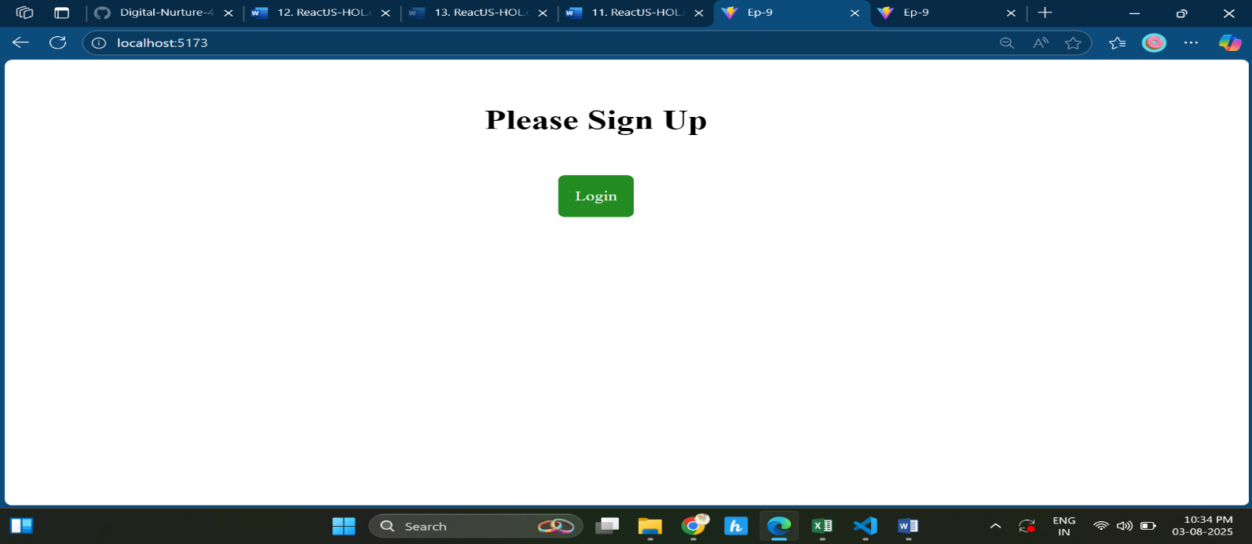

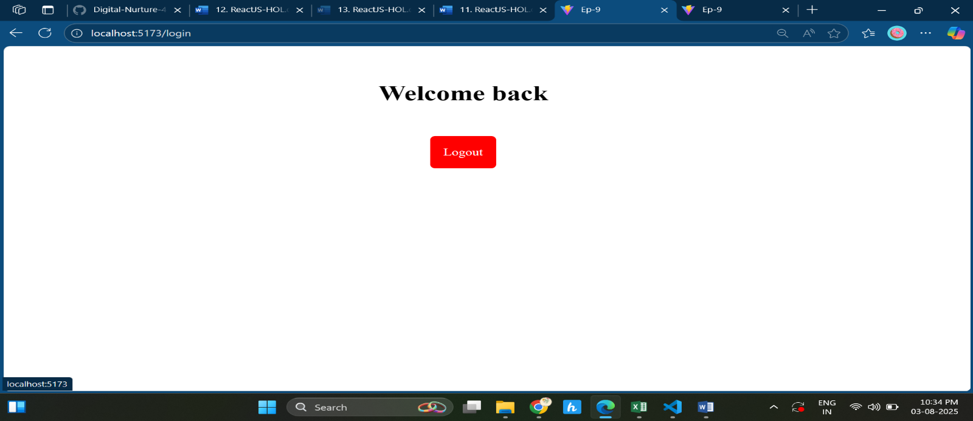

**Exp 13**

**Course.jsx**

function Course(props){

    return(

     <>

        <div style={{ margin: "0 auto", width: "300px" }}>

        <h4>{props.title}</h4>

        <h5>{props.date}</h5>

        </div>

        </>

    )

}

export default Course;

**Book.jsx**

function Book(props){

    return(

        <>

        <div style={{ margin: "0 auto", width: "300px" }}>

        <h4>{props.title}</h4>

        <h5>{props.price}</h5>

        </div>

        </>

    )

}

export default Book;

**Blog.jsx**

function Blog(props){

    return(

        <>

        <div style={{ margin: "0 auto", width: "300px" }}>

        <h4>{props.title}</h4>

        <h5>{props.authour}</h5>

        <p>{props.para}</p>

        </div>

        </>

    )

}

export default Blog;

**App.jsx**

import Blog from './Components/Blog'

import Book from './Components/Book'

// import Course from './Components/Course'

import './App.css'

import Course from './Components/Course'

function App() {

    const show_course=true;

    const show_book=true;

    const show_blog=true;

    return(

        <>

        <div style={{display:"inline-flex",margin:"13px"}}>

        {/* //Course */}

         {show_course && (

        <div style={{ margin: "5px", width: "300px",border:"2px solid black",padding:"10px",borderRadius:"5px" }}>

        <h1 style={{color:"forestgreen",textAlign:"center"}}>Course Details</h1>

        <Course title="React" date="4/8/2025"/>

        <Course title="Angular" date="10/45/24"/>

        </div> )}<br></br>

       {/* booksection */}

       {show_book &&(

        <div  style={{ margin: "5px", width: "300px",border:"2px solid black",padding:"10px",borderRadius:"5px" }}>

        <h1 style={{color:"forestgreen",textAlign:"center"}}>Book Details</h1>

        <Book title="Master React" price= {670} />

        <Book title="Deep Dive Into Angular" price={800}/>

        <Book title="Mongo Essentials" price ={470}/>

        </div>)}<br></br>

        {show_blog && (

        <div  style={{ margin: "5px", width: "300px",border:"2px solid black",padding:"10px",borderRadius:"5px" }}>

        <h1 style={{color:"forestgreen",textAlign:"center"}}>Blog Details</h1>

        <Blog title="React Learning" authour="Stephen Bizz" para="Welcome to learning react" />

        <Blog title="Installation" authour="Schewzdenier" para="You can install react from npm"/>

        </div>

        )}

        </div>

        </>

    )

}

export default App

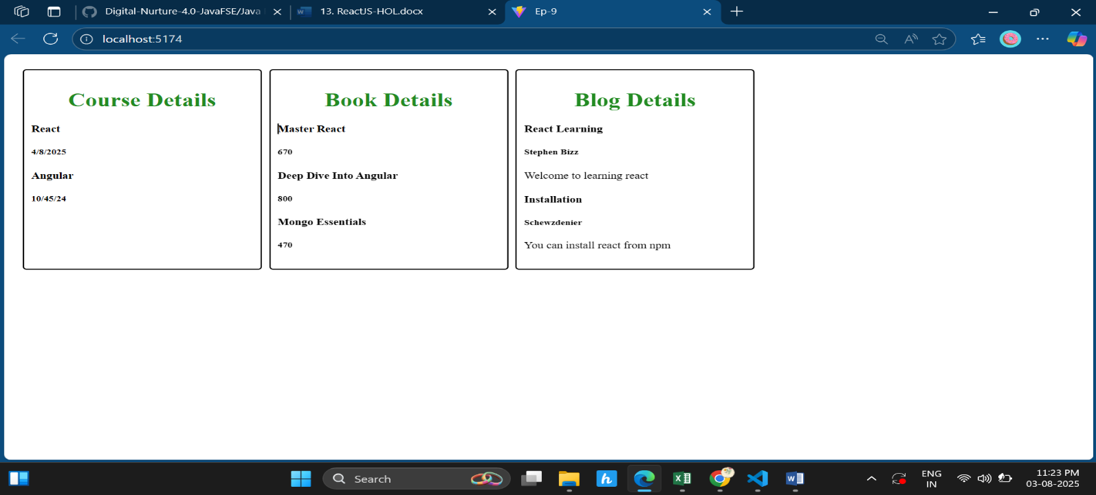

**const show_book=false;**

