**Exercise 1: Control Structures**

**Scenario 1:** The bank wants to apply a discount to loan interest rates for customers above 60 years old.

CREATE TABLE Bank(

    Customer_id INT,

    Customer_name VARCHAR(20),

    Customer_age INT

);

INSERT INTO Bank(Customer_id, Customer_name, Customer_age) VALUES (101, 'Zandeep', 20);

INSERT INTO Bank(Customer_id, Customer_name, Customer_age) VALUES (102, 'Yashwanth Saran', 67);

INSERT INTO Bank(Customer_id, Customer_name, Customer_age) VALUES  (103, 'Jothi Ramakumar', 61);

INSERT INTO Bank(Customer_id, Customer_name, Customer_age) VALUES (104, 'Rama Kumar', 64);

DECLARE

v_id Bank.Customer_id%TYPE;

v_name Bank.Customer_name%TYPE;

v_age Bank.Customer_age%TYPE;

-- DECLARE THE CURSOR FOR DISPLAYING MULITPLE ROWS

CURSOR Bank_cursor IS SELECT Customer_id, Customer_name, Customer_age FROM Bank;

BEGIN

    FOR record IN Bank_cursor LOOP

    IF  record.Customer_age > 60 THEN

    DBMS_OUTPUT.PUT_LINE('CUSTOMER ID :' || record.Customer_id );

    DBMS_OUTPUT.PUT_LINE('CUSTOMER NAME :' || record.Customer_name );

    DBMS_OUTPUT.PUT_LINE('CUSTOMER AGE :' || record.Customer_age );

    DBMS_OUTPUT.PUT_LINE('Eligible for apply a 1% discount to their current loan interest rates');

    DBMS_OUTPUT.PUT_LINE('------------------------------------------------------------------------');

    ELSE

     DBMS_OUTPUT.PUT_LINE('CUSTOMER ID :' || record.Customer_id );

    DBMS_OUTPUT.PUT_LINE('CUSTOMER NAME :' || record.Customer_name );

    DBMS_OUTPUT.PUT_LINE('CUSTOMER AGE :' || record.Customer_age );

    DBMS_OUTPUT.PUT_LINE(' Not Eligible for apply a 1% discount to their current loan interest rates');

    DBMS_OUTPUT.PUT_LINE('------------------------------------------------------------------------');

    END IF;

    END LOOP;

END;

**OUTPUT:**

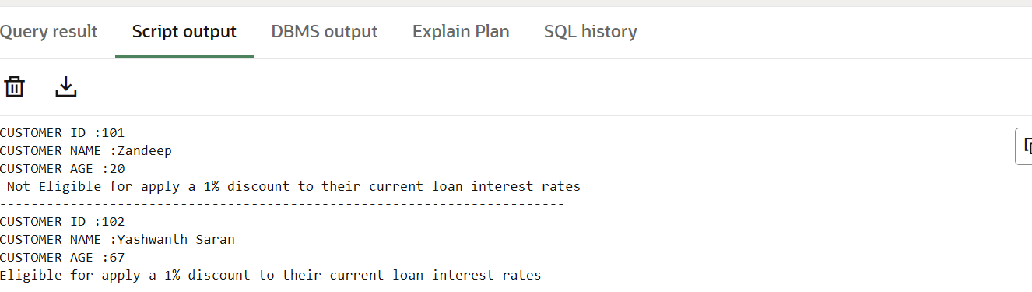

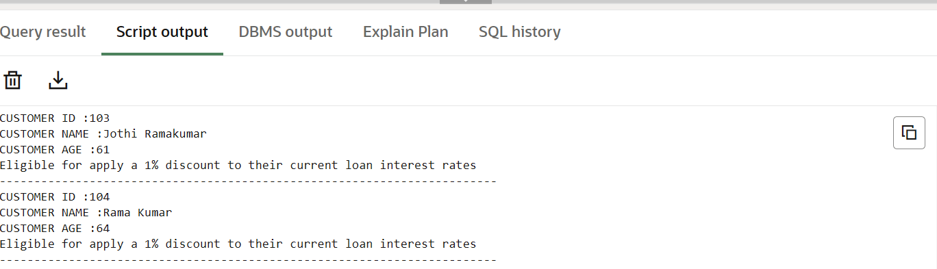

**Scenario 2:** A customer can be promoted to VIP status based on their balance.

CREATE TABLE Bank (

    Customer_id INT,

    Customer_name VARCHAR2(20),

    Customer_balance INT

);

INSERT INTO Bank(Customer_id, Customer_name, Customer_balance) VALUES (101, 'Zandeep', 9000);

INSERT INTO Bank(Customer_id, Customer_name, Customer_balance) VALUES (102, 'Yashwanth Saran', 20000);

INSERT INTO Bank(Customer_id, Customer_name, Customer_balance) VALUES (103, 'Jothi Ramakumar', 30000);

INSERT INTO Bank(Customer_id, Customer_name, Customer_balance) VALUES (104, 'Rama Kumar', 40000);

COMMIT;

DECLARE

    v_id Bank.Customer_id%TYPE;

    v_name Bank.Customer_name%TYPE;

    v_balance Bank.Customer_balance%TYPE;

    VIP BOOLEAN := FALSE;

    -- Cursor

    CURSOR Bank_cursor IS

        SELECT Customer_id, Customer_name, Customer_balance FROM Bank;

BEGIN

    FOR record IN Bank_cursor LOOP

        IF record.Customer_balance > 10000 THEN

            VIP := TRUE;

            DBMS_OUTPUT.PUT_LINE('CUSTOMER NAME (VIP CUSTOMER): ' || record.Customer_name);

            DBMS_OUTPUT.PUT_LINE('CUSTOMER CURRENT BALANCE IS : $' || record.Customer_balance);

            DBMS_OUTPUT.PUT_LINE('------------------------------------------------------------------------');

        ELSE

            DBMS_OUTPUT.PUT_LINE('CUSTOMER NAME (NOT VIP CUSTOMER): ' || record.Customer_name);

            DBMS_OUTPUT.PUT_LINE('CUSTOMER CURRENT BALANCE IS : $' || record.Customer_balance);

            DBMS_OUTPUT.PUT_LINE('------------------------------------------------------------------------');

        END IF;

    END LOOP;

END;

Output:

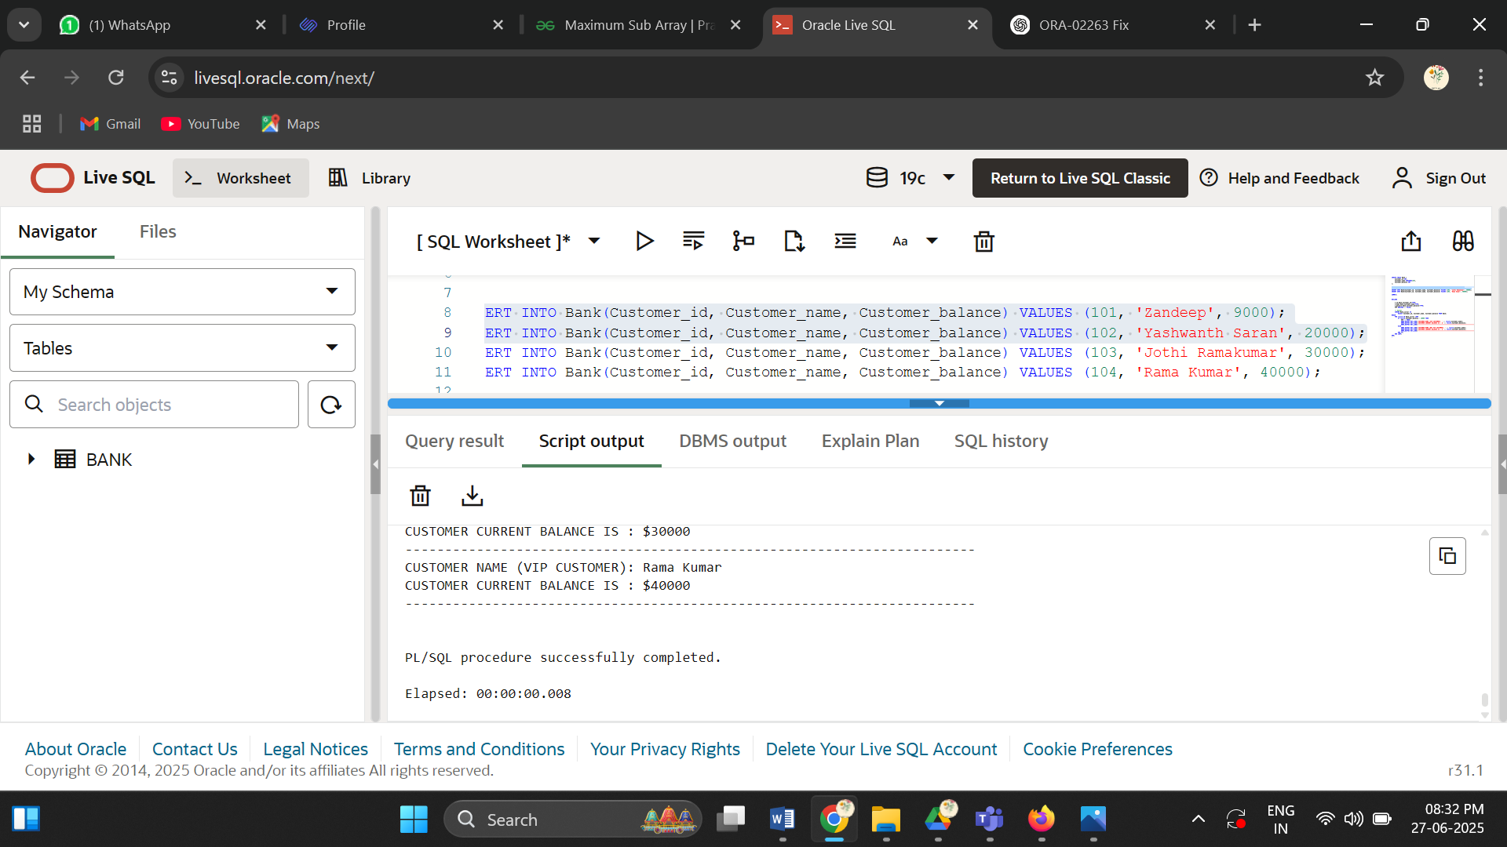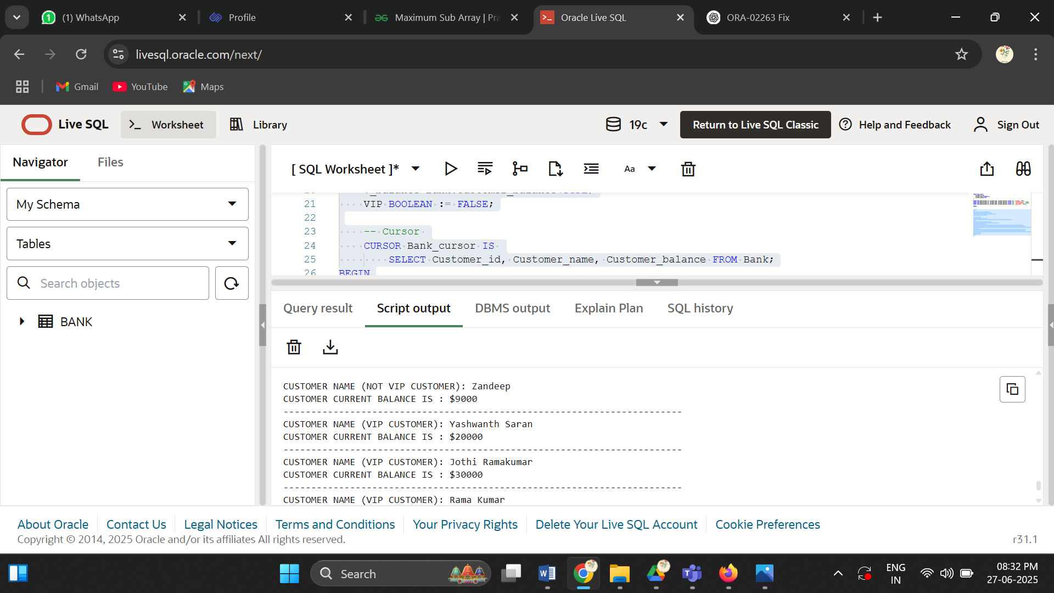

**Scenario 3:** The bank wants to send reminders to customers whose loans are due within the next 30 days.

CREATE TABLE Loan(

    Customer_id INT,

    Customer_name VARCHAR(50),

    Loan_amount INT,

    Due_date DATE

);

INSERT INTO Loan (Customer_id, Customer_name, Loan_amount, Due_date)

VALUES (1, 'DEEPTHIKHA', 30000, TO_DATE('2025-07-30','YYYY-MM-DD'));

INSERT INTO Loan( Customer_id, Customer_name, Loan_amount, Due_date)

VALUES (2, 'ZANDEEP', 50000, TO_DATE('2025-07-05','YYYY-MM-DD'));

INSERT INTO Loan( Customer_id, Customer_name, Loan_amount, Due_date)

VALUES (3, 'RAMAKUMAR', 80000, TO_DATE('2025-08-04','YYYY-MM-DD'));

INSERT INTO Loan( Customer_id, Customer_name, Loan_amount, Due_date)

VALUES (4, 'JOTHI RAMALUMAR', 90000, TO_DATE('2025-07-10','YYYY-MM-DD'));

DECLARE

    -- Cursor

    CURSOR Loan_cursor IS

        SELECT Customer_id, Customer_name, Loan_amount, Due_date

        FROM Loan

        WHERE Due_date BETWEEN SYSDATE AND SYSDATE + 30;

BEGIN

    FOR record IN Loan_cursor LOOP

        DBMS_OUTPUT.PUT_LINE('Customer Name: ' || record.Customer_name);

        DBMS_OUTPUT.PUT_LINE('Loan Amount: ' || record.Loan_amount);

        DBMS_OUTPUT.PUT_LINE('Due Date: ' || TO_CHAR(record.Due_date, 'YYYY-MM-DD'));

        DBMS_OUTPUT.PUT_LINE('------------------------------------------');

    END LOOP;

END;

/

Output:

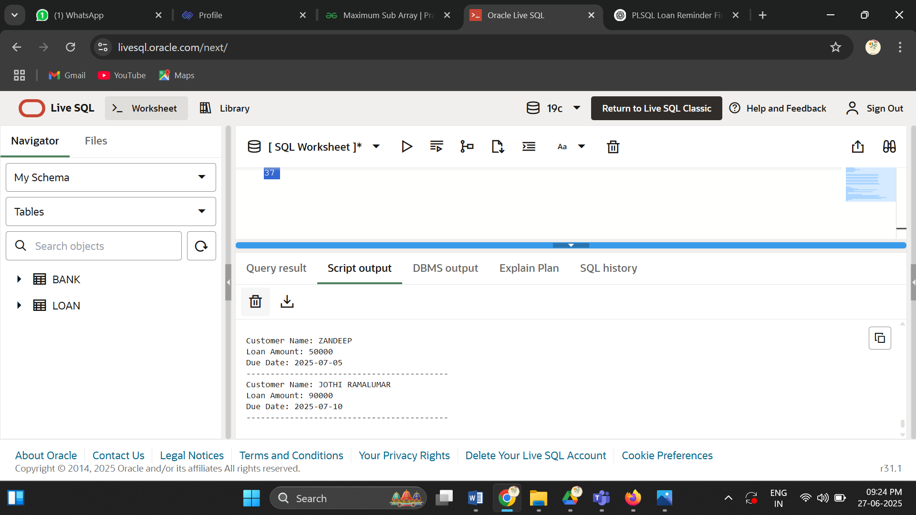

**Exercise 2: Error Handling**

**Scenario 1:** Handle exceptions during fund transfers between accounts.

CREATE table Transaction(

    account_owner_id int,

    amout DECIMAL(10,2),

    account_other_id int

);

insert into Transaction(account_owner_id ,amout,account_other_id) values (1000125,5000,100030);

insert into Transaction(account_owner_id ,amout,account_other_id) values (1000126,20000,1000126);

insert into Transaction(account_owner_id ,amout,account_other_id) values (1000127,50000,100040);

CREATE OR REPLACE PROCEDURE SafeTransferFunds(

    account_owner_id IN NUMBER,

    amount IN NUMBER,

    account_other_id IN NUMBER

) IS

    inSufficient EXCEPTION;

BEGIN

    IF account_owner_id != account_other_id THEN

        DBMS_OUTPUT.PUT_LINE('Valid Transaction');

        DBMS_OUTPUT.PUT_LINE('Transfer the amount: ' || amount);

    ELSE

        RAISE inSufficient;

    END IF;

EXCEPTION

    WHEN inSufficient THEN

        DBMS_OUTPUT.PUT_LINE('ERROR!! Accounts cannot be the same.');

END SafeTransferFunds;

/

DECLARE

v_account_1 Transaction.account_owner_id %type;

v_amount  Transaction.amout%type;

v_account_2 Transaction.account_other_id%type;

CURSOR c_record is

select account_owner_id ,amout,account_other_id from Transaction;

BEGIN

    OPEN c_record;

    LOOP

        FETCH c_record INTO v_account_1,v_amount,v_account_2;

        exit when c_record%NOTFOUND;

        DBMS_OUTPUT.PUT_LINE('Processing Transaction...');

        SafeTransferFunds(v_account_1, v_amount, v_account_2);

        DBMS_OUTPUT.PUT_LINE('------------------------------------');

    END LOOP;

    CLOSE c_record;

    END;

    /

Output:

Processing Transaction...  
Valid Transaction  
Transfer the amount: 5000  
------------------------------------  
Processing Transaction...  
Valid Transaction  
Transfer the amount: 20000  
------------------------------------  
Processing Transaction...  
Valid Transaction  
Transfer the amount: 50000  
------------------------------------  
  
  
PL/SQL procedure successfully completed.  
  
Elapsed: 00:00:00.016

**Scenario 2:** Manage errors when updating employee salaries

CREATE table Employee(

    Employee_id int,

    Employee_name VARCHAR(50),

    Salary NUMBER

);

insert into Employee(Employee_id,Employee_name,Salary ) VALUES(101,'Deepthikha',50000);

insert into Employee(Employee_id,Employee_name,Salary ) VALUES(102,'GunaPriya',60000);

insert into Employee(Employee_id,Employee_name,Salary ) VALUES(101,'Jothi Ramakumar',80000);

CREATE OR REPLACE PROCEDURE UpdateSalary(

    Employee_id IN NUMBER,

    Employee_name IN VARCHAR2,

    Salary IN NUMBER

) IS

    current_salary NUMBER;

    percentage CONSTANT NUMBER := 5;

    Exists_EXCEPTION EXCEPTION;

BEGIN

    IF Employee_id IS NOT NULL THEN

        current_salary := Salary + (Salary * percentage / 100);

        DBMS_OUTPUT.PUT_LINE('Old Salary :'||Salary);

        DBMS_OUTPUT.PUT_LINE('Increased the salary to: ' || current_salary);

    ELSE

        RAISE Exists_EXCEPTION;

    END IF;

EXCEPTION

    WHEN Exists_EXCEPTION THEN

        DBMS_OUTPUT.PUT_LINE('ERROR!! Invalid Employee ID.');

END UpdateSalary;

/

DECLARE

 v_id Employee.Employee_id%type;

 v_name Employee.Employee_name%type;

 v_salary  Employee.Salary%type;

 CURSOR c_rec is

 select Employee_id,Employee_name,Salary from Employee;

BEGIN

    OPEN c_rec;

    LOOP

        FETCH c_rec into v_id,v_name,v_salary;

        exit when c_rec%NOTFOUND;

        UpdateSalary(v_id,v_name,v_salary);

        DBMS_OUTPUT.PUT_LINE('--------------------');

    END LOOP;

    close c_rec;

    end;

    /

Output:

Old Salary :50000  
Increased the salary to: 52500  
--------------------  
Old Salary :60000  
Increased the salary to: 63000  
--------------------  
Old Salary :80000  
Increased the salary to: 84000  
--------------------  
  
  
PL/SQL procedure successfully completed.  
  
Elapsed: 00:00:00.003

**Scenario 3:** Ensure data integrity when adding a new customer.

CREATE TABLE Customer (

    customer_id INT,

    customer_name VARCHAR(50)

);

INSERT INTO Customer(customer_id, customer_name) VALUES (1, 'Deepthikha');

INSERT INTO Customer(customer_id, customer_name) VALUES (2, 'Kiruthiga');

CREATE OR REPLACE PROCEDURE AddNewCustomer(

    customer_id IN NUMBER,

    customer_name IN VARCHAR2

) IS

    customer_exists NUMBER;

BEGIN

    IF customer_id IS NULL OR customer_name IS NULL THEN

        DBMS_OUTPUT.PUT_LINE('Error: Customer ID and Name must not be NULL.');

        RETURN;

    END IF;

    SELECT COUNT(*) INTO customer_exists FROM Customer

    WHERE customer_id = AddNewCustomer.customer_id;

    IF customer_exists > 0 THEN

        DBMS_OUTPUT.PUT_LINE('Error: Customer with ID ' || customer_id || ' already exists.');

    ELSE

        INSERT INTO Customer (customer_id, customer_name)

        VALUES (customer_id, customer_name);

        DBMS_OUTPUT.PUT_LINE('Customer added successfully.');

    END IF;

EXCEPTION

    WHEN OTHERS THEN

        DBMS_OUTPUT.PUT_LINE('Unexpected ERROR: ' || SQLERRM);

END AddNewCustomer;

/

BEGIN

    AddNewCustomer(NULL,NULL);

    AddNewCustomer(102, 'Reepthikha');

END;

/

OUTPUT:

Error: Customer ID and Name must not be NULL.  
Customer added successfully.  
  
  
PL/SQL procedure successfully completed.  
  
Elapsed: 00:00:00.006

**Exercise 3: Stored Procedures**

**Scenario 1:** The bank needs to process monthly interest for all savings accounts.

**Scenario 2:** The bank wants to implement a bonus scheme for employees based on their performance.

CREATE TABLE Employee(

    Employee_id int,

    salary int,

    balance DECIMAL(10,2),

    department varchar(50)

);

insert into Employee(Employee_id,salary,balance,department) values(1,50000,800,'worker');

insert into Employee(Employee_id,salary,balance,department) values(2,80000,500,'manager');

insert into Employee(Employee_id,salary,balance,department) values(3,90000,7000,'manager');

-- 1) Change ProcessMonthlyInterest

CREATE OR REPLACE PROCEDURE ProcessMonthlyInterest(

    Employee_id IN NUMBER,

    salary IN NUMBER,

    balance IN OUT NUMBER,

    department IN VARCHAR2

) IS

    interest_rate CONSTANT NUMBER := 5;

BEGIN

    balance := balance + (balance * interest_rate / 100);

    DBMS_OUTPUT.PUT_LINE('Updated balance for Employee ' || Employee_id || ': ' || balance);

END ProcessMonthlyInterest;

/

-- 2) UpdateEmployeeBonus procedure

CREATE OR REPLACE PROCEDURE UpdateEmployeeBonus(

    Employee_id IN NUMBER,

    salary IN OUT NUMBER,

    balance IN NUMBER,

    department IN VARCHAR2

) IS

    m_bonus CONSTANT NUMBER := 5;

    w_bonus CONSTANT NUMBER := 2;

BEGIN

    IF LOWER(department) = 'manager' THEN

        salary := salary + (salary * m_bonus / 100);

        DBMS_OUTPUT.PUT_LINE('Bonus added for Manager ' || Employee_id || ': New salary = ' || salary);

    ELSIF LOWER(department) = 'worker' THEN

        salary := salary + (salary * w_bonus / 100);

        DBMS_OUTPUT.PUT_LINE('Bonus added for Worker ' || Employee_id || ': New salary = ' || salary);

    ELSE

        DBMS_OUTPUT.PUT_LINE('No bonus: Department not recognized for Employee ' || Employee_id);

    END IF;

END UpdateEmployeeBonus;

/

DECLARE

    v_id Employee.Employee_id%TYPE;

    v_salary Employee.salary%TYPE;

    v_balance Employee.balance%TYPE;

    v_department Employee.department%TYPE;

    CURSOR c_rec IS

        SELECT Employee_id, salary, balance, department FROM Employee;

BEGIN

    OPEN c_rec;

    LOOP

        FETCH c_rec INTO v_id, v_salary, v_balance, v_department;

        EXIT WHEN c_rec%NOTFOUND;

        -- Update balance by passing as IN OUT

        ProcessMonthlyInterest(v_id, v_salary, v_balance, v_department);

        -- Update salary by passing as IN OUT

        UpdateEmployeeBonus(v_id, v_salary, v_balance, v_department);

    END LOOP;

    CLOSE c_rec;

    COMMIT;

END;

/

Updated balance for Employee 1: 840  
Bonus added for Worker 1: New salary = 51000  
Updated balance for Employee 2: 525  
Bonus added for Manager 2: New salary = 84000  
Updated balance for Employee 3: 7350  
Bonus added for Manager 3: New salary = 94500  
  
  
PL/SQL procedure successfully completed.  
  
Elapsed: 00:00:00.014

**Scenario 3:** Customers should be able to transfer funds between their accounts.

create table customer(

    account_id varchar(50),

    amount decimal(10,2)

);

insert into customer(account_id, amount) values('Deepthikha',9000);

insert into customer(account_id, amount) values('Kiruthiga',5000);

insert into customer(account_id, amount) values('Jothi Ramakumar',35000);

insert into customer(account_id, amount) values('Rama Kumar',100000);

CREATE OR REPLACE FUNCTION HasSufficientBalance(

    amount in number

) RETURN BOOLEAN IS

   SufficientBalance BOOLEAN;

BEGIN

    IF amount >= 10000 THEN

    SufficientBalance := true;

    DBMS_OUTPUT.PUT_LINE('SufficientBalance!');

    else

    SufficientBalance := FALSE;

    DBMS_OUTPUT.PUT_LINE(' Not SufficientBalance!');

    end if;

    RETURN SufficientBalance;

END HasSufficientBalance;

/

DECLARE

    v_id customer.account_id%TYPE;

    v_balance customer.amount%TYPE;

    result BOOLEAN;

    cursor cursor_record IS

        SELECT account_id,amount FROM customer;

BEGIN

    OPEN cursor_record;

    LOOP

        FETCH cursor_record INTO v_id, v_balance;

        EXIT WHEN cursor_record%NOTFOUND;

        result := HasSufficientBalance(v_balance);

        DBMS_OUTPUT.PUT_LINE('Customer id: ' || v_id);

        DBMS_OUTPUT.PUT_LINE('Result: ' || CASE WHEN result THEN 'TRUE' ELSE 'FALSE' END);

        DBMS_OUTPUT.PUT_LINE('----------------------------------------');

    END LOOP;

    CLOSE cursor_record;

END;

/

Output:

Not SufficientBalance!  
Customer id: Deepthikha  
Result: FALSE  
----------------------------------------  
Not SufficientBalance!  
Customer id: Kiruthiga  
Result: FALSE  
----------------------------------------  
SufficientBalance!  
Customer id: Jothi Ramakumar  
Result: TRUE  
----------------------------------------  
SufficientBalance!  
Customer id: Rama Kumar  
Result: TRUE  
----------------------------------------  
  
  
PL/SQL procedure successfully completed.  
  
Elapsed: 00:00:00.009

**Exercise 4: Functions**

**Scenario 1:** Calculate the age of customers for eligibility checks.

create table new_customer(

    customer_name varchar(50),

    customer_dob date

);

insert into new_customer(customer_name,customer_dob)values('Jothi Ramakumar',TO_DATE('1976-06-25','YYYY-MM-DD'));

insert into new_customer(customer_name,customer_dob)values('Ramakumar',TO_DATE('1970-07-02','YYYY-MM-DD'));

insert into new_customer(customer_name,customer_dob)values('Deepthikha',TO_DATE('2005-01-06','YYYY-MM-DD'));

CREATE OR REPLACE FUNCTION calculateAge(customer_dob IN DATE)

RETURN NUMBER IS

    current_age NUMBER;

BEGIN

    current_age := EXTRACT(YEAR FROM SYSDATE) - EXTRACT(YEAR FROM customer_dob);

    RETURN current_age;

END calculateAge;

/

DECLARE

    v_name new_customer.customer_name%TYPE;

    v_dob new_customer.customer_dob%TYPE;

    display_age INT;

    CURSOR cursor_customer IS

        SELECT customer_name, customer_dob FROM new_customer;

BEGIN

    OPEN cursor_customer;

    LOOP

        FETCH cursor_customer INTO v_name, v_dob;

        EXIT WHEN cursor_customer%NOTFOUND;

        display_age := calculateAge(v_dob);

        DBMS_OUTPUT.PUT_LINE('Customer name: ' || v_name);

        DBMS_OUTPUT.PUT_LINE('Customer current age: ' || display_age);

        DBMS_OUTPUT.PUT_LINE('------------------------------');

    END LOOP;

    CLOSE cursor_customer;

END;

/

OUTPUT:

Customer name: Deepthikha  
Customer current age: 20  
------------------------------  
Customer name: Jothi Ramakumar  
Customer current age: 49  
------------------------------  
Customer name: Ramakumar  
Customer current age: 55  
------------------------------

PL/SQL procedure successfully completed.  
  
Elapsed: 00:00:00.003  
**Scenario 2:** The bank needs to compute the monthly installment for a loan

create table customer(

    customer_name varchar(50),

    loan_amount decimal(10,2),

    interest_rate decimal(10,2),

    loan_duration int

);

insert into customer(customer_name,loan_amount, interest_rate, loan_duration) values('Deepthikha',10000,12,2);

insert into customer(customer_name,loan_amount, interest_rate, loan_duration) values('Kiruthiga',50000,35,5);

insert into customer(customer_name,loan_amount, interest_rate, loan_duration) values('Jothi Ramakumar',35000,12,4);

insert into customer(customer_name,loan_amount, interest_rate, loan_duration) values('Rama Kumar',100000,562,6);

CREATE OR REPLACE FUNCTION monthlyinstallation(

    loan_amount IN NUMBER,

    interest_rate IN NUMBER,

    loan_duration IN NUMBER

) RETURN NUMBER IS

    int_monthlyinstallment NUMBER;

BEGIN

    int_monthlyinstallment := (loan_amount + (loan_amount * interest_rate * loan_duration / 100)) / (loan_duration * 12);

    RETURN int_monthlyinstallment;

END monthlyinstallation;

/

DECLARE

v_name customer.customer_name%type;

v_amount customer.loan_amount%type;

v_interest customer.interest_rate %type;

v_duration customer.loan_duration%type;

result NUMBER;

cursor cursor_record is

select customer_name,loan_amount, interest_rate, loan_duration from customer;

BEGIN

    open cursor_record;

    LOOP

        fetch cursor_record into v_name,v_amount,v_interest,v_duration ;

        exit when cursor_record%NOTFOUND;

        result := monthlyinstallation(v_amount,v_interest,v_duration);

        dbms_output.put_line('Customer name:'|| v_name);

        dbms_output.put_line('Monthly installation'|| ROUND(result, 2));

        dbms_output.put_line('----------------------------------------');

    END LOOP;

    close cursor_record;

END;

/

Output:

Customer name:Deepthikha  
Monthly installation516.67  
----------------------------------------  
Customer name:Kiruthiga  
Monthly installation2291.67  
----------------------------------------  
Customer name:Jothi Ramakumar  
Monthly installation1079.17  
----------------------------------------  
  
  
PL/SQL procedure successfully completed.  
  
Elapsed: 00:00:00.004

**Scenario 3:** Check if a customer has sufficient balance before making a transaction.

create table customer(

    account_id varchar(50),

    amount decimal(10,2)

);

insert into customer(account_id, amount) values('Deepthikha',9000);

insert into customer(account_id, amount) values('Kiruthiga',5000);

insert into customer(account_id, amount) values('Jothi Ramakumar',35000);

insert into customer(account_id, amount) values('Rama Kumar',100000);

CREATE OR REPLACE FUNCTION HasSufficientBalance(

    amount in number

) RETURN BOOLEAN IS

   SufficientBalance BOOLEAN;

BEGIN

    IF amount >= 10000 THEN

    SufficientBalance := true;

    DBMS_OUTPUT.PUT_LINE('SufficientBalance!');

    else

    SufficientBalance := FALSE;

    DBMS_OUTPUT.PUT_LINE(' Not SufficientBalance!');

    end if;

    RETURN SufficientBalance;

END HasSufficientBalance;

/

DECLARE

    v_id customer.account_id%TYPE;

    v_balance customer.amount%TYPE;

    result BOOLEAN;

    cursor cursor_record IS

        SELECT account_id,amount FROM customer;

BEGIN

    OPEN cursor_record;

    LOOP

        FETCH cursor_record INTO v_id, v_balance;

        EXIT WHEN cursor_record%NOTFOUND;

        result := HasSufficientBalance(v_balance);

        DBMS_OUTPUT.PUT_LINE('Customer id: ' || v_id);

        DBMS_OUTPUT.PUT_LINE('Result: ' || CASE WHEN result THEN 'TRUE' ELSE 'FALSE' END);

        DBMS_OUTPUT.PUT_LINE('----------------------------------------');

    END LOOP;

    CLOSE cursor_record;

END;

/

Output:

Not SufficientBalance!  
Customer id: Deepthikha  
Result: FALSE  
----------------------------------------  
Not SufficientBalance!  
Customer id: Kiruthiga  
Result: FALSE  
----------------------------------------  
SufficientBalance!  
Customer id: Jothi Ramakumar  
Result: TRUE  
----------------------------------------  
SufficientBalance!  
Customer id: Rama Kumar  
Result: TRUE  
----------------------------------------  
  
  
PL/SQL procedure successfully completed.  
  
Elapsed: 00:00:00.009

**Exercise 6: Cursors**

**Scenario 1:** Generate monthly statements for all customers.

CREATE TABLE Customer(

    Customer_id INT,

    Customer_name VARCHAR(50),

    Customer_total_transaction INT

);

INSERT INTO Customer( Customer_id, Customer_name,Customer_total_transaction)

VALUES(1,'Yashwanth saran',30);

INSERT INTO Customer( Customer_id, Customer_name,Customer_total_transaction)

VALUES(2,'Deepthikha ',10);

INSERT INTO Customer( Customer_id, Customer_name,Customer_total_transaction)

VALUES(3,'Jothi Ramakumar',5);

DECLARE

v_id Customer.Customer_id%TYPE;

v_name Customer.Customer_name%TYPE;

v_transaction Customer.Customer_total_transaction%TYPE;

CURSOR Cursor_customer IS

SELECT  Customer_id, Customer_name,Customer_total_transaction FROM Customer;

BEGIN

    OPEN Cursor_customer;

    IF Cursor_customer%ISOPEN THEN

    DBMS_OUTPUT.PUT_LINE('CURSOR IS OPEN.');

    END IF;

    LOOP

    FETCH Cursor_customer INTO v_id,v_name,v_transaction;

    EXIT  WHEN Cursor_customer%NOTFOUND;

    IF Cursor_customer%FOUND THEN

    DBMS_OUTPUT.PUT_LINE('Customer id : '||v_id || ' Customer Name :' ||v_name );

    DBMS_OUTPUT.PUT_LINE('TOTAL TRACTIONS FOR CURRENT MONTH:' || v_transaction );

    END IF;

    DBMS_OUTPUT.PUT_LINE('------------------------------------------');

    END LOOP;

    CLOSE Cursor_customer;

     IF NOT Cursor_customer%ISOPEN THEN

        DBMS_OUTPUT.PUT_LINE('CURSOR IS NOW CLOSED.');

    END IF;

END;

/

OUTPUT:

Customer id : 1 Customer Name :Yashwanth saran  
TOTAL TRACTIONS FOR CURRENT MONTH:30  
------------------------------------------  
Customer id : 2 Customer Name :Deepthikha   
TOTAL TRACTIONS FOR CURRENT MONTH:10  
------------------------------------------  
Customer id : 3 Customer Name :Jothi Ramakumar  
TOTAL TRACTIONS FOR CURRENT MONTH:5  
------------------------------------------  
CURSOR IS NOW CLOSED.  
  
  
PL/SQL procedure successfully completed.  
  
Elapsed: 00:00:00.003

**Scenario 2:** Apply annual fee to all accounts.

CREATE TABLE Customer(

    Customer_id INT,

    Customer_name VARCHAR(50),

    Customer_balance INTEGER

);

INSERT INTO Customer( Customer_id, Customer_name, Customer_balance)

VALUES(1,'Yashwanth saran',100);

INSERT INTO Customer( Customer_id, Customer_name, Customer_balance)

VALUES(2,'Deepthikha ',5000);

INSERT INTO Customer( Customer_id, Customer_name, Customer_balance)

VALUES(3,'Jothi Ramakumar',50000);

DECLARE

v_id Customer.Customer_id%TYPE;

v_name Customer.Customer_name%TYPE;

v_BALANCE Customer.Customer_balance%TYPE;

APPLY_FEE_BELOW_5000 INTEGER := 300;  APPLY_FEE_ABOVE_5000 INTEGER := 1000;

CURSOR Cursor_customer IS

SELECT  Customer_id, Customer_name, Customer_balance FROM Customer;

BEGIN

    OPEN Cursor_customer;

    IF Cursor_customer%ISOPEN THEN

    DBMS_OUTPUT.PUT_LINE('CURSOR IS OPEN.');

    END IF;

    LOOP

    FETCH Cursor_customer INTO v_id,v_name,v_balance;

    EXIT  WHEN Cursor_customer%NOTFOUND;

    IF v_balance <= 5000 THEN

     DBMS_OUTPUT.PUT_LINE('Customer Id: ' || v_id);

     DBMS_OUTPUT.PUT_LINE('Customer Name:'||v_name);

     DBMS_OUTPUT.PUT_LINE('Customer Balance:'||v_balance);

    DBMS_OUTPUT.PUT_LINE('APPLY ANNUAL MAINTENENCE FEE :' || APPLY_FEE_BELOW_5000 );

    ELSE

     DBMS_OUTPUT.PUT_LINE('Customer Id: ' || v_id);

     DBMS_OUTPUT.PUT_LINE('Customer Name:'||v_name);

     DBMS_OUTPUT.PUT_LINE('Customer Balance:'||v_balance);

    DBMS_OUTPUT.PUT_LINE('APPLY ANNUAL MAINTENENCE FEE :' || APPLY_FEE_ABOVE_5000);

     END IF;

    DBMS_OUTPUT.PUT_LINE('------------------------------------------');

    END LOOP;

    CLOSE Cursor_customer;

     IF NOT Cursor_customer%ISOPEN THEN

        DBMS_OUTPUT.PUT_LINE('CURSOR IS NOW CLOSED.');

    END IF;

END;

/

DROP TABLE Customer;

Output:

CURSOR IS OPEN.  
Customer Id: 1  
Customer Name:Yashwanth saran  
Customer Balance:100  
APPLY ANNUAL MAINTENENCE FEE :300  
------------------------------------------  
Customer Id: 2  
Customer Name:Deepthikha   
Customer Balance:5000  
APPLY ANNUAL MAINTENENCE FEE :300  
------------------------------------------  
Customer Id: 3  
Customer Name:Jothi Ramakumar  
Customer Balance:50000  
APPLY ANNUAL MAINTENENCE FEE :1000  
------------------------------------------  
CURSOR IS NOW CLOSED.  
  
  
PL/SQL procedure successfully completed.  
  
Elapsed: 00:00:00.004

**Scenario 3:** Update the interest rate for all loans based on a new policy.

CREATE TABLE Customer(

    Customer_id INT,

    Customer_name VARCHAR(50),

    Customer_LoanType VARCHAR(50)

);

INSERT INTO Customer( Customer_id, Customer_name, Customer_LoanType)

VALUES(1,'Yashwanth saran','Agriculture policy');

INSERT INTO Customer( Customer_id, Customer_name,Customer_LoanType)

VALUES(2,'Deepthikha ','Education policy');

INSERT INTO Customer( Customer_id, Customer_name, Customer_LoanType)

VALUES(3,'Jothi Ramakumar','Business policy');

DECLARE

v_id Customer.Customer_id%TYPE;

v_name Customer.Customer_name%TYPE;

v_LoanType Customer.Customer_LoanType%TYPE;

 Agriculture_policy INTEGER := 5;

 Education_policy NUMBER := 2.5;

 Business_policy INTEGER := 8;

CURSOR Cursor_customer IS

SELECT  Customer_id, Customer_name,  Customer_LoanType FROM Customer;

BEGIN

    OPEN Cursor_customer;

    IF Cursor_customer%ISOPEN THEN

    DBMS_OUTPUT.PUT_LINE('CURSOR IS OPEN');

    END IF;

    LOOP

    FETCH Cursor_customer INTO v_id,v_name,v_LoanType;

    EXIT  WHEN Cursor_customer%NOTFOUND;

    IF v_LoanType = 'Agriculture policy' THEN

     DBMS_OUTPUT.PUT_LINE('Customer Id: ' || v_id);

     DBMS_OUTPUT.PUT_LINE('Customer Name:'||v_name);

    DBMS_OUTPUT.PUT_LINE('Updated interest rates based on the policy.:' ||  Agriculture_policy ||'%' );

    ELSIF v_LoanType = 'Education policy' THEN

     DBMS_OUTPUT.PUT_LINE('Customer Id: ' || v_id);

     DBMS_OUTPUT.PUT_LINE('Customer Name:'||v_name);

    DBMS_OUTPUT.PUT_LINE('Updated interest rates based on the policy.:' ||Education_policy ||'%');

    ELSIF v_LoanType =  'Business policy'  THEN

    DBMS_OUTPUT.PUT_LINE('Customer Id: ' || v_id);

     DBMS_OUTPUT.PUT_LINE('Customer Name:'||v_name);

    DBMS_OUTPUT.PUT_LINE('Updated interest rates based on the policy.:' || Business_policy ||'%');

     END IF;

    DBMS_OUTPUT.PUT_LINE('------------------------------------------');

    END LOOP;

    CLOSE Cursor_customer;

     IF NOT Cursor_customer%ISOPEN THEN

        DBMS_OUTPUT.PUT_LINE('CURSOR IS NOW CLOSED.');

    END IF;

END;

/

Output:

CURSOR IS OPEN  
Customer Id: 1  
Customer Name:Yashwanth saran  
Updated interest rates based on the policy.:5%  
------------------------------------------  
Customer Id: 2  
Customer Name:Deepthikha   
Updated interest rates based on the policy.:2.5%  
------------------------------------------  
Customer Id: 3  
Customer Name:Jothi Ramakumar  
Updated interest rates based on the policy.:8%  
------------------------------------------  
CURSOR IS NOW CLOSED.  
  
  
PL/SQL procedure successfully completed.  
  
Elapsed: 00:00:00.005