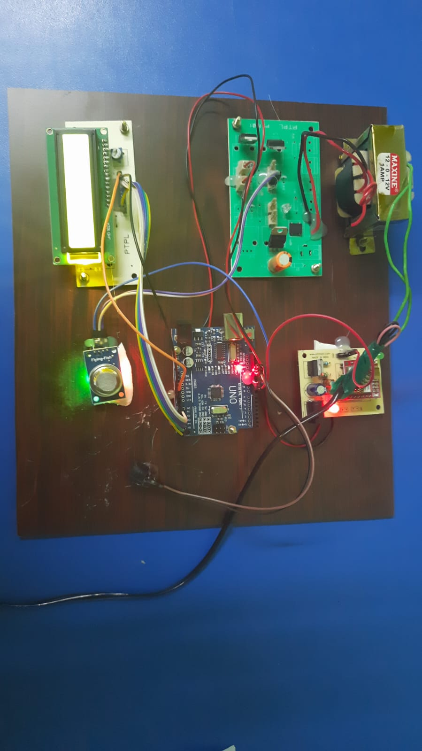

Fig 1. Automatic Gas Leakage Alert System Using Arduino

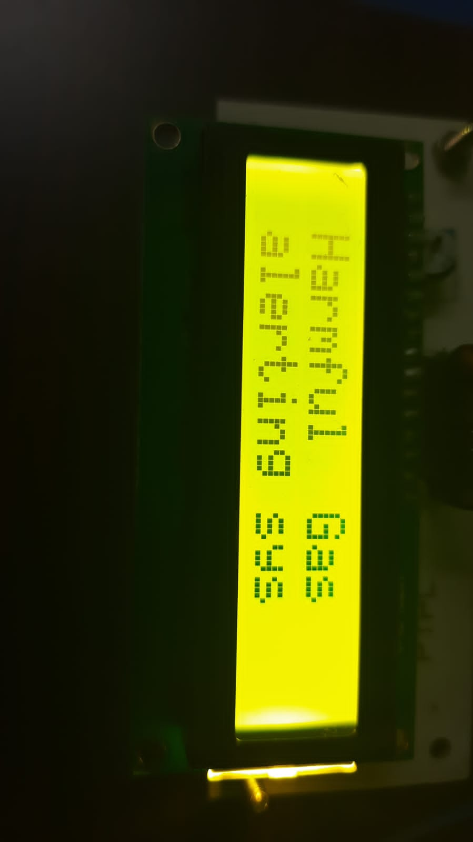

Fig 2. Harmful gas leakage is Detected
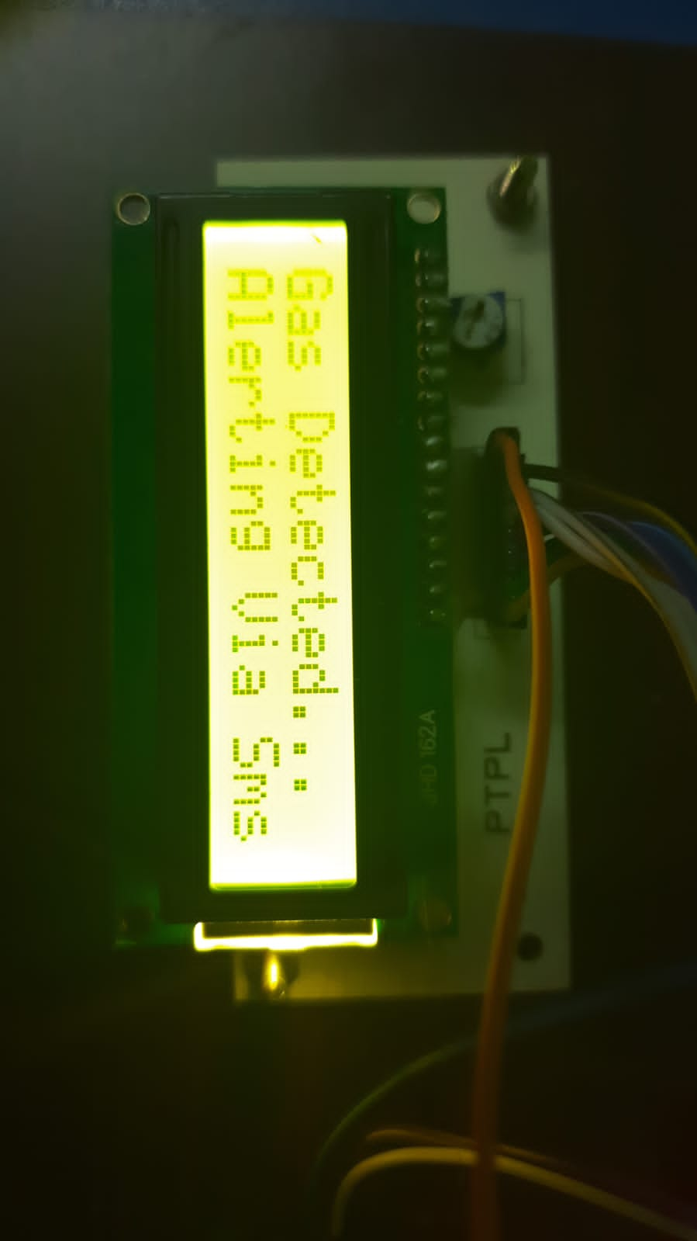
Fig 3. Alerting via SMS

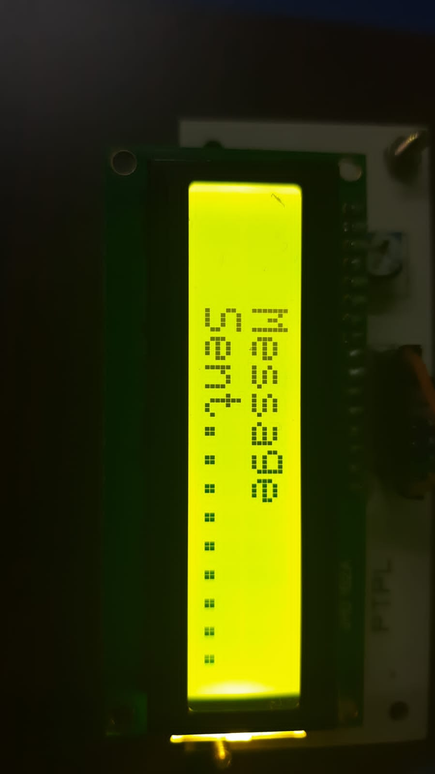

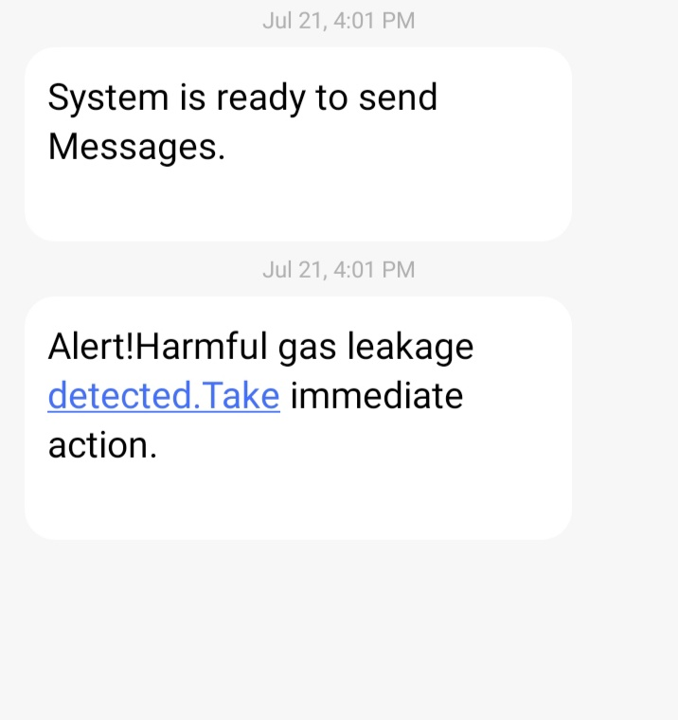

Fig 4. Received an alert message via SMS to the phone

