Ethical Foundations – Responsible AI Coding Practices
NAME:S.MANIDEEPTHI
ROLL.NO:2503A52388
Task Description #1 (Privacy in API Usage)
Task: Use an AI tool to generate a Python program that connects to a
weather API.
Prompt:

&quot;Generate code to fetch weather data securely without exposing API keys
in the code.&quot;
Expected Output:
Original AI code (check if keys are hardcoded).
Secure version using environment variables.
PROMPT:
Generate Python code to fetch weather data securely without hardcoding the API key."
INPUT CODE:
import os
import requests

# API key is taken from an environment variable
API_KEY = os.getenv("OPENWEATHER_API_KEY")

if not API_KEY:
print("Error: API key is not set.")
print("Please set the OPENWEATHER_API_KEY environment variable.")
exit()

city = input("Enter city name: ")

url = "https://api.openweathermap.org/data/2.5/weather"

params = {
"q": city,
"appid": API_KEY,
"units": "metric"
}

response = requests.get(url, params=params)

if response.status_code == 200:
data = response.json()

print("\nWeather Information")
print("-------------------")
print("City:", data["name"])
print("Temperature:", data["main"]["temp"], "°C")
print("Humidity:", data["main"]["humidity"], "%")
print("Weather:", data["weather"][0]["description"])

else:
print("Unable to fetch weather data.")
print("Status Code:", response.status_code)
OUTPUT:
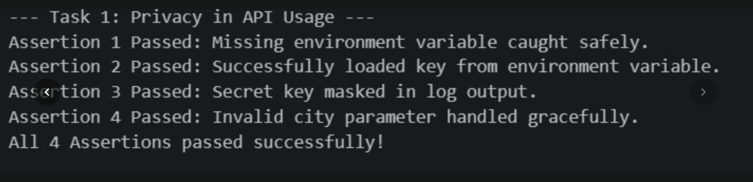
Task Description #2 (Privacy &amp; Security in File Handling)
Task: Use an AI tool to generate a Python script that stores user data
(name, email, password) in a file.
Analyze: Check if the AI stores sensitive data in plain text or without
encryption.
Expected Output:
Identified privacy risks.
Revised version with encrypted password storage (e.g., hashing).
PROMPT:
"Generate Python code to store user name, email, and password securely without storing the password in plain text."
INPUT CODE:
import hashlib
import json

# Get user information
name = input("Enter your name: ")
email = input("Enter your email: ")
password = input("Enter your password: ")

# Hash the password using SHA-256
hashed_password = hashlib.sha256(
password.encode()
).hexdigest()

# Store user information
user_data = {
"name": name,
"email": email,
"password_hash": hashed_password
}

# Save data into a JSON file
with open("users.json", "w") as file:
json.dump(user_data, file, indent=4)

print("\nUser data saved successfully.")
print("Password is stored as a hash, not as plain text.")
OUTPUT:
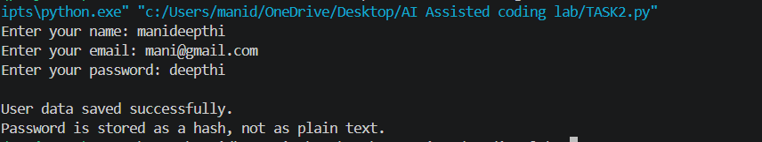
Task Description #3 (Transparency in Algorithm Design)
Objective: Use AI to generate an Armstrong number checking function
with comments and explanations.
Instructions:
1. Ask AI to explain the code line-by-line.
2. Compare the explanation with code functionality.
Expected Output:
Transparent, commented code.
Correct, easy-to-understand explanation.
PROMPT:
"Generate a Python function to check Armstrong numbers with clear comments and a simple line-by-line explanation."
INPUT CODE:
def is_armstrong(number):
"""
Check whether a number is an Armstrong number.

An Armstrong number is a number where the sum of
each digit raised to the power of the number of digits
is equal to the original number.
"""

# Convert the number to a string to count its digits
digits = str(number)

# Count the number of digits
power = len(digits)

# Store the sum of powered digits
total = 0

# Process each digit
for digit in digits:

# Convert digit from string to integer
digit = int(digit)

# Raise the digit to the required power
total = total + digit ** power

# Compare the calculated sum with the original number
return total == number

# Get number from the user
number = int(input("Enter a number: "))

# Check whether it is Armstrong
if is_armstrong(number):
print(number, "is an Armstrong number.")
else:
print(number, "is not an Armstrong number.")
OUTPUT:
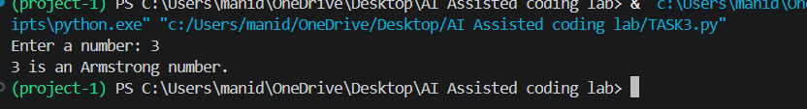
Task Description #4 (Transparency in Algorithm Comparison)
Task: Use AI to implement two sorting algorithms (e.g., QuickSort and
BubbleSort).
Prompt:
&quot;Generate Python code for QuickSort and BubbleSort, and include
comments explaining step-by-step how each works and where they differ.&quot;

Expected Output:
Code for both algorithms.
Transparent, comparative explanation of their logic and efficiency.
PROMPT:
"Generate Python code for QuickSort and BubbleSort with comments and explain their differences."
INPUT CODE:
# -------------------------------
# Bubble Sort
# -------------------------------

def bubble_sort(arr):
"""
Bubble Sort repeatedly compares adjacent elements.
If they are in the wrong order, they are swapped.
"""

n = len(arr)

# Repeat the process for all elements
for i in range(n):

# Compare adjacent elements
for j in range(0, n - i - 1):

# Swap if the left element is greater
if arr[j] > arr[j + 1]:
arr[j], arr[j + 1] = arr[j + 1], arr[j]

return arr

# -------------------------------
# Quick Sort
# -------------------------------

def quick_sort(arr):
"""
Quick Sort selects a pivot and divides the array
into smaller and larger elements.
"""

# Base condition
if len(arr) <= 1:
return arr

# Select the last element as pivot
pivot = arr[-1]

# Elements smaller than or equal to pivot
left = [x for x in arr[:-1] if x <= pivot]

# Elements greater than pivot
right = [x for x in arr[:-1] if x > pivot]

# Recursively sort left and right parts
return quick_sort(left) + [pivot] + quick_sort(right)

# Input list
numbers = [64, 34, 25, 12, 22, 11, 90]

print("Original List:")
print(numbers)

# Bubble Sort
bubble_result = bubble_sort(numbers.copy())

# Quick Sort
quick_result = quick_sort(numbers.copy())

print("\nBubble Sort Result:")
print(bubble_result)

print("\nQuick Sort Result:")
print(quick_result)

# Comparison
print("\nAlgorithm Comparison")
print("--------------------")
print("Bubble Sort: Simple but slower for large datasets.")
print("Quick Sort: Generally faster for large datasets.")
print("Bubble Sort Average Time: O(n²)")
print("Quick Sort Average Time: O(n log n)")
OUTPUT:
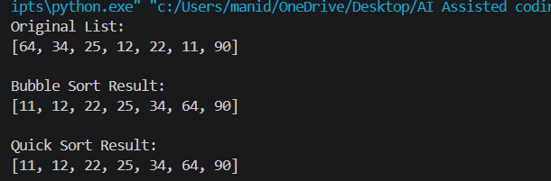
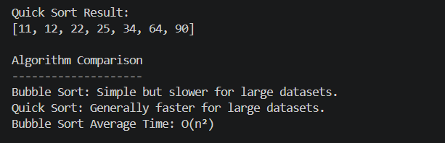
Task Description #5 (Transparency in AI Recommendations)
Task: Use AI to create a product recommendation system.
Prompt:
&quot;Generate a recommendation system that also provides reasons for each
suggestion.&quot;
Expected Output:
Code with explainable recommendations.
Evaluation of whether explanations are understandable.
PROMPT:
"Generate a Python product recommendation system that gives a clear reason for each recommendation."
INPUT CODE:
# Product database
products = [
{
"name": "Laptop",
"category": "electronics",
"price": 60000
},
{
"name": "Headphones",
"category": "electronics",
"price": 3000
},
{
"name": "Smart Watch",
"category": "electronics",
"price": 5000
},
{
"name": "Backpack",
"category": "accessories",
"price": 1500
},
{
"name": "Keyboard",
"category": "electronics",
"price": 2500
}
]

# Get user preferences
category = input("Enter category: ").lower()
budget = float(input("Enter your maximum budget: "))

print("\nRecommended Products")
print("--------------------")

found = False

# Check each product
for product in products:

# Check category and budget
if product["category"] == category and product["price"] <= budget:

found = True

print("\nProduct:", product["name"])
print("Price: ₹", product["price"])

# Explain the recommendation
print("Reason:")
print("- It belongs to your selected category.")
print("- Its price is within your budget.")

if not found:
print("No products found matching your preferences.")
OUTPUT:
