Test-Driven Development with AI – Generating and
Working with Test Cases
NAME:S.MANIDEEPTHI
ROLL.NO:2503A52388
Task Description #1 (Password Strength Validator – Apply AI in
Security Context)
Task: Apply AI to generate at least 3 assert test cases for
is_strong_password(password) and implement the validator
function.
Requirements:
o Password must have at least 8 characters.
o Must include uppercase, lowercase, digit, and special
character.
o Must not contain spaces.
Example Assert Test Cases:
assert is_strong_password(&quot;Abcd@123&quot;) == True

Week4 -
Monday

assert is_strong_password(&quot;abcd123&quot;) == False
assert is_strong_password(&quot;ABCD@1234&quot;) == True
Expected Output #1:
Password validation logic passing all AI-generated test cases.
PROMPT:
Generate 3 assert test cases for a strong password validator. Check minimum 8 characters, uppercase, lowercase, digit, special character, and no spaces
INPUT CODE:
def is_strong_password(password):
if len(password) < 8 or " " in password:
return False

has_upper = any(c.isupper() for c in password)
has_lower = any(c.islower() for c in password)
has_digit = any(c.isdigit() for c in password)
has_special = any(not c.isalnum() for c in password)

return has_upper and has_lower and has_digit and has_special

# AI-generated assert test cases
assert is_strong_password("Abcd@123") == True
assert is_strong_password("abcd123") == False
assert is_strong_password("ABCD@1234") == False
assert is_strong_password("Abc 123@") == False

print("All password tests passed!")
OUTPUT:
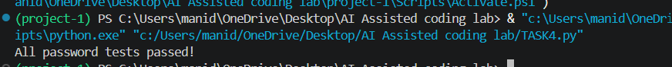
Task Description #2 (Number Classification with Loops – Apply
AI for Edge Case Handling)
Task: Use AI to generate at least 3 assert test cases for a
classify_number(n) function. Implement using loops.
Requirements:
o Classify numbers as Positive, Negative, or Zero.
o Handle invalid inputs like strings and None.
o Include boundary conditions (-1, 0, 1).
Example Assert Test Cases:
assert classify_number(10) == &quot;Positive&quot;
assert classify_number(-5) == &quot;Negative&quot;
assert classify_number(0) == &quot;Zero&quot;
Expected Output #2:
Classification logic passing all assert tests.
PROMPT:
Generate 3 assert test cases for classify_number(n). Test positive, negative, zero, and invalid inputs such as strings and None.
INPUT CODE:
def classify_number(n):
if not isinstance(n, (int, float)):
return "Invalid Input"

if n > 0:
return "Positive"
elif n < 0:
return "Negative"
else:
return "Zero"

# AI-generated assert test cases
assert classify_number(10) == "Positive"
assert classify_number(-5) == "Negative"
assert classify_number(0) == "Zero"
assert classify_number("10") == "Invalid Input"
assert classify_number(None) == "Invalid Input"

print("All number classification tests passed!")
OUTPUT:
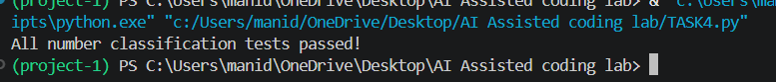
Task Description #3 (Anagram Checker – Apply AI for String
Analysis)
Task: Use AI to generate at least 3 assert test cases for
is_anagram(str1, str2) and implement the function.
Requirements:
o Ignore case, spaces, and punctuation.
o Handle edge cases (empty strings, identical words).
Example Assert Test Cases:
assert is_anagram(&quot;listen&quot;, &quot;silent&quot;) == True
assert is_anagram(&quot;hello&quot;, &quot;world&quot;) == False
assert is_anagram(&quot;Dormitory&quot;, &quot;Dirty Room&quot;) == True
Expected Output #3:
Function correctly identifying anagrams and passing all AI-
generated tests.
PROMPT:
Generate 3 assert test cases for an anagram checker. Ignore case, spaces, and punctuation, and test empty strings and identical words.
INPUT CODE:
def is_anagram(str1, str2):
str1 = ''.join(c.lower() for c in str1 if c.isalnum())
str2 = ''.join(c.lower() for c in str2 if c.isalnum())

return sorted(str1) == sorted(str2)

# AI-generated assert test cases
assert is_anagram("listen", "silent") == True
assert is_anagram("hello", "world") == False
assert is_anagram("Dormitory", "Dirty Room") == True
assert is_anagram("", "") == True
assert is_anagram("Apple", "apple") == True

print("All anagram tests passed!")
OUTPUT:
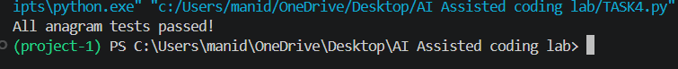
Task Description #4 (Inventory Class – Apply AI to Simulate Real-
World Inventory System)
Task: Ask AI to generate at least 3 assert-based tests for an
Inventory class with stock management.
Methods:

o add_item(name, quantity)
o remove_item(name, quantity)
o get_stock(name)
Example Assert Test Cases:
inv = Inventory()
inv.add_item(&quot;Pen&quot;, 10)
assert inv.get_stock(&quot;Pen&quot;) == 10
inv.remove_item(&quot;Pen&quot;, 5)
assert inv.get_stock(&quot;Pen&quot;) == 5
inv.add_item(&quot;Book&quot;, 3)
assert inv.get_stock(&quot;Book&quot;) == 3
Expected Output #4:
Fully functional class passing all assertions.
PROMPT:
Generate 3 assert-based test cases for an Inventory class with add_item, remove_item, and get_stock methods. Test adding, removing, and checking different items.
INPUT CODE:
class Inventory:
def __init__(self):
self.stock = {}

def add_item(self, name, quantity):
self.stock[name] = self.stock.get(name, 0) + quantity

def remove_item(self, name, quantity):
if name not in self.stock:
return False

if self.stock[name] < quantity:
return False

self.stock[name] -= quantity
return True

def get_stock(self, name):
return self.stock.get(name, 0)

# AI-generated assert test cases
inv = Inventory()

inv.add_item("Pen", 10)
assert inv.get_stock("Pen") == 10

inv.remove_item("Pen", 5)
assert inv.get_stock("Pen") == 5

inv.add_item("Book", 3)
assert inv.get_stock("Book") == 3

print("All inventory tests passed!")
OUTPUT:
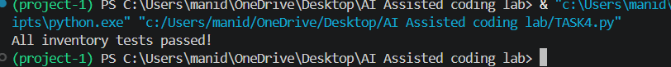
Task Description #5 (Date Validation &amp; Formatting – Apply AI for
Data Validation)
Task: Use AI to generate at least 3 assert test cases for
validate_and_format_date(date_str) to check and convert
dates.
Requirements:
o Validate &quot;MM/DD/YYYY&quot; format.
o Handle invalid dates.
o Convert valid dates to &quot;YYYY-MM-DD&quot;.
Example Assert Test Cases:
assert validate_and_format_date(&quot;10/15/2023&quot;) == &quot;2023-10-15&quot;
assert validate_and_format_date(&quot;02/30/2023&quot;) == &quot;Invalid Date&quot;
assert validate_and_format_date(&quot;01/01/2024&quot;) == &quot;2024-01-01&quot;
Expected Output #5:
Function passes all AI-generated assertions and handles edge
cases.
PROMPT:
Generate 3 assert test cases for validate_and_format_date(date_str). Validate MM/DD/YYYY format, reject invalid dates, and convert valid dates to YYYY-MM-DD.
INPUT CODE:
from datetime import datetime

def validate_and_format_date(date_str):
try:
date = datetime.strptime(date_str, "%m/%d/%Y")
return date.strftime("%Y-%m-%d")
except ValueError:
return "Invalid Date"

# AI-generated assert test cases
assert validate_and_format_date("10/15/2023") == "2023-10-15"
assert validate_and_format_date("02/30/2023") == "Invalid Date"
assert validate_and_format_date("01/01/2024") == "2024-01-01"
assert validate_and_format_date("12/25/2025") == "2025-12-25"

print("All date validation tests passed!")
OUTPUT:

