AI ASSISTED CODING
LAB-4
NAME:S.MANIDEEPTHI
ROLL.NO:2502A52388
BATCH:13

1. Palindrome Number — Zero-Shot Prompting
Objective: To use zero-shot prompting to generate a Python program that checks whether a given number is a palindrome, without providing any examples, and to evaluate the generated code using multiple test cases and edge cases.
CODE:
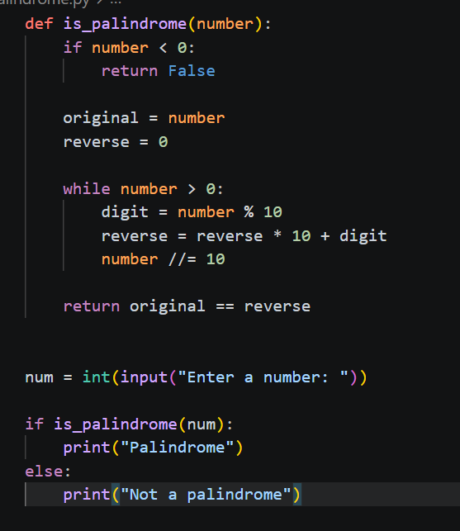
OUTPUT:
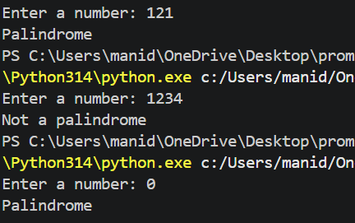
2. Factorial Calculation — One-Shot Prompting
Objective: To use one-shot prompting by providing a single input-output example to generate a Python program for calculating the factorial of a given number, and to analyze how the example influences the clarity and correctness of the generated code.
CODE:
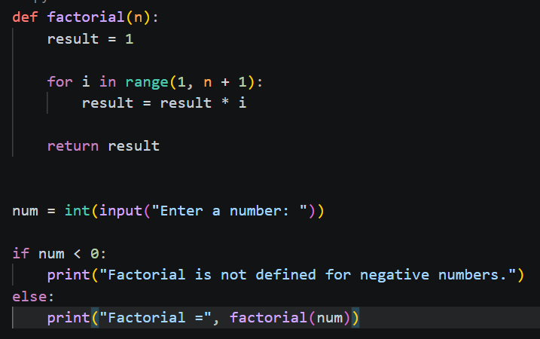
OUTPUT:
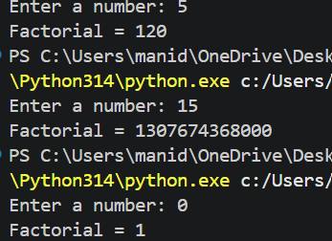
3. Armstrong Number — Few-Shot Prompting
Objective: To use few-shot prompting with multiple input-output examples to generate a Python program that checks whether a given number is an Armstrong number, and to evaluate the influence of multiple examples on the accuracy and structure of the generated code.
CODE:
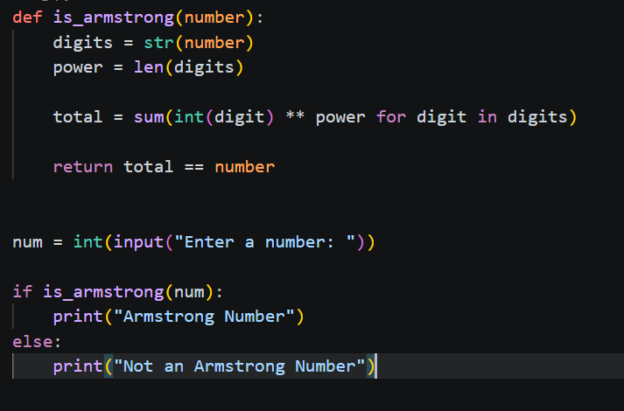
OUTPUT:
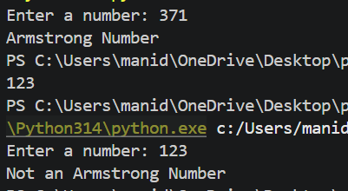
4. Perfect Number — Zero-Shot Prompting
Objective: To use zero-shot prompting to generate a Python program that checks whether a given number is a perfect number, and to identify missing conditions, edge cases, and possible inefficiencies in the AI-generated solution.
CODE:
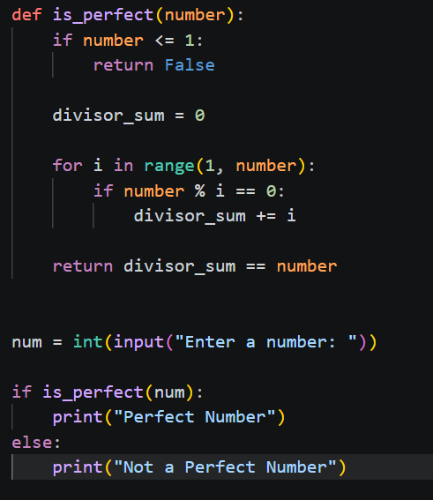
OUTPUT:
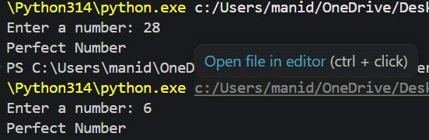
5. Even or Odd Classification — Few-Shot Prompting
Objective: To use few-shot prompting with multiple input-output examples to generate a Python program that classifies a number as even or odd, while incorporating proper input validation and testing the program with negative and non-integer inputs.
CODE:
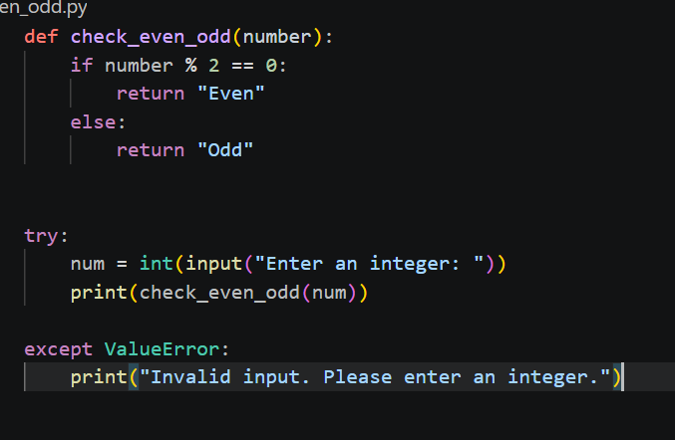
OUTPUT:
