Algorithms with AI Assistance – Sorting, Searching,
and Optimizing Algorithms
Name:s.manideepthi
Roll.no:2503a52388
Task Description #1 (Sorting – Merge Sort Implementation)
Task: Use AI to generate a Python program that implements
the Merge Sort algorithm.
Instructions:
o Prompt AI to create a function merge_sort(arr) that
sorts a list in ascending order.
o Ask AI to include time complexity and space
complexity in the function docstring.
o Verify the generated code with test cases.
Expected Output:
o A functional Python script implementing Merge Sort
with proper documentation.
PROMPT:
Write a Python program to implement Merge Sort using
a function merge_sort(arr). Sort the elements in ascending
order. Include time complexity and space complexity
in the docstring. Test the program with different inputs.
CODE:
def merge_sort(arr):
"""
Merge Sort Algorithm

Time Complexity:
Best Case: O(n log n)
Average Case: O(n log n)
Worst Case: O(n log n)

Space Complexity: O(n)
"""

if len(arr) <= 1:
return arr

mid = len(arr) // 2

left = merge_sort(arr[:mid])
right = merge_sort(arr[mid:])

result = []
i = 0
j = 0

while i < len(left) and j < len(right):
if left[i] <= right[j]:
result.append(left[i])
i += 1
else:
result.append(right[j])
j += 1

result.extend(left[i:])
result.extend(right[j:])

return result

# Test Cases
numbers = [38, 27, 43, 3, 9, 82, 10]

print("Original List:", numbers)
print("Sorted List:", merge_sort(numbers))
print("Test 2:", merge_sort([5, 2, 8, 1]))
print("Test 3:", merge_sort([]))
OUTPUT:
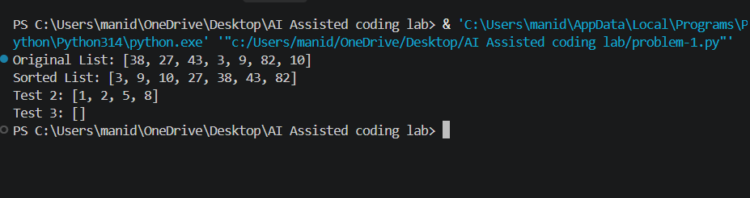
Task Description #2 (Searching – Binary Search with AI
Optimization)
Task: Use AI to create a binary search function that finds a
target element in a sorted list.
Instructions:
o Prompt AI to create a function binary_search(arr,
target) returning the index of the target or -1 if not
found.
o Include docstrings explaining best, average, and
worst-case complexities.
o Test with various inputs.
Expected Output:
o Python code implementing binary search with AI-
generated comments and docstrings.
PROMPT:
Write a Python program implementing iterative Binary
Search using binary_search(arr, target).

Return the index if the target is found, otherwise return -1.
Include best, average and worst-case time complexities.
Test with different inputs.
CODE:
def binary_search(arr, target):
"""
Binary Search Algorithm

Best Case: O(1)
Average Case: O(log n)
Worst Case: O(log n)

Space Complexity: O(1)
"""

low = 0
high = len(arr) - 1

while low <= high:

mid = (low + high) // 2

if arr[mid] == target:
return mid

elif arr[mid] < target:
low = mid + 1

else:
high = mid - 1

return -1

# Test Cases
arr = [10, 20, 30, 40, 50, 60, 70]

print("Array:", arr)
print("Search 40:", binary_search(arr, 40))
print("Search 90:", binary_search(arr, 90))
print("Search 10:", binary_search(arr, 10))
OUTPUT:
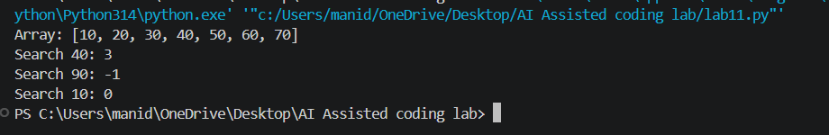
Task Description #3 (Real-Time Application – Inventory
Management System)
Scenario: A retail store’s inventory system contains
thousands of products, each with attributes like product ID,
name, price, and stock quantity. Store staff need to:
1. Quickly search for a product by ID or name.
2. Sort products by price or quantity for stock analysis.
Task:
o Use AI to suggest the most efficient search and sort
algorithms for this use case.
o Implement the recommended algorithms in Python.
o Justify the choice based on dataset size, update
frequency, and performance requirements.

Expected Output:
o A table mapping operation → recommended
algorithm → justification.
o Working Python functions for searching and sorting
the inventory.
PROMPT:
Create a Python Inventory Management System.

Each product should contain product ID, name, price
and quantity.

Implement searching by product ID and product name.
Implement sorting by price and quantity.

Use efficient searching and sorting algorithms.
Explain their time complexities.
CODE:
products = [
{"id": 101, "name": "Laptop", "price": 50000, "quantity": 10},
{"id": 102, "name": "Mouse", "price": 500, "quantity": 50},
{"id": 103, "name": "Keyboard", "price": 1000, "quantity": 30},
{"id": 104, "name": "Monitor", "price": 12000, "quantity": 15}
]

# Search by Product ID
def search_product_id(product_id):
product_index = {p["id"]: p for p in products}
return product_index.get(product_id)

# Search by Product Name
def search_product_name(name):
for product in products:
if product["name"].lower() == name.lower():
return product
return None

# Sort by Price
def sort_by_price():
return sorted(products, key=lambda x: x["price"])

# Sort by Quantity
def sort_by_quantity():
return sorted(products, key=lambda x: x["quantity"])

print("Search Product ID 103:")
print(search_product_id(103))

print("\nSearch Product Name Mouse:")
print(search_product_name("Mouse"))

print("\nProducts Sorted by Price:")
for p in sort_by_price():
print(p)

print("\nProducts Sorted by Quantity:")
for p in sort_by_quantity():
print(p)
OUTPUT:
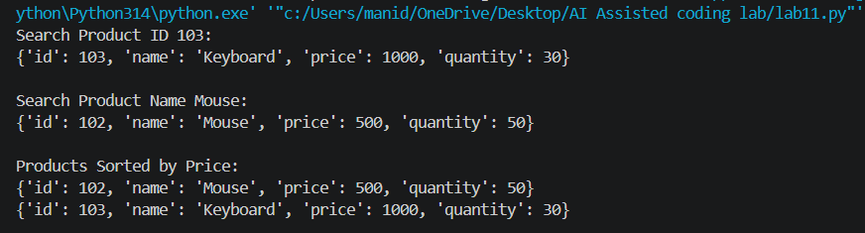
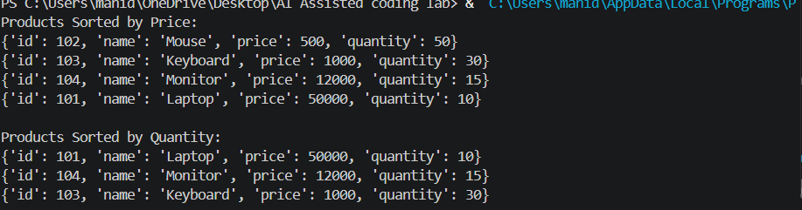
Task description #4: Smart Hospital Patient Management
System
A hospital maintains records of thousands of patients with details
such as patient ID, name, severity level, admission date, and bill
amount. Doctors and staff need to:

1. Quickly search patient records using patient ID or name.
2. Sort patients based on severity level or bill amount for
prioritization and billing.
Student Task
Use AI to recommend suitable searching and sorting
algorithms.
Justify the selected algorithms in terms of efficiency and
suitability.
Implement the recommended algorithms in Python.
PROMPT:
Write a Python program for a Hospital Patient Management
System.

Store patient ID, name, severity level, admission date
and bill amount.

Implement searching by patient ID and patient name.
Sort patients by severity and bill amount.
Use efficient searching and sorting algorithms.
Code:
patients = [
{"id": 201, "name": "Rahul", "severity": 1,
"date": "2026-11-01", "bill": 25000},

{"id": 202, "name": "Ananya", "severity": 3,
"date": "2026-11-02", "bill": 12000},

{"id": 203, "name": "Kiran", "severity": 2,
"date": "2026-11-03", "bill": 18000},

{"id": 204, "name": "Meera", "severity": 1,
"date": "2026-11-04", "bill": 30000}
]

def search_patient_id(patient_id):
patient_index = {p["id"]: p for p in patients}
return patient_index.get(patient_id)

def search_patient_name(name):
for p in patients:
if p["name"].lower() == name.lower():
return p
return None

def sort_by_severity():
return sorted(patients, key=lambda x: x["severity"])

def sort_by_bill():
return sorted(patients, key=lambda x: x["bill"], reverse=True)

print("Search Patient ID 202:")
print(search_patient_id(202))

print("\nSearch Patient Name Rahul:")
print(search_patient_name("Rahul"))

print("\nPatients Sorted by Severity:")
for p in sort_by_severity():
print(p)

print("\nPatients Sorted by Bill:")
for p in sort_by_bill():
print(p)
OUTPUT:

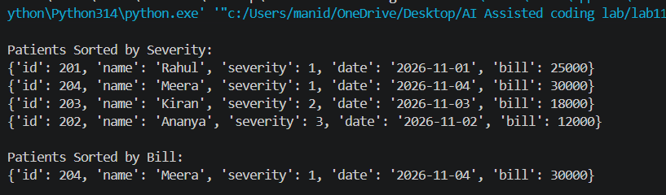
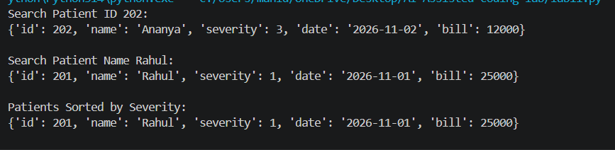

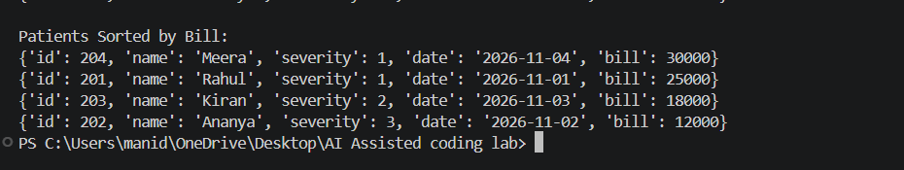
Task Description #5: University Examination Result Processing
System
A university processes examination results for thousands of students
containing roll number, name, subject, and marks. The system must:
1. Search student results using roll number.
2. Sort students based on marks to generate rank lists.
Student Task
Identify efficient searching and sorting algorithms using AI
assistance.
Justify the choice of algorithms.
Implement the algorithms in Python.
PROMPT:
Write a Python program for University Examination
Result Processing.

Store roll number, name, subject and marks.

Implement searching by roll number.
Sort students based on marks to generate rank lists.

Use efficient searching and sorting algorithms.
Explain time complexity.
CODE:
students = [
{"roll": 101, "name": "Asha", "subject": "Python", "marks": 85},
{"roll": 102, "name": "Rahul", "subject": "Python", "marks": 92},
{"roll": 103, "name": "Kiran", "subject": "Python", "marks": 76},
{"roll": 104, "name": "Meena", "subject": "Python", "marks": 95}
]

def search_student(roll_no):
student_index = {s["roll"]: s for s in students}
return student_index.get(roll_no)

def sort_students():
return sorted(students, key=lambda x: x["marks"], reverse=True)

print("Search Roll Number 102:")
print(search_student(102))

print("\nStudent Rank List:")

rank = 1

for student in sort_students():
print(rank, student["name"], student["marks"])
rank += 1
OUTPUT:
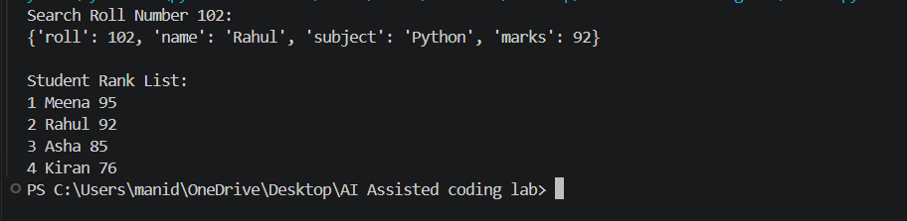
Task Description #6: Online Food Delivery Platform
An online food delivery application stores thousands of orders with
order ID, restaurant name, delivery time, price, and order status. The
platform needs to:
1. Quickly find an order using order ID.
2. Sort orders based on delivery time or price.
Student Task
Use AI to suggest optimized algorithms.
Justify the algorithm selection.

Implement searching and sorting modules in Python.
PROMPT:
Write a Python program for an Online Food Delivery
Platform.

Store order ID, restaurant name, delivery time, price
and order status.

Implement searching by order ID.
Sort orders by delivery time and price.

Use efficient searching and sorting algorithms.
Explain time complexity.
CODE:
orders = [
{"id": 501, "restaurant": "Pizza Hut",
"time": 30, "price": 500, "status": "Delivered"},

{"id": 502, "restaurant": "Dominos",
"time": 20, "price": 350, "status": "Preparing"},

{"id": 503, "restaurant": "KFC",
"time": 45, "price": 600, "status": "On the way"},

{"id": 504, "restaurant": "Burger King",
"time": 25, "price": 250, "status": "Delivered"}
]

def search_order(order_id):
order_index = {o["id"]: o for o in orders}
return order_index.get(order_id)

def sort_by_delivery_time():
return sorted(orders, key=lambda x: x["time"])

def sort_by_price():
return sorted(orders, key=lambda x: x["price"])

print("Search Order ID 502:")
print(search_order(502))

print("\nOrders Sorted by Delivery Time:")
for o in sort_by_delivery_time():
print(o)

print("\nOrders Sorted by Price:")
for o in sort_by_price():
print(o)
OUTPUT:


