Documentation Generation -Automatic
documentation and code comments
NAME:S.MANIDEEPTHI
ROLL.NO:2503A52388
PROBLEM-1
Consider the following Python function:
def find_max(numbers):
return max(numbers)
Task:
• Write documentation for the function in all three formats:
(a) Docstring
(b) Inline comments
(c) Google-style documentation
Critically compare the three approaches. Discuss the
advantages, disadvantages, and suitable use cases of each
style.
Recommend which documentation style is most effective
for a mathematical utilities library and justify your
answer.
PROMPT:
Generate documentation for the find_max(numbers) Python function in three formats: simple docstring, inline comments, and Google-style documentation. Also compare their advantages, disadvantages, and suitable use cases, and recommend the best style for a mathematical utilities library.
INPUT CODE:
- Docstring
def find_max(numbers):
"""Return the maximum value from a list of numbers."""
return max(numbers)

numbers = [10, 25, 7, 40, 15]
print("Maximum value:", find_max(numbers))
- Inline comments
def find_max(numbers):
# Find and return the largest number in the list
return max(numbers)

numbers = [10, 25, 7, 40, 15]
print("Maximum value:", find_max(numbers))
- Google-style documentation
def find_max(numbers):
"""Find the maximum value in a list of numbers.

Args:
numbers (list): A list of numeric values.

Returns:
int or float: The largest value in the list.
"""
return max(numbers)

numbers = [10, 25, 7, 40, 15]
print("Maximum value:", find_max(numbers))
OUTPUT:
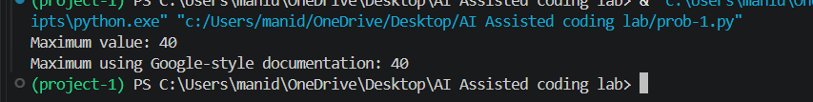
COMPARISION TABLE:
Style | Advantages | Disadvantages
DOC-STRING | Simple, readable, available through help() | Less detailed
INLINE-COMMENTS | Easy to understand individual steps | Can become outdated and does not appear in documentation tools
Google-style | Detailed, structured, professional | Takes more time to write

Problem 2: Consider the following Python function:
def login(user, password, credentials):
return credentials.get(user) == password
Task:
1. Write documentation in all three formats.
2. Critically compare the approaches.
3. Recommend which style would be most helpful for new
developers onboarding a project, and justify your choice.
PROMPT:
Generate documentation for the login(user, password, credentials) Python function in three formats: simple docstring, inline comments, and Google-style documentation. Compare the three approaches and recommend the best style for new developers onboarding a project.
INPUT CODE:
(1) Docstring
def login(user, password, credentials):
"""Check whether the username and password are valid."""
return credentials.get(user) == password

credentials = {
"admin": "1234",
"student": "abcd"
}

print(login("admin", "1234", credentials))
(2) Inline comments
def login(user, password, credentials):
# Get the stored password for the user
# Compare it with the password provided
return credentials.get(user) == password

credentials = {
"admin": "1234",
"student": "abcd"
}

print(login("admin", "1234", credentials))
(3) Google-style documentation
def login(user, password, credentials):
"""Validate a user's login credentials.

Args:
user (str): Username entered by the user.
password (str): Password entered by the user.
credentials (dict): Dictionary containing usernames and passwords.

Returns:
bool: True if credentials are valid, otherwise False.
"""
return credentials.get(user) == password

credentials = {
"admin": "1234",
"student": "abcd"
}

print(login("admin", "1234", credentials))
OUTPUT:
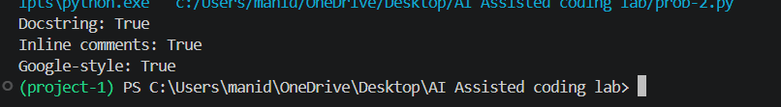
COMPARISION TABLE:
Aspect | Docstring | Inline Comments | Google-Style Documentation
Purpose | Gives a short description of the function | Explains specific steps or logic | Gives detailed and structured information
Advantages | Easy to write, keeps code clean, available through help() | Easy to understand program flow and logic | Clearly explains parameters, return values, and purpose
Disadvantages | Less detailed | Can become outdated and is less structured | Takes more time to write
Readability | Good | Good for understanding individual steps | Very good
Suitable for | Small/simple functions | Complex logic or specific code steps | Large projects, libraries, and team projects
Use in onboarding | Moderate | Limited | Excellent
Recommendation | Good for simple functions | Good as additional explanation | Best for new developers
PROBLEM-3
Calculator (Automatic Documentation Generation)
Task: Design a Python module named calculator.py and
demonstrate automatic documentation generation.
Instructions:
1. Create a Python module calculator.py that includes the
following functions, each written with appropriate docstrings:
o add(a, b) – returns the sum of two numbers
o subtract(a, b) – returns the difference of two numbers
o multiply(a, b) – returns the product of two numbers
o divide(a, b) – returns the quotient of two numbers
2. Display the module documentation in the terminal using
Python’s documentation tools.
3. Generate and export the module documentation in HTML

format using the pydoc utility, and open the generated HTML
file in a web browser to verify the output.
PROMPT:
Create a calculator.py module with add, subtract, multiply, and divide functions. Add clear Google-style docstrings to each function and show how to generate terminal and HTML documentation using Python pydoc.
INPUT CODE:
"""Calculator module providing basic mathematical operations."""

def add(a, b):
"""Return the sum of two numbers.

Args:
a (int or float): First number.
b (int or float): Second number.

Returns:
int or float: Sum of a and b.
"""
return a + b

def subtract(a, b):
"""Return the difference between two numbers.

Args:
a (int or float): First number.
b (int or float): Second number.

Returns:
int or float: Difference between a and b.
"""
return a - b

def multiply(a, b):
"""Return the product of two numbers.

Args:
a (int or float): First number.
b (int or float): Second number.

Returns:
int or float: Product of a and b.
"""
return a * b

def divide(a, b):
"""Return the quotient of two numbers.

Args:
a (int or float): Dividend.
b (int or float): Divisor.

Returns:
float: Quotient of a and b.

Raises:
ZeroDivisionError: If b is zero.
"""
if b == 0:
raise ZeroDivisionError("Cannot divide by zero")
return a / b
import calculator

print("Addition:", calculator.add(10, 5))
print("Subtraction:", calculator.subtract(10, 5))
print("Multiplication:", calculator.multiply(10, 5))
print("Division:", calculator.divide(10, 5))
OUTPUT:
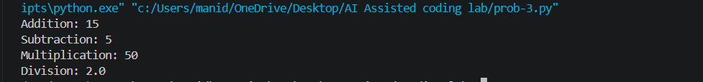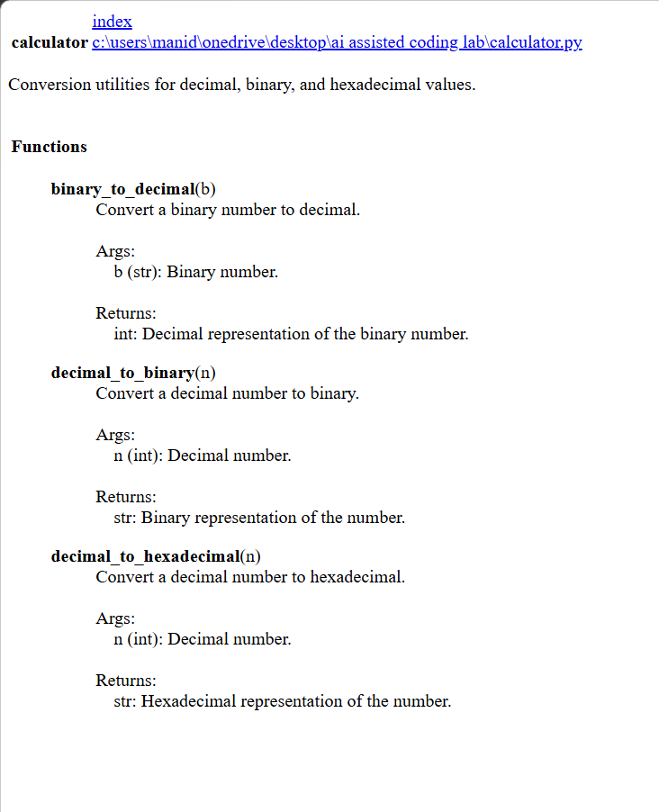
PROBLEM-4:
Conversion Utilities Module
Task:
1. Write a module named conversion.py with functions:
o decimal_to_binary(n)
o binary_to_decimal(b)
o decimal_to_hexadecimal(n)
2. Use Copilot for auto-generating docstrings.
3. Generate documentation in the terminal.
4. Export the documentation in HTML format and open it in a
browser.
PROMPT:
Create a conversion.py module with decimal_to_binary, binary_to_decimal, and decimal_to_hexadecimal functions. Generate clear Google-style docstrings for all functions and explain how to generate terminal and HTML documentation using pydoc.
INPUT CODE:
"""Conversion utilities for decimal, binary, and hexadecimal values."""

def decimal_to_binary(n):
"""Convert a decimal number to binary.

Args:
n (int): Decimal integer.

Returns:
str: Binary representation of the number.
"""
return bin(n)[2:]

def binary_to_decimal(b):
"""Convert a binary number to decimal.

Args:
b (str): Binary number as a string.

Returns:
int: Decimal representation of the binary number.
"""
return int(b, 2)

def decimal_to_hexadecimal(n):
"""Convert a decimal number to hexadecimal.

Args:
n (int): Decimal integer.

Returns:
str: Hexadecimal representation of the number.
"""
return hex(n)[2:]

if __name__ == "__main__":
print("Decimal to Binary:", decimal_to_binary(10))
print("Binary to Decimal:", binary_to_decimal("1010"))
print("Decimal to Hexadecimal:", decimal_to_hexadecimal(255))
OUTPUT:
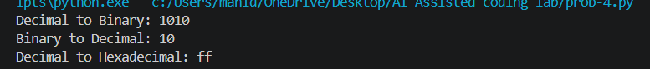
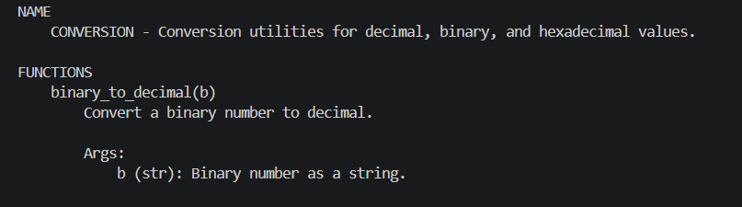
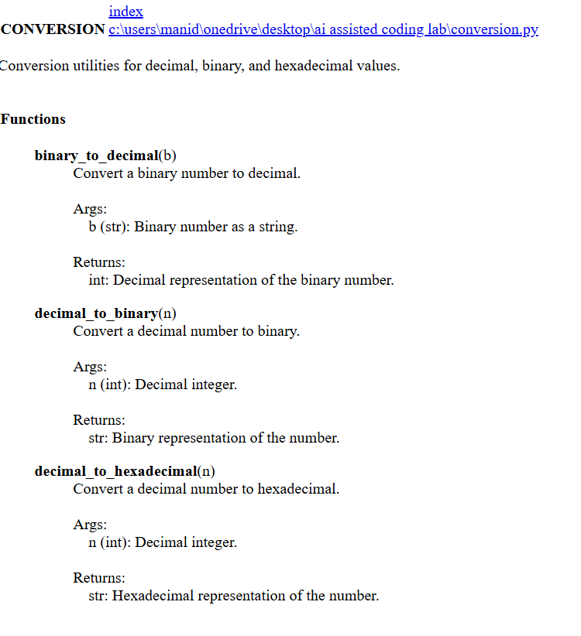
PROBLEM-5:
Course Management Module
Task:
1. Create a module course.py with functions:
o add_course(course_id, name, credits)
o remove_course(course_id)
o get_course(course_id)
2. Add docstrings with Copilot.
3. Generate documentation in the terminal.
4. Export the documentation in HTML format and open it in a
browser.
PROMPT:
Create a course.py module with add_course, remove_course, and get_course functions. Add Google-style docstrings using Copilot and show how to generate terminal and HTML documentation using Python pydoc.
INPUT CODE:
"""Course management module for adding, removing, and retrieving courses."""

courses = {}

def add_course(course_id, name, credits):
"""Add a new course to the course collection.

Args:
course_id (str): Unique ID of the course.
name (str): Name of the course.
credits (int): Number of credits for the course.

Returns:
str: Confirmation message.
"""
courses[course_id] = {
"name": name,
"credits": credits
}
return "Course added successfully"

def remove_course(course_id):
"""Remove a course using its course ID.

Args:
course_id (str): ID of the course to remove.

Returns:
str: Confirmation or error message.
"""
if course_id in courses:
del courses[course_id]
return "Course removed successfully"
return "Course not found"

def get_course(course_id):
"""Retrieve course details using the course ID.

Args:
course_id (str): ID of the course to retrieve.

Returns:
dict or None: Course details if found, otherwise None.
"""
return courses.get(course_id)

if __name__ == "__main__":
print(add_course("C101", "Python Programming", 4))
print(add_course("C102", "Database Management", 3))

print("Course:", get_course("C101"))

print(remove_course("C102"))

print("All Courses:", courses)
OUTPUT:
