Bangalore, Karnataka

## +91 9495188810

[**deepthivjainlal@gmail.com**](mailto:deepthivjainlal@gmail.com)

**Linkedin**

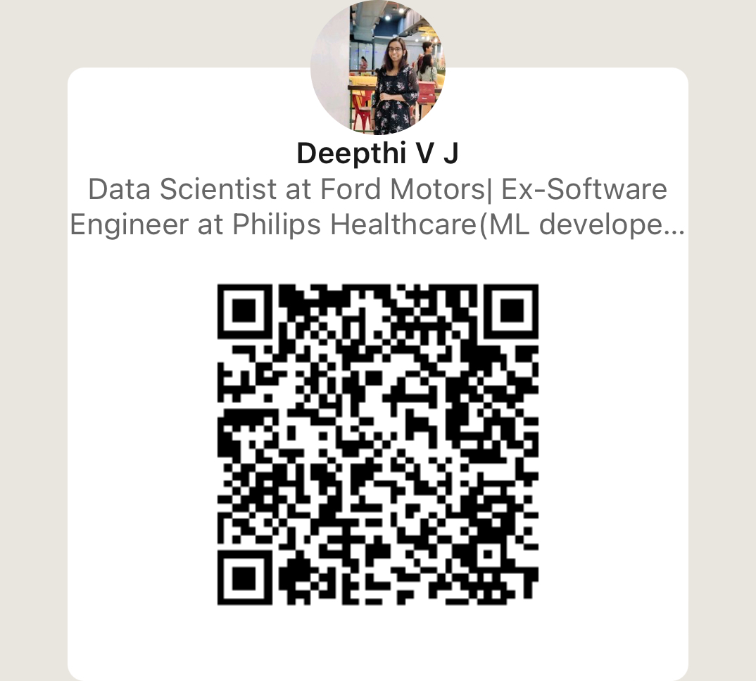

DEEPTHI V J

Dedicated Machine Learning Developer with a proven track record in designing and developing machine learning models to solve real-world problems. Seeking an opportunity to leverage my expertise in ML algorithms, data analysis, and programming skills to drive innovation in a dynamic organization

10-Emotion based music player-

It plays music based on the emotion detected using camera. Used Convolutional neural network (CNN

) and openCV library.

9-Melanoma skin cancer diagnosis- Using convolutional neural networks algorithm, python

8-Corona Probability Prediction(Hackethon)- Using convolutional neural networks algorithm, python



7-Nuts and Bolts cost Analysis

Worked on predicting Nuts and Bolts price prediction using regression .Did Feature engineering,Created Alteryx App,Worked on Qlik sense dashboard USING **– python, alteryx, Qlik Sense, Regression**

6-Totel landed cost

Worked on Total landed cost prediction for supply chain USING **xgboost, python and alteryx, GCP**



5-Test Automation

Used to test Support tool automatically

* Used Gherkin ,SpecFlow and c#

4-Background Upgrade POC

* Used to upgrade patient monitors using specific policies in background
* Used C# ,GRPC

3-SUPPORT TOOL

* Used to service and upgrade PHILIPS Intelliview patient monitors
* Used c#, .Net 4.8,WPF,GRPC 4-Background Upgrade POC
* Used to upgrade patient monitors using specific policies in background
* Used C# ,GRPC

2-Synthetic data generation and Organisational risk forecasting(RANOMETER) (PRESENT as ML developer)

Used random forest for determining required KRI(risk indicator)s and Used Linear regression for RAN (risk analysing number) value forecasting.

* Finding Synthetic data using different models(Experimented with **GANs**)
* Finding relationship between data using **mutual information score , correlation matrix**
* Done data analysis **using network diagrams ,clustering and working on monte carlo simulation**

COURSES

* + - Introduction to Large language models-2024
    - Introduction to responsible AI-2024
    - Introduction to SQL for Bigquery and Cloud SQL -2023
    - Introduction to ROS2-2021
    - Neural Networks and Deep Learning Issued by Coursera-2020
    - Python for Data Science and AI by IBM on Coursera-2020
    - R Programming Issued by Coursera- 2020
    - AMCAT Certificate On Data Processing Specialist-2018
    - National Programming Aptitude Test Certified by NPTEL.-2017
    - Introduction To Modern Application Development- 2017 Certified by IIT Madras

11-Mela Urban sound classification-

Compared dilated convolutional neural network (DILATED CNN), Artificial neural network (ANN) and convolutional neural network without dilation (CNN) and compared their efficiency over Urban sound data.

Got better accuracy for dilated convolutional neural network (DILATED CNN) with dilation 2.

**EDUCATION**

* 1. MTech (20**19** -20**21**) — **VIT Vellore**. ***Artificial Intelligence and Machine Learning***

# GPA 8.4/10.00

* 1. BTech (20**14**-201**8**) — **SNMIMT**. ***Computer Science and Engineering***

# GPA 7.2/10.00

**TECHNICAL SKILLS**

Machine Learning. C#, Docker, Python, Pytorch, Neural Networks, Deep Learning, GCP, Alteryx, Qlik Sense, NLP, Data structures and Algorithms, Data Science, GRPC, WPF, Clustering, Classification, Software Development, Data Visualization, Data Analysis, Image Segmentation, Object Detection



1-Semantic segmentation over fetal heart images(Internship)-

* Compared algorithms **- HRNet ,Unet3+, Resunet++, MobilenetV2, Resnet ,Unet+ +**

## ,NNunet and got better result for NNunet for semantic segmentation of the images.

* Used **YOLOv3** for detecting thorax
* Created **annotated** images using VGG Annotator
* Working on images under different axial view of fetal heart.

PROJECTS

**WORK EXPERIANCE**

* 1. Ford Motors— ***Data Scientist***

***December 2023-Present***

* *Worked on* ***Machine learning Models, Regression, Python, Alteryx, GCP, Data Analysis, Feature Engineering, ETL, Qlik Sense***
  1. Philips — ***ML Developer(GIG)***

# January 2023 – December 2023

* + - * Worked on Ranometer project to **forecast** RAN(Risk Analysis Number) values,
      * **Synthetic data generation** for KRI(Key Risk Indicators) values
      * **Analysis of risk data** using network diagrams and Machine Learning Algorithms
      * Worked on **Monte Carlo Simulation** to do Risk data analysis
  1. Philips — ***Software engineer I***

# August 2021 - December2023

* worked on **POCS**, **Support tool project** to support patient monitors in hospitals. In addition to that, I played a role in developing a **simulator** for patient monitors and implementing **test automation project**. The technologies used in this project included .NET, GRPC, WPF, WCF, Docker, and UDP
* Worked using Agile Approach
  1. Philips — **Research Intern**

# September 2020– August 2021

* Worked on Semantic segmentation of fetal heart view plane images **using deep learning algorithms and used dice score as evaluation matrix.**