Session 10 Assignment 2

Load data into hbase using Pig Script

First, transfer the file student.txt (sample data) to hdfs.

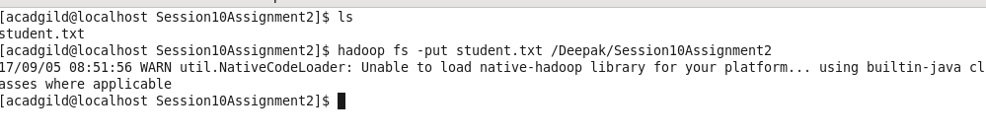
Make sure that the file has been transferred.

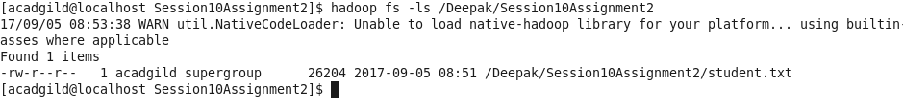
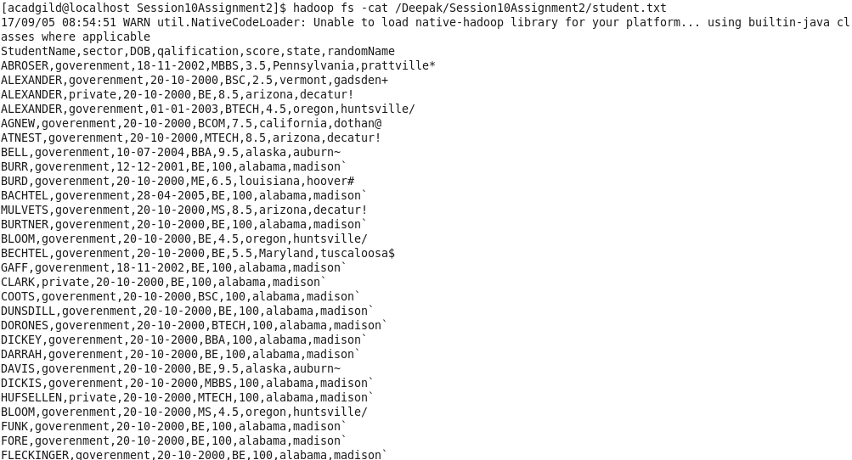
Export PIG_CLASSPATH=/usr/local/hbase/lib/hbase-server-0.98.14-hadoop2.jar:/usr/local/hbase/lib/hbase-*.jar

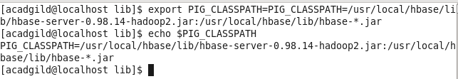

Start hbase

hbase shell

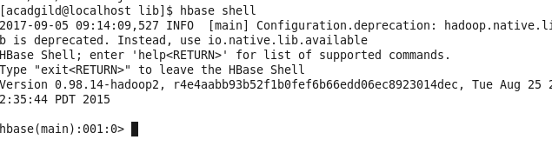
create table

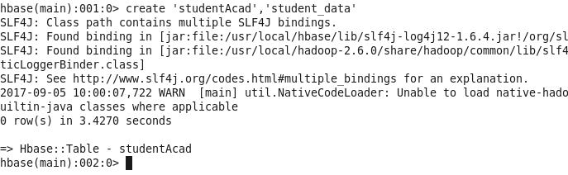
exit and go to pig grunt

rawD = LOAD '/Deepak/Session10Assignment2/student.txt' USING PigStorage(',') AS (StudentName:chararray, sector:chararray, DOB:chararray, qualification:chararray,score:int,state:chararray,randomName:chararray)

Verify that data is loaded.

dump rawD;

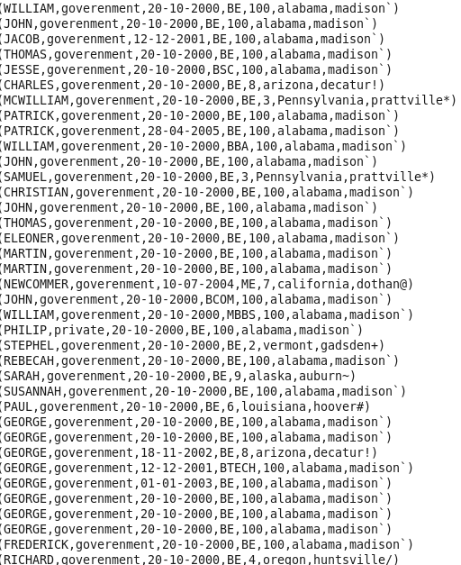

Now, load this data into hbase table.

STORE rawD INTO 'hbase://studentAcad' USING org.apache.pig.backend.hadoop.hbase.HBaseStorage('student_data:StudentName,student_data:sector,student_data:DOB,student_data:qualification,student_data:score,student_data:state,student_data:randomName');

verify in hbase

scan 'studentAcad'

