# Session 11 Assignment 2

Task –

Read from MySQL Table and load it in Hive table.

Create hive table if it does not exist.

If it exists, perform the incremental load.

Step 1 – Create a table in mysql and load data into it.

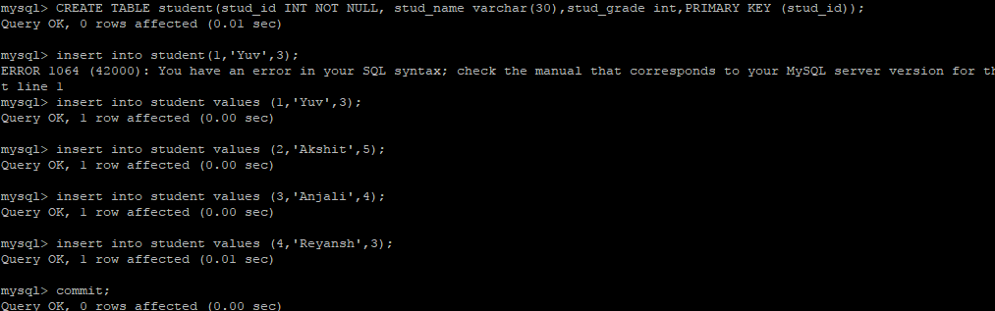

Now, import this data to hive.

sqoop import --connect jdbc:mysql://localhost/deepak --driver com.mysql.jdbc.Driver --username root -P --split-by stud_id --columns stud_id,stud_name,stud_grade --table student --target-dir /user/maria_dev/hivestudent --fields-terminated-by "," --hive-import --create-hive-table --hive-table custom.hivestudent

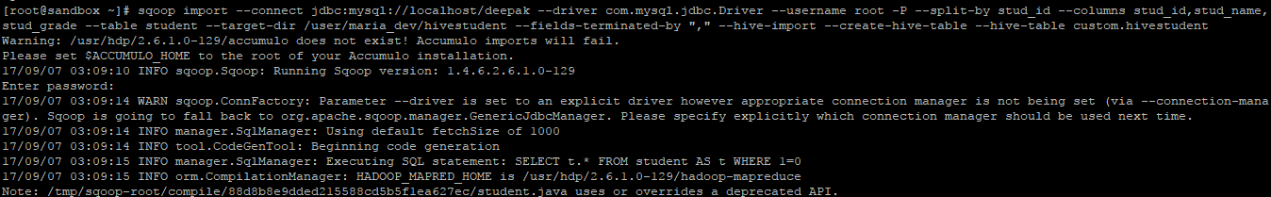

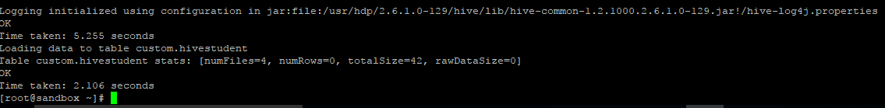

Check in hive table.

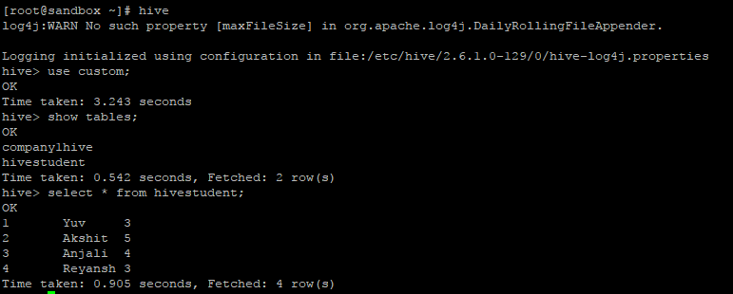

Check hive metastore

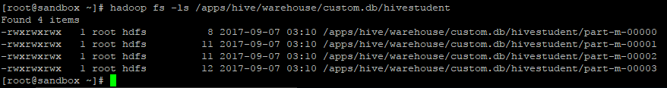

We can see that four records are present.

Now, let us add some more records to the table student in mysql.

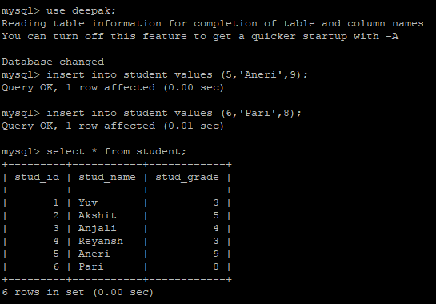

So, we have added two new rows.

Now, we will perform incremental load to hive.

sqoop import --connect jdbc:mysql://localhost/deepak --driver com.mysql.jdbc.Driver --username root --password hadoop --table student --target-dir /apps/hive/warehouse/custom.db/hivestudent --incremental append --check-column stud_id --last-value 4

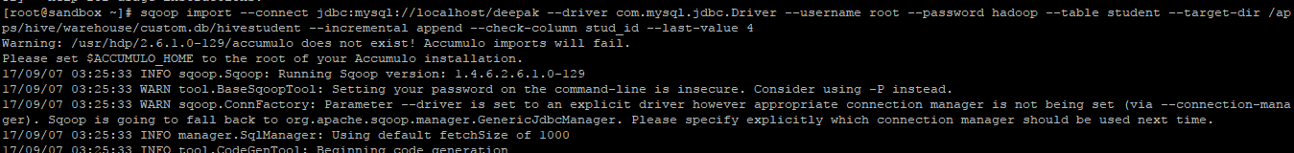

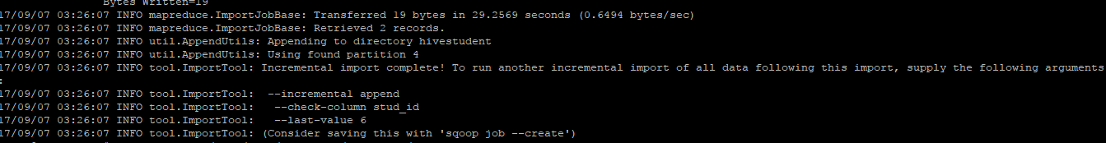

Check data in hive

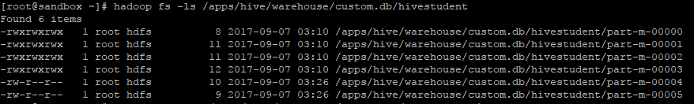

We can see that 0004 and 00005 have been added newly.

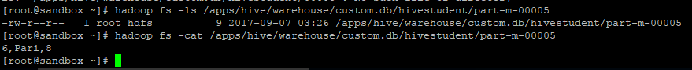

Check in hive table.

