# Session 11 Assignment 3

Twitter data analysis using Flume

Login to twitter apps – <https://apps.twitter.com>

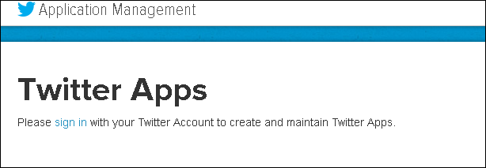

Login with your account details.

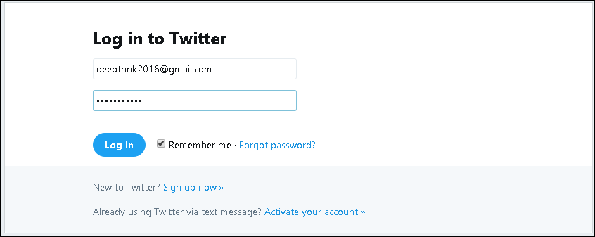

Click on “Create New App”

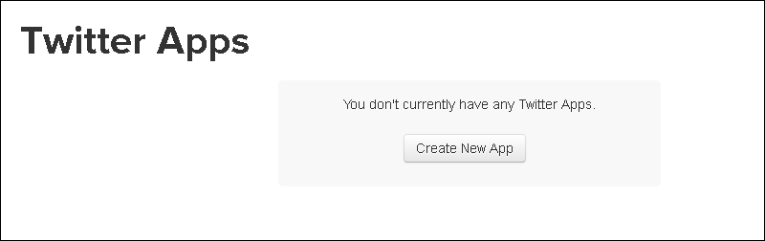

Enter the following details, accept the agreement and click on “Click on Twitter Application”

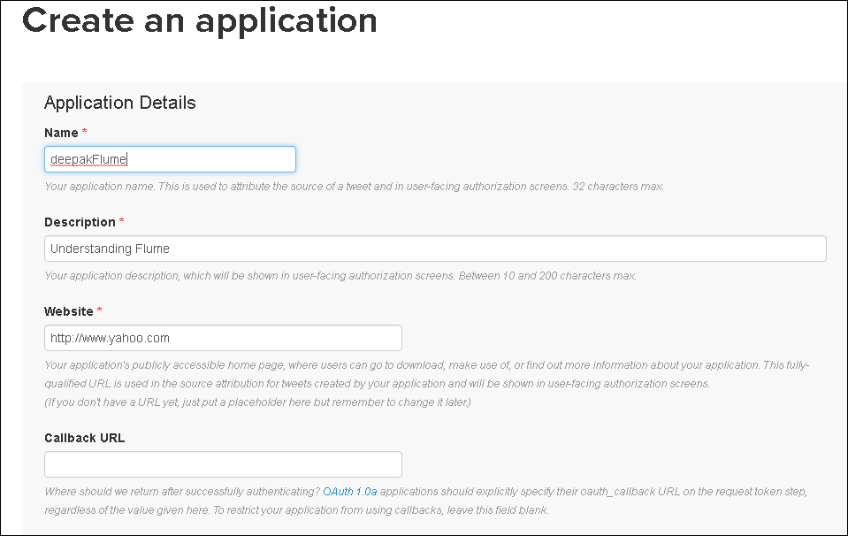

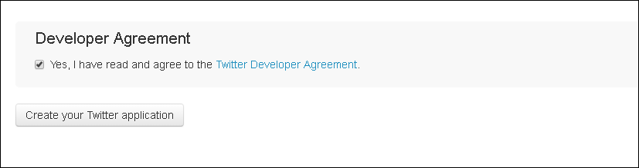

Now, the app is created. Click on “Keys and Access tokens”

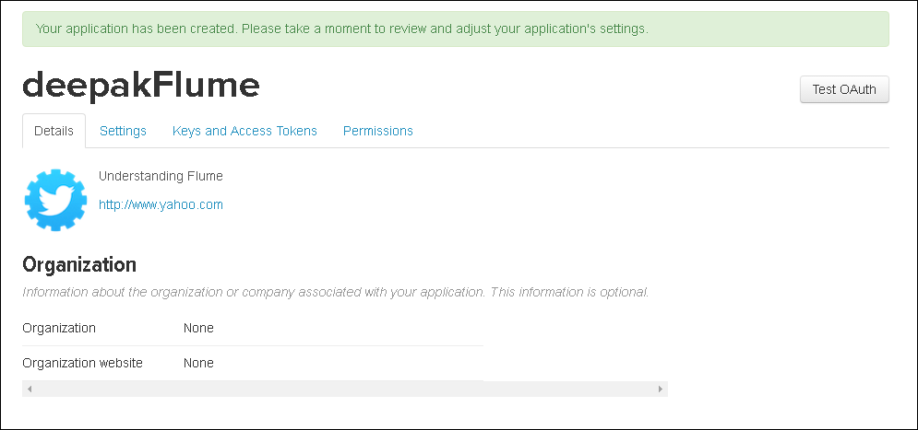

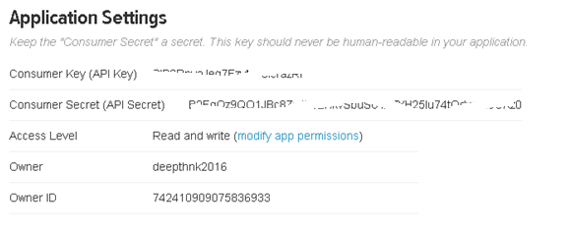

Scroll down and click on Create my access token.

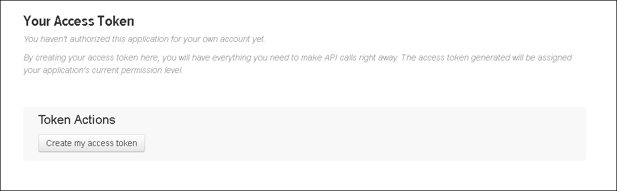

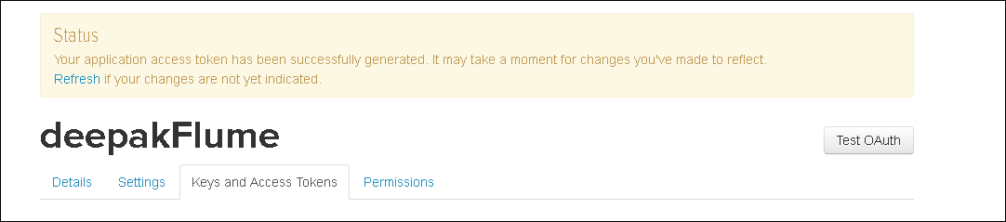

Note down the access token and access token secret.

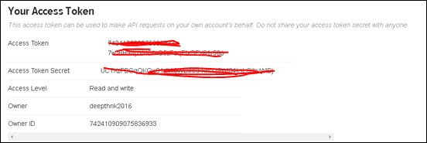

Check that you have the following jar files under $FLUME_HOME/lib

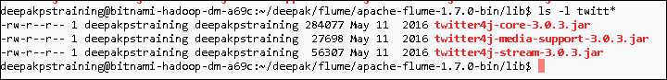

Create a file under $FLUME_HOME/conf

In this we will specify the takens and security keys generated above.

Flume.conf

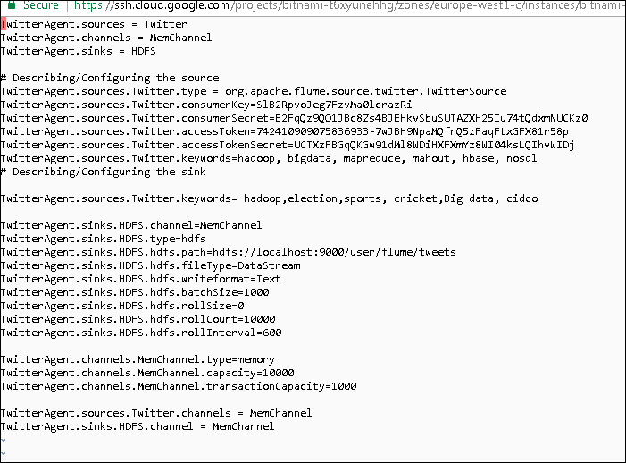

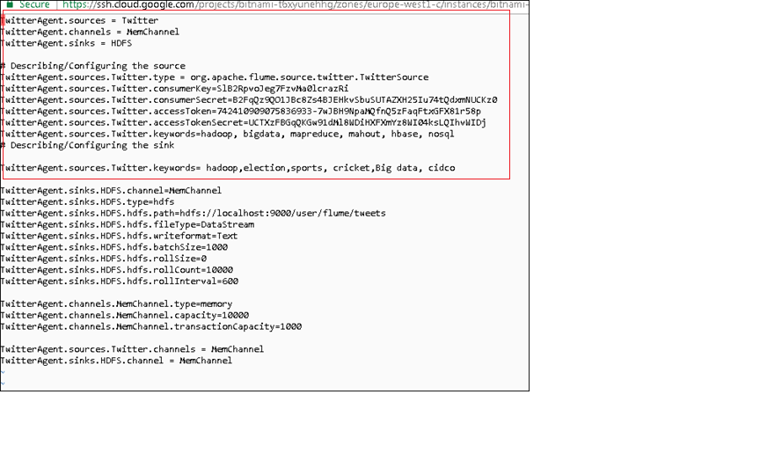

The keywords we are searching are hadoop, election, sports, cricket, Big data, cidco

Now, create a directory under in HDFS /user/flume/tweets



Invoke flume agent.

./flume-ng agent -n TwitterAgent -f $FLUME_HOME/conf/flume.conf

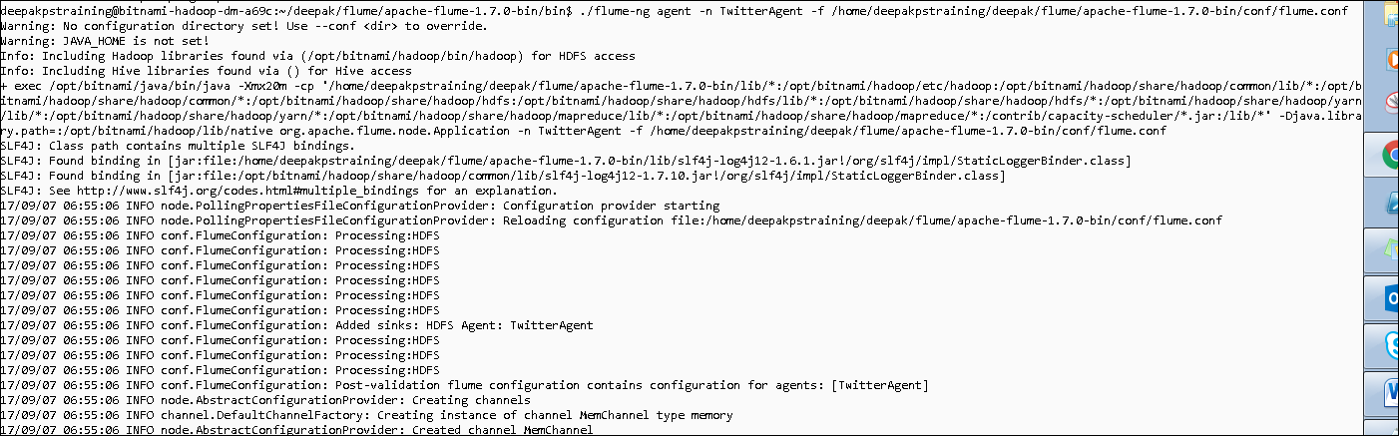

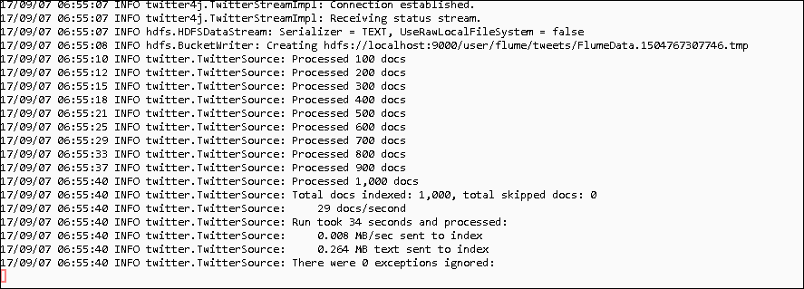

Press Ctrl + C to stop streaming and view the contents of the streaming output file.

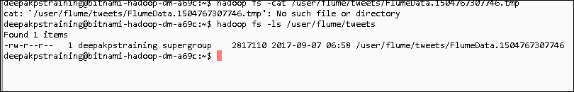

Check the output.



