Session 13 Assignment 3

To find the square root of a number using Babylonian method.

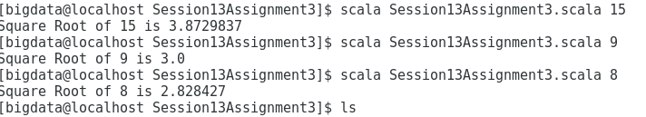
Session13Assignment3.scala

//Session 13 Assignment 3 - Find the square root of a number using Babylonian Method
object Session13Assignment3 {
def squareRoot(a:Float): Float = {
//Assume that the number is the square root itself
var x:Float=a

//Set y to 1;
var y:Float=1

//Set the variable to decide the number of digits for precision
var e:Float=.000001f

//Loop till the difference is greater than e
while (x-y>e){
//Calculate average
x=(x+y)/2
y=a/x
}
//return the final value
x
}

def main(args: Array[String]) {
//Accept the input from command line and pass it to Square Root function
println("Square Root of " + args(0) + " is " + squareRoot(args(0).toInt));
}
}

