# Session 17 Assignment 1

Sample File:

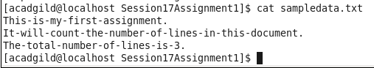

Task 1 – To count the numbers of lines in the input file

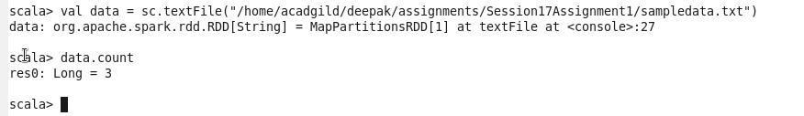

Task 2 – Count of each word in the file

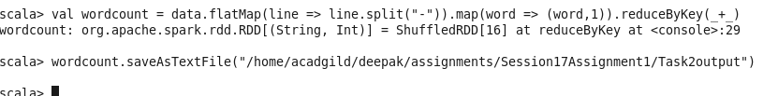

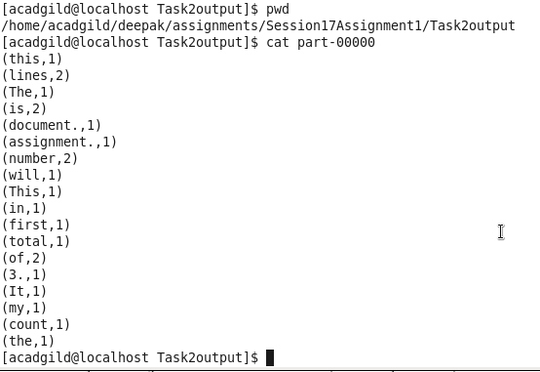

Task 3 – Total word count in the file

