# Session 19 Assignment 1

Problem 1 – What are the total number of gold medals every year

Import the required package.

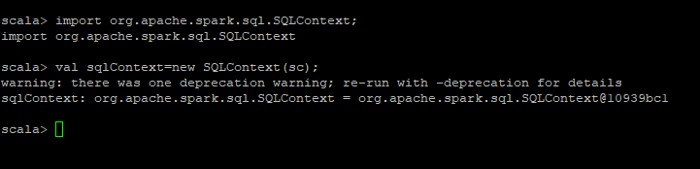

Read the input data file and convert it into a temp table.

val df=sqlContext.read.format("csv").option("header","true").load("/home/bigdata/deepak/docs/Acadgild/Session19Assignment1/Sports_data.txt").registerTempTable("sportsdata")

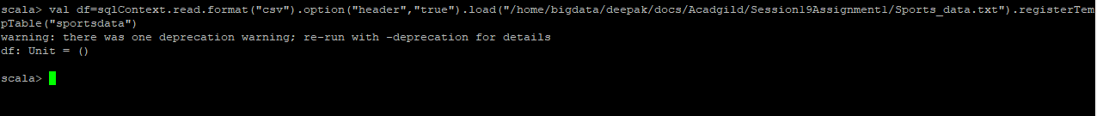

Now, execute the following SQL query to get the results.

val result=sqlContext.sql("select year,medal_type,count(*) from sportsdata where medal_type='gold' group by year,medal_type")



Display the output

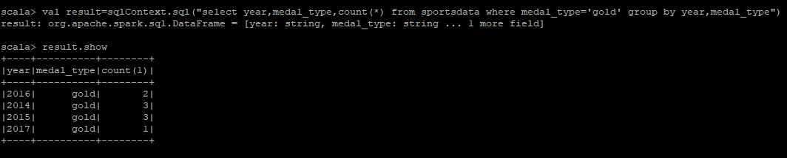

Problem 2 – What are the total number of silver medals have been won by USA in each sport?

Import the required package.



Read the input data file and convert it into a temp table.

val df=sqlContext.read.format("csv").option("header","true").load("/home/bigdata/deepak/docs/Acadgild/Session19Assignment1/Sports_data.txt").registerTempTable("sportsdata")



Execute the following query to get the results.

val result=sqlContext.sql("select sports,count(medal_type) from sportsdata where medal_type='silver' and country='USA' group by sports")

Display the results.

