# Session 19 Assignment 2

Problem 1 – To read the data from input file and concatenate the first two characters of firstname and lastname using UDF



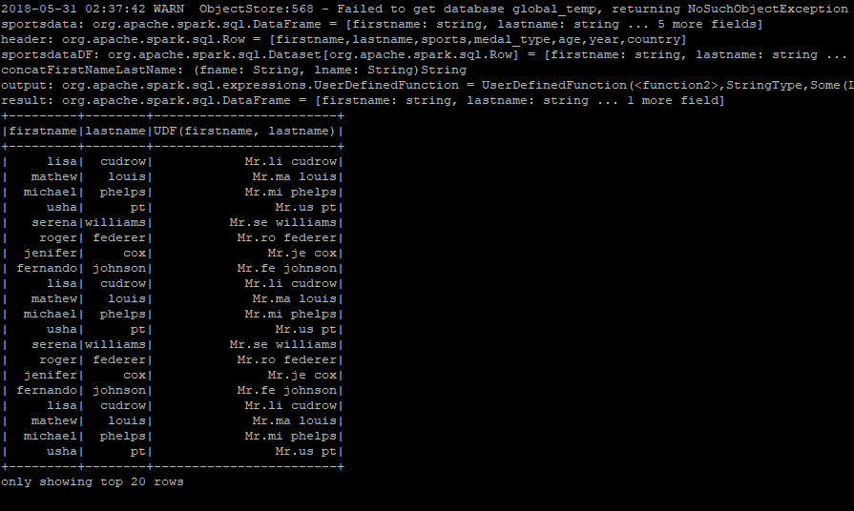

Code Snapshot

