# Session 19 Assignment 2

Problem 2 – To add a new column to dataframe using UDF



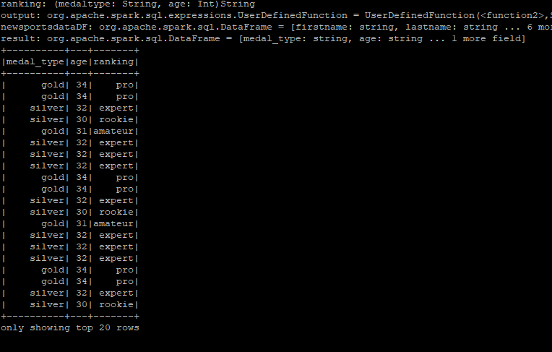

Code Snapshot

