# Session 19 Assignment 3

Create a dataframe from 1 to 100 and write it to parquet file.

First, create a dataframe from 1 to 100

val dataDF = spark.sparkContext.makeRDD(1 to 100).toDF("value")

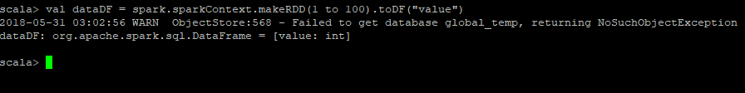

Now, write it to parquet file

dataDF.write.parquet("/home/bigdata/deepak/docs/Acadgild/Session19Assignment3/data")



Once written, we are getting the following files

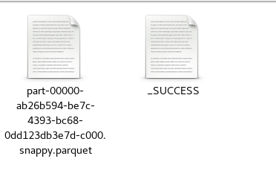

Now, validate the parquet file by reading the contents back to dataframe

