# Session 20 Assignment 2

Twitter Sentiment Analysis Using Spark

//First read the input data file.

val tweets = sc.textFile("/home/bigdata/deepak/docs/Acadgild/Session20Assignment2/demonetization-tweets.csv").map(x => x.split(",")).filter(x=>x.length>=2).map(x => (x(0).replaceAll("\"",""),x(1).replaceAll("\"","").toLowerCase)).map(x => (x._1,x._2.split(" "))).toDF("id","words")



tweets.registerTempTable("tweets")



val explode = spark.sql("select id as id,explode(words) as word from tweets").registerTempTable("tweet_word")

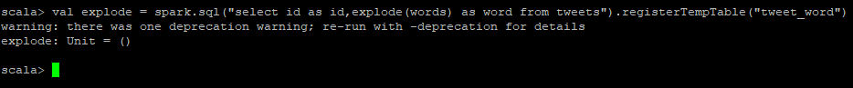

val afinn = sc.textFile("/home/bigdata/deepak/docs/Acadgild/Session20Assignment2/AFINN.txt").map(x => x.split("\t")).map(x => (x(0),x(1))).toDF("word","rating").registerTempTable("afinn")

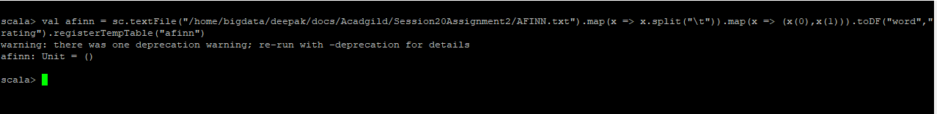

val join = spark.sql("select t.id,AVG(a.rating) as rating from tweet_word t join afinn a on t.word=a.word group by t.id order by rating desc").show

