# Session 21 Assignment 1

Count the total number of blank lines using spark accumulators

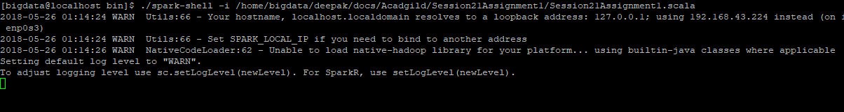

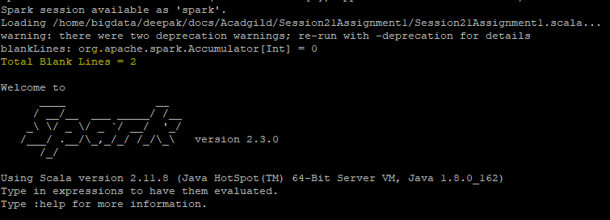

Contents of input file: There are two blank lines

*Hi Deepak how are you*

*I am good*

*Today weather is going to be hot*

*It seems to be very hot*