# Session 23 Assignment 1

To count popular hashtags.

Solution:

Kept the sample tweet under /home/bigdata/deepak/docs/Acadgild/Session23Assignment1/tweets

Read the tweet file

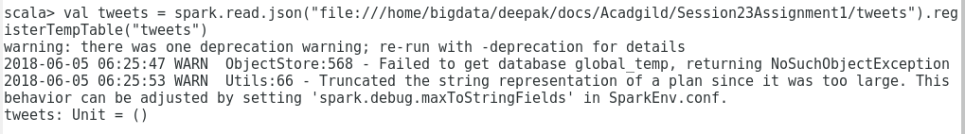

Execute the below commands to get the count of the hashtags.

