Session 23 Assignment 2

**Problem Statement 1**

Find out the top 5 most visited destinations.

val delayed_flights = sc.textFile("file:///home/bigdata/deepak/docs/Acadgild/Session23Assignment2/DelayedFlights.csv")

val mapping = delayed_flights.map(x => x.split(",")).map(x => (x(18),1)).filter(x =>

x._1!=null).reduceByKey(_+_).map(x => (x._2,x._1)).sortByKey(false).map(x => (x._2,x._1)).take(5)

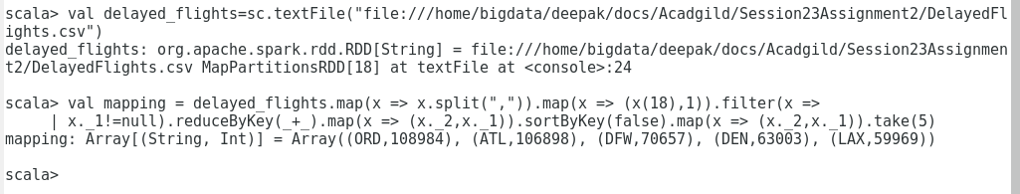

**Problem Statement 2**

Which month has seen the most number of cancellations due to bad weather?

val delayed_flights = sc.textFile("file:///home/bigdata/deepak/docs/Acadgild/Session23Assignment2/DelayedFlights.csv")

val canceled = delayed_flights.map(x => x.split(",")).filter(x => ((x(22).equals("1"))&&

(x(23).equals("B")))).map(x => (x(2),1)).reduceByKey(_+_).map(x =>

(x._2,x._1)).sortByKey(false).map(x => (x._2,x._1)).take(1)

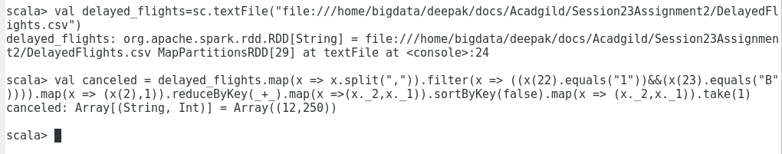

**Problem Statement 3**

Top ten origins with the highest AVG departure delay

val delayed_flights = sc.textFile("file:///home/bigdata/deepak/docs/Acadgild/Session23Assignment2/DelayedFlights.csv")

val avg = delayed_flights.map(x => x.split(",")).map(x => (x(17),x(16).toDouble)).mapValues((_,

1)).reduceByKey((x, y) => (x._1 + y._1, x._2 + y._2)).mapValues{ case (sum, count) => (1.0 *

sum)/count}.map(x => (x._2,x._1)).sortByKey(false).map(x => (x._2,x._1)).take(10)

**Problem Statement 4**

Which route (origin & destination) has seen the maximum diversion?

val delayed_flights = sc.textFile("file:///home/bigdata/deepak/docs/Acadgild/Session23Assignment2/DelayedFlights.csv")

val diversion = delayed_flights.map(x => x.split(",")).filter(x => ((x(24).equals("1")))).map(x =>

((x(17)+","+x(18)),1)).reduceByKey(_+_).map(x => (x._2,x._1)).sortByKey(false).map(x =>

(x._2,x._1)).take(10).foreach(println)

