Session 3 Assignment 2 - Output

Invoke the mapreduce program

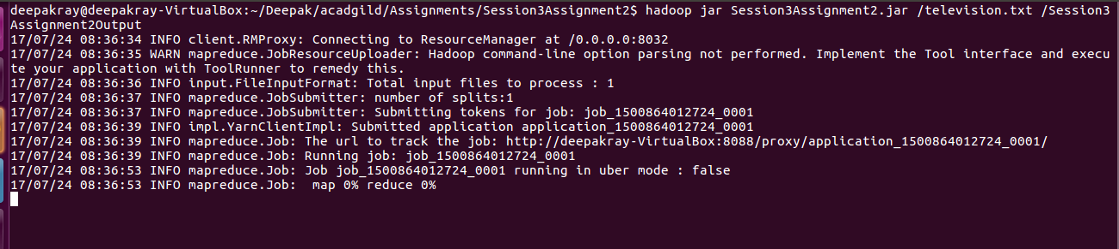

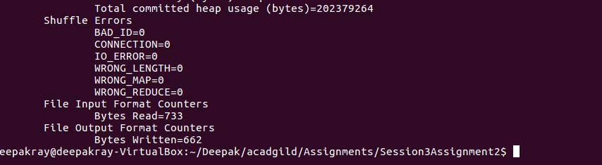
Now, navigate under folder Session3Assignment 2 to view the output files generated.

To view the output of, open the contents of the file part-r-00000

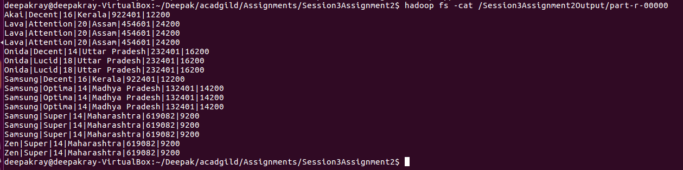
So, in the above output we can see that there are no rows where there is NA in either company name or product name.

