Big Data – Session 4 Assignments

Assignment 1 – Create a class called acad with function main to declare two integers and display their sum.

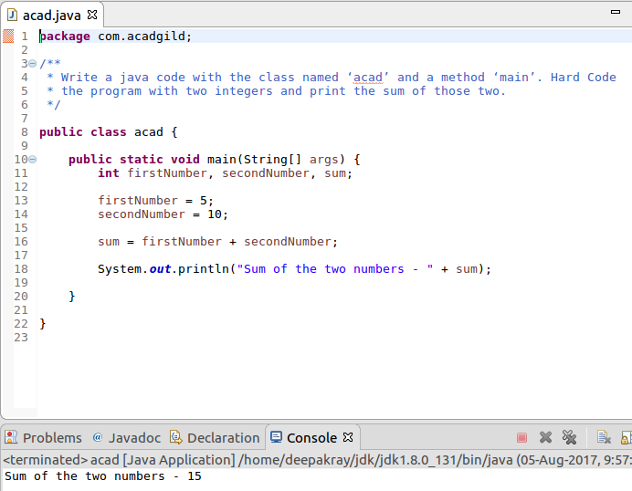

Assignment 2 – Program to accept two numbers as input and display thier sum.

Assignment 3 – Create a function which has two integers as input parameters and display their sum.

Assignment 4 – Accept two numbers and display the list of odd and even numbers between them.

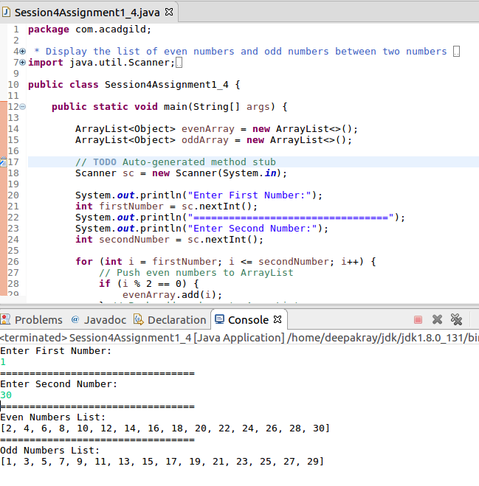
Assignment 5 – Accept a number and display its two multiples.

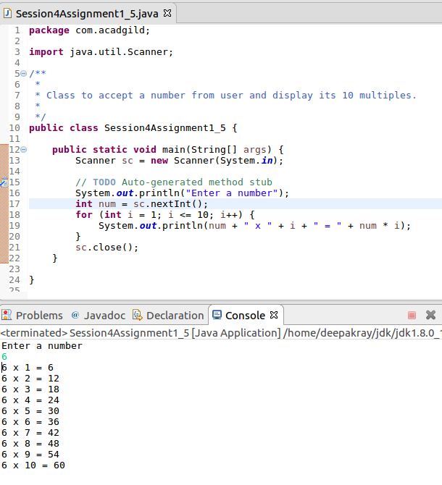
Assignment 6 – To display concept of function overloading.

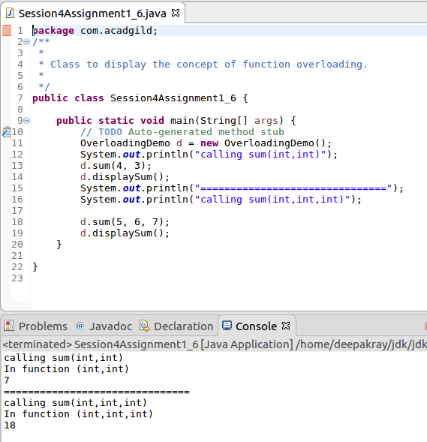

Assignment 7 – Can you overload a method with same return type?
Answer – Yes, we can overload a method with same return type, provided the number if input parameters and type of input parameters to the function should be different.

Assignment 8 – To Sort the contents of Array.

