Session 4 Assignment 2 – Understanding PIG Commands

1. CONCATENATE – To concatenate two strings.

Contents of input_dataset

Type pig to enter pig shell.

Load the contents of the file to a pig variable.

inputfile = LOAD ‘hdfs://deepakray-VirtualBox:9000/pig/Session4Assignment2/input_dataset’ as (firstname:chararray, lastname:chararray, dept:chararray, salary:int) ;

View the contents of input file

DUMP inputfile ;

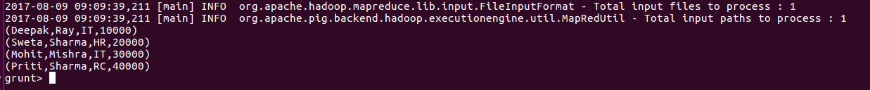
Now, we will perform the concatenation on firstname and lastname with a hyphen ‘ - ‘ in between them.

concatfile = foreach inputfile GENERATE CONCAT (firstname,’-’,lastname) ;

View the contents of concatfile

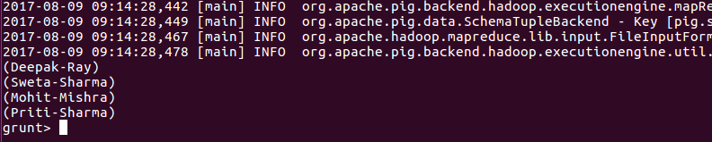
We can see that firstname and lastname are concatenated.

2. TOKENIZE

To split a string having a group of words in a single tuple and return a bag which contains the output of the split operation. The acceptable deimiters are comma (,), space, asterisk (*), parenthesis (), double quotes “

First, we will concatenate the firstname and lastname by a space.

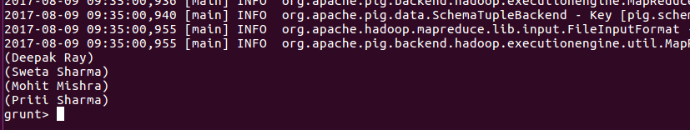
Now, we will perform the TOKENIZE operation.

tokenizedata = foreach concatfile GENERATE TOKENIZE(fullname) ;

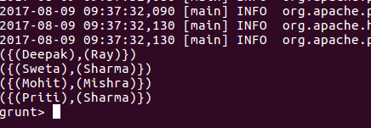

We can see that firstname and last name were splitted in tuples and the output is a bag of thesetuples.

3. SUM
Sum is to calculate sum of a column of all rows or on the fields grouping is done.

Inputfile -

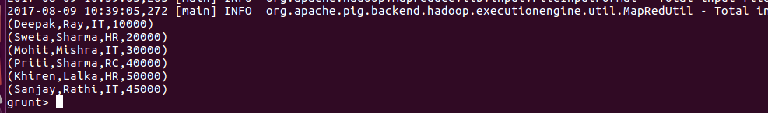
In this example, we will find the sum of salaries of every department.

First, group all the rows by dept.

grouprows = GROUP empldataset by dept ;

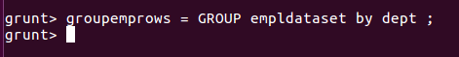

View the contents of groupemprows

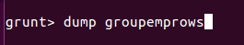

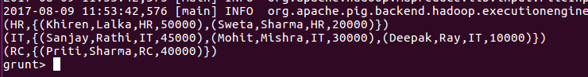

Now, perform the sum
sumsalbydept = foreach groupemprows GENERATE group as dept,SUM(empldataset.salary) ;

check the sum

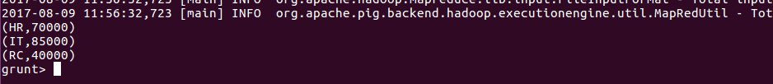
To sum all the salaries:
groupemprows = GROUP empldataset ALL ;
sumsal = foreach groupemprows GENERATE SUM(empldataset.salary);

DUMP sumsal ;

4. MIN

In this example, we will find the minimum salary in every department.
Continuing with the above dataset, first group the rows by department and then find the minimum salary of them.
groupemprows = GROUP empldataset by dept ;


minsalbydept = foreach groupemprows GENERATE group as dept, MIN(empdataset.salary)
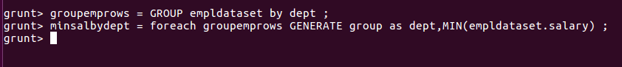
now, display the result.
DUMP minsalbydept
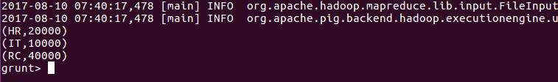
5. MAX

In this example, we will find the maximum salary in every department.
Continuing with the above dataset, first group the rows by department and then find the maximum salary of them.
groupemprows = GROUP empldataset by dept ;

maxsalbydept = foreach groupemprows GENERATE group as dept, MAX(empdataset.salary)
now, display the result.
DUMP maxsalbydept
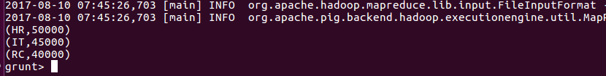
6. LIMIT
The limit operator is to get a limited number of tuples from a relation.
Dataset
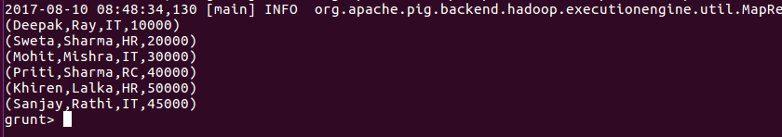
Now, lets fetch the first 3 rows from the above dataset.
limit_data = LIMIT empldataset 3;

verify the results.
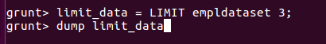

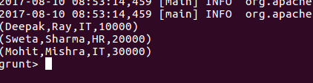

7. STORE
STORE command is to store the results into filesystem
STORE empldataset INTO ‘hdfs://deepakray-VirtualBox:9000/pig/Session4Assignment2/output’ ;
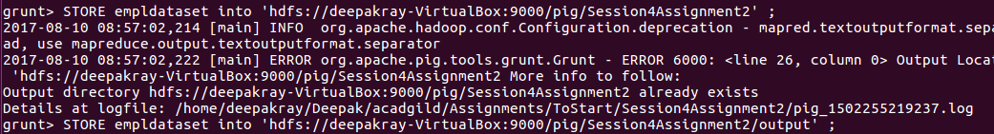
Verify the output
Result will be in the file part-m-00000
hadoop fs -cat /pig/Session4Assignment2/output/part-m-00000
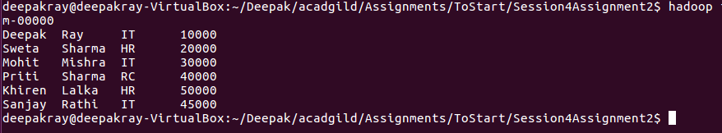
8. DISTINCT
Distinct command is to remove duplicate tuples from a relation.
Let say we have the following data
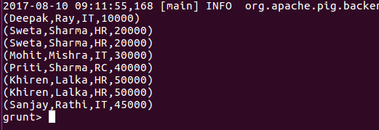
We can see that there are two duplicate rows – Sweta Sharma and Khiren Lalka
Lets apply DISTINCT command and see the output.
distinct_emprows = DISTINCT emprows;
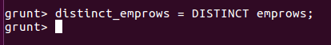

Verify the results.
DUMP distinct_emprows
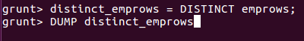

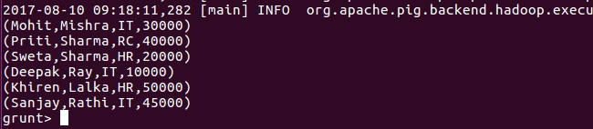
We can see that both the duplicate rows have been eliminated.
9. FLATTEN
Flatten operator is used to un-nest the tuples.
Lets say we have the following dataset
groupemprowsbydept = GROUP emprows by dept;
dump groupemprowsbydept

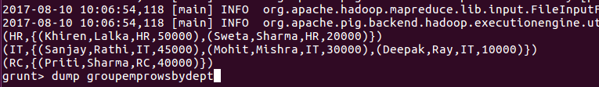

Lets apply flatten operator to it.
flattenrows = foreach groupemprowsbydept GENERATE $0,FLATTEN($1) ;
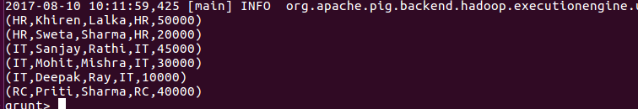
We can carry out the above example – sum of salary by department through flatten operator.
flattenrows = foreach groupemprowsbydept GENERATE FLATTEN(group),SUM(emprows.salary) ;
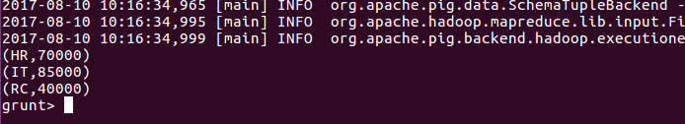
10. IsEmpty
IsEmpty command is to check if a tuple or bag is empty or not.

emp_sales = LOAD 'hdfs://deepakray-VirtualBox:9000/pig/Session4Assignment2/emp_sales.txt' using PigStorage(',') as (sno:int, name:chararray, age:int, salary:int,dept:chararray) ;
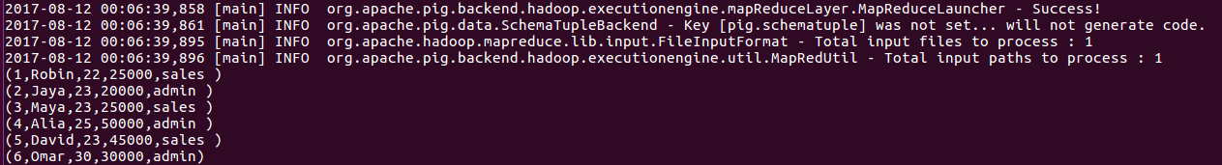
emp_bonus = LOAD 'hdfs://deepakray-VirtualBox:9000/pig/Session4Assignment2/emp_bonus.txt' using PigStorage(',') as (sno:int, name:chararray, age:int, salary:int,dept:chararray) ;
cogroup_data = COGROUP emp_sales by age, emp_bonus by age;
We can see, that for age 30, bag emp_sales is blank. Lets retrieve this bag.
isemptydata = FILTER cogroup_data by IsEmpty(emp_sales);

