Session 4 Assignment 3 – Wordcount using Pig

First, load the data having random words.

article_data = LOAD 'hdfs://deepakray-VirtualBox:9000/pig/Session4Assignment3/inputdata.txt' as (lines:chararray);

dump article_data

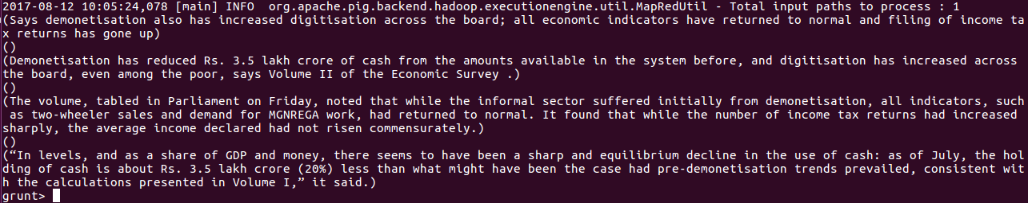
tokendata = foreach article_data GENERATE FLATTEN(TOKENIZE(lines)) as word ;

dump tokendata

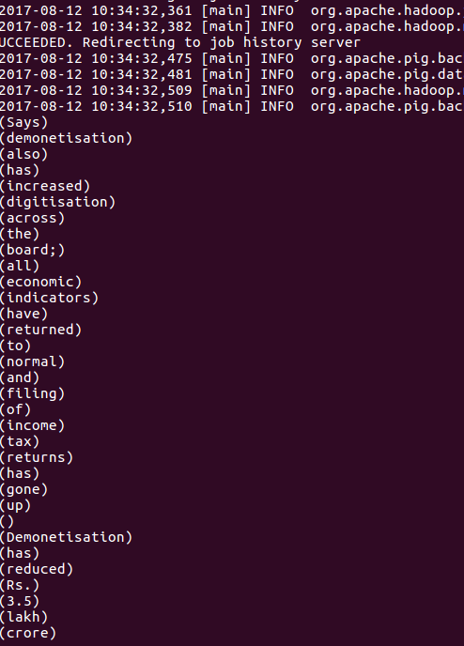

wordcount = foreach groupwords GENERATE FLATTEN(group), COUNT(tokendata.word) ;

