Session 5 Assignment 2

(a) Top 5 employees (employee id and employee name) with highest rating. (In case two
employees have same rating, employee with name coming first in dictionary should get
preference)

/*
Task - Fetch top 5 employees having highest rating
*/

-- Load emp details data
emp_details = LOAD '/home/deepakray/Deepak/acadgild/Assignments/Session5Assignment1/employee_details.txt' using PigStorage(',')
as (empid:chararray, name:chararray, salary:int,rating:int);

-- Sort emp details by descending rating and ascending name
emp_order = ORDER emp_details BY rating DESC, name;

-- fetch employee id and name
emp_output = foreach emp_order GENERATE empid,name;

-- fetch top 5 employees
emp_final_output = LIMIT emp_output 5 ;

-- display output
dump emp_final_output ;

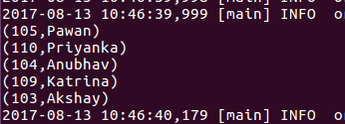

(b) Top 3 employees (employee id and employee name) with highest salary, whose employee id
is an odd number. (In case two employees have same salary, employee with name coming first
in dictionary should get preference)

/*
Task - Fetch top 3 employees having max salary with odd employee id's
*/

-- Load emp details data
emp_details = LOAD '/home/deepakray/Deepak/acadgild/Assignments/Session5Assignment1/employee_details.txt' using PigStorage(',')
as (empid:int, name:chararray, salary:int,rating:int);

-- Filter odd employee ids
emp_odd = FILTER emp_details BY empid%2 != 0;

-- Sort emp details by descending rating and ascending name
emp_order = ORDER emp_odd by salary DESC, name ;

-- fetch employee id and name
emp_output_columns = foreach emp_order GENERATE empid,name;

-- limit the output to 3
emp_output = LIMIT emp_output_columns 3 ;

-- display output
dump emp_output ;
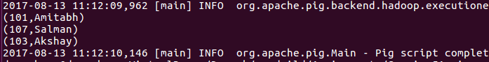

(c) Employee (employee id and employee name) with maximum expense (In case two
employees have same expense, employee with name coming first in dictionary should get
preference)

/*
Task - To find the employee having maximum expense.
*/

-- Load emp details data
emp_details = LOAD '/home/deepakray/Deepak/acadgild/Assignments/Session5Assignment1/employee_details.txt' using PigStorage(',')
as (empid:int, name:chararray, salary:int,rating:int);

-- Load emp expense data
emp_expenses = LOAD '/home/deepakray/Deepak/acadgild/Assignments/Session5Assignment1/employee_expenses.txt'
as (empid:int, expense:int);

-- join emp details and expense by empid
emp_details_expenses = JOIN emp_details by empid, emp_expenses by empid ;

-- fetch empid, name and expense from the above relation
emp_output_columns = foreach emp_details_expenses GENERATE emp_details::empid,emp_details::name,emp_expenses::expense ;

-- sort the output by highest expense and name
emp_output_sort = ORDER emp_output_columns by emp_expenses::expense DESC, emp_details::name ;

-- fetch the employee having max expense
max_expense_emp = LIMIT emp_output_sort 1 ;

-- display the final output
DUMP max_expense_emp ;

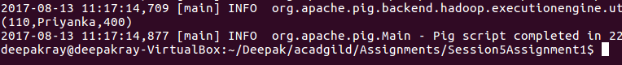

(d) List of employees (employee id and employee name) having entries in employee_expenses
file.

/*
Task - To fetch the employees who have details in expenses
*/

-- Load emp details data
emp_details = LOAD '/home/deepakray/Deepak/acadgild/Assignments/Session5Assignment1/employee_details.txt' using PigStorage(',')
as (empid:int, name:chararray, salary:int,rating:int);

-- Load emp expense data
emp_expenses = LOAD '/home/deepakray/Deepak/acadgild/Assignments/Session5Assignment1/employee_expenses.txt'
as (empid:int, expense:int);

-- Perform left outer join
emp_details_expenses = JOIN emp_details by empid LEFT, emp_expenses by empid ;

-- Fitler the rows having expense amount
emp_having_expense = FILTER emp_details_expenses by emp_expenses::expense is not null ;

-- fetch empid and name from the above relation
emp_output_columns = foreach emp_having_expense GENERATE emp_details::empid,emp_details::name ;

-- fetch only distinct rows
distinct_data = DISTINCT emp_output_columns ;

DUMP distinct_data ;

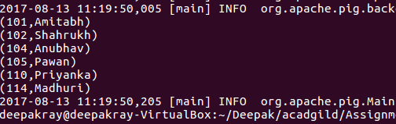

(e) List of employees (employee id and employee name) having no entry in employee_expenses
file.

/*
Task - To fetch the employees who don't have details in expenses
*/

-- Load emp details data
emp_details = LOAD '/home/deepakray/Deepak/acadgild/Assignments/Session5Assignment1/employee_details.txt' using PigStorage(',')
as (empid:int, name:chararray, salary:int,rating:int);

-- Load emp expense data
emp_expenses = LOAD '/home/deepakray/Deepak/acadgild/Assignments/Session5Assignment1/employee_expenses.txt'
as (empid:int, expense:int);

-- Perform left outer join
emp_details_expenses = JOIN emp_details by empid LEFT, emp_expenses by empid ;

-- Fitler the rows having no expense amount
emp_having_noexpense = FILTER emp_details_expenses by emp_expenses::expense is null ;

-- fetch empid and name from the above relation
emp_output_columns = foreach emp_having_noexpense GENERATE emp_details::empid,emp_details::name ;

-- fetch only distinct rows
distinct_data = DISTINCT emp_output_columns ;

DUMP distinct_data ;

