Problem Statement 1
Find out the top 5 most visited destinations.
/*
Problem Statement 1 - Find out the top 5 most visited destinations.
*/
-- Register piggybank.jar to use CSVExcelStorage
REGISTER '/home/deepakray/Deepak/acadgild/Assignments/Session5Assignment2/piggybank.jar';

--Load flight details
flight_data = load '/home/deepakray/Deepak/acadgild/Assignments/Session5Assignment2/DelayedFlights.csv' USING org.apache.pig.piggybank.storage.CSVExcelStorage(',','NO_MULTILINE','UNIX','SKIP_INPUT_HEADER');

-- Get the destinations
flight_dest_details = foreach flight_data generate (chararray) $18 as dest;

-- Filter the destinations - get only not null destinations
dest_data = filter flight_dest_details by dest is not null;

-- group result by destination
dest_group = group dest_data by dest;

-- count destinations for every group
dest_count = foreach dest_group generate group, COUNT(dest_data.dest);

-- sort results by count of destinations in descending order
top_dest = order dest_count by $1 DESC;

-- fetch top 5 rows from the result
top5_dest = LIMIT top_dest 5;

-- load Airport details
airport_data = load '/home/deepakray/Deepak/acadgild/Assignments/Session5Assignment2/airports.csv' USING org.apache.pig.piggybank.storage.CSVExcelStorage(',','NO_MULTILINE','UNIX','SKIP_INPUT_HEADER');

-- get destination, city and country
airport_country_city = foreach airport_data generate (chararray)$0 as dest, (chararray)$2 as city, (chararray)$4 as country;

-- join flight data and airport data to get destination's country and city
dest_country_city = join top5_dest by $0, airport_country_city by dest;

-- sort final result by count of destinations
final_result = order dest_country_city by $1 DESC ;

-- display the results
dump final_result;

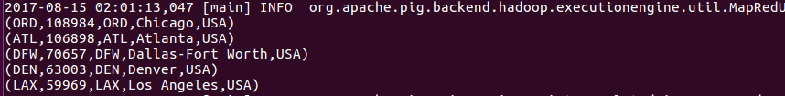

Problem Statement 2
Which month has seen the most number of cancellations due to bad weather?
/*
Problem Statement 2 - Which month has seen the most number of cancellations due to bad weather?
*/
-- Register piggybank.jar to use CSVExcelStorage
REGISTER '/home/deepakray/Deepak/acadgild/Assignments/Session5Assignment2/piggybank.jar';
--Load flight details
flight_data = load '/home/deepakray/Deepak/acadgild/Assignments/Session5Assignment2/DelayedFlights.csv' USING org.apache.pig.piggybank.storage.CSVExcelStorage(',','NO_MULTILINE','UNIX','SKIP_INPUT_HEADER');
-- Get the month, cancelled and cancellation code
flight_details = foreach flight_data generate (chararray) $2 as month,(int) $22 as cancelled, (chararray)$23 as reason;
-- Filter the flight details - get only cancelled flights due to bad weather
cancelled_flights_badweather = filter flight_details by cancelled==1 AND reason=='B';
-- group results by month
group_cancelled_flights_by_month = group cancelled_flights_badweather by month;
-- count bad weather cancellations by month
count_cancelled_flights_by_month = foreach group_cancelled_flights_by_month generate group, COUNT(cancelled_flights_badweather.reason);
-- sort results by count of cancellations in descending order
sort_cancellation_by_month = order count_cancelled_flights_by_month by $1 DESC;
-- fetch top row from the result
top_cancellation_month = LIMIT sort_cancellation_by_month 1;
dump top_cancellation_month ;

Problem Statement 3
Top ten origins with the highest AVG departure delay
/*
Problem Statement 3 - Top ten origins with the highest AVG departure delay
*/
-- Register piggybank.jar to use CSVExcelStorage
REGISTER '/home/deepakray/Deepak/acadgild/Assignments/Session5Assignment2/piggybank.jar';
--Load flight details
flight_data = load '/home/deepakray/Deepak/acadgild/Assignments/Session5Assignment2/DelayedFlights.csv' USING org.apache.pig.piggybank.storage.CSVExcelStorage(',','NO_MULTILINE','UNIX','SKIP_INPUT_HEADER');
-- Get the month, cancelled and cancellation code
flight_details = foreach flight_data generate (int) $16 as delay,(chararray) $17 as origin;
-- Filter the flight details - delay time should not be null and origin should not be null
flight_details_filter = FILTER flight_details by origin is not null and delay is not null ;
-- group result by origin
group_by_origin = group flight_details_filter by origin;
-- get the average of delays by origin
sum_delay = foreach group_by_origin generate group, AVG(flight_details_filter.delay);
-- sort results by descending order of delay
sort_flight_delays = order sum_delay by $1 DESC;
-- fetch top 10 rows from the result
top10_flight_delays = LIMIT sort_flight_delays 10;
-- load Airport details
airport_data = load '/home/deepakray/Deepak/acadgild/Assignments/Session5Assignment2/airports.csv' USING org.apache.pig.piggybank.storage.CSVExcelStorage(',','NO_MULTILINE','UNIX','SKIP_INPUT_HEADER');
-- get destination, city and country
airport_country_city = foreach airport_data generate (chararray)$0 as origin, (chararray)$2 as city, (chararray)$4 as country;
-- join flight data and airport data to get destination's country and city
dest_country_city = join top10_flight_delays by $0, airport_country_city by origin;
-- sort final result by count of destinations
final_result = order dest_country_city by $1 DESC ;

-- display the results
dump final_result;
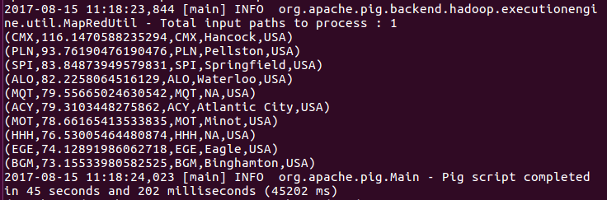

Problem Statement 4
Which route (origin & destination) has seen the maximum diversion?
/*
Problem Statement 4 - Which route (origin & destination) has seen the maximum diversion?
*/
-- Register piggybank.jar to use CSVExcelStorage
REGISTER '/home/deepakray/Deepak/acadgild/Assignments/Session5Assignment2/piggybank.jar';
--Load flight details
flight_data = load '/home/deepakray/Deepak/acadgild/Assignments/Session5Assignment2/DelayedFlights.csv' USING org.apache.pig.piggybank.storage.CSVExcelStorage(',','NO_MULTILINE','UNIX','SKIP_INPUT_HEADER');
-- Get the origin, destination and diverted details
flight_details = foreach flight_data generate (chararray) $17 as origin,(chararray)$18 as dest, (int)$24 as diverted;
-- Filter the flight details - origin and destination should not be null and it should be diverted.
flight_details_filter = FILTER flight_details by origin is not null and dest is not null and diverted==1 ;
-- group result by origin and destination
group_by_origindest = group flight_details_filter by (origin,dest);
-- get the number of diversions
count_diversions = foreach group_by_origindest generate group, COUNT(flight_details_filter.diverted);

-- sort results by descending order of diversions
sort_flight_diversions = order count_diversions by $1 DESC;
-- fetch top 10 rows from the result
top10_flight_diversions = LIMIT sort_flight_diversions 10;
dump top10_flight_diversions ;
