Ques 1: Find the list of players that have been selected in the qualifying round (DEFENCE>55)

/* Ques 1: Find the list of players that have been selected in the qualifying round (DEFENCE>55). */

pokemon_data = LOAD '/home/deepakray/Deepak/acadgild/Assignments/Session5Assignment3/Pokemon.csv' USING PigStorage(',') AS(Sno:int,Name:chararray,Type1:chararray,Type2:chararray,Total:int,HP:int,Attack:int,Defense:int,splatck:int,spldefenct:int,speed:int);

qualifying_data = FILTER pokemon_data by Defense>55 ;

dump qualifying_data;

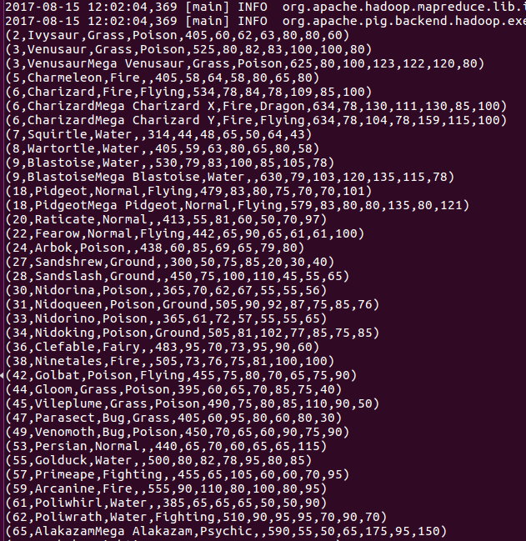

Ques 2: State the number of players taking part in the competition after getting selected in the qualifying round.

/* Ques 2: State the number of players taking part in the competition after getting selected in the qualifying round. */

-- Load Data
pokemon_data = LOAD '/home/deepakray/Deepak/acadgild/Assignments/Session5Assignment3/Pokemon.csv' USING PigStorage(',') AS(Sno:int,Name:chararray,Type1:chararray,Type2:chararray,Total:int,HP:int,Attack:int,Defense:int,splatck:int,spldefenct:int,speed:int);

-- filter qualifying data
qualifying_data = FILTER pokemon_data by Defense>55 ;

-- group the qualifying data
group_qualifying_data = GROUP qualifying_data ALL ;

-- get count
count_qualifying_data = foreach group_qualifying_data GENERATE COUNT(qualifying_data) ;

-- display results
dump count_qualifying_data ;

Ques 3: Using random() generate random numbers for each Pokémon on the selected list.
/* Ques 3: Using random() generate random numbers for each Pokémon on the selected list. */

-- Load Data
pokemon_data = LOAD '/home/deepakray/Deepak/acadgild/Assignments/Session5Assignment3/Pokemon.csv' USING PigStorage(',') AS(Sno:int,Name:chararray,Type1:chararray,Type2:chararray,Total:int,HP:int,Attack:int,Defense:int,splatck:int,spldefenct:int,speed:int);

-- filter qualifying data
generate_random = foreach pokemon_data GENERATE RANDOM(),Name,Type1,Type2,Total,HP,Attack;

-- display results
dump generate_random ;

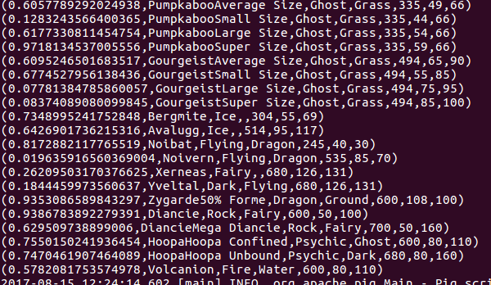

Ques 4: Arrange the new list in a descending order according to a column randomly.
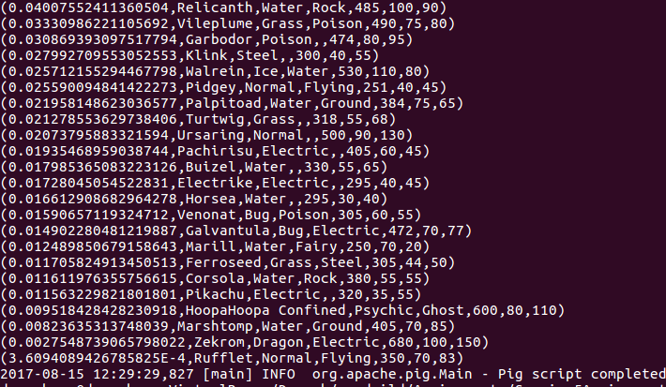

Ques 5: Now on a new relation again associate random numbers for each Pokémon and arrange in descending order according to column random.
Same as solution 4

Ques 7: Store the data on a local drive to announce for the final match. By the name player1 and player2 (only show the NAME and HP).
/* Store the data on a local drive to announce for the final match. By the name player1 and player2 (only show the NAME and HP). */

-- Load Data
pokemon_data = LOAD '/home/deepakray/Deepak/acadgild/Assignments/Session5Assignment3/Pokemon.csv' USING PigStorage(',') AS(Sno:int,Name:chararray,Type1:chararray,Type2:chararray,Total:int,HP:int,Attack:int,Defense:int,splatck:int,spldefence:int,speed:int);

qualifying_data = FILTER pokemon_data by Defense>55 ;

-- generate random for relation 1
random_include1 = foreach qualifying_data GENERATE RANDOM(),Name,Type1,Type2,Total,HP,Attack,Defense,splatck,spldefence,speed;

-- sort by random function relation 1
random1_desending = ORDER random_include1 BY $0 DESC;

-- generate random for relation 2
random_include2 = foreach qualifying_data GENERATE RANDOM(),Name,Type1,Type2,Total,HP,Attack,Defense,splatck,spldefence,speed;

-- sort by random function relation 2
random2_desending = ORDER random_include2 BY $0 DESC;

-- top 5 from relation 1
limit_data_random1_desending = LIMIT random1_desending 5 ;

-- top 5 from relation 2
limit_data_random2_desending = LIMIT random2_desending 5 ;

-- filter name from relation 1
filter_only_name1 = foreach limit_data_random1_desending Generate ($1,HP);

-- filter name from relation 2
filter_only_name2 = foreach limit_data_random2_desending Generate ($1,HP);

-- store relation 1 data to local file
STORE limit_data_random1_desending INTO '/home/deepakray/Deepak/acadgild/Assignments/Session5Assignment3/player1.txt';

-- store relation 2 data to local file
STORE limit_data_random2_desending INTO '/home/deepakray/Deepak/acadgild/Assignments/Session5Assignment3/player2.txt';

