Session 6 Assignment 1

In this expample, first we will load the data into a temporary table. Since the data format in file is dd-mm-yyyy, so we will load data into temporary table and then we will format the date to yyyy-mm-dd so that its compatible with hive.

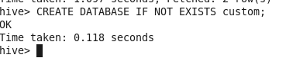

CREATE TABLE IF NOT EXISTS temparature_data_tmp(tempdate string ,zipcode string, temprature int)
ROW FORMAT DELIMITED
FIELDS TERMINATED BY ',';

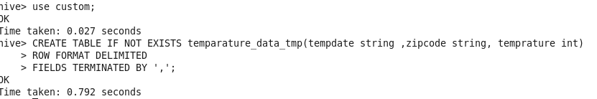

load '/home/acadgild/Deepak/Assignments/Session6Assignment1/datasest_Session_14.txt' into table temparature_data_tmp;

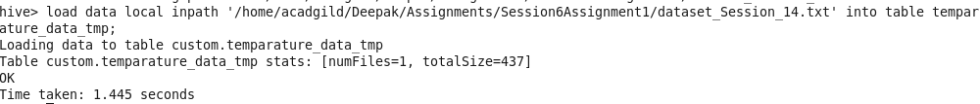
Now, create the main table from the temp table.

CREATE TABLE temparature_data as select to_date(from_unixtime(UNIX_TIMESTAMP(tempdate,'dd-MM-yyyy'))),zipcode,temprature from temparature_data_tmp;

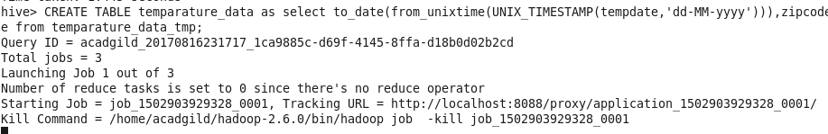
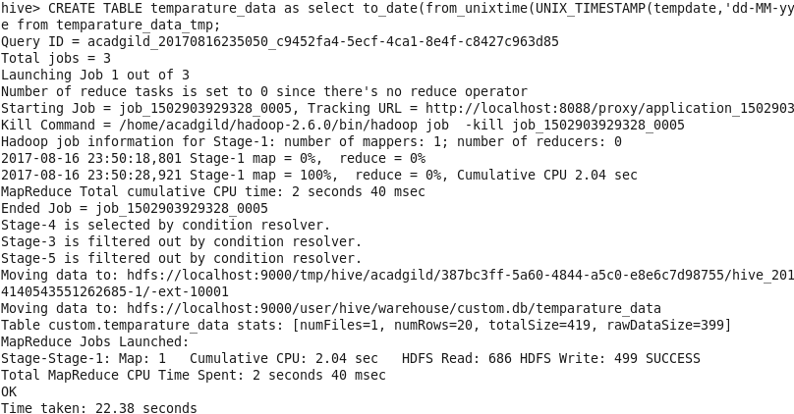
Verify the contents of table.
