Session 6 Assignment 2

1 – Fetch date and temparature from temparature_data where zipcode is between 300000 and 399999.

select tempdate, zipcode from temparature_data where zipcode>=300000 and zipcode<=399999;

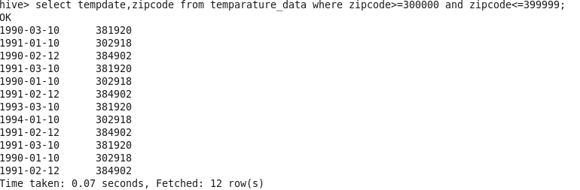
2 – fetch max temprature for every year

select substring(tempdate,1,4),max(temprature) from temparature_data group by substring(tempdate,1,4);

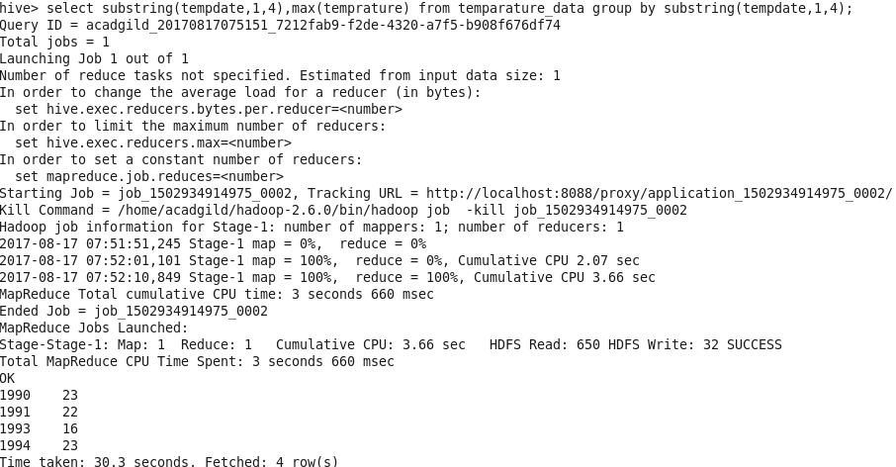
3 – Calculate max temparature corresponding to those years which have atleast two entries.

So, for this example we will insert a new row for year 1995 so that this is the only entry and this should not come up in the output.

INSERT INTO table temparature_data values ('1995-01-01','123456',32);

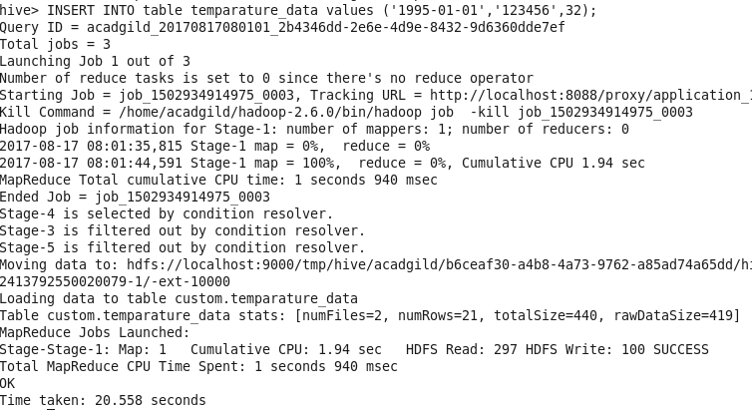
we can see that this new row has been inserted.

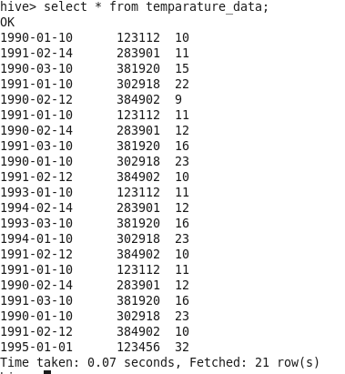

select substring(tempdate,1,4),max(temprature) from temparature_data group by substring(tempdate,1,4) having count(tempdate)>1;

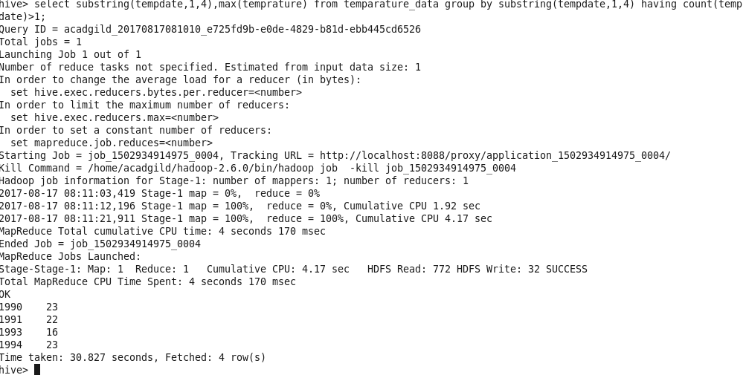
We can see that year 1995 didn't came up in the result.

4 – Create a view on top of last query.

create view if not exists temparature_data_vw as select substring(tempdate,1,4),max(temprature) from temparature_data group by substring(tempdate,1,4) having count(tempdate)>1;

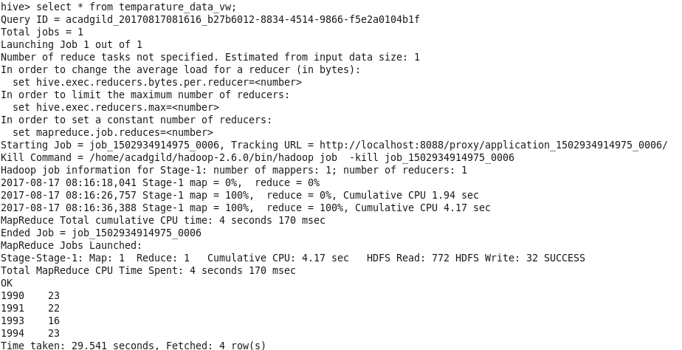
5 – Export the contents of the table to local directory with fields delimited by |

INSERT OVERWRITE LOCAL DIRECTORY '/home/acadgild/Deepak/Assignments/output/Session6Assignment2'
ROW FORMAT DELIMITED
FIELDS TERMINATED BY '|'
SELECT * from temparature_data;

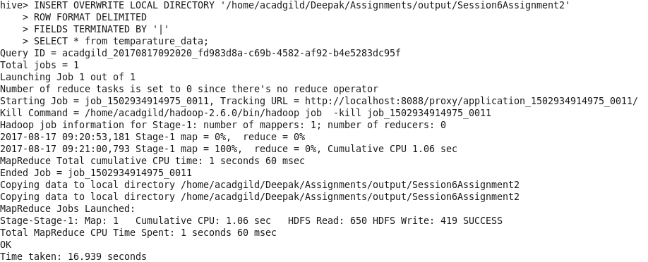
View the contents of the output file

