Session 8 Assignment 2

UDF Class:

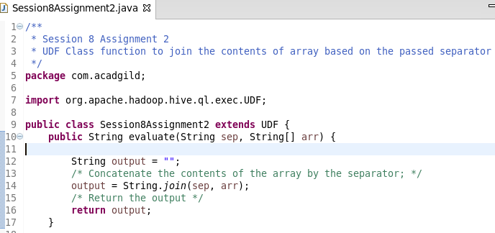
ADD JAR /home/acadgild/Deepak/Assignments/Session8Assignment2/Session8Assignment2UDF.jar;

CREATE TEMPORARY FUNCTION concat_ws AS 'com.acadgild.Session8Assignment2';

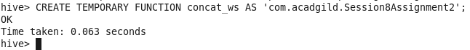
Invoke the function concat_ws based on udf.

