# Session 8 Assignment 3

To carry out, updates and deletes in hive first we need to set the following in hive-site.xml

*<property>*

*<name>hive.support.concurrency</name>*

*<value>true</value>*

*</property>*

*<property>*

*<name>hive.enforce.bucketing</name>*

*<value>true</value>*

*</property>*

*<property>*

*<name>hive.exec.dynamic.partition.mode</name>*

*<value>nonstrict</value></property>*

*<property>*

*<name>hive.txn.manager</name>*

*<value>org.apache.hadoop.hive.ql.lockmgr.DbTxnManager</value>*

*</property>*

*<property>*

*<name>hive.compactor.initiator.on</name>*

*<value>true</value></property>*

*<property>*

*<name>hive.compactor.worker.threads</name>*

*<value>2</value>*

*</property>*

*<property>*

*<name>hive.in.test</name>*

*<value>true</value>*

*</property>*

Once, these settings are done, restart the hive server.

Now, open the hive console and create a table.

CREATE TABLE college(clg_id int,clg_name string,clg_loc string) clustered by (clg_id) into 5 buckets stored as orc TBLPROPERTIES('transactional'='true');



Note that the clustered by clause, stored as orc and TBLPROPERTIES(‘transactional’=’true’) should be set.

Now, insert data into college table.

INSERT INTO table college values(1,'nec','nlr'),(2,'vit','vlr'),(3,'srm','chen'),(4,'lpu','del'),(5,'stanford','uk'),(6,'JNTUA','atp'),(7,'cambridge','us');

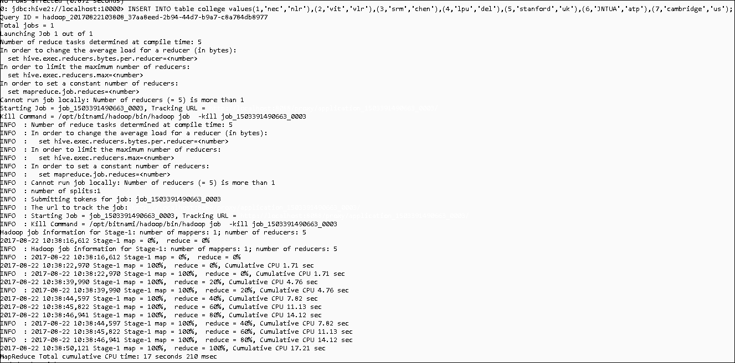

View data in the table.

Select * from college;

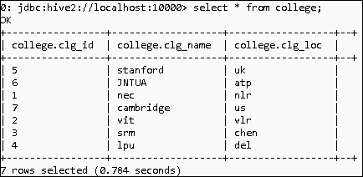

Lets update the college location of college id 1 to xyz (currently it is nlr)

UPDATE college set clg_loc=’XYZ’ where clg_id=1;

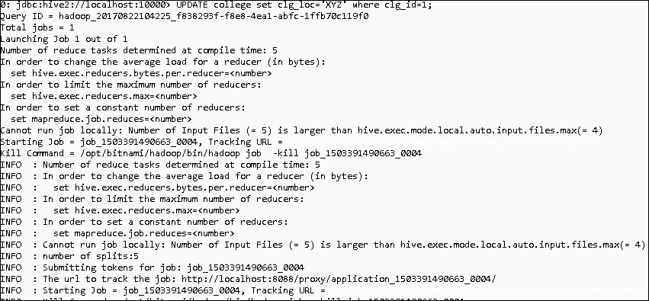

Now, again check the data.

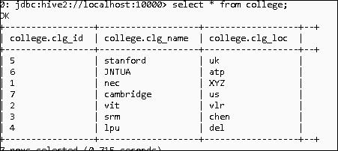

We can see that location has been changed to XYZ for college id 1

Now, lets delete this row from the table.

DELETE from college where clg_id=1

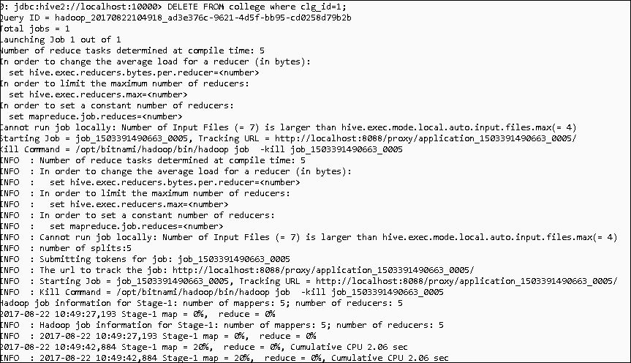

Again, query the table.

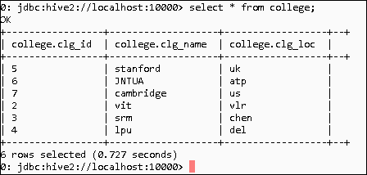

We can see that clg_id =1 is no more present.