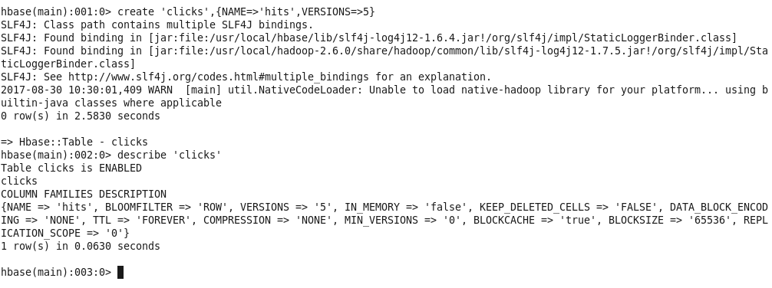
Insert data into table 'clicks'

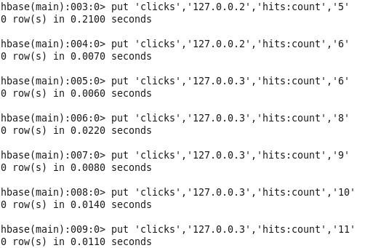
if we select data from this table we can see only the latest added rows for each row-key

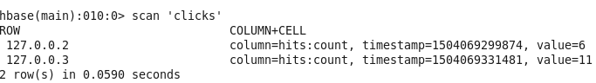
Now, to view the previous versions:

