Case 1 – Trying to assign a new value to a variable declared as Final

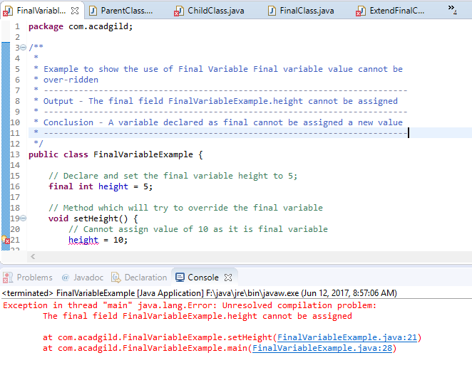

Case 2 – Trying to override a method declared as final.

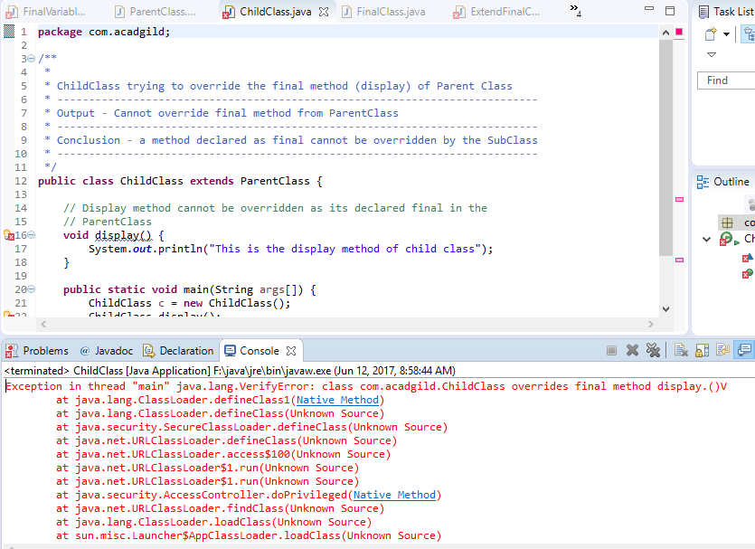

Case 3 – Trying to extend a final class and trying to declare a constructor as final

