Case 1 – when age is greater than 0

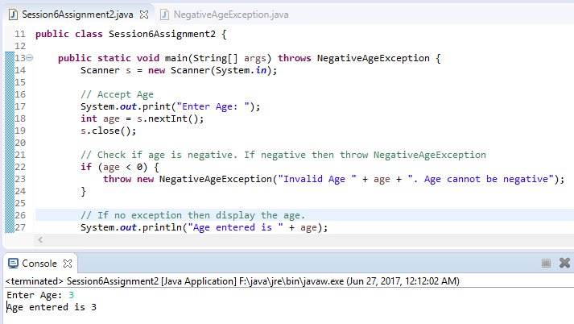

Case 2 – when age is lesser than 0

